**Module Design Document**

**For**

**MotCtrlPrmEstimn**

**06-Dec-2017**

**Prepared For:**

**Software Engineering**

**Nexteer Automotive,**

**Saginaw, MI, USA**

**Prepared By:**

**Brendon Binder,**

**Nexteer Automotive,**

**Saginaw, MI, USAChange History**

|  |  |  |  |  |
| --- | --- | --- | --- | --- |
| **Sl. No.** | **Description** | **Author** | **Version** | **Date** |
| 1 | Initial Version | Rijvi | 1.0 | 20-JUN-2015 |
| 2 | Updated per design rev. 1.5.0 | Rijvi | 2.0 | 07-APRIL-2016 |
| 3 | Updated per design rev. 2.1.0 | ML | 3.0 | 29-NOV-2016 |
| 4 | New Input added MotAndThermProtnLoaMod and deleted IvtrLoaMtgtnEna | TATA | 4.0 | 25-SEP-2017 |
| 5 | Removed local function which didn’t exist, migrated document to latest template | BRB | 5.0 | 06-DEC-2017 |

**Table of Contents**

1 Introduction 5

1.1 Purpose 5

1.2 Scope 5

2 MotCtrlPrmEstimn & High-Level Description 6

3 Design details of software module 7

3.1 Graphical representation of MotCtrlPrmEstimn 7

3.2 Data Flow Diagram 7

3.2.1 Component level DFD 7

3.2.2 Function level DFD 7

4 Constant Data Dictionary 8

4.1 Program (fixed) Constants 8

4.1.1 Embedded Constants 8

5 Software Component Implementation 9

5.1 Sub-Module Functions 9

5.1.1 Init: MotCtrlPrmEstimnInit1 9

5.1.1.1 Design Rationale 9

5.1.1.2 Module Outputs 9

5.1.2 Per: MotCtrlPrmEstimnPer1 9

5.1.2.1 Design Rationale 9

5.1.2.2 Store Module Inputs to Local copies 9

5.1.2.3 (Processing of function)……… 9

5.1.2.4 Store Local copy of outputs into Module Outputs 9

5.1.1 Per: MotCtrlPrmEstimnPer2 9

5.1.1.1 Design Rationale 9

5.1.1.2 Store Module Inputs to Local copies 9

5.1.1.3 (Processing of function)……… 9

5.1.1.4 Store Local copy of outputs into Module Outputs 9

5.2 Server Runnables 10

5.2.1 SetMotPrmNomEol 10

5.2.1.1 Design Rationale 10

5.2.1.2 (Processing of function)……… 10

5.2.2 SetMotPrmNomEol 10

5.2.2.1 Design Rationale 10

5.2.2.2 (Processing of function)……… 10

5.3 Interrupt Functions 10

5.4 Module Internal (Local) Functions 10

5.5 GLOBAL Function/Macro Definitions 10

6 Known Limitations with Design 11

7 UNIT TEST CONSIDERATION 12

Appendix A Abbreviations and Acronyms 13

Appendix B Glossary 14

Appendix C References 15

# Introduction

## Purpose

## Scope

# MotCtrlPrmEstimn & High-Level Description

Please refer FDD

# Design details of software module

## Graphical representation of MotCtrlPrmEstimn

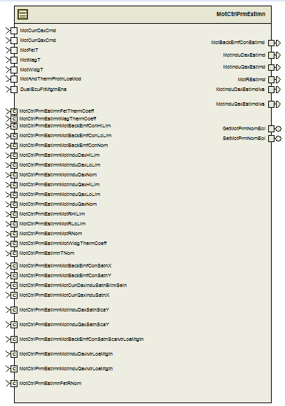

## Data Flow Diagram

Refer FDD

### Component level DFD

Refer FDD

### Function level DFD

Refer FDD

# Constant Data Dictionary

## Program (fixed) Constants

### Embedded Constants

#### Local Constants

|  |  |  |  |
| --- | --- | --- | --- |
| Constant Name | Resolution | Units | Value |
| BITMASK2_CNT_U08 | 1 | Cnt | 2U |
| Refer constants from .m file |  |  |  |

# Software Component Implementation

## Sub-Module Functions

### Init: Init1

## Design Rationale

*Refer to FDD*

## Module Outputs

*Refer to FDD*

### Per: Per1

## Design Rationale

*Refer to FDD*

## Store Module Inputs to Local copies

*Refer to FDD*

## (Processing of function)………

*Refer to FDD*

## Store Local copy of outputs into Module Outputs

*Refer to FDD*

### Per: MotCtrlPrmEstimnPer2

## Design Rationale

*Refer to FDD*

## Store Module Inputs to Local copies

*Refer to FDD*

## (Processing of function)………

*Refer to FDD*

## Store Local copy of outputs into Module Outputs

*Refer to FDD*

## Server Runnables

## SetMotPrmNomEol

## Design Rationale

*None*

## (Processing of function)………

*See* GetMotPrmNomEol *block in FDD*

## SetMotPrmNomEol

## Design Rationale

*None*

## (Processing of function)………

*See* SetMotPrmNomEol *block in FDD*

## Interrupt Functions

*None*

## Module Internal (Local) Functions

None

## GLOBAL Function/Macro Definitions

None

# Known Limitations with Design

CurrMeasLoaMtgtnEna and FetLoaMtgtnEna are terminated. These flags need not be computed at all.

# UNIT TEST CONSIDERATION

None

Abbreviations and Acronyms

| **Abbreviation or Acronym** | **Description** |
| --- | --- |
|  |  |
|  |  |

Glossary

**Note**: Terms and definitions from the source “Nexteer Automotive” take precedence over all other definitions of the same term. Terms and definitions from the source “Nexteer Automotive” are formulated from multiple sources, including the following:

* ISO 9000
* ISO/IEC 12207
* ISO/IEC 15504
* Automotive SPICE® Process Reference Model (PRM)
* Automotive SPICE® Process Assessment Model (PAM)
* ISO/IEC 15288
* ISO 26262
* IEEE Standards
* SWEBOK
* PMBOK
* Existing Nexteer Automotive documentation

| **Term** | **Definition** | **Source** |
| --- | --- | --- |
| MDD | Module Design Document |  |
| DFD | Data Flow Diagram |  |

References

|  |  |  |
| --- | --- | --- |
| **Ref. #** | **Title** | **Version** |
| 1 | [AUTOSAR Specification of Memory Mapping](http://www.autosar.org/fileadmin/files/standards/classic/4-0/software-architecture/implementation-integration/standard/AUTOSAR_SWS_MemoryMapping.pdf?_sm_au_=iVVkW148vj2N42wj) | v1.3.0 R4.0 Rev 2 |
| 2 | MDD Guideline | EA4 01.00.00 |
| 3 | EA4 Software Naming Conventions | 01.01.00 |
| 4 | Software Design and Coding Standards | 2.1 |
| 5 | FDD – SF102A Motor Control Parameter Estimation | See Synergy subproject version |