**Module Design Document**

**For**

**‘AssiSumLim’**

**VERSION: 1.0**

**DATE: 03-June-2015**

**Prepared By:**

**Sankardu Varadapureddi,**

**Nexteer Automotive,**

**Saginaw, MI, USA**

**Location:** The official version of this document is stored in the Nexteer Configuration Management System.

**Revision History**

|  |  |  |  |  |
| --- | --- | --- | --- | --- |
| **Sl. No.** | **Description** | **Author** | **Version** | **Date** |
| 1 | Initial Version | Sankardu Varadapureddi | 1.0 | 03-June-2015 |
|  |  |  |  |  |
|  |  |  |  |  |
|  |  |  |  |  |
|  |  |  |  |  |

**Table of Contents**

1 Abbrevations And Acronyms 5

2 References 6

3 AssiSumLim High-Level Description 7

4 Design details of software module 8

4.1 Graphical representation of AssiSumLim 8

4.2 Data Flow Diagram 8

4.2.1 Module level DFD 8

4.2.2 Sub-Module level DFD 9

4.3 COMPONENT FLOW DIAGRAM 9

5 Variable Data Dictionary 10

5.1 User defined typedef definition/declaration 10

5.2 Variable definition for enumerated types 10

6 Constant Data Dictionary 11

6.1 Program(fixed) Constants 11

6.1.1 Embedded Constants 11

6.1.1.1 Local 11

6.1.1.2 Global 11

6.1.2 Module specific Lookup Tables Constants 11

7 Software Module Implementation 12

7.1 Sub-Module Functions 12

7.1.1 Initialization Functions 12

7.1.1.1 INIT: AssiSumLimInit1 12

7.1.1.1.1 Design Rationale 12

7.1.1.1.2 Module Outputs 12

7.1.1.1.3 Module Internal 12

7.1.2 PERIODIC FUNCTIONS 12

7.1.2.1 Per: AssiSumLimPer1 12

7.1.2.1.1 Design Rationale 12

7.1.2.1.2 Store Module Inputs to Local copies 12

7.1.2.1.3 (Processing of function)……… 12

7.1.2.1.4 Store Local copy of outputs into Module Outputs 12

7.1.3 Interrupt Functions 12

7.1.4 Server runnables 13

7.1.4.1 SetManTqCmd 13

7.1.4.1.1 Design Rationale 13

7.1.4.1.2 Store Module Inputs to Local copies 13

7.1.4.1.3 (Processing of function)……… 13

7.1.4.1.4 Store Local copy of outputs into Module Outputs 13

7.1.5 Local Function/Macro Definitions 13

7.1.5.1 Local Function #1 13

7.1.5.1.1 Description 13

7.1.5.2 Local Function #2 13

7.1.5.2.1 Description 13

7.1.6 GLObAL Function/Macro Definitions 13

7.1.7 Tranisition FUNCTIONS 13

8 Known Limitations With Design 14

9 UNIT TEST CONSIDERATION 15

10 Appendix 16

# Abbrevations And Acronyms

|  |  |
| --- | --- |
| Abbreviation | Description |
| DFD | Design functional diagram |
| MDD | Module design Document |
| FDD | Functional Design Document |

# References

This section lists the title & version of all the documents that are referred for development of this document

|  |  |  |
| --- | --- | --- |
| Sr. No. | Title | Version |
| 1 | MDD Guidelines | Process 3.06.00 |
| 2 | Software Naming Conventions | Process 3.06.00 |
| 3 | Software Design and Coding standards | Process 3.06.00 |
| 4 | FDD - SF004B_AssiSumLim_Design | See Synergy sub project version |
|  |  |  |

# AssiSumLim High-Level Description

# Design details of software module

## Graphical representation of AssiSumLim

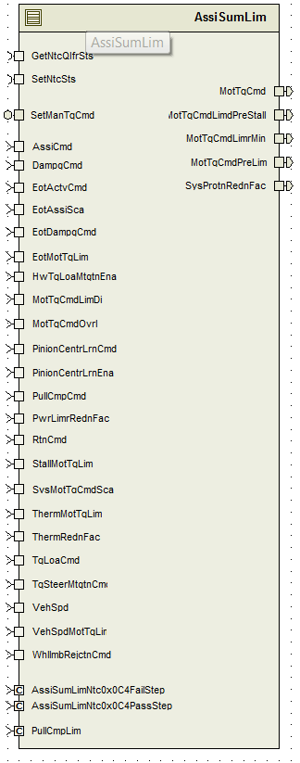

## Data Flow Diagram

*Refer FDD*

## Module level DFD

*Refer FDD*

## Sub-Module level DFD

*Refer FDD*

## COMPONENT FLOW DIAGRAM

*Refer FDD*

# Variable Data Dictionary

## User defined typedef definition/declaration

*<This section documents any user types uniquely used for the module.>*

|  |  |  |  |  |
| --- | --- | --- | --- | --- |
| Typedef Name | Element Name | User Defined Type | Legal Range  (min) | Legal Range  (max) |
| None |  |  |  |  |
|  |  |  |  |  |

## Variable definition for enumerated types

|  |  |  |
| --- | --- | --- |
| Enum Name | Element Name | Value |
| None |  |  |

# Constant Data Dictionary

## Program(fixed) Constants

## Embedded Constants

## Local

|  |  |  |  |
| --- | --- | --- | --- |
| Constant Name | Resolution | Units | Value |
|  |  |  |  |

**Note**: Refer .m file for constants definitions.

## Global

|  |
| --- |
| Constant Name |
| None |

## Module specific Lookup Tables Constants

|  |  |  |  |
| --- | --- | --- | --- |
| Constant Name | Resolution | Value | Software Segment |
| None |  |  |  |

# Software Module Implementation

## Sub-Module Functions

## Initialization Functions

*AssiSumLimInit1*

## INIT: AssiSumLimInit1

## Design Rationale

*Design follows implemenetation in FDD.*

## Module Outputs

*Refer ‘AssiSumLimInit1’ block in FDD*

## Module Internal

None

## PERIODIC FUNCTIONS

## Per: AssiSumLimPer1

## Design Rationale

*Design follows implementation in FDD.*

## Store Module Inputs to Local copies

*Refer to FDD*

## (Processing of function)………

*Refer to FDD (Block ‘AssiSumLmtPer1’)*

## Store Local copy of outputs into Module Outputs

*Refer to FDD*

## Interrupt Functions

*None*

## Server runnables

## SetManTqCmd

## Design Rationale

*None*

## Store Module Inputs to Local copies

*None*

## (Processing of function)………

*Refer ‘SetManTqCmd’ block in FDD*

## Store Local copy of outputs into Module Outputs

*None*

## Local Function/Macro Definitions

None

## GLObAL Function/Macro Definitions

None

## Tranisition FUNCTIONS

None

# Known Limitations With Design

None

# UNIT TEST CONSIDERATION

None

# Appendix

*None*