**Module Design Document**

**For**

**LimrCdng**

**July 22, 2015**

**Prepared For:**

**Software Engineering**

**Nexteer Automotive,**

**Saginaw, MI, USA**

**Prepared By:**

**Nick Saxton,**

**Nexteer Automotive,**

**Saginaw, MI, USAChange History**

|  |  |  |  |
| --- | --- | --- | --- |
| **Description** | **Author** | **Version** | **Date** |
| Initial Version | N. Saxton | 1.0.0 | 22-Jul-2015 |

**Table of Contents**

1 LimrCdng High-Level Description 4

2 Design details of software module 5

2.1 Graphical representation of LimrCdng 5

2.2 Data Flow Diagram 5

2.2.1 Component level DFD 5

2.2.2 Function level DFD 5

3 Constant Data Dictionary 6

3.1 Program (fixed) Constants 6

3.1.1 Embedded Constants 6

4 Software Component Implementation 7

4.1.1 Sub-Module Functions 7

4.1.2 Interrupt Service Routines 7

4.1.3 Server Runnable Functions 7

4.1.4 Module Internal (Local) Functions 7

4.1.5 Transition Functions 7

5 Known Limitations with Design 8

6 UNIT TEST CONSIDERATION 9

Appendix A Abbreviations and Acronyms 10

Appendix B Glossary 11

Appendix C References 12

# LimrCdng High-Level Description

*This function provides a layer of protection from erroneous signals feeding into SF04 Sum & Limit. It is applied primarily to limiting signals that serve to reduce motor torque command under certain operating conditions. This function can prevent step response or toggling behavior that might cause undesirable vehicle feel. It includes fault injection capability at some inputs to facilitate tuning.*

# Design details of software module

*Refer FDD*

## Graphical representation of LimrCdng

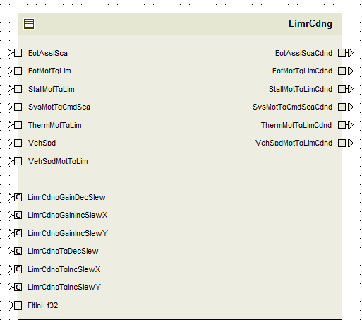

## Data Flow Diagram

*Refer FDD*

### Component level DFD

*N/A*

### Function level DFD

*N/A*

# Constant Data Dictionary

## Program (fixed) Constants

### Embedded Constants

#### Local Constants

*Refer .m file*

# Software Component Implementation

### Sub-Module Functions

#### Initialization sub-module {_Init()}

*None*

#### Periodic sub-module {LimrCdngPer1}

*Refer FDD*

### Interrupt Service Routines

*None*

### Server Runnable Functions

*None*

### Module Internal (Local) Functions

*None*

### Transition Functions

*None*

# Known Limitations with Design

*None*

# UNIT TEST CONSIDERATION

*None*

Abbreviations and Acronyms

Glossary

**Note**: Terms and definitions from the source “Nexteer Automotive” take precedence over all other definitions of the same term. Terms and definitions from the source “Nexteer Automotive” are formulated from multiple sources, including the following:

* ISO 9000
* ISO/IEC 12207
* ISO/IEC 15504
* Automotive SPICE® Process Reference Model (PRM)
* Automotive SPICE® Process Assessment Model (PAM)
* ISO/IEC 15288
* ISO 26262
* IEEE Standards
* SWEBOK
* PMBOK
* Existing Nexteer Automotive documentation

| **Term** | **Definition** | **Source** |
| --- | --- | --- |
| MDD | Module Design Document |  |
| DFD | Data Flow Diagram |  |

References

| **Ref. #** | **Title** | **Version** |
| --- | --- | --- |
| 1 | AUTOSAR Specification of Memory Mapping (Link:[AUTOSAR_SWS_MemoryMapping.pdf](http://www.autosar.org/download/R4.0/AUTOSAR_SWS_MemoryMapping.pdf)) | v1.3.0 R4.0 Rev 2 |
| 2 | MDD Guideline | EA4 01.00.00 |
| 3 | [Software Naming Conventions.doc](http://misagweb01.nexteer.com/eRoomReq/Files/erooms8/NextGeneration/0_fc55f/Software%20Naming%20Conventions%2003x(In%20Work).doc) | 2.0 |
| 4 | [Software Design and Coding Standards.doc](http://eroom1.nexteer.com/eRoomReq/Files/erooms8/NextGeneration/0_1a67a9/Software%20Design%20and%20Coding%20Standards.doc) | 2.1 |
| 5 | SF038A LimrCdng FDD | See Synergy subproject version |