Polyspace Support Usage

TL108A_PolyspaceSuprt

|  |  |  |  |
| --- | --- | --- | --- |
| Version | Date | Author | Description |
| 01.00.00 | 3-Oct-2016 | Owen Tosh | Initial version |

Table of Contents

Introduction 3

Running the Tool 4

The Main Interface 5

Files and Directories 7

Generation and Analysis Process 8

# Introduction

Polyspace Support is a wrapper for EA4 integration project Polyspace project management and execution. It automates most redundant tasks, while providing consistency across EA4 programs. It also enables more effective usage of Polyspace licenses, which are released immediately as analysis is completed.

## Dependencies

This tool requires the TL112A_Python component.

# Running the Tool

## Launch.bat

In the tools directory, running Launch.bat will load the tool directly with no arguments. The tool prompts the user to select a Green Hills project file. Select the main GPJ file for the desired EA4 project, and you will be provided with the main interface.

## PolyspaceHelper.bat

Once the tool is integrated, it can be launched with PolyspaceHelper.bat, located in the project’s tools/Polyspace directory. This will immediately launch the main interface.

# The Main Interface

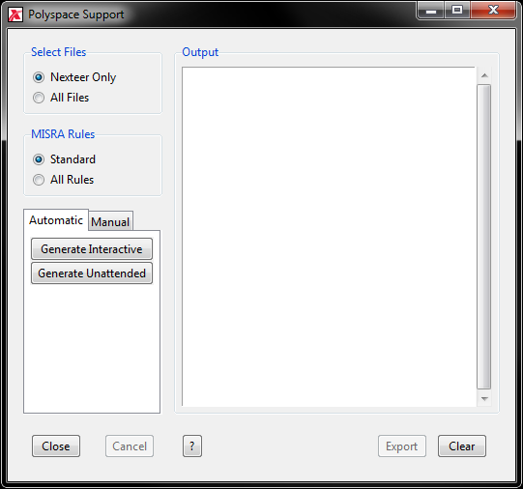

The main interface consists of four main areas:

## Configuration

Select which files and MISRA rules are to be checked. By default, only Nexteer (Type 1) files are checked. This means that any files with non-Nexteer copyrights are ignored by default. IgnoreOverrides.cfg is used to include or ignore files manually.

By default, MISRA rules are checked according to the EA4 Static Analysis Compliance Guideline. Some customers require that all MISRA rules be enabled; in this case, select All Rules.

## Generation Command Buttons

For the simplest interaction, use the commands on the Automatic tab. By selecting Generate Interactive, the tool will provide various prompts during the analysis process. This is the best place to start using this tool.

Generate Unattended allows for a prompt-less report generation. Note that this will not give you any chance to comment or justify any violations.

The Manual tab provides a list of commands to generate and run the Polyspace analysis manually. This may be useful for debugging issues, or for projects with special requirements.

## Output Window

This provides messages from generation and analysis.

## Other Command Buttons

Click Close to close the tool.

Click Cancel to terminate a running process. Note that this may leave the integration project in an undefined state; some manual cleanup work may be required.

Click ‘?’ to open this usage document.

Click Export to save the current output window to the integration project’s tools/Polyspace directory.

Click Clear to clear the current output window.

# Files and Directories

The tool provides the following persistent files and directories.

## doc/Polyspace

## doc/Polyspace-allmisra

## doc/Polyspace-allfiles

## doc/Polyspace-all

These directories contain the final reports generated by the tool. Only those directories with reports will exist.

## tools/Polyspace

This is the main directory for integration project Polyspace files.

## tools/Polyspace/Saved

This directory contains archives of the previous results.

## tools/Polyspace/IgnoreOverrides.cfg

This file allows the integrator to specify specific files to ignore or include in the analysis. Used only when Select Files is set to Nexteer Only. IgnoreOverrides.cfg is a plain text file that can be updated with any text editor.

## tools/Polyspace/MISRASettings.cfg

This file is used by Polyspace to ignore specific MISRA rules. Used only when MISRA Rules is set to Standard.

## tools/Polyspace/Polyspace.bf.psprj

This is the main Polyspace project file.

## tools/Polyspace/PolyspaceHelper.bat

Run this script to launch the Polyspace Support tool.

# Generation and Analysis Process

The process is broken down here for reference.

1. Generate Project Files
   * Populates the tools/Polyspace folder with all necessary files, including PolyspaceHelper.bat.
2. Unzip Previous Results
   * Loading the previous analysis results is required to preserve any comments or justification in Polyspace.
3. Run Analysis
   * Run the Polyspace analysis. This process typically takes over an hour.
4. Open Results
   * Open the analysis results in Polyspace. Review the results and provide any comments or justification necessary. When finished, every violation should be classified.
5. Generate Report
   * Create a Polyspace report from the analysis results.
6. Zip Current Results
   * Archive the current results for later reference.
7. Clean Up
   * Remove all files and folders that are not needed in Synergy. This includes the current (unarchived) results.