Coding Challenge

**Problem Statement:**

The company needs a web page that loads randomly generated users from a 3rd party API via AJAX, with the ability to drill into the details for each user.

**Specific Requirements:**

To accomplish this challenge, demonstrate your capabilities with HTML, CSS, JavaScript, AJAX, and jQuery. Use the jQuery and jQuery UI scripts from their CDN:

https://code.jquery.com/jquery-1.12.4.js

https://code.jquery.com/ui/1.12.0/jquery-ui.js

Also, feel free to use the jQuery UI CSS stylesheet:

https://code.jquery.com/ui/1.12.0/themes/base/jquery-ui.css

No other JS, HTML, CSS, or jQuery libraries or plugins can be used, including bootstrap. Avoid using inline styles, and HTML tables. The file to submit to Unit4 should simply be a single HTML file, with embedded script and styles, for easy review and testing. The API URL that returns randomly generated users is located here:

https://randomuser.me/api/?results=10

The result of the API call is a JSON object containing 10 randomly generated users, with this structure:

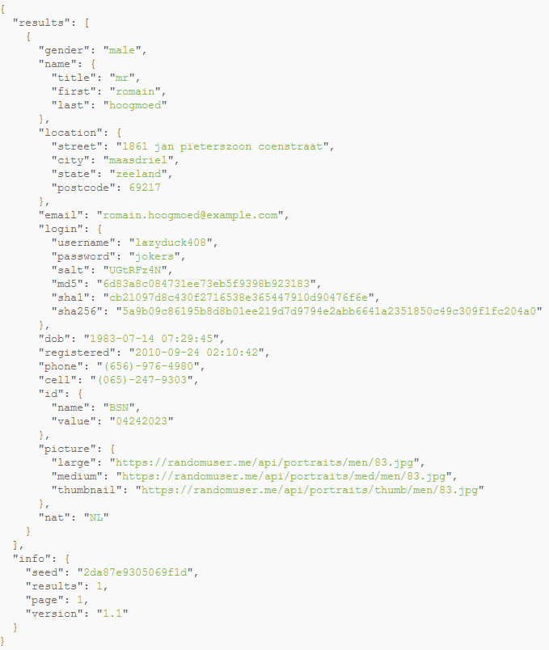

**Project Details:**

Your web page should look and behave roughly like the images below.

**Screenshots and Explanation:**

1. The user loads the initial screen



1. The user clicks the “Load Users” link and a list of users appears. Each user should show the thumbnail picture of the user, as well as their title, first name, last name, city, and state:

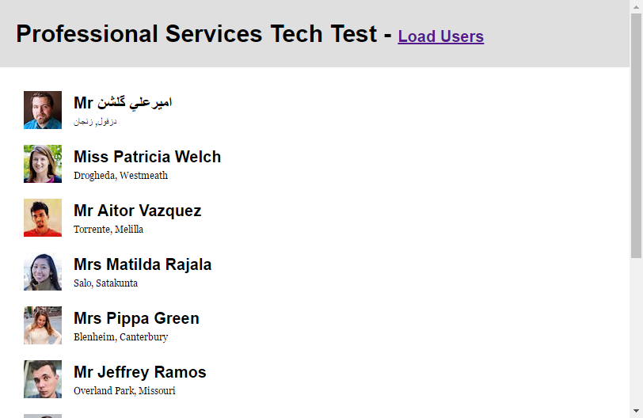

1. The user then clicks “Load Users” again, and a completely different set of users appear:



1. The user then clicks on any of the users in the list, and they are presented with a detailed dialog about the user, which includes the large size photo, full address, gender, cell number, date of birth, and email address. The dialog should be modal, and should disallow interaction with the web page behind the dialog.

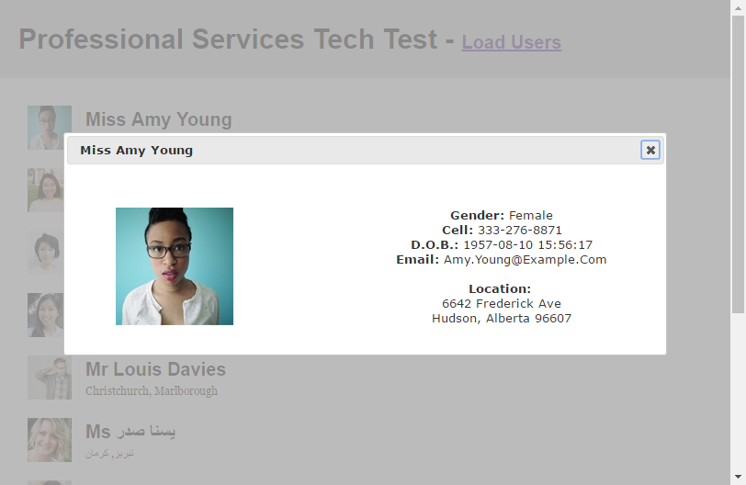

1. The user then clicks the close icon in the corner of the dialog, and the list should be selectable again:

