Supplementary Note 1
Consistency of the ν-gap analysis with the DyDE framework and robustness to implementation choices
The dynamical-systems analysis used here applies the same framework as the dynamical differential expression (DyDE) approach of Mombaerts et al. (2019): first-order single-input single-output models are fitted between standardised time-courses, validated by their goodness of fit in both conditions, and compared across conditions with the Vinnicombe ν-gap. Two implementation choices differ between our pipeline and the original MATLAB DyDE implementation. First, we evaluate the full-spectrum Vinnicombe ν-gap together with its winding-number condition (so that topologically incompatible model pairs are assigned the maximal distance of 1), whereas DyDE measures the ν-gap only over the oscillation frequency band and does not test the winding-number condition. Second, we gate models on the simulation coefficient of determination (R² > 0.5 in both genotypes), whereas DyDE additionally discards any model whose absolute DC gain is at or below 0.1. We retained the more stringent choices—the full-spectrum ν-gap with the winding-number test, which yields larger distances and hence a smaller, more conservative candidate set—as the main analysis, and we verified that the conclusions do not depend on either choice. Both alternatives are available as options in the accompanying nugap software (nu_gap(…, band=…, check_winding=False) and fit_first_order(…, min_dc_gain=…)).
To assess the effect of the frequency band, we recomputed the transcript↔[Ca²⁺]cyt ν-gap for every reliable transcript using the DyDE-style band-limited ν-gap (restricted to circadian periods of 16–36 h, with the winding-number test disabled). The two metrics are highly concordant in both directions (Pearson r = 0.96 for the forward transcript→[Ca²⁺]cyt ν-gap, n = 274; and r = 0.96 for the reverse [Ca²⁺]cyt→transcript ν-gap, n = 199; Supplementary Figure S4a). The band-limited values are slightly smaller (forward median between-genotype ν-gap 0.16 versus 0.21), as expected when the supremum is taken over a narrower frequency range, but the central result is unchanged: between-genotype ν-gaps remain larger than the within-genotype replicate floor (median 0.16 versus 0.12; Wilcoxon p = 2×10⁻¹⁹). Crucially, the set of transcripts with a preserved coupling in both directions is stable: the 14 direction-robust candidates identified with the main (broadband) metric are a strict subset of the 29 identified with the band-limited metric, so every candidate reported in the main text is recovered, and the main analysis is the more conservative of the two.
To assess the effect of the DC-gain filter, we computed the DC gain of the forward first-order models for the direction-robust candidates. All 14 candidates have an input→output DC gain far above the DyDE rejection threshold (minimum 0.77, median 0.94, against a floor of 0.1; Supplementary Figure S4b), so applying the DyDE filter removes none of them. This confirms that the low ν-gap of these transcripts reflects a genuine, preserved dynamic coupling to [Ca²⁺]cyt rather than the degenerate case of a model in which the input does not drive the output. Indeed, because an autoregressive model of [Ca²⁺]cyt alone explains under 20% of its variance at this 4-hourly sampling, and a first-order system cannot oscillate autonomously, the simulation-R² gate already requires the transcript to drive the [Ca²⁺]cyt trajectory; the explicit DC-gain floor is a redundant safeguard here.
In summary, the transcript↔[Ca²⁺]cyt results, including the direction-robust candidate set, are robust to the two ways in which our implementation differs from the original DyDE framework. We adopt the more stringent full-spectrum ν-gap with the winding-number condition and the simulation-R² gate in the main analysis, and provide the band-limited ν-gap and the DC-gain floor as options for direct comparability with DyDE.

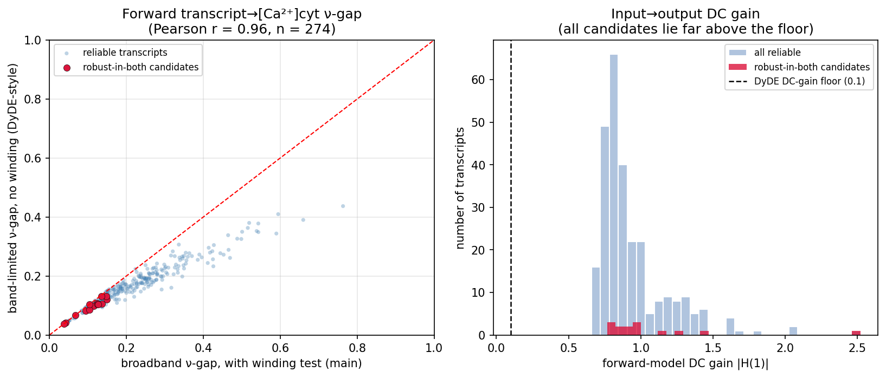
Supplementary Figure S4. Robustness of the transcript↔[Ca²⁺]cyt ν-gap analysis to implementation choices. (a) The forward transcript→[Ca²⁺]cyt ν-gap computed with the main full-spectrum metric (with the winding-number test) versus the DyDE-style band-limited metric (circadian band 16–36 h, no winding test), for the 274 transcripts with a reliable model; the two agree closely (Pearson r = 0.96) and the 14 direction-robust candidates (red) cluster at low values under both. (b) Distribution of the forward-model input→output DC gain for all reliable transcripts and for the direction-robust candidates; all candidates lie far above the DyDE DC-gain rejection floor of 0.1 (dashed line), so that filter removes none of them.

