NEXCLUBV2 — INTERNAL VERIFICATION MEMO
New Functionality Since V1
Nine additions found by diffing every file against nexclub (V1). Each one below was exercised against the running dev instance with a real seeded account — not just read from source — via an authenticated browser session, direct API calls, or the CLI script itself.
REVIEWED | 22 July 2026
ENVIRONMENT | nexclubV2 dev · localhost:3010
DATABASE | Neon Postgres · seeded demo org
VERIFICATION | Playwright session + API + CLI

01 Lead consent capture
ROUTE /leads/new · RULE Privacy Principle 6 · ACCOUNT marcus@valetcrm.test
Sending a lead now requires the sender to explicitly confirm they hold the third party's consent — the checkbox has to be checked, not merely present in the form. The exact statement version and a timestamp are written onto the Lead row, so a later compliance check can show precisely what wording was agreed to and when.
localhost:3010/leads/new
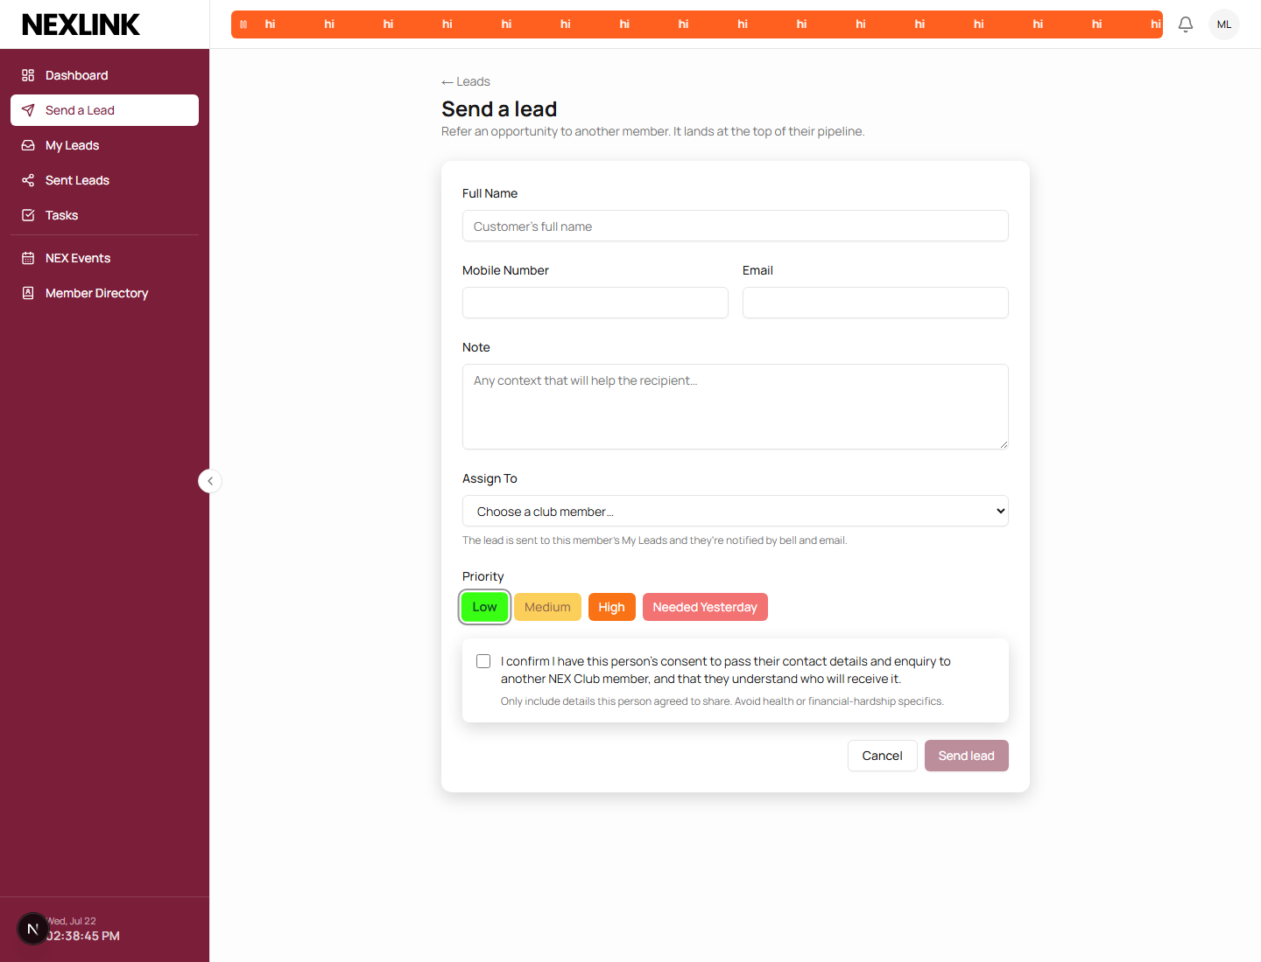
Full “Send a Lead” form as Marcus Lee sees it — consent block sits directly above the submit action, not tucked away.

02 One dispatcher for every notification
FILE server/notify.ts · ACCOUNT priya@valetcrm.test · METHOD browser session
Every event that used to write its own ad-hoc notification row — and sometimes fire a separate hand-built email — now goes through one function. It writes the in-app entry and the matching email template together, so the two channels can't drift apart, and it de-dupes recipients so nobody is ever told about their own action.
localhost:3010/notifications
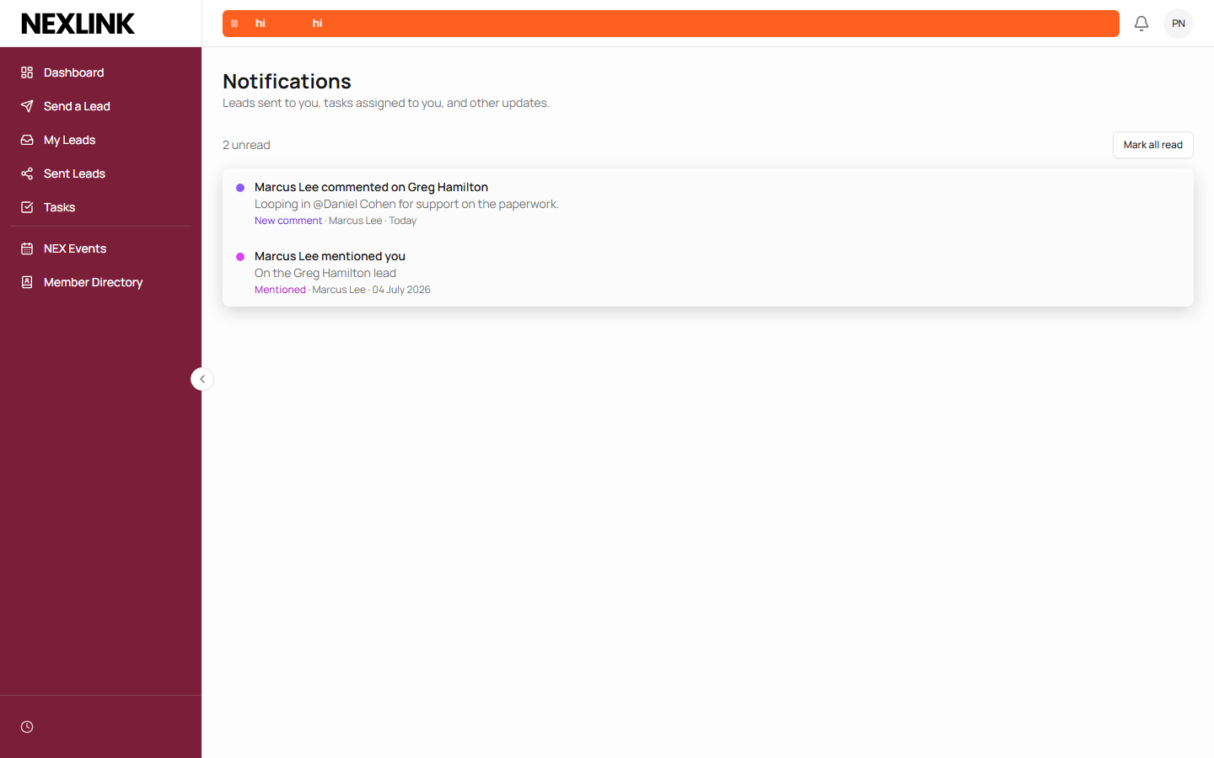
Priya Nair's feed — a comment and a mention on the same lead render as two distinct, correctly labelled entries from the one dispatcher call site.

03 Email preference & one-click unsubscribe
ROUTE /settings · RULE Spam Act · TOKEN HMAC-SHA256, timing-safe
Members can turn notification emails off from Settings, and every notification email carries an unsubscribe link that needs no login — an unforgeable token tied to the account. Following it only ever disables email; it can't read or change anything else.
Fixed this session — the “back on” direction of this toggle didn't exist until now. The unsubscribe page always promised “turn email back on any time from your profile settings,” but no such control was wired up. That gap is closed below.

localhost:3010/settings
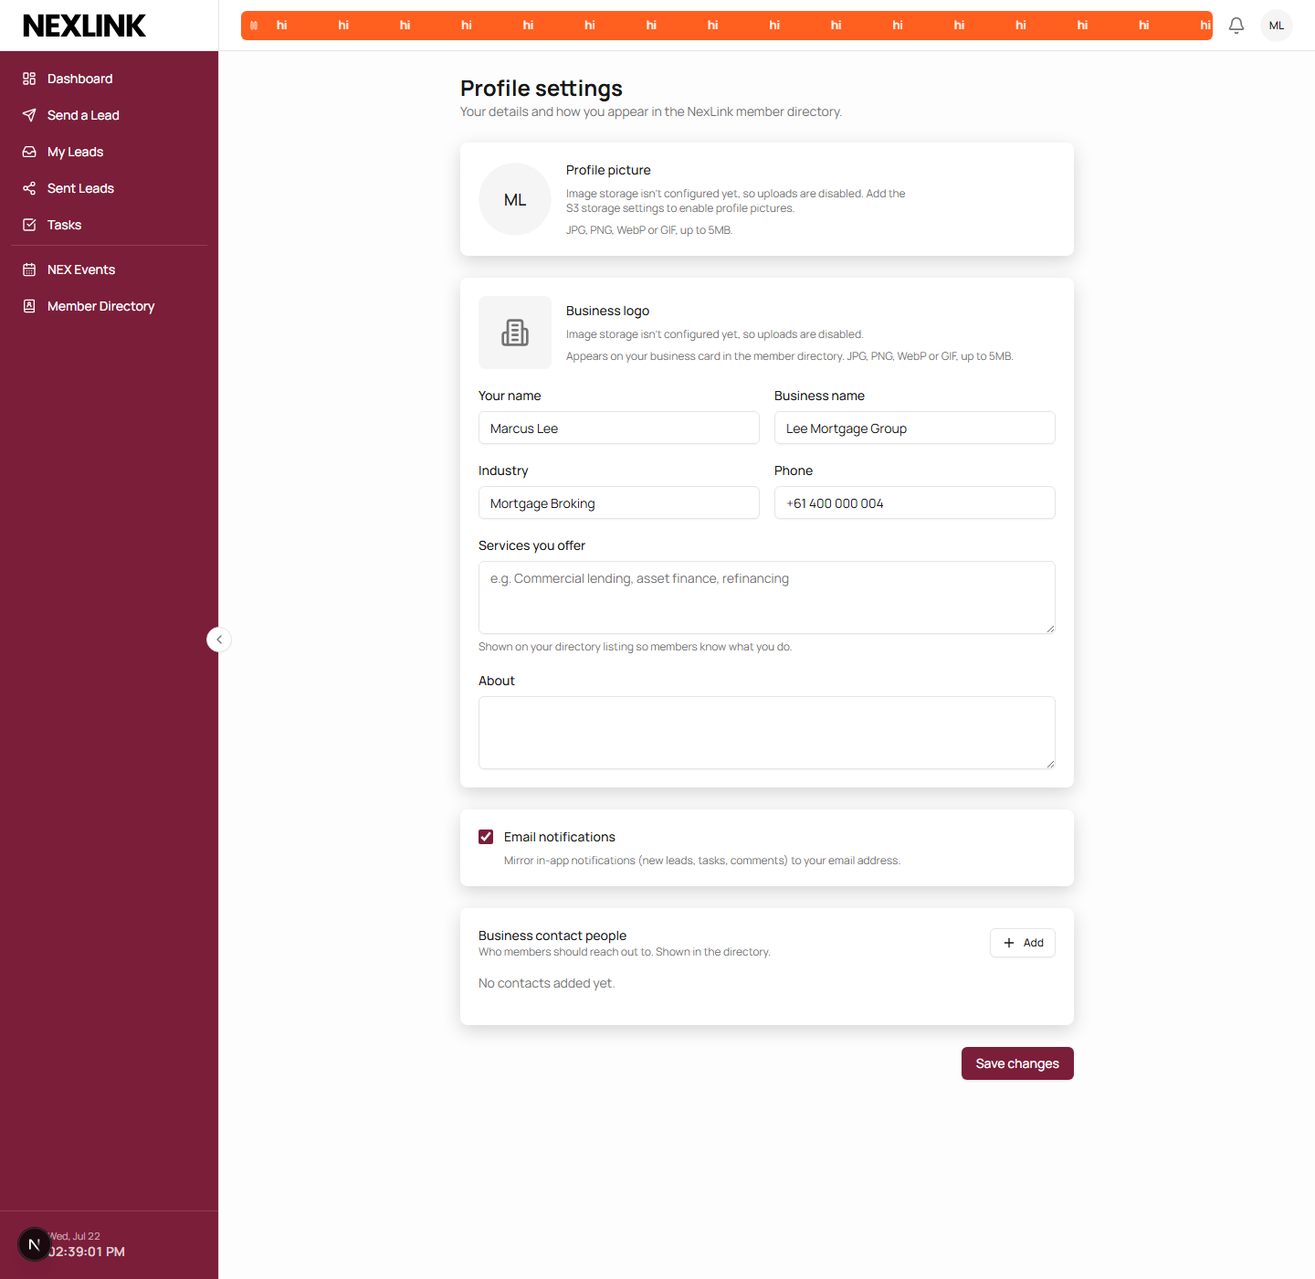
Settings — Email notifications, checked on for Marcus Lee, and the Business logo card above it (covered in §05).
.../api/notifications/unsubscribe?u=…&t=…
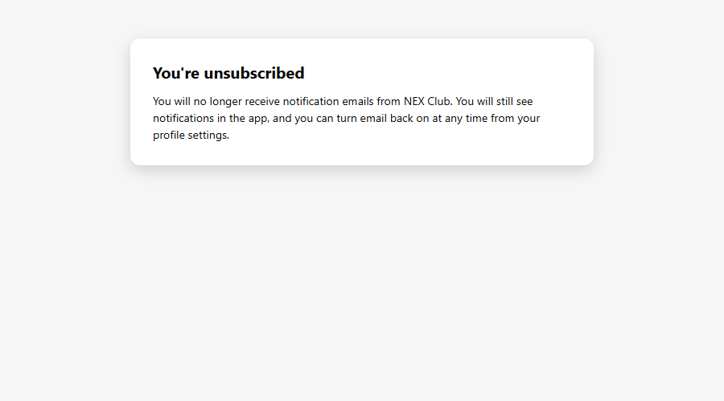
The public confirmation page a real unsubscribe link resolves to — no session required.

04 AI response redaction
FILE server/ai-redact.ts · RULE Privacy Principle 8 · TESTS ai-redact.test.ts
Names, emails and phone numbers are swapped for stable tokens before any lead, deal, contact or company text reaches the Claude API, and swapped back before the result is shown or saved — the model reasons over [CONTACT_1], the member reads “Jordan Reyes.”
Can't demo live — this environment has no ANTHROPIC_API_KEY configured, so the panel correctly reports the feature as off rather than attempting a call. The token swap/restore logic itself is exercised directly by the test suite.

localhost:3010/leads/cmr5zshft…
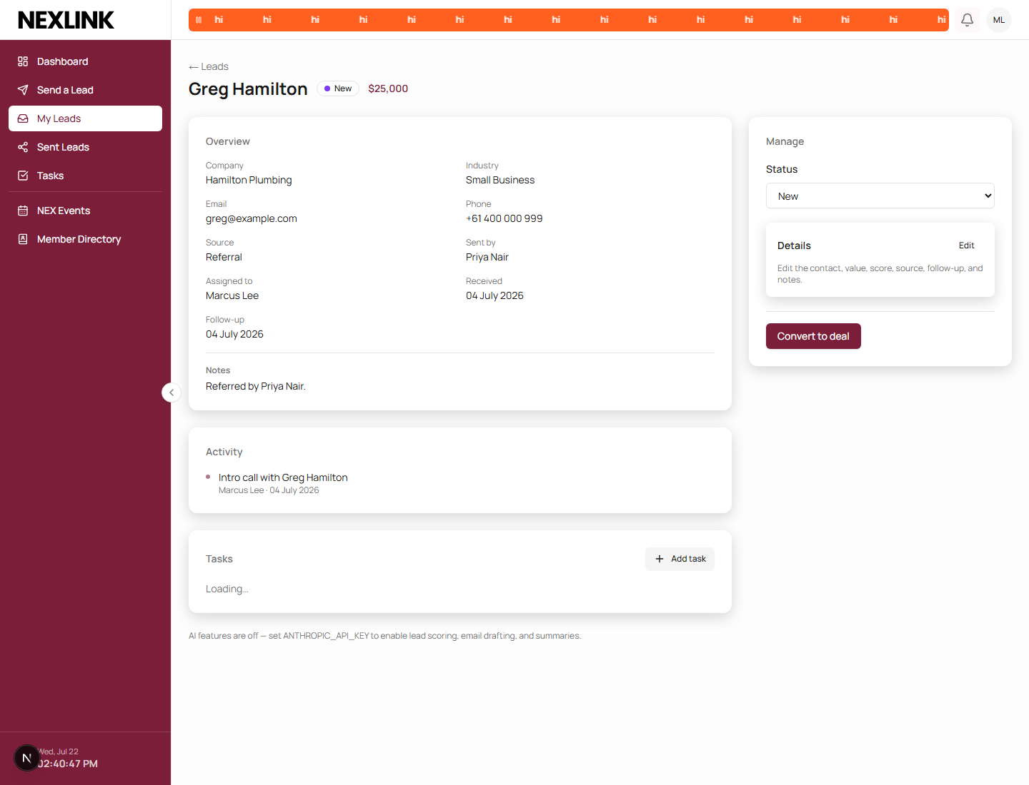
Lead detail page — the exact off-state message a deployment without a Claude key sees, in place of the email-writer and summary panels.

05 Business logo upload
ROUTE /settings · /directory · MIRRORS avatar upload path
Members can upload a logo for their business, shown on its card in the Member Directory. It reuses the existing avatar-upload route's validation and delete-on-replace logic exactly, rather than a second code path with its own edge cases.
Storage unconfigured — this environment has no S3 credentials set, so the upload control is correctly disabled with an explanation, matching what a fresh self-hosted deployment sees before S3 is set up. See the Business logo card in the Settings screenshot under §03.

06 Export hardening
ROUTES leads/export · contacts/export · RULE Privacy Principle 11.1 · ACCOUNT admin@valetcrm.test
Bulk CSV export is now rate-limited to five requests per five minutes per user, capped at 10,000 rows with a truncation flag on the response, and always writes an EXPORT entry to the audit log with the requester, row count and IP. A whole book of members' personal information leaving in one click is exactly the action a privacy review asks to trace.
localhost:3010/admin/audit
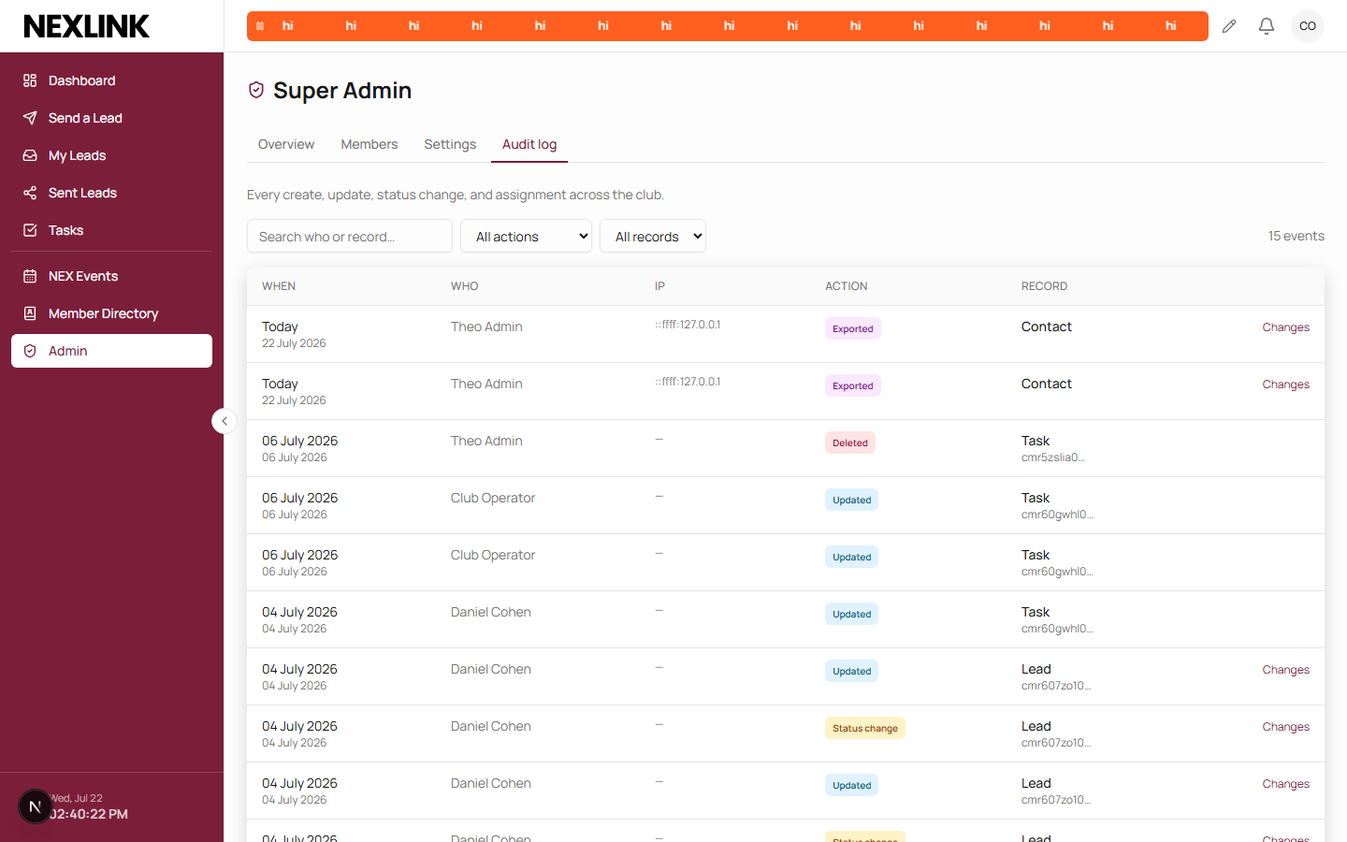
Super Admin → Audit log, viewed as Club Operator — two Exported / Contact rows for Theo Admin, timestamped moments after the export request in this review.

07 @mention detection in lead comments
ROUTE /leads?lead=… · TYPE MENTIONED_IN_NOTE
Typing @Full Name in a lead comment resolves against active org members and fires a dedicated “mentioned you” notification to anyone named who wasn't already going to hear about the comment as a party to the lead — so a mention is never silently absorbed into an existing notification, and never double-fires for someone already told.
localhost:3010/leads?lead=cmr5zshft…
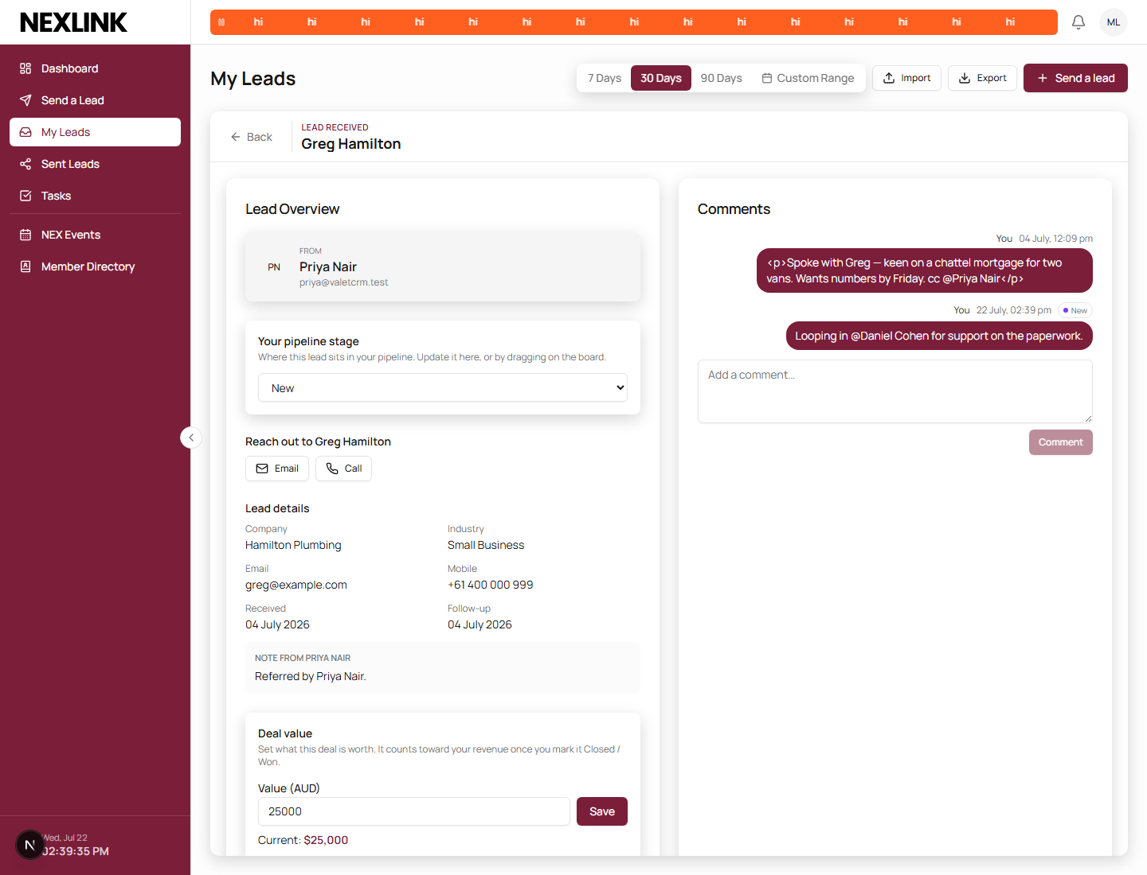
Marcus Lee comments on the Greg Hamilton lead, mentioning Daniel Cohen — who is neither the lead's owner nor its referrer.
localhost:3010/notifications
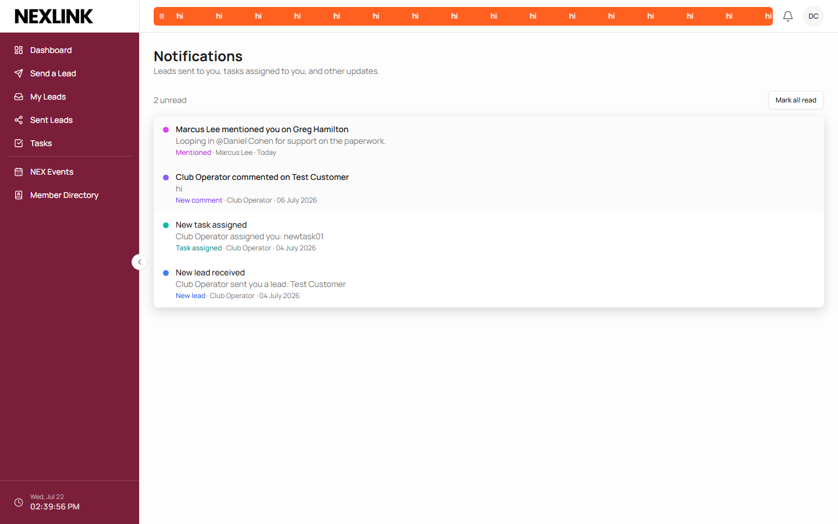
Daniel Cohen's feed — a distinct Mentioned entry, not a generic comment notice.

08 First-admin bootstrap
FILE prisma/bootstrap.ts · CMD npm run bootstrap
Self-registration is disabled, and accounts otherwise arrive only by invitation from an existing admin — so a brand-new database needs one deliberate way in. This script creates exactly one Super Admin and refuses outright if any user already exists, which is what makes it safe to leave in a production runbook without it ever becoming a second front door.
$ npm run bootstrap
Refusing to bootstrap: 6 user(s) already exist.
Add people by inviting them from Members instead.
Run against this session's seeded database — correctly refuses, since 6 users already exist.

09 Retention purge
FILE prisma/purge.ts · CMD npm run purge -- --dry-run · RULE Privacy Principle 11.2
A “deleted” record in this app is soft-deleted — the row stays, marked, so deletion is recoverable. Left alone forever, that keeps personal information indefinitely. This script permanently removes soft-deleted leads, contacts, companies, deals, tasks and notes past a configurable retention window (default 365 days) — deliberately excluding Users and Organizations, since a departed member's referral history still belongs to whoever they're linked with.
$ npm run purge -- --dry-run
[dry run] Purging records soft-deleted before 2025-07-22T10:05:34.094Z (retention: 365 days).
note: nothing to purge
task: nothing to purge
deal: nothing to purge
contact: nothing to purge
company: nothing to purge
lead: nothing to purge
[dry run] 0 record(s) would be removed. Re-run without --dry-run to apply.
Dry run against the seeded database — nothing is old enough to purge yet, and nothing was changed.

