Getting Started Guide – Pathways Plugin for MedSavant

# Installation

This guide assumes that you already have the MedSavant client running, and can connect to a MedSavant server. Medsavant can be [downloaded on the MedSavant website](http://genomesavant.com/p/medsavant/download), instructions for [logging into a server can be found here](http://genomesavant.com/p/medsavant/taketutorial.shtml?tutorial=gettingstarted), and if you are a system administrator and would like to set up a server, [instructions can be found here](http://genomesavant.com/p/medsavant/tutorial_admin).

To get the plugin from the app store, log into MedSavant and click on the orange app store icon.

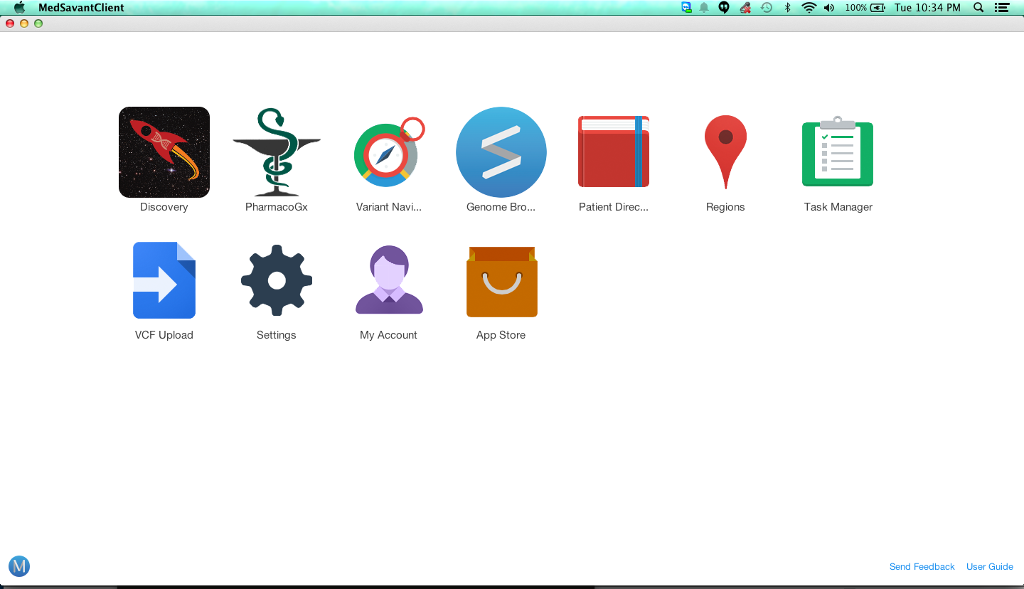

Find the app titled Pathway Analysis, and click Install.

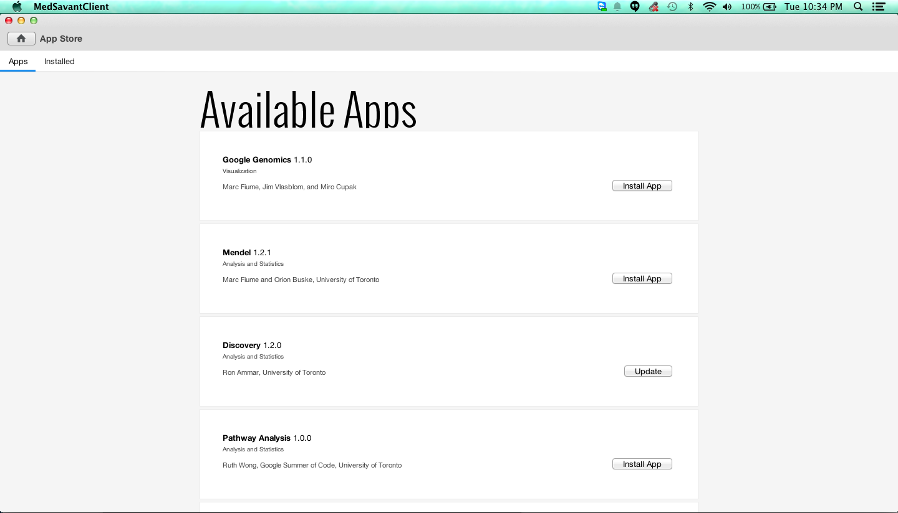

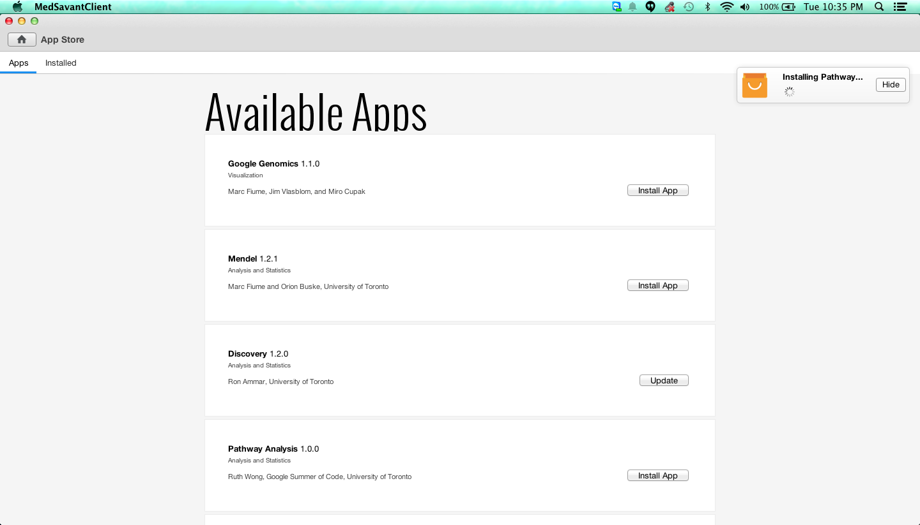

After the app is done installing, you will be prompted to restart MedSavant.

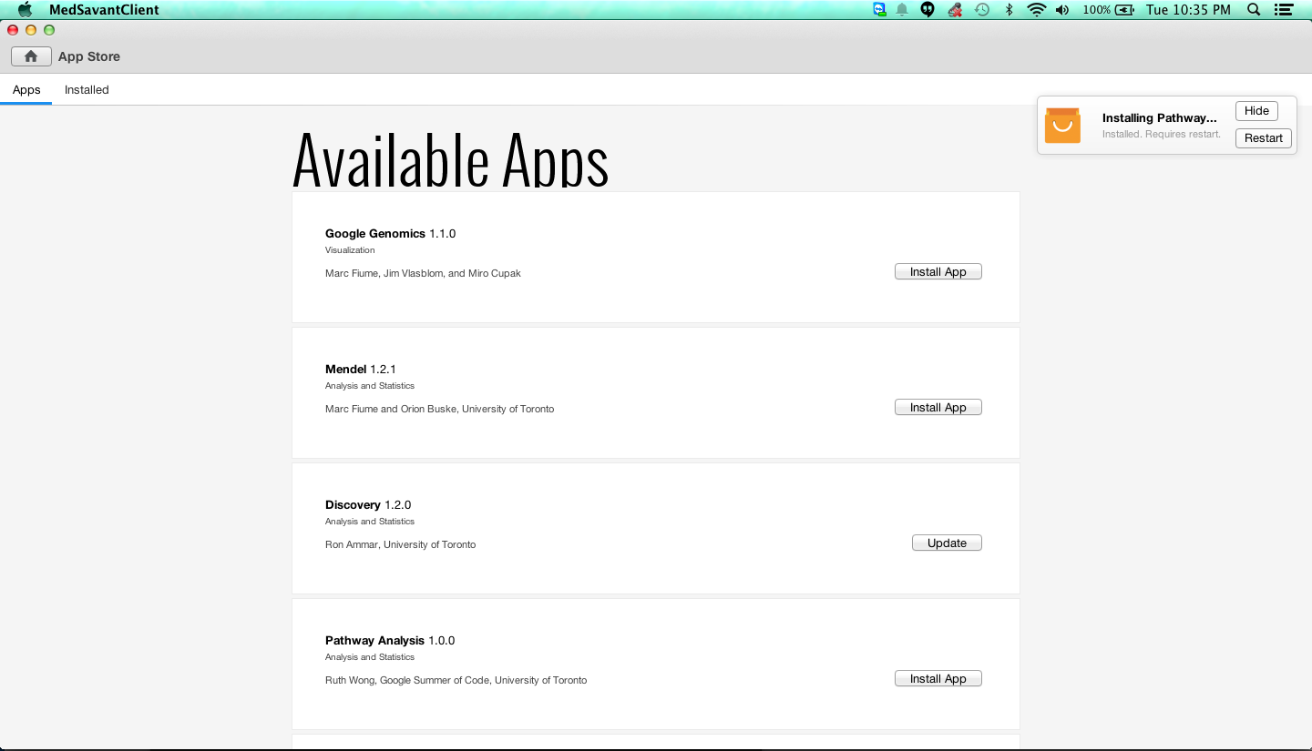

On restart, the app should appear in your home page.

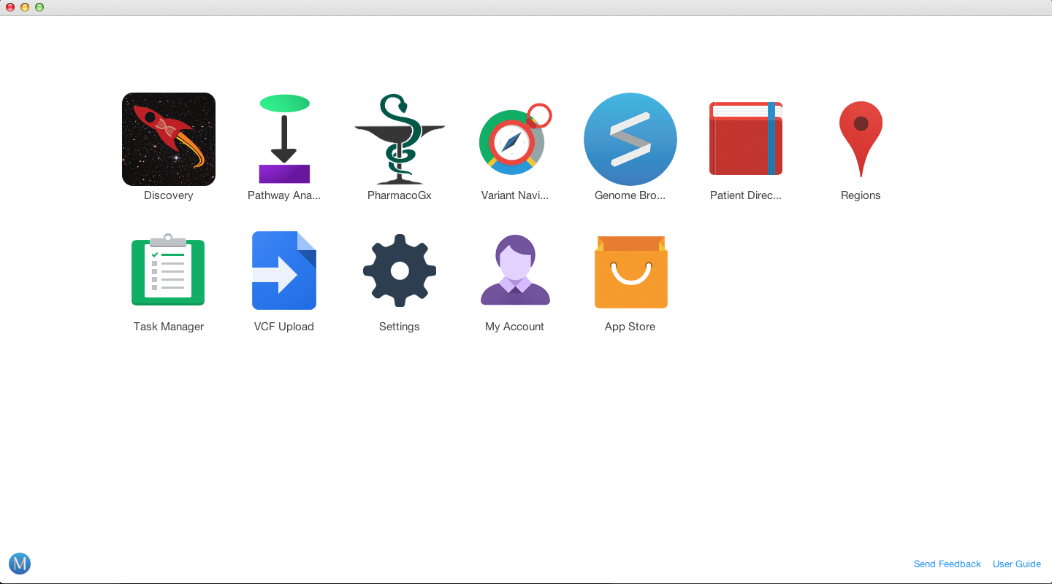

Alternatively, you can build the app from source. Build instructions can be found at <https://github.com/compbio-UofT/pathways-app>.

# Quick Start

Click the Pathway App icon on the home page.

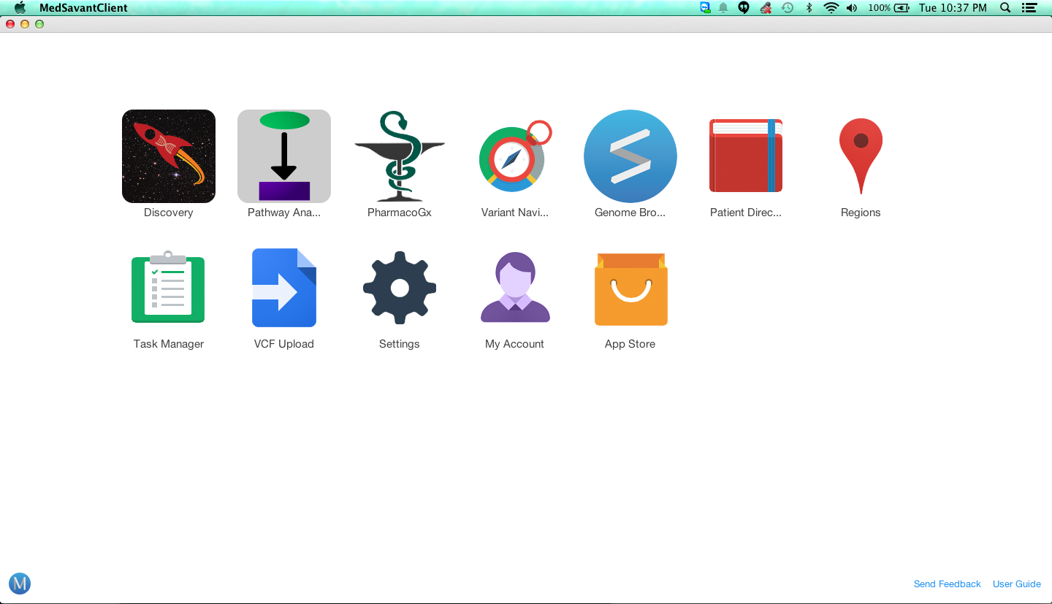

Choose a patient from the database. If you do not have any data in your database, you may upload Variant Call Files with the VCF Uploader app ([instructions can be found here](http://genomesavant.com/p/medsavant/taketutorial.shtml?tutorial=apps&part=vcfuploader)).

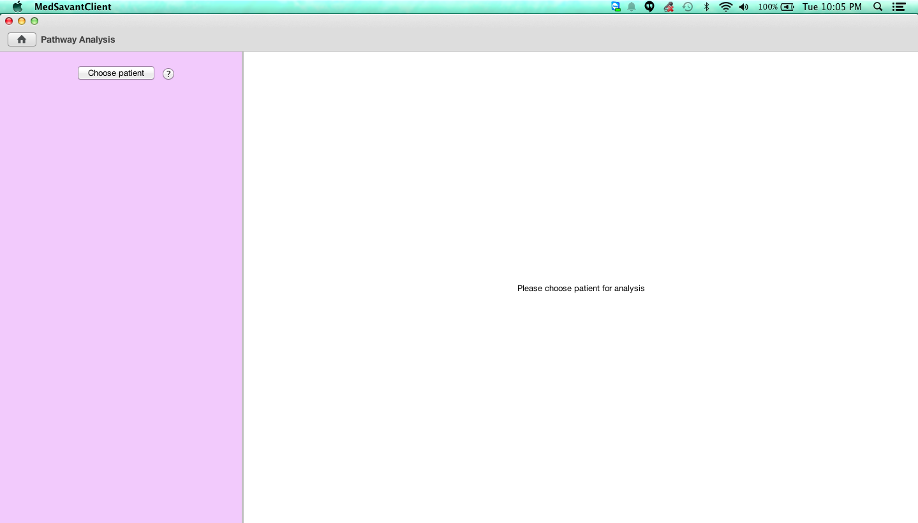

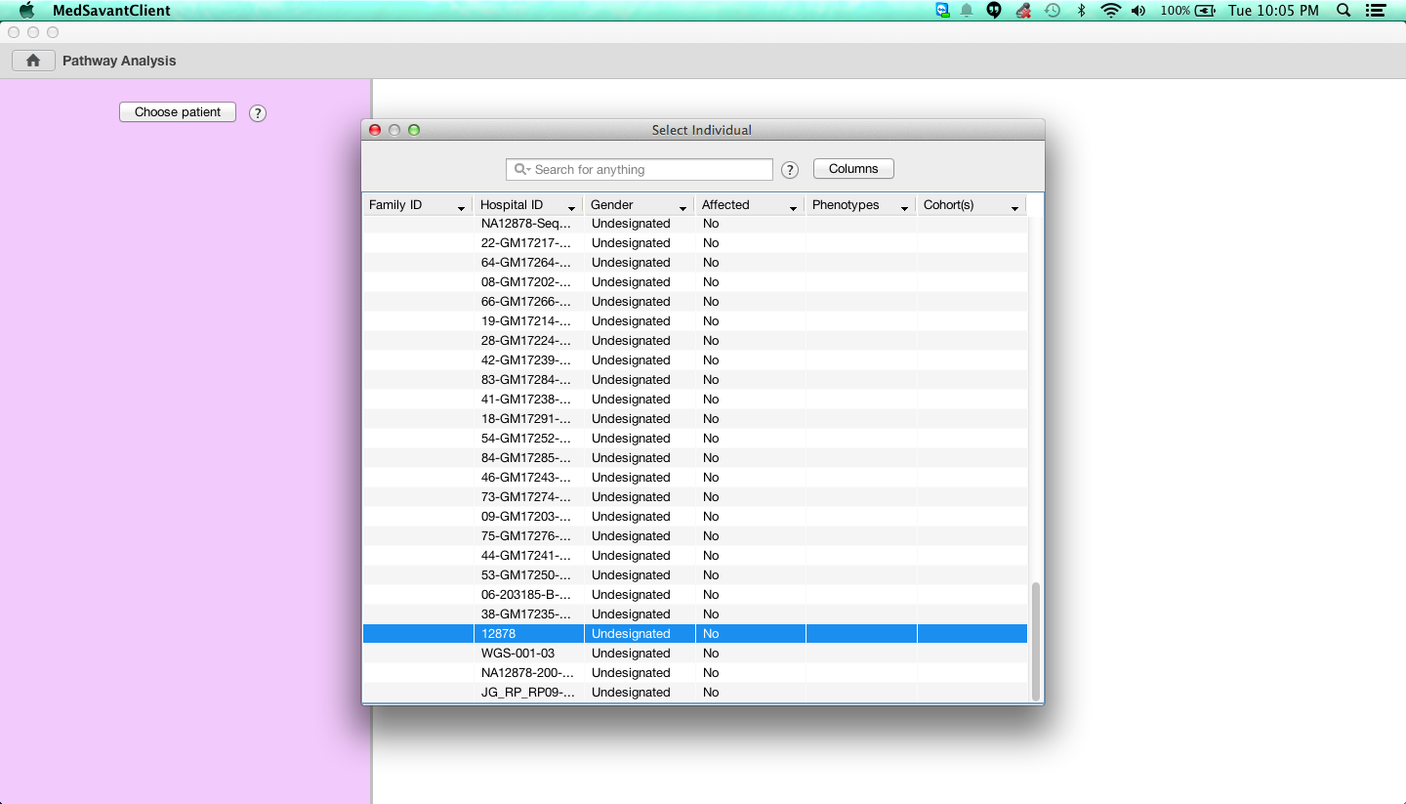

Adjust the analysis parameters and click Perform Hypergeometric Analysis.

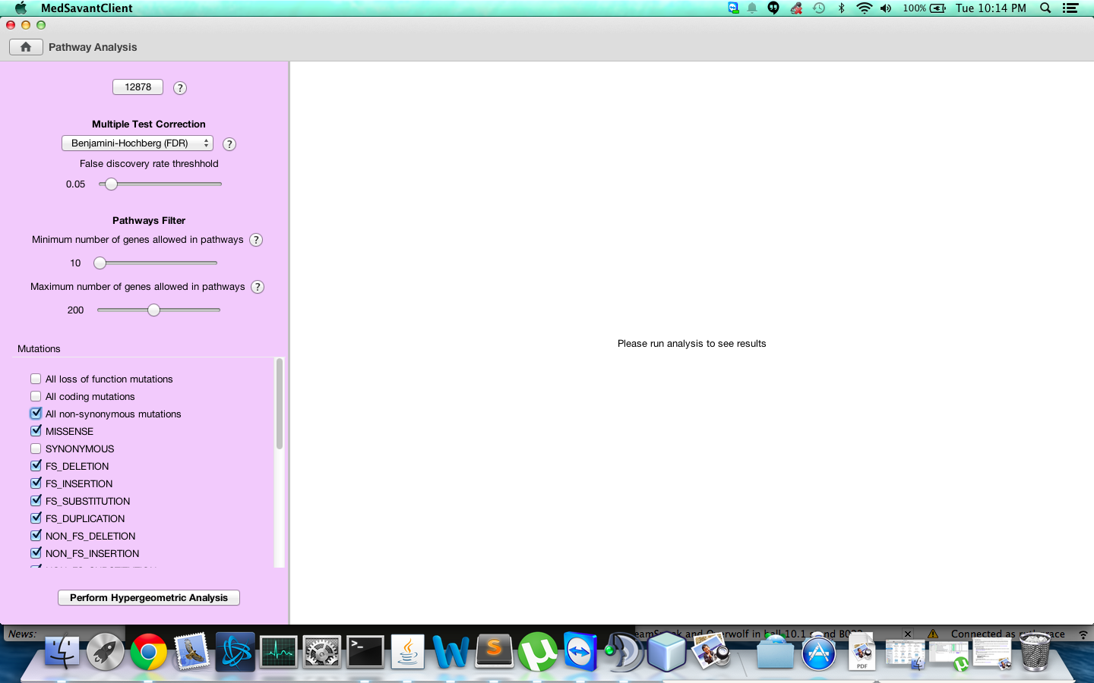

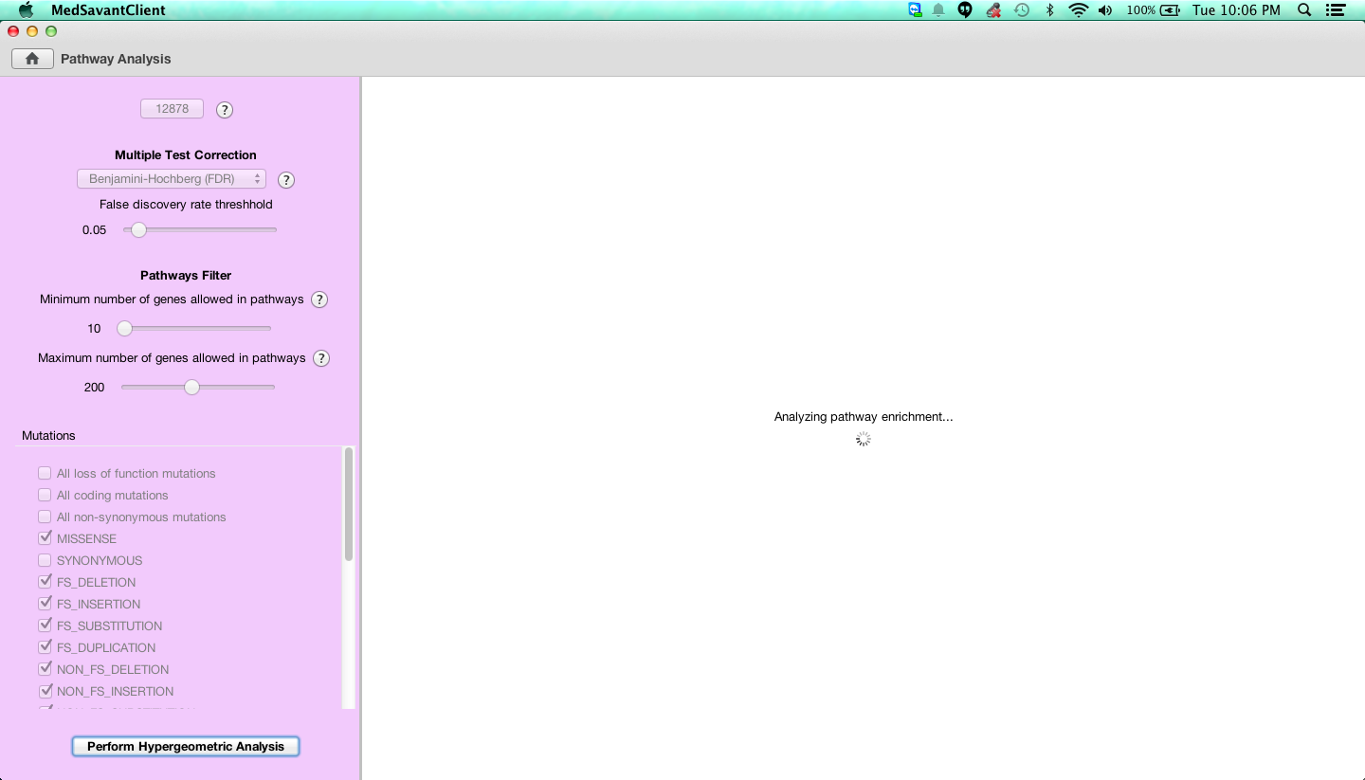

Your results will be shown.

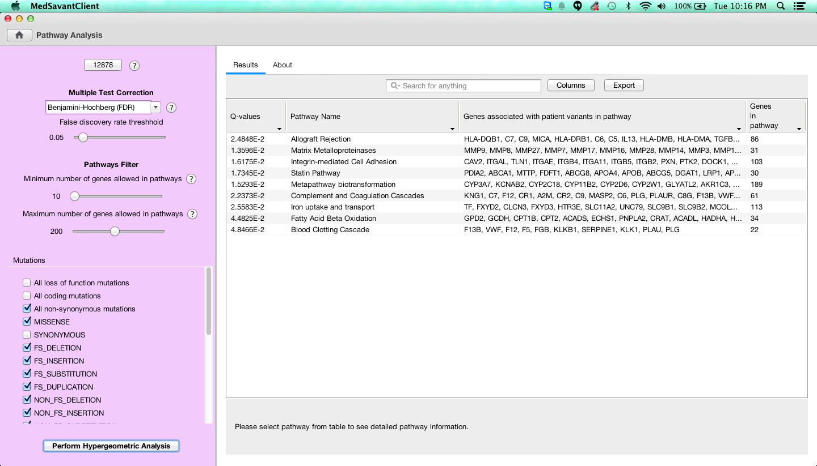

# Detailed Guide

Choose a patient from the database. If you do not have any data in your database, you may upload Variant Call Files with the VCF Uploader app ([instructions can be found here](http://genomesavant.com/p/medsavant/taketutorial.shtml?tutorial=apps&part=vcfuploader)).



The "choose patient" button opens a pop-up window. Select a patient. Here we have chosen patient 12878, from whom we have variants derived from whole exome data.



Once a patient is chosen, you have the option to change some analysis parameters: Multiple test correction type, the maximum and minimum number of genes allowed in pathways used for analysis, and the types of mutations you would like to analyze.

The multiple test corrections available are the Bonferroni correction, which is very conservative, and the Benjamini-Hochberg correction, which is less conservative, and based on a False Discovery Rate cutoff which you can adjust. The default FDR cutoff is 0.05.

There are also options for filtering which pathways should be used in the analysis. The standard cutoffs allow pathways with at least 10 genes and at most 200 genes. Pathways with too many genes are disproportionately likely to contain many genes from the sample, while pathways with too few genes are disproportionately likely to be called significant if they only contain one gene from the sample.

The mutation types available are from the Jannovar standard set. Variant call files are annotated by Jannovar after upload into the database.

Here we have selected all non-synonymous mutations, and left the other options at their default values.



The analysis may take up to a minute to run, depending on how many genes are associated with your variants.



Once the analysis is complete, a table of results will be displayed.



You can select a row of the table to see more details about the pathway.

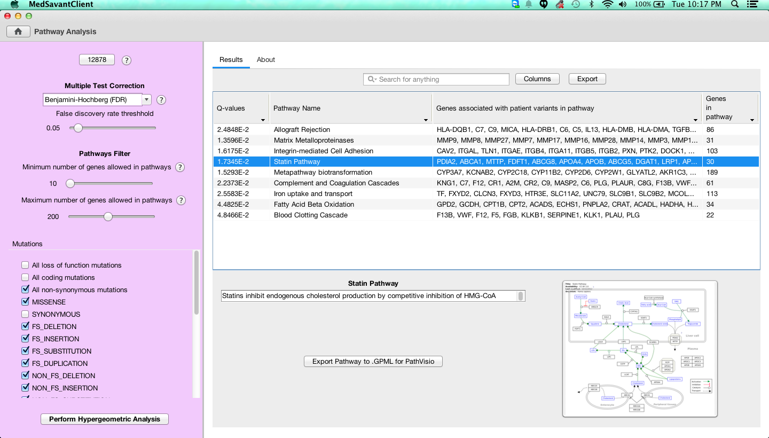

Clicking on the pathway thumbnail opens a Cytoscape.js view of the pathway in your default browser, which you can manipulate.

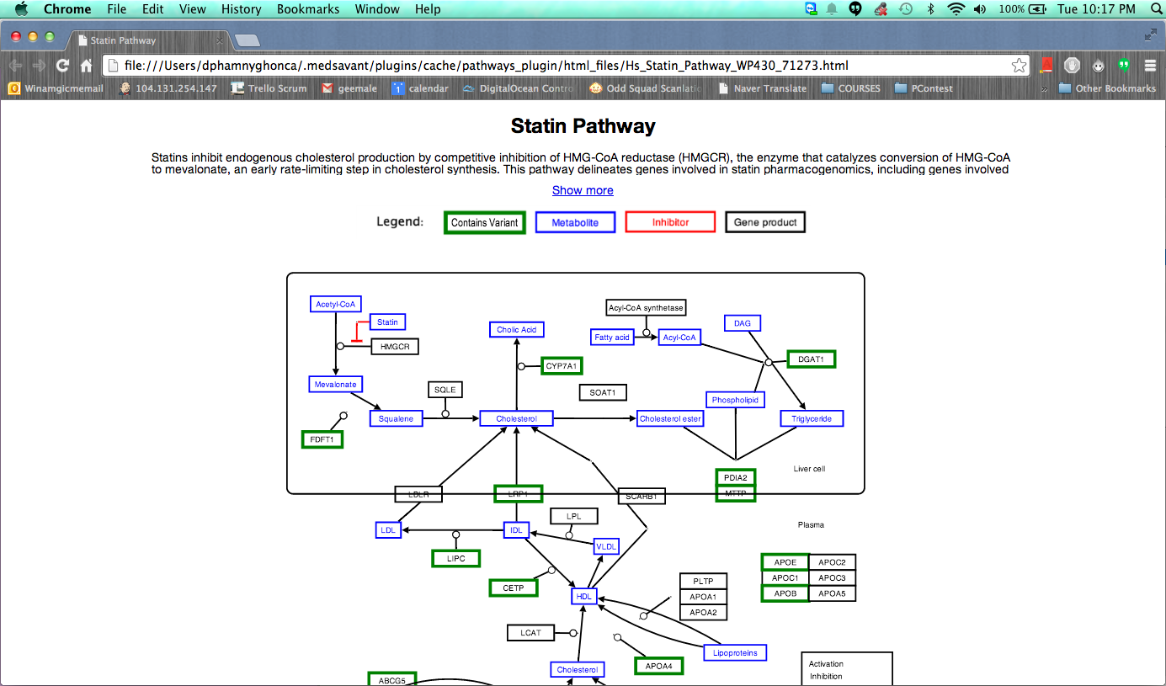

You can also export the pathway into GPML format for visualization in PathVisio.

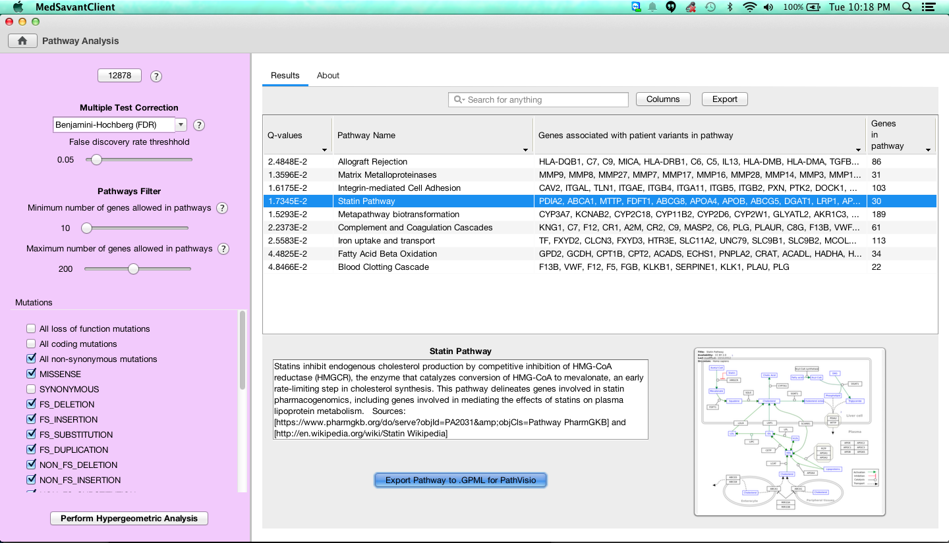

Lastly, there is an About tab with information about the analysis.

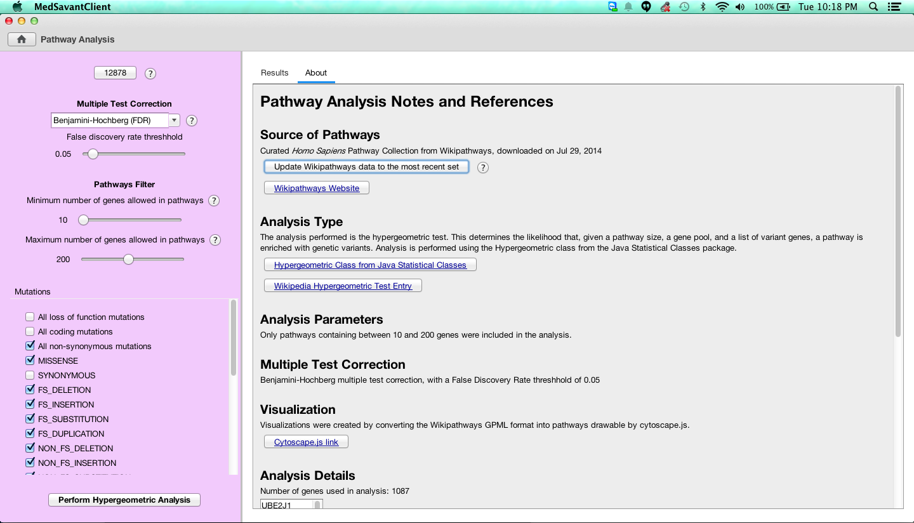

Here you can see which genes were not included in the analysis because they were not found in any pathways.

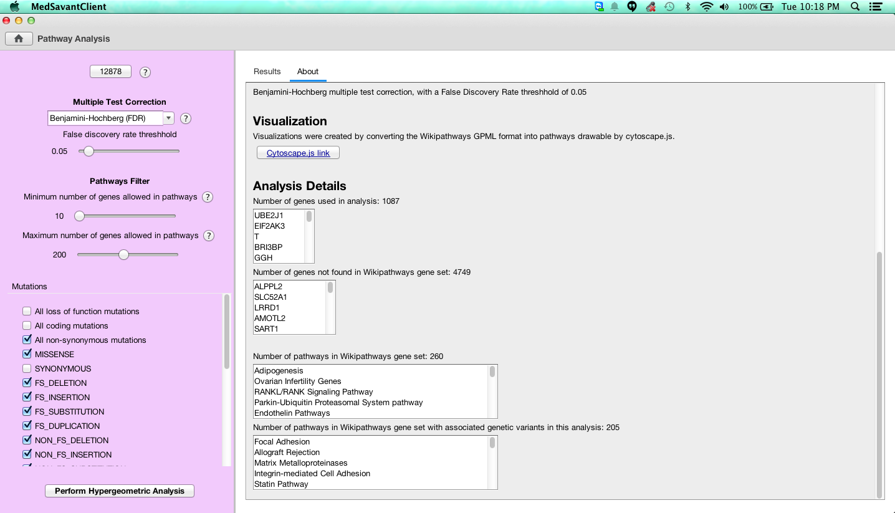

For more tutorials, see the [MedSavant website](http://genomesavant.com/p/medsavant/). For more information about the Pathways plugin, see the [GitHub repository](https://github.com/compbio-UofT/pathways-app).

This project was funded by Google Summer of Code, in conjunction with the Sick Kids Center for Computational Medicine, and the Bader Lab at the University of Toronto.