DATA405 Genomic Data Science · Fall 2026 · Howard University
Lab 2 · Statistics in personal and population genomics
Wednesday Oct 14, 2026 · 1.5 hours · Instructor: Jinrui Xu
Name: ______________________________ Lab partner (optional): ______________________________

Before you start
- Open the course website, go to Lab 2, and run both setup cells. Python and R run inside the page; nothing is installed.
- Choose one language, Python or R, and use it for the whole lab; every code box below shows both, so follow your column. Predict the output before you press Run. Use the Hint before the Solution.
- Part A follows Lecture 12 (one person, reads from two copies). Part B follows Lecture 13 (many people: Hardy–Weinberg and GWAS).
- Write your answers to Q1–Q7 here or in your lab report. Report due Tuesday, Oct 20 on Canvas.

Data
File | What | Used in
(generated in the cells) | read counts at heterozygous sites — simulated | Ex 1–3
rs2814778_by_population.tsv | genotype counts at rs2814778 (ACKR1, Duffy) in the five 1000 Genomes groups — real | Ex 4
gwas_region.tsv, gwas_snps.tsv | 2,000 people × 15 SNPs in one region + a trait — simulated | Ex 5
stratification.tsv | 1,000 people in two groups, one SNP, a trait — simulated | Ex 6

PART A · ONE PERSON: READS FROM TWO COPIES

Exercise 1 · Is 16 of 20 evidence of imbalance? (10 min)
A heterozygous site has 16 ChIP-seq reads from copy 1 and 4 from copy 2. If the site is balanced, each read comes from copy 1 with probability 0.5. Fill in the null value and compare three sites that all show 80 % copy 1.
Python  for k, n in [(8, 10), (16, 20), (160, 200)]:  r = stats.binomtest(k, n, ______)  ci = r.proportion_ci()  print(k, "of", n, r.pvalue,  ci.low, ci.high) | R  for (x in list(c(8, 10), c(16, 20),  c(160, 200))) {  r <- binom.test(x[1], x[2], p = ______)  cat(x[1], "of", x[2], r$p.value,  r$conf.int, "\n")  }
Site | p-value | 95 % interval
8 of 10
16 of 20
160 of 200
Q1. Why does 8 of 10 fail the test while 160 of 200, with the same 80 %, gives p = 3.4 × 10⁻¹⁸? Answer with the width of the 95 % interval.

Exercise 2 · One person, 100,000 tests (10 min)
Every one of 100,000 heterozygous sites is balanced and has 30 reads. All sites share the same depth, so there are only 31 possible p-values: compute them once in a table and look each site up.
Python  k = rng.binomial(30, 0.5, size=100_000)  pmf = stats.binom.pmf(np.arange(31), 30, 0.5)  p_table = np.array([two_sided(x, 30, pmf)  for x in range(31)])  p = p_table[k]  print((p < ______).sum())  print((p < 0.05 / 100_000).sum()) | R  k <- rbinom(100000, 30, 0.5)  pmf <- dbinom(0:30, 30, 0.5)  p_table <- sapply(0:30,  function(x) two_sided(x, 30, pmf))  p <- p_table[k + 1]  sum(p < ______)  sum(p < 0.05 / 100000)
Checkpoint About 4,300–4,400 balanced sites pass p < 0.05, all false; none passes the Bonferroni line of 5 × 10⁻⁷.
Q2. Why is the count a little below 5 % of 100,000? (Look at p_table: can 30 reads give a p-value of exactly 0.05?)

Exercise 3 · A balanced site that looks imbalanced (25 min)
- The truth: the factor binds both copies equally, 50 / 50.
- A technical factor: PCR happens to copy fragments from copy 1 more often, so the 20 reads come from a pool that is 75 % copy 1.
- The data: 16 reads from copy 1, 4 from copy 2. The binomial test says p = 0.012, “significant”. The conclusion is wrong: the imbalance came from the experiment, not the biology.

3a · How ordinary is 16 of 20 from a 75 % pool?
Run the cell. P(16 or more | 75 % pool) = ________ Binomial test with p = 0.5: ________

3b · Add a layer: let p stray, by an amount we do not know
Each experiment draws its own p from a Beta(α, β) distribution; then the reads are drawn as before. This two-layer model is the beta-binomial.
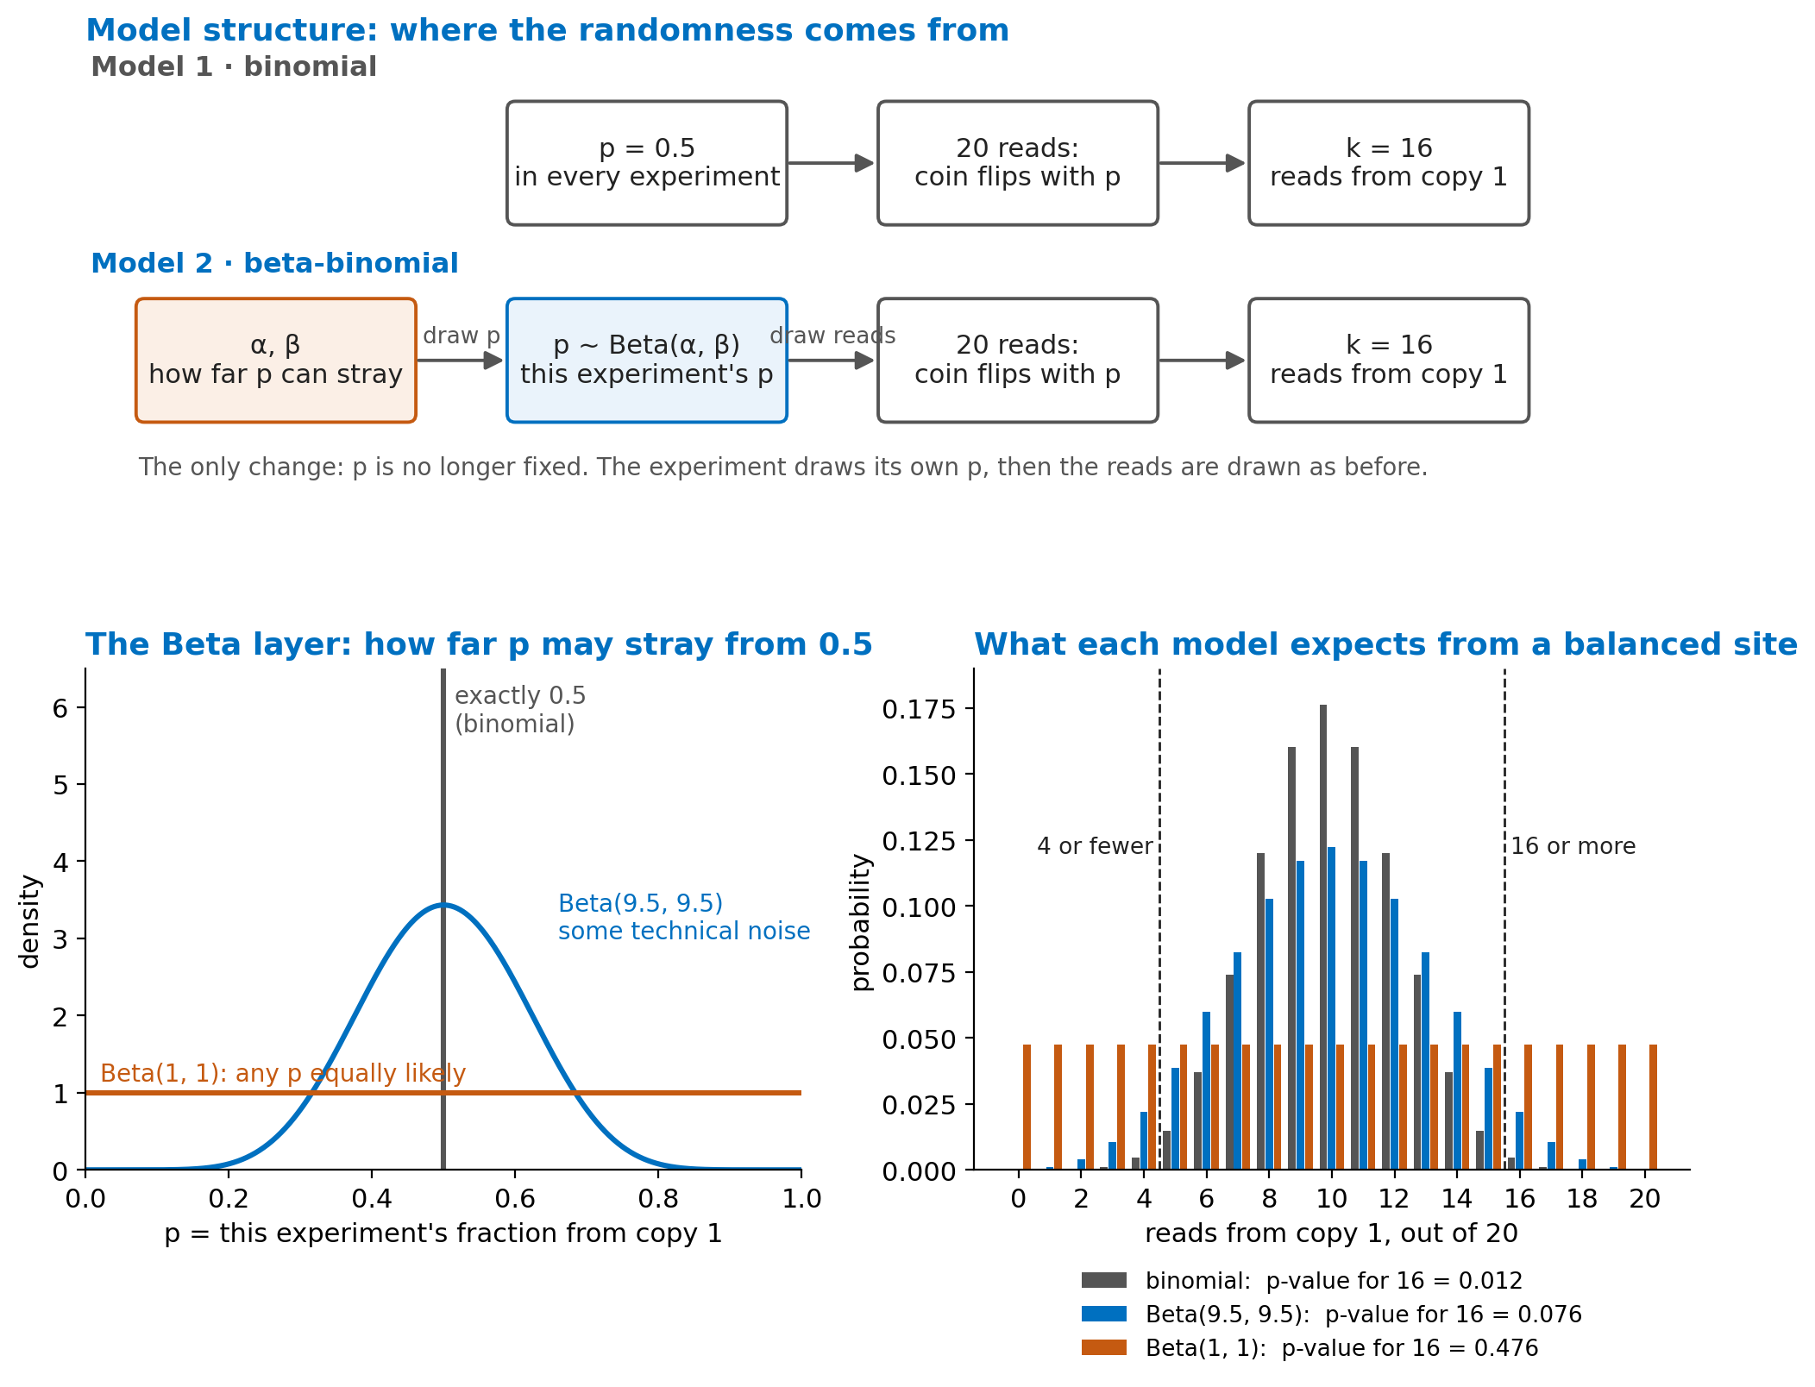
What α and β mean. Think of them as imaginary reads held in mind before seeing any data: α from copy 1, β from copy 2. Their ratio sets the centre (average p = α / (α + β); α = β keeps it at 0.5). Their sum sets how sure we are: a large α + β gives a narrow Beta (p stays near 0.5); a small sum gives a wide Beta (p can stray far).
Python  for a in [50, 9.5, ______]:  ax.plot(x, stats.beta.pdf(x, a, a)) | R  lines(x, dbeta(x, 9.5, 9.5), col = "blue")  lines(x, dbeta(x, ______, ______),  col = "orange")

3c · Test 16 of 20 again, now allowing p to stray
Python  pmf = stats.betabinom.pmf(counts, n, a, ______)  print(two_sided(16, 20, pmf)) | R  pmf <- dbetabinom(0:n, n, a, ______)  two_sided(16, 20, pmf)
Model | What it says | p-value for 16 of 20
Binomial (p = 0.5 exactly) | no technical noise
Beta(50, 50) | very little noise
Beta(9.5, 9.5) | some technical noise
Beta(1, 1) | any p equally likely

3d · From one site to many
Simulate 10,000 balanced sites: draw each site's p from Beta(9.5, 9.5), then draw 20 reads. Test every site with both models.
Python  p_site = rng.beta(9.5, 9.5, size=10_000)  k = rng.binomial(20, ______) | R  p_site <- rbeta(10000, 9.5, 9.5)  k <- rbinom(10000, 20, ______)
Balanced sites called significant: binomial ________ % beta-binomial ________ %
Q3. In 3c you had to choose α and β. One site in real data gives a single count. Explain in two sentences why α and β are estimated from all heterozygous sites of a dataset together, and why that works (think of 3d).

PART B · MANY PEOPLE: THE 1000 GENOMES PROJECT

Exercise 4 · Hardy–Weinberg at rs2814778 (15 min)
Real genotype counts in 2,504 people. T has frequency p, C has q = 1 − p. Fill in the expected heterozygote frequency, then test the whole cohort and each group.
Python  expected = n * np.array([p**2, ______, q**2]) | R  expected <- n * c(p^2, ______, q^2)
Group | TT | CT | CC | χ² | fits HW?
ALL | 1,793 | 88 | 623
AFR | 4 | 40 | 617
AMR | 299 | 42 | 6
EAS | 504 | 0 | 0
EUR | 497 | 6 | 0
SAS | 489 | 0 | 0
Q4. Splitting by group removed almost all of the failure. Why do AFR and AMR still fail a little? (Each continental group combines several populations, some of recently mixed ancestry, such as ASW and PUR.)

Exercise 5 · A GWAS of one region (15 min)
Regress the trait on each of 15 SNPs, compute z = β / SE and the p-value, and draw the region with the line at 5 × 10⁻⁸. Then compute r² between the lead SNP and every other SNP.
Python  fit = stats.linregress(gw[s], gw["trait"])  z = fit.slope / ______ | R  co <- summary(lm(gw$trait ~ gw[[s]]))$coef[2, ]  z <- co[["Estimate"]] / ______
Lead SNP: ________ β = ________ SE = ________ z = ________ p = ________
SNPs that pass 5 × 10⁻⁸: ______________________ their r² with the lead SNP: ______________________
Q5. (a) From the results alone, could you tell which SNP in the significant block is causal? Why or why not? (b) Why is p = 0.04 at snp12 not a finding in a GWAS?

Exercise 6 · Group differences create a false hit (10 min)
Two groups; allele frequency about 0.2 vs 0.7; the trait is higher in group 2 for a non-genetic reason. The SNP has no effect on the trait. Fit the regression without, then with, the group.
Python  ols([g], y)  ols([g, ______], y) | R  lm(trait ~ genotype, data = st)  lm(trait ~ genotype + ______, data = st)
Model | β for genotype | p-value
trait ~ genotype
trait ~ genotype + group
Q6. Why did the SNP look associated with the trait? In a real GWAS, people do not come labelled with a group: what do studies put in the model instead? (Lecture 13)

Q7. Exercises 3 and 6 have the same shape: a hidden factor makes an ordinary test too confident, and the fix adds that factor to the model. Name the hidden factor and the fix in each.

Lab report (due Tuesday, Oct 20)
Answers to Q1–Q7, plus two figures: the Beta curves from 3b with one choice of your own added, and the regional plot from Exercise 5. One to two pages.

