Genomic Data Science · DATA405/BIOL480 · Fall 2026 · Howard University
Lab 3 · Discovering genetic variants, GWAS and polygenic scores
Wednesday Oct 21, 2026 · about 1 h 45 min · Instructor: Jinrui Xu
Name: ______________________________ Lab partner (optional): ______________________________

What you will do today
Real genomics is done with pipelines: chains of standard programs, each taking a file in and handing a file on. Today you run the two most common pipelines yourself, with the same tools that research labs and hospitals use.
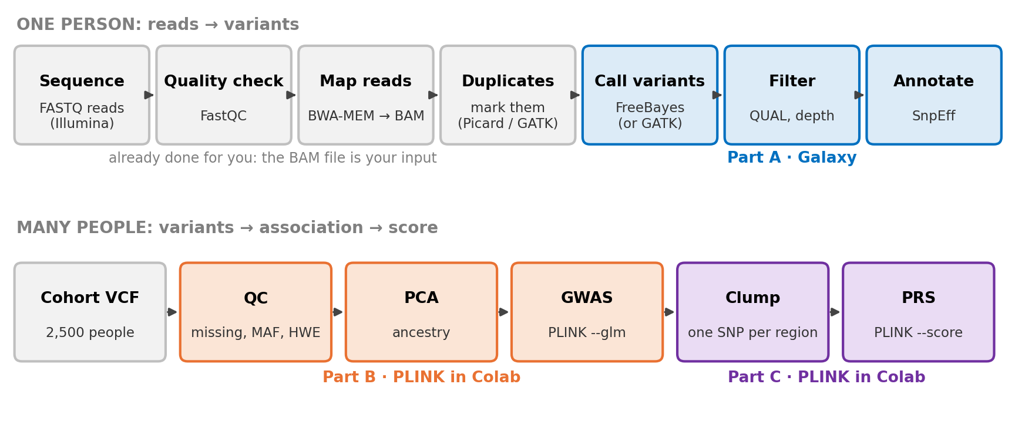
Figure 1. The two pipelines. Grey steps were done before the lab; coloured steps are yours.
Part | Question | Tool and where it runs | Time
A | Which positions in one family's DNA differ from the reference genome, and do the differences matter? | Galaxy (a website that runs bioinformatics tools) | ≈ 45 min
B | Which variants are associated with LDL cholesterol in 2,500 people? | PLINK 2 in Google Colab | ≈ 40 min
C | Can those variants predict LDL in people who were not in the study? | PLINK 2 in Google Colab | ≈ 20 min

Before you start
- Galaxy: open usegalaxy.org and click Login or Register (top right) to make a free account. If usegalaxy.org is slow, usegalaxy.eu has the same tools (the screenshots in this handout are from it).
- Colab: you need a Google account. The notebooks are linked from the Lab 3 page of the course site: https://compbio-geb.github.io/DATA405_2026/lab3.html.
- Language: Parts B and C come in a Python notebook and an R notebook. Choose one. The PLINK commands are identical in both.
- Galaxy jobs wait in a queue. When a job is grey or orange it is waiting or running. Start FreeBayes, then open Part B while it runs, and come back.
- Write the numbers marked ✏️ in the notebook, and answer Q1–Q8 at the end. The report is due Tuesday, Oct 27, 11:59 pm on Canvas.

PART A · FINDING VARIANTS IN ONE FAMILY (GALAXY)

A1 · The ideas you need

Reference genome and reads
The reference genome is one agreed-upon DNA sequence for each chromosome (here hg19, also called GRCh37). It is not anyone's "correct" genome; it is a coordinate system. Your genome differs from it at about 4–5 million positions, and finding those positions is called variant calling.
A sequencing machine does not read a chromosome from end to end. It reads millions of short random pieces, each 100–150 letters long. Each piece is a read. Reads arrive in a FASTQ file, four lines per read:
FASTQ record
@read_0001 ← name of the read
GATTCAGGCTACGATGCAAT ← the letters (bases)
+ ← separator
IIIIIHHHGG@@@>>;;5552 ← one quality letter per base
Each quality letter encodes a Phred score Q, the machine's estimate of how likely that base is wrong:
Phred score Q | Chance the base is wrong | Shown as | Meaning
10 | 1 in 10 | + | poor
20 | 1 in 100 | 5 | acceptable
30 | 1 in 1,000 | ? | good
40 | 1 in 10,000 | I | excellent
The rule is Q = −10 × log₁₀(error probability). The same scale is used later for the confidence of a variant call (QUAL).

Mapping, BAM files and the pileup
Mapping finds where each read came from by matching it to the reference (Lecture 6: index, seed, extend). The mapped reads are stored in a BAM file: every read with its chromosome, start position and how it lines up. Stack all the reads that cover a position and you get a pileup.
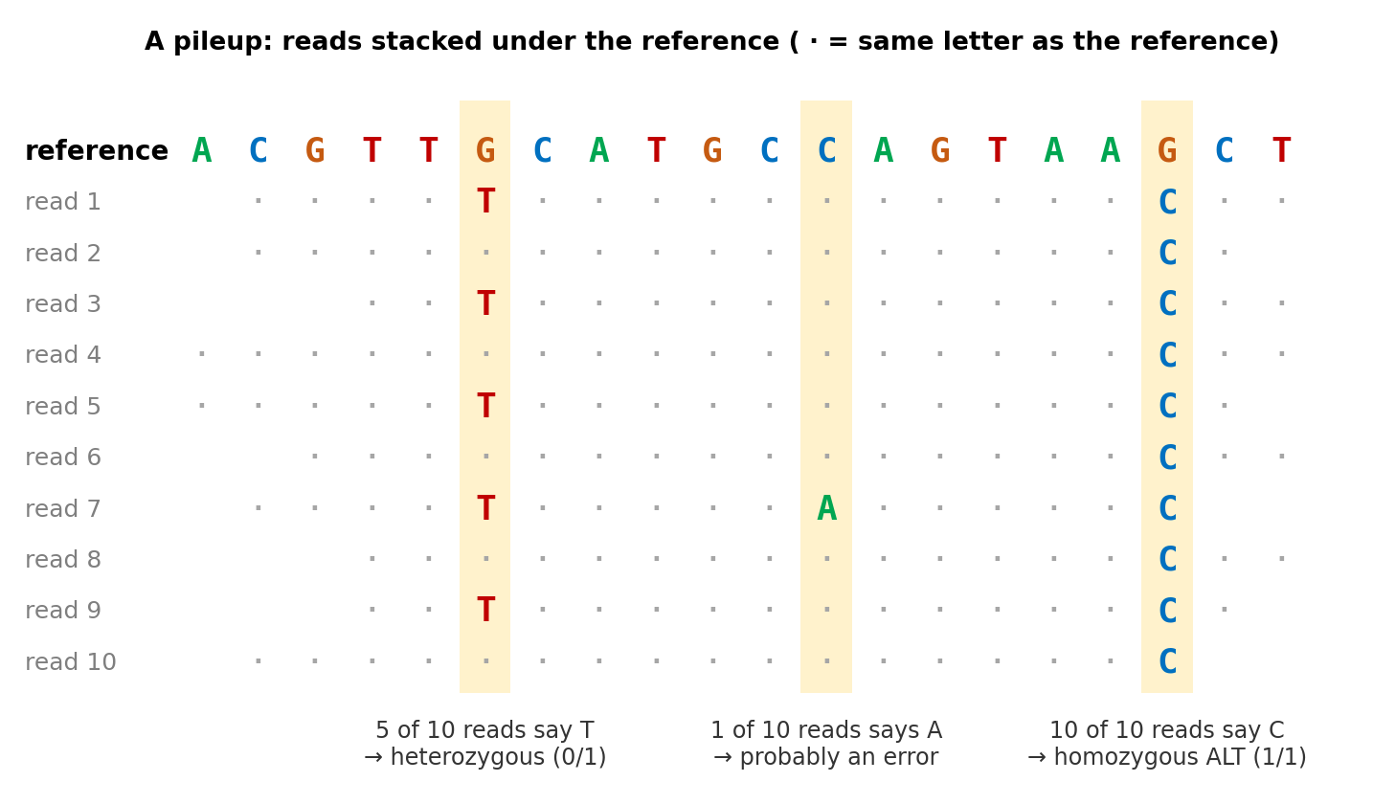
Figure 2. Three kinds of column in a pileup. Depth = the number of reads covering a position (here 10).

Variant or sequencing error?
You inherited two copies of each chromosome, one from each parent. At any position there are three possible genotypes:
Genotype | Meaning | What the reads should look like
0/0 | both copies match the reference (REF) | almost all reads show REF; a few errors
0/1 | one copy REF, one copy different (ALT): heterozygous | about half the reads show ALT
1/1 | both copies ALT: homozygous ALT | almost all reads show ALT
A variant caller asks, at every position: which genotype explains these reads best? If the base error rate is 1 in 1,000, then 1 ALT read out of 10 is easily explained as an error (0/0), but 5 out of 10 is not; it fits 0/1, where each read comes from the ALT copy with probability 0.5. This is the binomial reasoning from Lab 2. The caller also weighs base qualities and mapping quality, and reports:
- QUAL: how confident it is that the position is a variant at all, on the Phred scale. QUAL 30 means about a 1 in 1,000 chance that there is no variant.
- GT: the genotype it chose for each person.
Key idea Depth matters. With 4 reads, 2 ALT reads could be a heterozygote or two errors, and a heterozygote can easily show 4 REF reads by chance (probability 0.5⁴ = 1/16). Low depth is the most common reason for a wrong genotype.

The VCF file
A caller writes its results to a VCF (Variant Call Format) file: header lines start with ##, then one line per variant. This is a real line from today's data:
One VCF line (shortened: ID and FILTER are "." here; INFO and FORMAT have more fields)
#CHROM POS REF ALT QUAL INFO FORMAT son father mother
chr19 617614 G A 39.3 DP=13;... GT:DP:AD 0/0:5:5,0 0/1:5:2,3 0/0:3:3,0
Column | What it says in this line
CHROM, POS | chromosome 19, position 617,614 (hg19 coordinates)
REF, ALT | the reference has G; some reads show A
QUAL | 39.3 → confident there is a variant here (Phred scale)
INFO | facts about the site: DP = 13 reads in total, TYPE = snp (a single-letter change)
FORMAT | the order of the fields in each person's column: GT = genotype, DP = reads for that person, AD = reads for REF, ALT
son | 0/0 from 5 reads (5 REF, 0 ALT)
father | 0/1 from 5 reads (2 REF, 3 ALT): the variant is his
mother | 0/0 from 3 reads (3 REF, 0 ALT)

Filtering and annotation
Callers are tuned to miss nothing, so their raw output contains many weak calls. Filtering keeps only calls with enough evidence, for example QUAL > 30 and depth > 10. Annotation then asks what each surviving variant could do: is it in a gene, and does it change the protein?
SnpEff effect | Impact | Meaning
stop_gained, frameshift | HIGH | the protein is cut short or scrambled
missense_variant | MODERATE | one amino acid changes
synonymous_variant | LOW | the codon changes but the amino acid does not (Lab 1: the genetic code is redundant)
splice_region_variant | LOW | near an exon–intron boundary; might affect splicing
intron, upstream, downstream | MODIFIER | outside the coding sequence; effect unknown, usually small

Today's data
A real family from the Genome in a Bottle project (Ashkenazi trio: son HG002, father HG003, mother HG004). Their reads were already mapped to hg19, and the file was cut down to a 5,000-letter stretch of chromosome 19 inside the gene POLRMT (mitochondrial RNA polymerase), so every step runs in a minute or two. All three people are in one BAM file; each read carries a tag saying whose it is. (Data from the Galaxy Training Network tutorial "Calling variants in diploid systems".)

A2 · Step by step in Galaxy
Galaxy has three panels: tools on the left, the tool form in the middle, and your history on the right. Every file you upload or make appears in the history as a numbered box. Green = done, grey = waiting, orange = running, red = error. Click a box's title to open it; click the eye icon to view the file.

Step 1 · Upload the BAM file (≈ 3 min)
- Click Upload (left edge), then Paste/Fetch data.
- Paste this address into the box: https://zenodo.org/record/60520/files/GIAB-Ashkenazim-Trio-hg19.gz
- Leave Type on Auto-detect. In the box on the same row that says unspecified (?), type hg19 and choose Human (Homo sapiens): hg19.
- Click Start, then Close.
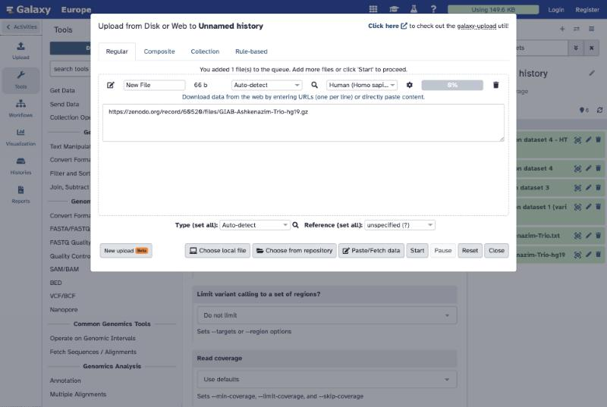
Upload → Paste/Fetch data, with the address pasted and hg19 chosen.
What you should see A new box "1: GIAB-Ashkenazim-Trio-hg19.gz" turns green, about 52 KB, format bam.
Why this step The BAM file is the output of the grey steps in Figure 1. Galaxy needs to know which reference it was mapped to (hg19) so that later tools use the same coordinates.

Step 2 · Call variants with FreeBayes (≈ 5 min, mostly waiting)
- In the tool search box (top left) type FreeBayes and open "FreeBayes bayesian genetic variant detector".
- Choose the source for the reference genome: Locally cached. Run in batch mode: Run individually.
- BAM or CRAM dataset: your BAM (dataset 1). Using reference genome: Human (Homo sapiens): hg19.
- Leave everything else as it is and click Run Tool. While it runs, open Part B (page 7) and come back.
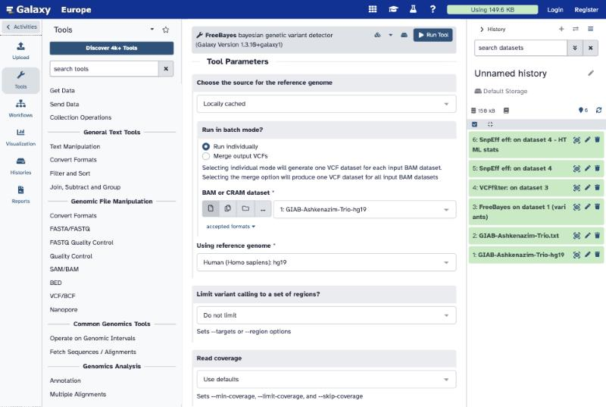
The FreeBayes form. Only the three settings at the top are changed.
What you should see "FreeBayes on data 1 (variants)", a VCF. Click the eye icon and scroll past the ## header lines: there are 39 variant lines, one per candidate site.
Why this step This is the variant-calling step: for every position, FreeBayes compares the genotypes 0/0, 0/1 and 1/1 for each of the three people and reports positions where at least one person is likely not 0/0. Its default is to report generously, including very weak candidates.
✏️ Look at the QUAL column (6th). Many lines have QUAL far below 1, such as 0.00002. Find chr19:618428: QUAL ________ ; total reads DP = ________ ; ALT reads AO = ________ .

Step 3 · Keep the confident calls with VCFfilter (≈ 2 min)
- Search VCFfilter and open it. VCF dataset to filter: the FreeBayes output.
- Click Insert Filters. Select the filter type: Info filter (-f). Specify filtering value: QUAL > 30 & DP > 10 (spaces matter).
- Click Run Tool.
What you should see A VCF with 10 variant lines. Of the 39 calls, 27 had QUAL ≤ 30 and 2 more had fewer than 11 reads in total.
Why this step Removing weak calls trades a few missed variants for far fewer false ones. QUAL > 30 means each kept call has roughly a 1 in 1,000 chance or less of being a pure error. GATK and every other pipeline end with a filter step like this.

Step 4 · Annotate with SnpEff (≈ 3 min)
- Search SnpEff eff and open "SnpEff eff: annotate variants".
- Important: switch the tool version. Click the Versions icon (stacked-boxes icon left of Run Tool) and choose Switch to 4.3+T.galaxy2. Newer versions do not have the hg19 database installed on these servers.
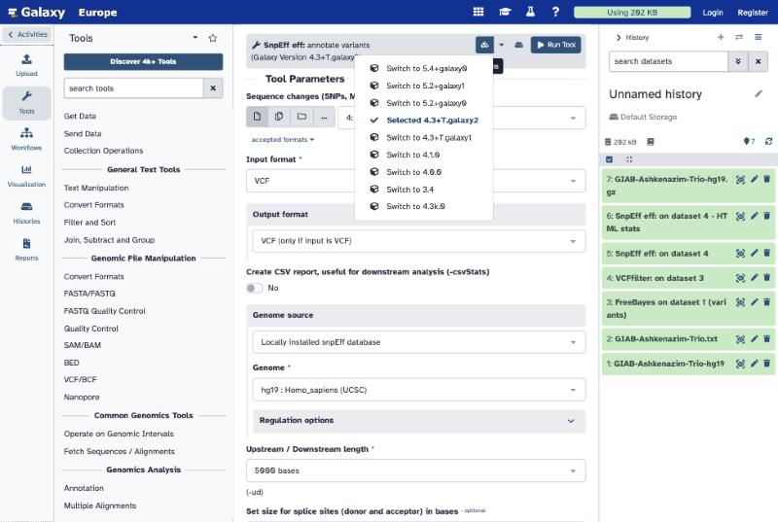
Choosing SnpEff version 4.3+T.galaxy2 from the Versions menu.
- Sequence changes: the VCFfilter output. Genome source: Locally installed snpEff database. Genome: type hg19 and choose hg19 : Homo_sapiens (UCSC). Run Tool.
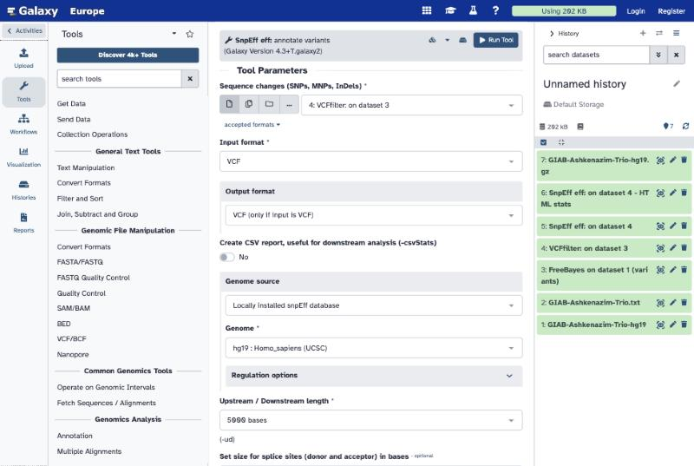
SnpEff 4.3+T.galaxy2 with the filtered VCF and the hg19 database.
What you should see Two new boxes: an annotated VCF and an HTML report. Open the HTML report with the eye icon: "Number of effects by impact" and "Number of effects by type" are the tables you need. In the VCF, each line now has an ANN= field: ALT allele | effect | impact | gene | … | protein change.
Why this step A list of positions is not yet biology. Annotation connects each variant to genes and to the genetic code, which is the first thing a clinical lab looks at.

Step 5 · Read your results (≈ 10 min)
Open the annotated VCF. The three person columns are, in order: HG002 son, HG003 father, HG004 mother. Fill in the table for the 10 filtered variants (the first is done).
POS | REF>ALT | son GT (DP) | father GT (DP) | mother GT (DP) | SnpEff effect (first one listed)
617614 | G>A | 0/0 (5) | 0/1 (5) | 0/0 (3) | synonymous_variant, p.Ile1179Ile
618851
619021
619139
619408
619574
619772
619913
620999
621712
Key idea Mendelian check. A child gets one copy from each parent, so the son's genotype must be possible from his parents'. Example: if the son is 1/1, both parents must carry at least one ALT. A site that breaks this rule is a Mendelian error, and it almost always means one of the three genotypes is wrong.

PART B · A GENOME-WIDE ASSOCIATION STUDY (PLINK)

B1 · From one family to 2,500 people
Part A ended with a VCF for 3 people. A GWAS starts from the same kind of VCF, but with thousands of people as columns, and asks a different question: at which variants does the average trait differ by genotype? (Lecture 13; Lab 2, Exercises 5–6.)
Our cohort: 2,500 people, 11,000 common variants on chromosomes 1–22, and LDL cholesterol in mg/dL. The data are simulated, with real file formats, so we know the right answers. 2,000 people are the discovery set for the GWAS; the other 500 are kept aside as the target set for the PRS in Part C.
PLINK is the standard program for this. It is a single command-line program; each step is one command with options that start with --. The notebook downloads PLINK 2 and the data, then runs each command for you. (In the notebook the program is called ./plink2, meaning "the plink2 in this folder"; below it is written plink2.)

Open the notebook
- Python: Lab3_GWAS_PRS_Python.ipynb
- R: Lab3_GWAS_PRS_R.ipynb (in Colab: Runtime → Change runtime type → R, then Save)
Click File → Save a copy in Drive, so your work is kept. Then run the cells from the top with the ▶ button or Shift+Enter.

B2 · What each step does

Step 0–2 · Install, look, convert
Terminal command
plink2 --vcf cohort.vcf.gz --make-pgen --out cohort
Why this step VCF is text: easy to read, slow to compute on. PLINK converts it once into three binary files: .pgen (genotypes), .pvar (one line per variant) and .psam (one line per person). --out sets the name of the output files.

Step 3 · Quality control (QC)
Terminal command
plink2 --pfile cohort --missing --out miss # measure
plink2 --pfile cohort --freq --out freq
plink2 --pfile cohort --hardy --out hardy
plink2 --pfile cohort --mind 0.02 --geno 0.02 --maf 0.01 --hwe 1e-6 --make-pgen --out qc # remove
Filter | Removes | Why
--mind 0.02 | people with more than 2% of genotypes missing | a failed or poor-quality DNA sample gives unreliable genotypes everywhere
--geno 0.02 | variants missing in more than 2% of people | a variant the array or caller often fails on is likely badly measured
--maf 0.01 | variants whose minor allele frequency is below 1% | too few carriers to estimate an effect; rare errors pile up here
--hwe 1e-6 | variants that fail Hardy–Weinberg with p < 10⁻⁶ | Lecture 13: a strong HW failure in a whole cohort usually means a genotyping error (e.g. heterozygotes called as homozygotes)
What you should see 15 people fail --mind; 165 variants fail --geno; 54 are removed by --maf and 29 by --hwe. 2,485 people and 10,752 variants remain.

Step 4 · Principal component analysis (PCA)
Terminal command
plink2 --pfile qc --indep-pairwise 50 5 0.2 --out prune
plink2 --pfile qc --extract prune.prune.in --pca 10 --out pca
PCA turns each person's 10,000 genotypes into a few summary numbers, PC1, PC2, …, chosen to capture the biggest differences between people. People with shared ancestry have similar allele frequencies, so they land close together on a PC1–PC2 plot.
Why this step LD pruning first (--indep-pairwise) keeps a set of variants that are not strongly correlated with each other (r² < 0.2 within windows of 50 variants), so that long blocks of linked variants do not dominate the PCs. The PCs are then used to correct the GWAS.
What you should see 1,347 variants remain after pruning. The PC1–PC2 plot shows two clearly separated clusters of people: this cohort has two ancestry groups.

Step 5 · GWAS without correction
Terminal command
plink2 --pfile qc --keep discovery.txt --pheno pheno.txt --glm allow-no-covars --out gwas_nopc
--glm fits, for each variant, the regression from Lab 2: LDL = a + β × (number of copies of allele A1) + error. It reports β, its standard error, and the p-value. --keep restricts to the 2,000 discovery people.
Two standard pictures: a Manhattan plot (each dot a variant, height −log₁₀ p, red line at 5 × 10⁻⁸) and a QQ plot (observed vs expected −log₁₀ p if nothing were associated). λ (lambda) compares the median test statistic with what chance alone gives: λ ≈ 1 is healthy; λ ≫ 1 means the tests are inflated across the whole genome.
What you should see About 230 variants pass 5 × 10⁻⁸, spread over every chromosome, and λ ≈ 3.9. The QQ plot leaves the diagonal almost immediately.

Step 6 · GWAS with the PCs as covariates
Terminal command
plink2 --pfile qc --keep discovery.txt --pheno pheno.txt \
--covar pca.eigenvec --covar-name PC1-PC5 --glm hide-covar --out gwas_pc
plink2 --pfile qc --keep discovery.txt --clump gwas_pc.LDL.glm.linear \
--clump-p1 5e-8 --clump-r2 0.1 --clump-kb 250 --out loci
Now the model is LDL = a + β × genotype + c₁·PC1 + … + c₅·PC5 + error: each variant is compared among people with similar ancestry. This is the fix from Lab 2, Exercise 6, without needing group labels. Clumping groups significant variants that are in LD (r² > 0.1, within 250 kb) and keeps the strongest one per region.
What you should see 9 variants pass 5 × 10⁻⁸, λ ≈ 1.17, and clumping gives 4 independent regions (on chromosomes 2, 11, 16 and 19). The strongest: 2:127602350, β ≈ 7.8 mg/dL per copy of A, p ≈ 1 × 10⁻¹¹.
PART C · A POLYGENIC RISK SCORE (PRS)
A PRS adds up a person's risk alleles, each weighted by its effect size from the GWAS:
PRS = β₁·g₁ + β₂·g₂ + … + βₖ·gₖ (gᵢ = 0, 1 or 2 copies of allele A1)
This is the clumping + thresholding method (what PRSice does): clump the discovery GWAS so each region is counted once, then keep only variants with p below a cut-off. The question is which cut-off predicts best in people who were not in the GWAS.
Terminal command
plink2 --pfile qc --keep discovery.txt --clump gwas_pc.LDL.glm.linear \
--clump-p1 1 --clump-r2 0.1 --clump-kb 250 --out prs_clump
plink2 --pfile qc --keep target.txt --score weights.txt 1 2 3 header \
--q-score-range ranges.txt snp_p.txt --out prs
File | Contains | Made by
weights.txt | variant ID, allele A1, β | the notebook, from the GWAS
snp_p.txt | variant ID, GWAS p-value | the notebook
ranges.txt | cut-offs: 5e-8, 1e-5, 0.001, 0.01, 0.05, 0.5, 1 | the notebook
For each cut-off the notebook reports R², the share of LDL differences in the 500 target people that the PRS explains beyond the PCs (ancestry), and draws a bar chart.
What you should see 1,925 clumped variants. R² rises from about 0.03 with only the 4 genome-wide hits to a peak near 0.10 at p < 0.01 (about 120 variants), then falls slightly as more noise is added (0.08 with all variants). Mean LDL rises from about 108 in the lowest PRS tenth to about 153 in the highest.
Key idea Genome-wide significant hits explain little on their own; many small effects below the 5 × 10⁻⁸ line add real signal. But a cut-off that is too loose adds mostly noise. And a PRS built in one ancestry group usually predicts worse in another (Lecture 13: portability).

Report questions (5 points)
Answer in short paragraphs. Each question is 0.5 point; the two figures are 0.5 point each.
Q1. Read the VCF line at chr19:619021 in your annotated VCF. What are REF and ALT? Give each person's genotype and the number of reads (DP and AD) behind it. What does its QUAL say?

Q2. FreeBayes reported 39 candidate sites; your filter kept 10. Use chr19:618428 (which you recorded in Step 2) to explain why a site with 2 ALT reads out of 23 is most likely a sequencing error and not a heterozygous variant. (Hint: what fraction of ALT reads would a heterozygote give?)

Q3. Do a Mendelian check on your table from Step 5. Find the site(s) where the son's genotype is impossible given his parents'. Look at the depth of each person there: which genotype is most likely wrong, and why?

Q4. How many of the 10 variants change the protein sequence? Which effect types did SnpEff report? Give one reason why most variants found in a gene do not change its protein.

Q5. Report the QC numbers (people and variants removed by each filter). In one sentence each, explain why a variant that fails --geno and one that fails --hwe should not be used in a GWAS.

Q6. Compare the GWAS without and with the PCs: number of significant variants and λ. Use the PCA plot to explain where the ~230 false hits came from. Which Lab 2 exercise showed the same problem on one SNP?

Q7. With the PCs, 9 variants pass 5 × 10⁻⁸ but they form only 4 regions. Why do several neighbouring variants pass together, and why can't the GWAS alone tell which one is causal? The simulation actually contains 5 large-effect variants; give one reason a real effect can be missed.

Q8. Which p-value cut-off gave the best PRS, and what was its R²? Explain why both the strictest cut-off (5 × 10⁻⁸) and the loosest (1) did worse. Would you expect this PRS to work equally well in people of a third ancestry? Why or why not?

Figures to include
- Figure A: your PC1–PC2 plot (Step 4).
- Figure B: your Manhattan and QQ plot with the 5 PCs (Step 6).
Submit one PDF or Word file on Canvas by Tuesday, Oct 27, 11:59 pm.

Glossary
Term | Meaning
Reference genome | the agreed coordinate system for a species (human: hg19/GRCh37, hg38/GRCh38, T2T-CHM13)
Read | one short piece of DNA sequenced by the machine (100–150 bases for Illumina)
FASTQ | file of reads with one quality score per base
Phred score | Q = −10 log₁₀(P error); Q30 = 1 error in 1,000
Mapping / alignment | finding where each read comes from in the reference
BAM | binary file of mapped reads (SAM is the text version)
Depth (DP) | number of reads covering a position
Duplicate reads | copies of the same DNA fragment made by PCR; counted once
Variant calling | deciding, at each position, which genotype each person has
Genotype 0/0, 0/1, 1/1 | two REF copies; one REF and one ALT; two ALT copies
QUAL | Phred-scaled confidence that a site is a variant
VCF | Variant Call Format: one line per variant, one column per person
Annotation | linking variants to genes and predicted effects (SnpEff, VEP)
Mendelian error | a child genotype impossible from the parents' genotypes
MAF | minor allele frequency: frequency of the less common allele
Hardy–Weinberg (HWE) | expected genotype frequencies p², 2pq, q² under random mating
LD, r² | correlation between nearby variants inherited together
PCA, PC | principal components: summary axes of genetic variation, used as ancestry covariates
λ (lambda) | genomic inflation factor: median observed χ² / median expected χ²
Clumping | keeping the strongest variant in each LD region
PRS | polygenic risk score: sum of allele counts weighted by GWAS effect sizes

APPENDIX · THE SAME CALLING WITH GATK, ON YOUR OWN COMPUTER (OPTIONAL)
GATK (the Genome Analysis Toolkit, Broad Institute) is the most widely used variant-calling toolkit; its "Best Practices" pipeline is what large projects such as gnomAD follow. It runs from a terminal (macOS, Linux, or Windows with WSL). This appendix is optional and was not run in class.

1 · Install
The easiest route is conda (Miniforge), which installs GATK with a matching Java, plus samtools and BWA:
Terminal command
conda create -n gatk -c conda-forge -c bioconda gatk4 samtools bwa
conda activate gatk
gatk --version
Alternatives: Docker (docker pull broadinstitute/gatk), or download the zip from github.com/broadinstitute/gatk/releases (GATK 4.x needs Java 17).

2 · The full Best Practices pipeline, from FASTQ to VCF
GATK Best Practices (germline SNPs and indels)
# once: index the reference
bwa index ref.fa
samtools faidx ref.fa
gatk CreateSequenceDictionary -R ref.fa

# map reads (the read group -R names the sample), then sort
bwa mem -t 4 -R "@RG\tID:s1\tSM:sample1\tPL:ILLUMINA" ref.fa reads_1.fastq.gz reads_2.fastq.gz \
| samtools sort -o sample1.sorted.bam
samtools index sample1.sorted.bam

# mark PCR duplicates
gatk MarkDuplicates -I sample1.sorted.bam -O sample1.dedup.bam -M sample1.dup_metrics.txt
samtools index sample1.dedup.bam

# (optional) base quality recalibration, needs a file of known variants such as dbSNP
gatk BaseRecalibrator -I sample1.dedup.bam -R ref.fa --known-sites dbsnp.vcf.gz -O recal.table
gatk ApplyBQSR -I sample1.dedup.bam -R ref.fa --bqsr-recal-file recal.table -O sample1.recal.bam

# call variants per sample (GVCF mode), then genotype all samples together
gatk HaplotypeCaller -R ref.fa -I sample1.recal.bam -O sample1.g.vcf.gz -ERC GVCF
gatk CombineGVCFs -R ref.fa -V sample1.g.vcf.gz -V sample2.g.vcf.gz -O cohort.g.vcf.gz
gatk GenotypeGVCFs -R ref.fa -V cohort.g.vcf.gz -O cohort.vcf.gz

# hard filters for SNPs (GATK's recommended starting values)
gatk VariantFiltration -R ref.fa -V cohort.vcf.gz -O cohort.filtered.vcf.gz \
--filter-expression "QD < 2.0 || FS > 60.0 || MQ < 40.0" --filter-name "basic_snp_filter"
GATK step | Matches in today's lab
bwa mem + MarkDuplicates | the grey steps: already done to make the BAM
HaplotypeCaller → GenotypeGVCFs | Step 2, FreeBayes
VariantFiltration | Step 3, VCFfilter (GATK uses quality-by-depth QD, strand bias FS and mapping quality MQ)
Funcotator, VEP or SnpEff | Step 4, SnpEff

3 · Try it on today's BAM
The BAM is mapped to hg19, so you need hg19 chromosome 19 from UCSC. Because the BAM header lists every hg19 chromosome while this reference has only chr19, tell GATK not to compare the two lists. If GATK still complains about contigs, use the full hg19 reference instead.
GATK on the Lab 3 trio
wget -O trio.bam https://zenodo.org/record/60520/files/GIAB-Ashkenazim-Trio-hg19.gz
samtools index trio.bam
wget https://hgdownload.soe.ucsc.edu/goldenPath/hg19/chromosomes/chr19.fa.gz
gunzip chr19.fa.gz
samtools faidx chr19.fa
gatk CreateSequenceDictionary -R chr19.fa

gatk HaplotypeCaller -R chr19.fa -I trio.bam -O trio.gatk.vcf.gz \
-L chr19:617000-622000 --disable-sequence-dictionary-validation true
gatk VariantFiltration -R chr19.fa -V trio.gatk.vcf.gz -O trio.gatk.filtered.vcf.gz \
--filter-expression "QD < 2.0 || FS > 60.0" --filter-name "basic" --disable-sequence-dictionary-validation true
Compare trio.gatk.filtered.vcf.gz with your Galaxy VCF: do GATK and FreeBayes agree on the 10 confident variants, and on the two Mendelian errors?
Further reading: GATK Best Practices for germline short variants (gatk.broadinstitute.org); Galaxy Training Network, "Calling variants in diploid systems" (training.galaxyproject.org); PLINK 2 documentation (cog-genomics.org/plink/2.0); Choi, Mak & O'Reilly 2020, "Tutorial: a guide to performing polygenic risk score analyses", Nature Protocols 15: 2759–2772.

