

**Curso de Tecnologia em Sistemas de Computação**

**Disciplina: Inglês Instrumental**

**AD1- 2012-2**

**Nome: __________________________________________________________________________________**

**Leia o texto abaixo e responda as perguntas que o seguem**

**Sales on Social Networks**

[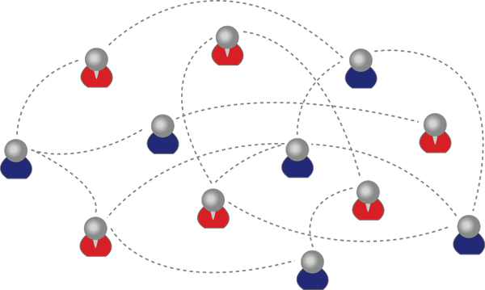](http://socialnetworksales.net/selling/social-network/attachment/social-networking-can-help-your-business/)

1As a business in the 21st century, it is absolutely necessary that you have a presence on multiple social networks. A social network is not simply a place where friends can reunite, share photos, and gossip about their latest activities. A social network is a gold mine of potential business opportunities. Here at **Social Network Sales** we are **5**dedicated to showing you how to grow your business online presence so you will be able to grow your sales. This new form of advertising brings with it an entirely new way of advertising that has some of the best sale success that we have ever heard of.

You should start by creating your presence on the most important social networking sites. If potential consumers can find you on their favorite social networking site, then **10** they can see what interesting offers you have available, they can see what you are doing to help the community and, finally, they can see how many of their friends recommend your business.

Every time someone clicks on your ad, buys your product, and enjoys the deal that they got, they can recommend the deal to their friends. Before you know it, you have **15**created a phenomenon with your product at a very minimal cost to you. It does not matter what type of advertising you have done in the past: if you are not using the new form of advertising through social media, you are missing a gold mine of opportunities.

**Glossário**:

*gossip*: fofocar; *gold mine*: mina de ouro; *will be able to grow*: poderá crescer; *advertising*: publicidade; *available*: disponível; *deal*: negócio (compra e/ou venda);

*it does not matter*: não importa; *through*: através, *ad*: anúncio

RESPONDA EM PORTUGUÊS:

1-Qual o nome da firma responsável pelo texto acima? ( 0,5 ponto)

____________________________________________________________________________

2-A que tipo de atividade essa firma se dedica? ( 1 ponto)

____________________________________________________________________________

____________________________________________________________________________

____________________________________________________________________________

____________________________________________________________________________

3-Qual é a finalidade do texto? ( 1,5 ponto)

____________________________________________________________________________

____________________________________________________________________________

____________________________________________________________________________

____________________________________________________________________________

4- O texto ressalta as vantagens ou desvantagens de se anunciar em redes sociais? Copie do texto duas frases EM INGLÊS que justifiquem sua resposta.

( 1,5 ponto)

Resposta:_________________________________________________________________

Frases: ___________________________________________________________________

____________________________________________________________________________

____________________________________________________________________________

____________________________________________________________________________

____________________________________________________________________________

____________________________________________________________________________

5- Cite três coisas que podem acontecer, de acordo com o texto, quando clientes em potencial acham seu anúncio nas redes sociais. (1,5 ponto)

____________________________________________________________________________

____________________________________________________________________________

____________________________________________________________________________

____________________________________________________________________________

____________________________________________________________________________

____________________________________________________________________________

6- O texto menciona algumas coisas que você pode fazer nas redes sociais.

Marque a opção que indica qual dessas coisas está sendo promovida ou enfocada no texto. ( 1 ponto)

A- ( ) You can reunite with your friends.

B- ( ) You can share photos with your friends.

C- ( ) You can grow the presence of your business online.

D- ( ) You can gossip about your friends’ latest activities

7- Entre as palavras abaixo, encontradas no texto e terminadas com o sufixo *ING,* qual delas **não** está sendo usada como um adjetivo, que qualifica um nome? Marque a opção correta. ( 1 ponto)

A- ( ) missing ( linha 17 )

B- ( ) creating ( linha 8 )

C- ( ) advertising ( linha 6 )

D- ( ) interesting ( linha 10 )

8- Na segunda sentença do segundo parágrafo, o que a conjunção “ **if** ” indica? Marque a opção correta: ( 1 ponto)

A- ( ) contraste/ dúvida

B- ( ) impossibilidade/negação

C- ( ) condição/consequência

D- ( ) alternância/adição

9- Explique o uso da expressão “*gold mine*” ( linhas 4 e 17) no contexto do texto. Ou seja: por que o autor usou esta expressão, cuja tradução está no glossário, para reforçar seu argumento? ( 1 ponto).

____________________________________________________________________________

____________________________________________________________________________

____________________________________________________________________________

____________________________________________________________________________