

Fundação CECIERJ - Vice Presidência de Educação Superior a Distância
Curso de Tecnologia em Sistemas de Computação
AD1 Disciplina: Inglês Instrumental
Semestre 1/2017

LEIA O TEXTO.

Stephen Hawking says artificial intelligence (AI) could be humanity's greatest disaster
James Titcomb
October 2016
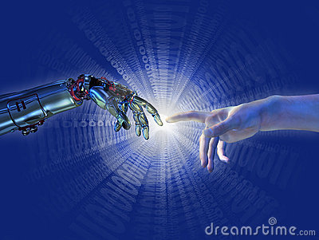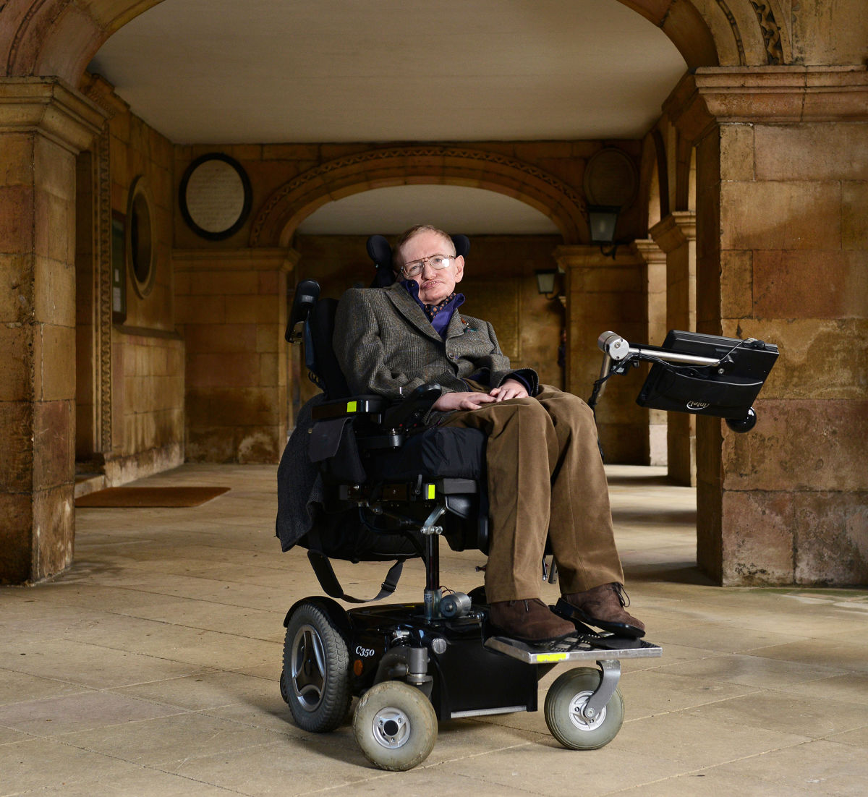

The invention of AI could be the biggest disaster in humanity’s history, Professor Stephen Hawking has said, warning that if they are not properly managed, thinking machines could mean the end for civilisation.
“The rise of powerful AI will be either the best or the worst thing ever to happen to humanity. We do not know which,” the British physicist said. He was speaking at the opening of a new Cambridge centre that seeks to address the potential dangers and conundrums of AI.
Professor Hawking, a prominent critic of making unchecked advances in AI, said that the technology promised to bring great benefits, such as eradicating disease and poverty, but “will also bring dangers, like powerful autonomous weapons or new ways for the few to oppress the many”.
“It will bring great disruption to our economy, and in the future AI could develop a will of its own that is in conflict with ours,” he said. His comments come among breakthroughs in AI that are being achieved faster than many predicted. For instance, Google’s DeepMind* subsidiary defeated the world champion of the ancient board game Go earlier this year.
Professor Hawking has been one of the most eminent sceptics of AI. He was one of more than 1,000 other experts and researchers to sign an open letter warning of the perils of artificially intelligent weapons last year.

Stephen Hawking´s Quotes
On intelligence: “Intelligence is the ability to adapt to change.”
On celebrity: “The downside of my celebrity is that I cannot go anywhere in the world without being recognised. It is not enough for me to wear dark sunglasses and a wig. The wheelchair gives me away.”
On his disability: “It is a waste of time to be angry about my disability. One has to get on with life and I haven’t done badly."
On his favourite superhero: “If I had to choose a superhero to be, I would pick Superman. He’s everything that I’m not.”
On human nature: “We are all different, but we share the same human spirit. Perhaps it’s human nature that we adapt and survive.”
On staying curious: “I am just a child who has never grown up. I still keep asking these ‘how’ and ‘why’ questions. Occasionally, I find an answer.”
On death: “I have lived with the prospect of an early death for the last 49 years. I’m not afraid of death, but I’m in no hurry to die. I have so much I want to do first.”
*DeepMind, uma empresa de inteligência artificial adquirida pelo Google em 2010.

(adapted from The Telegraph)

Glossary
properly managed: adequadamente conduzido; seek to address: procura direcionar; conundrum: enigma; a will of its own: seu próprio poder; defeated: venceu; breakthrough: avanço; warning: alertando; perils: perigos; wig: peruca; give someone away: revelar a identidade.

Responda as questões.
1. No primeiro parágrafo do texto, lê-se: “... thinking machines could mean the end for civilisation.” (1 pt)
O verbo modal could nesta frase sugere
A. ( ) uma forte expectativa.
B- ( ) uma nítida certeza.
C- ( ) uma considerável probabilidade.
2. No parágrafo seguinte, Professor Hawking afirma que AI (1 pt)
A. ( ) é a pior coisa a acontecer à humanidade.
B- ( ) pode ser a melhor e pior coisa para a humanidade.
C- ( ) não sabe ainda se é a melhor ou pior coisa para a humanidade.

3. Em que circunstâncias, AI (segundo Professor Hawking!) não seria o maior desastre parta a humanidade? (1 pt)
A. ( ) Se ele, Professor Hawking, morresse.
B- ( ) Se outros planetas fossem descobertos.
C- ( ) Se AI fosse adequadamente gerenciada.

4. Observe a frase: “Professor Hawking, a prominent critic of making unchecked advances in AI...”. (1 pt)
O prefixo UN denota contrário, negação.
O que quer dizer, então, unchecked advances?
A. ( ) descobertas pouco analisadas
B- ( ) descobertas não analisadas
C- ( ) avanços científicos importantes.

5. Observe a frase do texto: “will also bring dangers, like powerful autonomous weapons or new ways for the few to oppress the many.”
Onde está o contraste semântico (de significado) deste comentário? Copie aqui as palavras da frase que expressam esse contraste. (1 pt)
____________________________________________________________

6. Qual é o exemplo dado no texto que atesta os rápidos e incríveis avanços da AI? Copie aqui a frase do texto. (1 pt)
___________________________________________________________________________
Nas questões 7 e 7a, vamos nos concentrar nas QUOTES de Stephen Hawking.
7. Diga se as afirmações abaixo são verdadeiras (V) ou falsas (F). Escreva V ou F nos parênteses. (1 pt)
A. ( ) Superman é tudo o que Hawking não poderia ser.
B- ( ) Hawking acha que perdeu totalmente a curiosidade infantil.
C- ( ) Sua perspectiva de vida foi ultrapassada em uns poucos anos.

7a. Professor Hawking é uma celebridade que não pode esconder um item primordial de sua sobrevivência. Qual é ele? (1 pt)
____________________________________________________________

8. A que se refere ours no quarto parágrafo? (1 pt)

A. ( ) Google’s DeepMind subsidiary
B- ( ) os humanos
C- ( ) AI breakthroughs

9. Sublinhe o núcleo (ou núcleos) dos seguintes sintagmas nominais complexos. (1 pt; 0,5 cada)

A- powerful autonomous weapons
B- the potential dangers and conundrums

