

Fundação CECIERJ - Vice Presidência de Educação Superior a Distância
Curso de Tecnologia em Sistemas de Computação
AD2 Disciplina: Inglês Instrumental
Semestre 2/2015

Nome –
Assinatura –

Robot Kills Worker at Volkswagen Plant in Germany
July 2, 2015 | by Aamna Mohdin
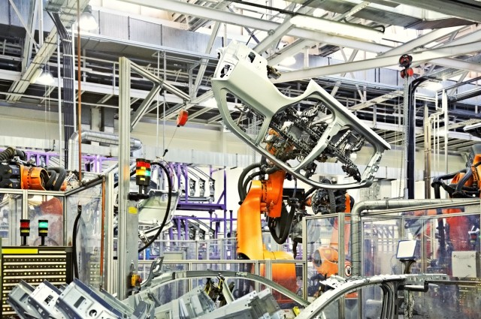
Photo credit: Robotic arms in a car factory. Nataliya Hora/Shutterstock
A robot has crushed a man to death at a Volkswagen production plant in Germany. The company confirmed the death on Wednesday.
The 22-year-old German worker was a technician installing a stationary robot, which is programmed to complete a series of tasks in the assembly process by grabbing parts and manipulating them. The incident occurred at the factory in Baunatal, which assembles car components for other plants.
The robot grabbed and crushed the technician against a metal plate. He was rushed to a nearby hospital, but later died of his injuries. Volkswagen has not released the man’s name.
But before you start believing this is an early sign of an imminent robot apocalypse, Volkswagen spokesman Heiko Hillwig suggests that human error was to blame rather than a ‘rogue’ robot, the Associated Press reports. Workers in the plant are usually separated from the robots, which operate within a confined area, but in this instance, the victim was working on the robot inside the cage when he was attacked. Another worker who was present during the accident was not harmed, Hillwig said.
Currently, there isn’t a lot of information available on the details of the case, but it is being investigated by German authorities. The other worker who witnessed the incident has declined to give further details about the case while the investigation is ongoing. Prosecutors, who are looking into how the accident occurred, have yet to decide whether charges will be brought against anyone involved.
(Adapted from Follow @IFLScience )

Glossary
plant: fábrica; crush to death: esmagar; stationary: parado; assemble/assembly: montar/montagem; grab: agarrar; release: liberar; to blame: culpar; decline: recusar-se a; rogue: vigarista/velhaco; prosecutor: promotor; charges: acusação

COMPREHENSION

Assinale as respostas corretas de acordo com o texto. (cada resposta vale 1.0 pt)

1. No acidente relatado no texto,

A. ( ) a vítima não trabalhava diretamente com o robot.

B. ( ) a vítima apenas observava outra pessoa.

C. ( ) a vítima estava instalando o robot.

2. A informação do texto determina que

A. ( ) a vítima morreu na fábrica.

B. ( ) a vítima morreu a caminho do hospital.

C. ( ) a vítima morreu mais tarde no hospital.

3. O que causa certa surpresa neste acidente é que

A. ( ) os operários geralmente não trabalham diretamente com os robots.

B. ( ) os operários estavam todos dentro da ‘gaiola’ do robot.

C. ( ) o robot não estava na ‘gaiola’.

4. A pessoa que testemunhou o acidente,

A. ( ) já deu todas as informações ao promotor.

B. ( ) se recusa a falar sobre o acidente.

C. ( ) destruiu o ‘robô assassino’.

5. Qual é a avaliação de Heiko Hillwig sobre o acidente? Responda em português. (1.5 pt)

____________________________________________________________________________________________________________________________________________

Language Focus

- Observe a frase: “Workers in the plant are usually separated from the robots, which operate within a confined area, but in this instance, the victim was working on the robot inside the cage when he was attacked.” (paragraph 4) (1.0 pt)

Qual par de palavras retiradas da frase acima revela uma forte aproximação semântica*?

A. ( ) instance/robot

B. ( ) confined/cage

C. ( ) inside/but

D. ( ) workers/usually

* de significado

7. Observe as frases (retiradas do texto).

A robot has crushed a man to death [...]
Volkswagen has not released the man’s name.
The other worker who witnessed the incident has declined to give further details [...]
Todas as frases estão no present perfect. Há uma característica gramatical deste tempo verbal que se pode observar em todas as 3 frases. Marque as 2 opções corretas. (1.0 pt)

A. ( ) Há definição de quando a ação foi realizada.

B. ( ) Não se sabe quando a ação foi realizada.

C. ( ) A ação é mais importante do que o momento em que ela foi realizada.

D. ( ) O fato relatado na frase não aconteceu ainda.

8. Dois grupos nominais (A e B) foram retirados do texto. Identifique e escreva seus núcleos e seus modificadores. (1.5 pt)

A. an imminent robot apocalypse

núcleo: ______________ modificador(es) _________________________________

B. a Volkswagen production plant in Germany

núcleo: ______________ modificador(es) _________________________________

C. (Agora selecione um grupo nominal do texto e faça o mesmo.)

Grupo nominal: _______________________________________________________

núcleo: ______________ modificador(es) _________________________________

9. A que se refere them no parágrafo 2? Marque a opção certa. (1.0 pt)

A. ( ) tasks

B. ( ) assembly process

C. ( ) parts

