

Fundação CECIERJ - Vice Presidência de Educação Superior a Distância
Curso de Tecnologia em Sistemas de Computação
AD2 Disciplina: Inglês Instrumental
Semestre 2/2016

Nome –
Assinatura –

Read the text and answer the questions.

Sports Illustrated

Paralympics: a source of inspiration
Tom Taylor
Wednesday September 7th, 2016
Every two years the sports world is treated to a celebration of exceptionalism—the Olympic Games—followed by a festival of inspiration—the Paralympics—a few weeks later.
Born in 1948 as an annual competition for World War II veterans with spinal injuries at Stoke Mandeville Hospital in Aylesbury, England, the first official quadrennial Paralympic Games were held in Rome in 1960. In the 56 years since then, the Paralympics have evolved from a competition for wheelchair athletes to a major international sporting event. Some 4,350 athletes, from more than 160 countries, will compete in Rio.
“Ideally we should just be treated like any athlete,” says Alana Nichols, a multisport athlete who first won gold with the U.S. wheelchair basketball team at Pequim in 2008, then five more medals in skiing in Vancouver and Sochi. “We should be given honest critical feedback about our athletic performance, and not put into this box of inspiration, exception, and other.”
“I thought disabled sports were for people who didn’t know how to play real sports,” says Nichols, who grew up playing softball, basketball and volleyball. She had hoped to get a college softball scholarship before she broke her back trying to land a backflip on a snowboard in November 2000, leaving her paralyzed from the waist down. When it came to disability sports, Nichols thought, I’m a fast-pitch softball player. Don’t talk to me about adaptive sports.

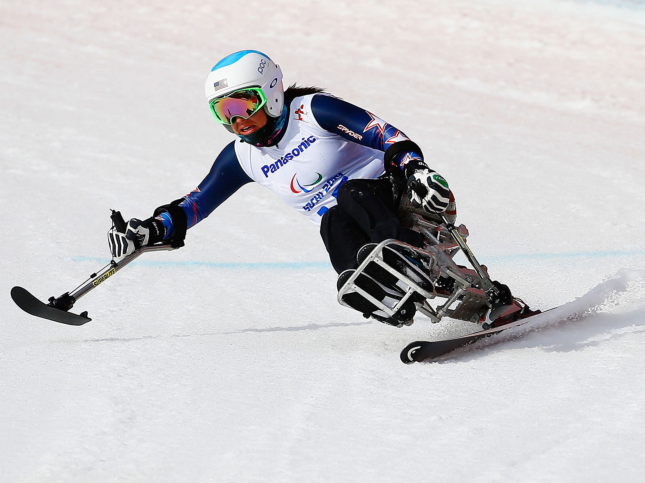
Alana Nichols competing in the 2014 Paralympic Winter Games in Sochi.
A chance encounter with a five-on-five game of wheelchair basketball in the gym at the University of Arizona in 2002 convinced her that disability sports were not just an activity to keep disabled people busy—the game was aggressive, even violent. Three years later Nichols was named to the U.S. national team. After Beijing in 2008, she started skiing, and she won two gold medals in Vancouver two years later. A bad crash in the Super-G in Sochi convinced her to try a different sport, and so in Rio, Nichols is hoping to add to her collection a medal in sprint kayaking—in this sport’s Paralympic debut.
(adapted from www.si.com)
Glossary
held: realizado; spinal injuries: problemas na coluna vertebral; wheelchair: cadeira de rodas; grew up: cresceu; back: costas; snowboard: prancha semelhante a um esqui usada para deslizar sobre neve; scholarship: bolsa de estudos; chance encounter: encontro por acaso; crash: colisão; waist down: cintura para baixo; debut: estreia.

COMPREHENSION
1. Responda em Português. Quais foram os primeiros para-atletas na história dos Jogos Paralímpicos? (1.5 pt)
__________________________________________________________________________________________________________________________________
2. De acordo com o texto, as frases a seguir são verdadeiras (TRUE) ou falsas (FALSE). Escolha uma opção. (1 pt)

A. Nas primeiras Paralímpiadas da história, os atletas eram somente aqueles em cadeira de rodas. ( ) TRUE ( ) FALSE

B. Alana esperava conseguir uma bolsa de estudos antes do acidente que afetou sua coluna vertebral. ( ) TRUE ( ) FALSE

C. O time de basquete em cadeira de rodas de Alana não ganhou uma medalha nos jogos em Pequim 2008. ( ) TRUE ( ) FALSE
3.a Observe a frase: “I’m a fast-pitch softball player. Don’t talk to me about adaptive sports.” Esta opinião de Alana Nichols após seu acidente em 2000, sugere que (marque a resposta correta): (1 pt)
A. ( ) Alana quis dizer que não queria saber de esportes paralímpicos.
B. ( ) Alana estava pronta para participar de esportes paralímpicos.
C. ( ) Ao dizer isso, Alana encerrava sua carreira nos esportes.

3.b O que a fez mudar de opinião? (1 pt)

A. ( ) Ela queria se engajar em um esporte paralímpico.

B. ( ) Ela resolveu seguir a carreira acadêmica.

C. ( ) Ela por acaso foi assistir a um jogo de basquete em cadeiras de rodas.

4. Que modalidade de esporte estreou na Paralimpíada Rio 2016? (1 pt)

_________________________________________________________________

Language Focus
5. Observe a frase: “I thought disabled sports were for people who didn’t know how to play real sports,” says Nichols. Nesta frase, real sports significa (1 pt)

A. ( ) esportes praticados por atletas paralímpicos

B. ( ) esportes praticados por atletas olímpicos.

C. ( ) modalidades de esportes que não competem em Olimpíadas.

6. As reinvindicações de Alana são: (1 pt)
“Ideally we should just be treated like any athlete”
“We should be given honest critical feedback about our athletic performance, and not put into this box of inspiration, exception, and other.”
O uso do modal should sugere:
A. ( ) uma forte expectativa
B- ( ) uma nítida certeza.
C- ( ) uma considerável probabilidade.

7. Três grupos nominais (A, B e C) foram retirados do texto. Identifique e escreva seus núcleos e seus modificadores. (1.5 pt)

A. honest critical feedback

núcleo: ______________ modificador(es) _______________________

B. a college softball scholarship

núcleo: ______________ modificador(es) _______________________

C. a major international sporting event

núcleo: ______________ modificador(es) _______________________

8. Observe as palavras: inspiration, competition, exception, collection. Elas têm o mesmo sufixo: ion Este sufixo indica que estas palavras são (1 pt)

A. ( ) adjetivos
B. ( ) substantivos
C. ( ) verbos

