Table 1: Vertical excitation energies and dominant contributions of the S0 and S1 states of fulvene optimized with SA2-CASSCF(6,6)/6-31G* and MRCI(CAS(6,6))/6-31G*. For MRCI, the Pople correction is also given (MRCI/+Pople).

|  |  |  |  |
| --- | --- | --- | --- |
| State | ∆E (eV) | Configuration | % |
| SA2-CASSCF(6,6) – S0 optimization | | | |
| S0 | 0.000 | (19a)2(20a)2(21a)2(22a)0(23a)0(24a)0 | 77.3 |
| S1 | 4.110 | (19a)2(20a)2(21a)1(22a)1(23a)0(24a)0 | 74.0 |
|  |  | (19a)2(20a)1(21a)1(22a)2(23a)0(24a)0 | 14.1 |
|  | | | |
| SA2-CASSCF(6,6) – S1 optimization | | | |
| S0 | 1.446 | (19a)2(20a)2(21a)2(22a)0(23a)0(24a)0 | 66.5 |
|  |  | (19a)2(20a)1(21a)2(22a)1(23a)0(24a)0 | 13.8 |
| S1 | 2.611 | (19a)2(20a)2(21a)1(22a)1(23a)0(24a)0 | 72.3 |
|  |  | (19a)2(20a)1(21a)1(22a)2(23a)0(24a)0 | 15.8 |
|  |  |  |  |
| SA2-CASSCF(6,6) – MXS optimization - Planar | | | |
| S0 | 2.880 | (19a)2(20a)2(21a)1(22a)1(23a)0(24a)0 | 73.0 |
|  |  | (19a)2(20a)1(21a)1(22a)2(23a)0(24a)0 | 15.4 |
| S1 | 2.880 | (19a)2(20a)2(21a)2(22a)0(23a)0(24a)0 | 60.1 |
|  |  | (19a)2(20a)1(21a)2(22a)1(23a)0(24a)0 | 16.8 |
|  |  |  |  |
| SA2-CASSCF(6,6) – MXS optimization – nonplanar (fixed 20°) | | | |
| S0 | 2.796 | (19a)2(20a)2(21a)2(22a)0(23a)0(24a)0 | 59.8 |
|  |  | (19a)2(20a)1(21a)2(22a)1(23a)0(24a)0 | 17.2 |
| S1 | 2.796 | (19a)2(20a)2(21a)1(22a)1(23a)0(24a)0 | 72.9 |
|  |  | (19a)2(20a)1(21a)1(22a)2(23a)0(24a)0 | 15.4 |
|  |  |  |  |
| SA2-CASSCF(6,6) – MXS optimization – nonplanar (fixed 45°) | | | |
| S0 | 2.549 | (19a)2(20a)2(21a)2(22a)0(23a)0(24a)0 | 51.1 |
|  |  | (19a)2(20a)1(21a)2(22a)1(23a)0(24a)0 | 17.4 |
| S1 | 2.549 | (19a)2(20a)2(21a)1(22a)1(23a)0(24a)0 | 64.7 |
|  |  | (19a)2(20a)1(21a)1(22a)2(23a)0(24a)0 | 13.6 |
|  |  |  |  |
| SA2-CASSCF(6,6) – MXS optimization – nonplanar (63°) | | | |
| S0 | 2.445 | (19a)2(20a)2(21a)1(22a)1(23a)0(24a)0 | 73.4 |
|  |  | (19a)2(20a)1(21a)1(22a)2(23a)0(24a)0 | 13.5 |
| S1 | 2.456 | (19a)2(20a)2(21a)2(22a)0(23a)0(24a)0 | 48.1 |
|  |  | (19a)2(20a)1(21a)2(22a)1(23a)0(24a)0 | 28.3 |
|  |  |  |  |
| SA2-CASSCF(6,6) – MXS optimization – nonplanar (fixed 70°) | | | |
| S0 | 2.470 | (19a)2(20a)2(21a)1(22a)1(23a)0(24a)0 | 79.7 |
| S1 | 2.470 | (19a)2(20a)1(21a)2(22a)1(23a)0(24a)0 | 47.0 |
|  |  | (19a)2(20a)2(21a)2(22a)0(23a)0(24a)0 | 28.3 |
|  |  |  |  |
| SA2-CASSCF(6,6) – MXS optimization – nonplanar (fixed 90°) | | | |
| S0 | 2.553 | (19a)2(20a)2(21a)1(22a)1(23a)0(24a)0 | 87.8 |
| S1 | 2.553 | (19a)2(20a)2(21a)1(22a)1(23a)0(24a)0 | 85.5 |
|  | | | |
| MRCI – S0 optimization | | | |
| S0 | 0.000/0.000 | (19a)2(20a)2(21a)2(22a)0(23a)0(24a)0 | 69.1 |
| S1 | 3.841/3.633 | (19a)2(20a)2(21a)1(22a)1(23a)0(24a)0 | 71.1 |
|  |  |  |  |
| MRCI – S1 optimization | | | |
| S0 | 1.235/1.152 | (19a)2(20a)2(21a)2(22a)0(23a)0(24a)0 | 62.3 |
| S1 | 2.609/2.459 | (19a)2(20a)2(21a)1(22a)1(23a)0(24a)0 | 67.8 |
|  |  | (19a)2(20a)1(21a)1(22a)2(23a)0(24a)0 | 10.1 |
|  |  |  |  |
| MRCI – MXS optimization - Planar | | | |
| S0 | 3.022/2.972 | (19a)2(20a)2(21a)1(22a)1(23a)0(24a)0 | 62.8 |
| S1 | 3.022/2.860 | (19a)2(20a)2(21a)2(22a)0(23a)0(24a)0 | 52.8 |
|  |  | (19a)2(20a)1(21a)2(22a)1(23a)0(24a)0 | 11.9 |
|  |  |  |  |
| MRCI – MXS optimization – Nonplanar (fixed 20°) | | | |
| S0 | 2.930/2.891 | (19a)2(20a)2(21a)1(22a)1(23a)0(24a)0 | 65.9 |
|  |  | (19a)2(20a)1(21a)1(22a)2(23a)0(24a)0 | 10.4 |
| S1 | 2.930/2.769 | (19a)2(20a)2(21a)2(22a)0(23a)0(24a)0 | 55.4 |
|  |  | (19a)2(20a)1(21a)2(22a)1(23a)0(24a)0 | 12.8 |
|  |  |  |  |
| MRCI – MXS optimization – Nonplanar (fixed 45°) | | | |
| S0 | 2.649/2.584 | (19a)2(20a)2(21a)1(22a)1(23a)0(24a)0 | 40.4 |
|  |  | (19a)2(20a)2(21a)2(22a)0(23a)0(24a)0 | 21.3 |
| S1 | 2.649/2.559 | (19a)2(20a)2(21a)2(22a)0(23a)0(24a)0 | 33.0 |
|  |  | (19a)2(20a)2(21a)1(22a)1(23a)0(24a)0 | 26.1 |
|  |  |  |  |
| MRCI – MXS optimization – nonplanar (65.1°) | | | |
| S0 | 2.519/2.521 | (19a)2(20a)2(21a)1(22a)1(23a)0(24a)0 | 66.9 |
| S1 | 2.519/2.423 | (19a)2(20a)2(21a)2(22a)0(23a)0(24a)0 | 45.1 |
|  |  | (19a)2(20a)1(21a)2(22a)1(23a)0(24a)0 | 23.7 |
|  |  |  |  |
| MRCI – MXS optimization – Nonplanar (fixed 70°) | | | |
| S0 | 2.527/2.446 | (19a)2(20a)2(21a)2(22a)0(23a)0(24a)0 | 39.3 |
|  |  | (19a)2(20a)1(21a)2(22a)1(23a)0(24a)0 | 29.2 |
| S1 | 2.527/2.534 | (19a)2(20a)2(21a)1(22a)1(23a)0(24a)0 | 67.7 |
|  |  |  |  |
| MRCI – MXS optimization – Nonplanar (fixed 90°) | | | |
| S0 | 2.618/2.628 | (19a)2(20a)2(21a)1(22a)1(23a)0(24a)0 | 63.2 |
|  |  | (19a)2(20a)1(21a)2(22a)1(23a)0(24a)0 | 13.0 |
| S1 | 2.618/2.595 | (19a)2(20a)1(21a)2(22a)1(23a)0(24a)0 | 62.9 |
|  |  | (19a)2(20a)2(21a)1(22a)1(23a)0(24a)0 | 13.1 |
|  |  |  |  |

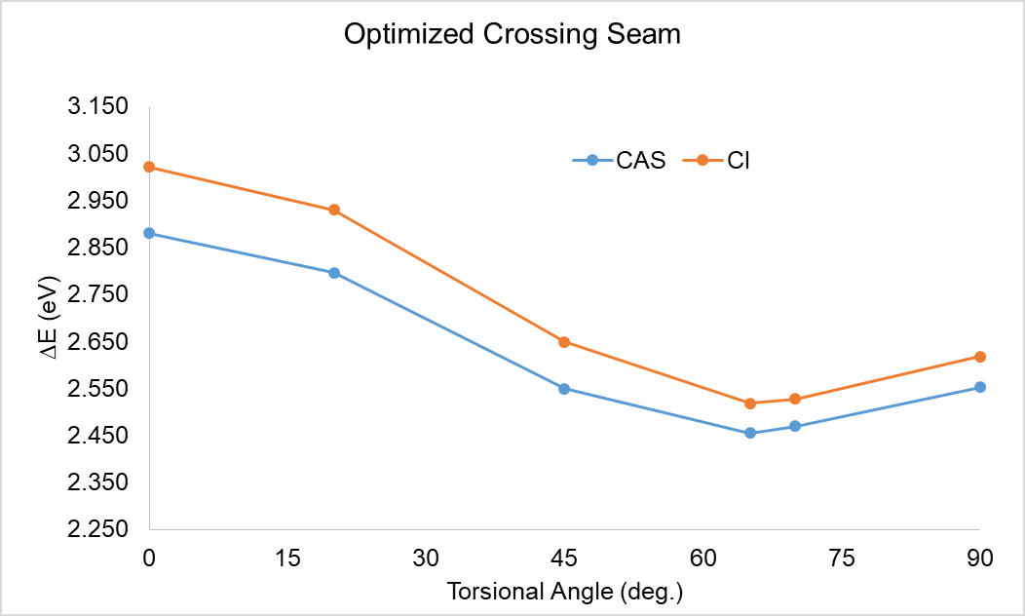

Figure 1: Relative energy of the optimized crossing seam between the S0 and S1 states using the SA2-CASSCF(6,6)/6-31G* and MRCI(CAS(6,6))/6-31G* methods. Energies relative to the optimized S0 ground state in each method.

Table 2: Total energies in Hartree of fulvene

|  |  |  |
| --- | --- | --- |
|  | S0 | S1 |
| SA2-CASSCF(6,6)-S0 opt | -230.72231 | -230.57127 |
| SA2-CASSCF(6,6)-S1 opt | -230.66916 | -230.62635 |
| SA2-CASSCF(6,6)-MXS-planar | -230.61647 | -230.61647 |
| SA2-CASSCF(6,6)-MXS-nonplanar (20°) | -230.61957 | -230.61955 |
| SA2-CASSCF(6,6)-MXS-nonplanar (45°) | -230.62862 | -230.62862 |
| SA2-CASSCF(6,6)-MXS-nonplanar (63°) | -230.63208 | -230.63206 |
| SA2-CASSCF(6,6)-MXS-nonplanar (70°) | -230.63154 | -230.63154 |
| SA2-CASSCF(6,6)-MXS-nonplanar (90°) | -230.62850 | -230.62850 |
| MRCI-S0 opt | -231.33320 | -231.19206 |
| MRCI+Q-S0 opt | -231.46471 | -231.33121 |
| MRCI-S1 opt | -231.28780 | -231.23732 |
| MRCI+Q-S1 opt | -231.42239 | -231.37102 |
| MRCI-MXS-planar | -231.22216 | -231.22216 |
| MRCI+Q-MXS-planar | -231.35550 | -231.35960 |
| MRCI-MXS-nonplanar (20°) | -231.22553 | -231.22553 |
| MRCI+Q-MXS-nonplanar (20°) | -231.35848 | -231.36297 |
| MRCI-MXS-nonplanar (45°) | -231.23585 | -231.23585 |
| MRCI+Q-MXS-nonplanar (45°) | -231.36976 | -231.37068 |
| MRCI-MXS-nonplanar (65.1°) | -231.24064 | -231.24064 |
| MRCI+Q-MXS-nonplanar (65.1°) | -231.37206 | -231.37566 |
| MRCI-MXS-nonplanar (70°) | -231.24033 | -231.24033 |
| MRCI+Q-MXS-nonplanar (70°) | -231.37480 | -231.37157 |
| MRCI-MXS-nonplanar (90°) | -231.23698 | -231.23698 |
| MRCI+Q-MXS-nonplanar (90°) | -231.36814 | -231.36934 |

Table 3: Oscillator strength of the S0 to S1 transition of fulvene optimized with SA2-CASSCF(6,6)/6-31G* and MRCI(CAS(6,6))/6-31G*.

|  |  |
| --- | --- |
| Method | *f* |
| SA2-CASSCF(6,6) – S0 optimization | 0.00 |
| SA2-CASSCF(6,6) – S1 optimization | 0.00 |
| MRCI – S0 optimization | 0.01 |
| MRCI – S1 optimization | 0.00 |

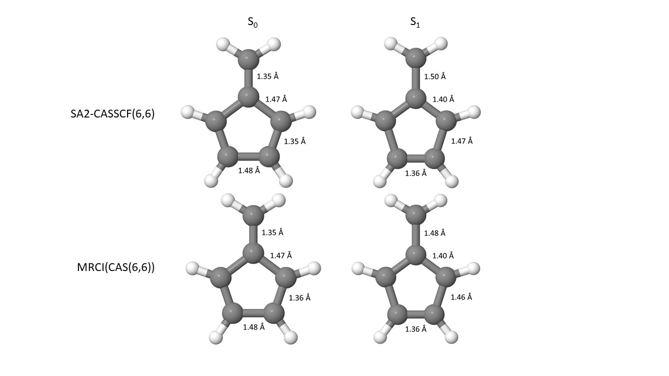

Figure 2: Bond distances of the S0 to S1 states optimized with SA2-CASSCF(6,6)/6-31G* and MRCI(CAS(6,6))/6-31G*.

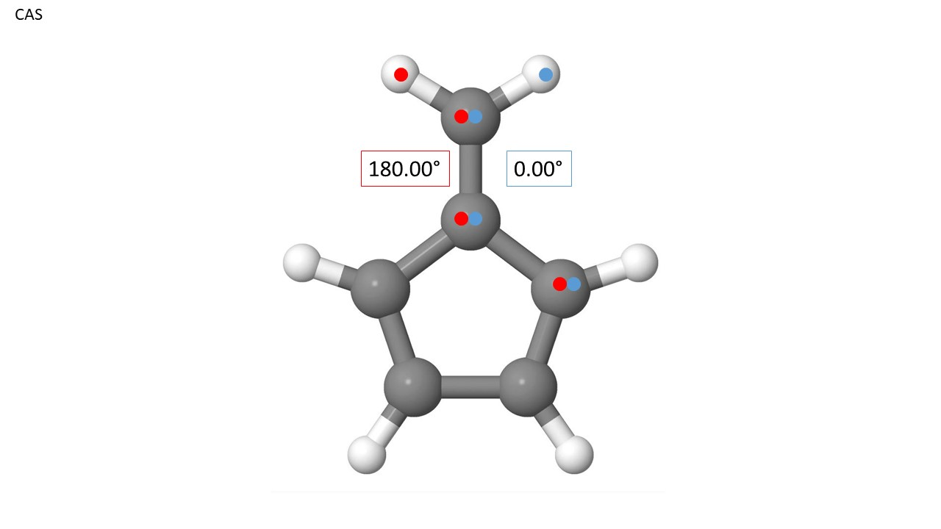

Figure 3: Torsional angles of the S0 to S1 states optimized with SA2-CASSCF(6,6)/6-31G* and MRCI(CAS(6,6))/6-31G*. The molecule is planar, so there is no variation. Torsional angles, blue and red, are designated with colored dots.

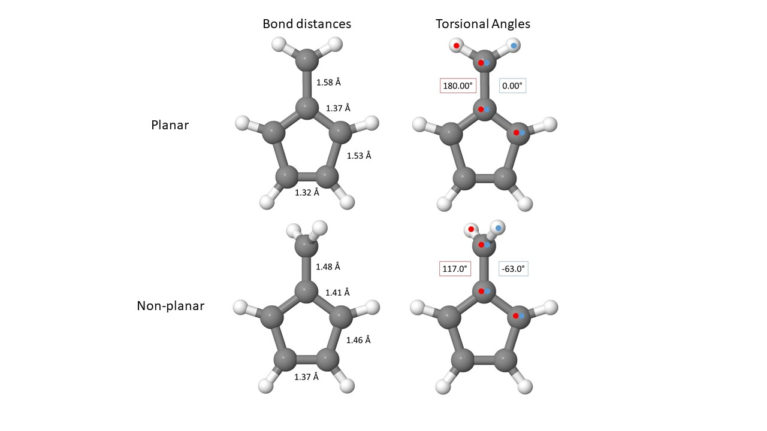

Figure 4: Bond distances and torsional angles of the optimized crossing seam between the S0 to S1 states optimized with SA2-CASSCF(6,6)/6-31G*. Torsional angles, blue and red, are designated with colored dots.

Table 4: C-C bond distances for each fixed torsional angle about the CH2 group using the SA2-CASSCF(6,6)/6-31G* and MRCI(CAS(6,6))/6-31G* methods.

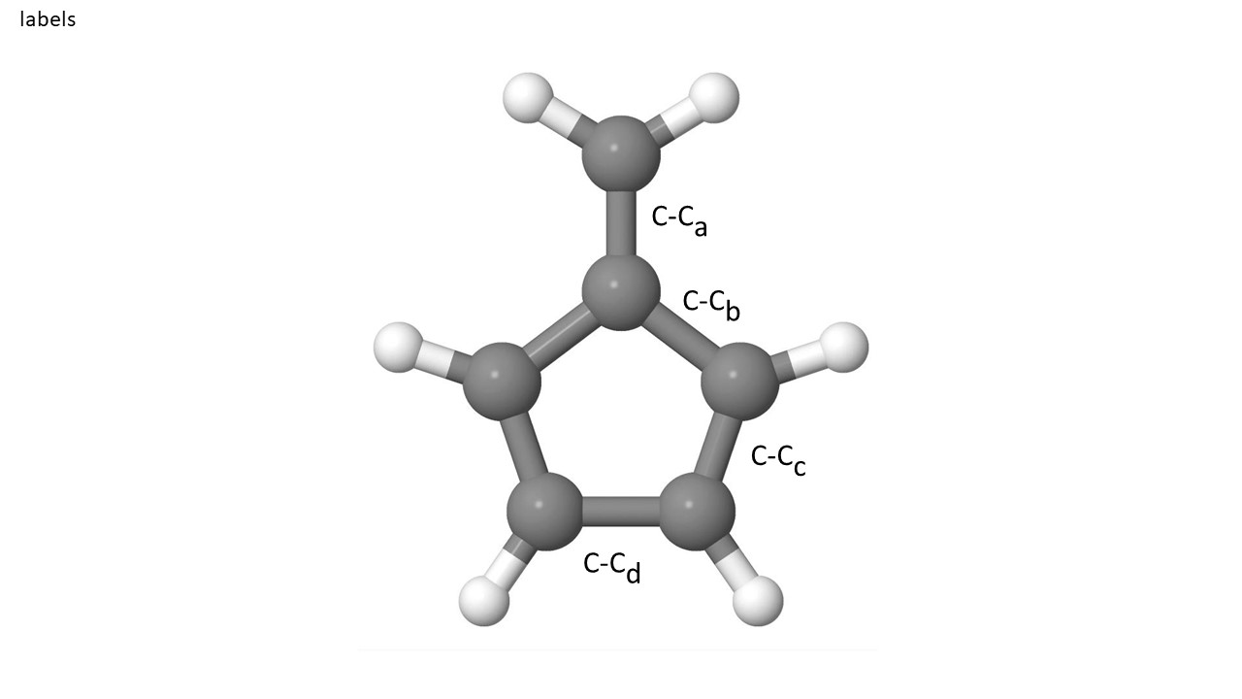

|  |  |  |  |  |
| --- | --- | --- | --- | --- |
| Torsional Angle | C-Ca | C-Cb | C-Cc | C-Cd |
|  | SA2-CASSCF(6,6) | | | |
| 20.0° | 1.56 | 1.37 | 1.52 | 1.32 |
| 45.0° | 1.51 | 1.39 | 1.49 | 1.34 |
| 63.0° | 1.48 | 1.41 | 1.46 | 1.37 |
| 70.0° | 1.47 | 1.41 | 1.44 | 1.38 |
| 90.0° | 1.48 | 1.42 | 1.42 | 1.41 |
|  |  |  |  |  |
|  | MRCI | | | |
| 20.0° | 1.56 | 1.37 | 1.53 | 1.32 |
| 45.0° | 1.51 | 1.38 | 1.50 | 1.33 |
| 65.1° | 1.47 | 1.40 | 1.46 | 1.37 |
| 70.0° | 1.47 | 1.41 | 1.45 | 1.38 |
| 90.0° | 1.47 | 1.42 | 1.42 | 1.41 |

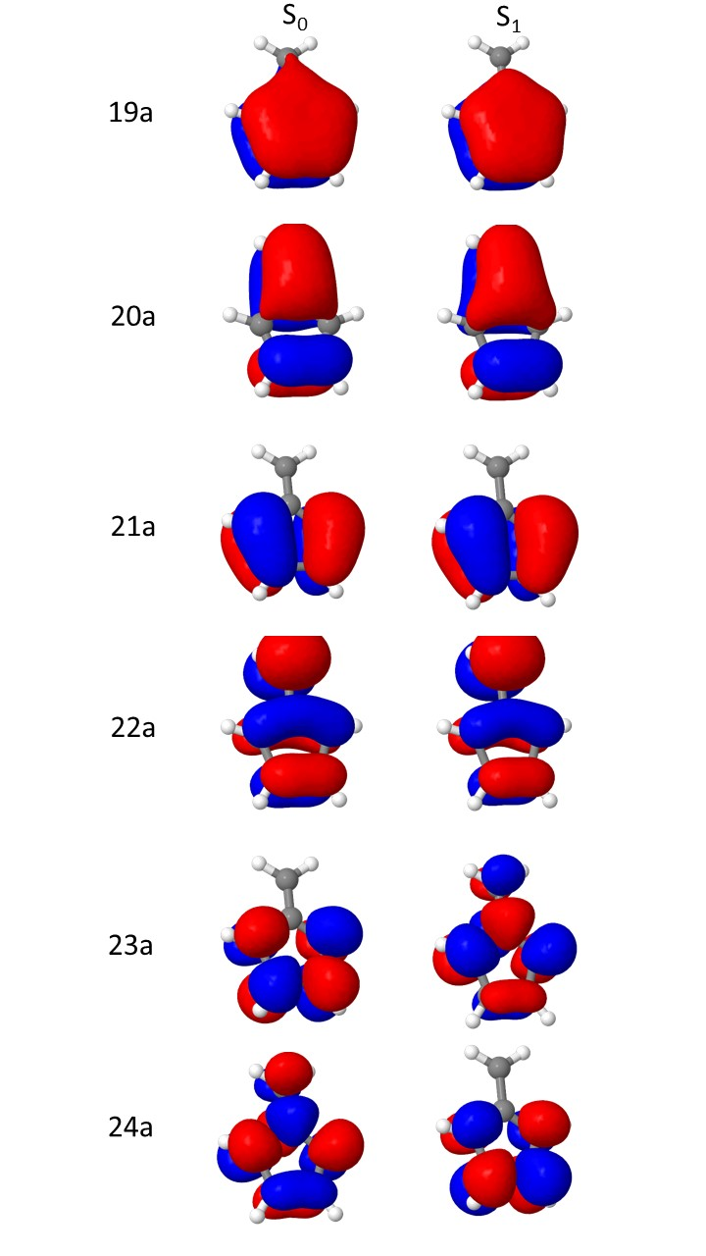

Figure 5: Optimized active orbitals for the S0 and S1 states, respectively, optimized with SA2-CASSCF(6,6)/6-31G*.

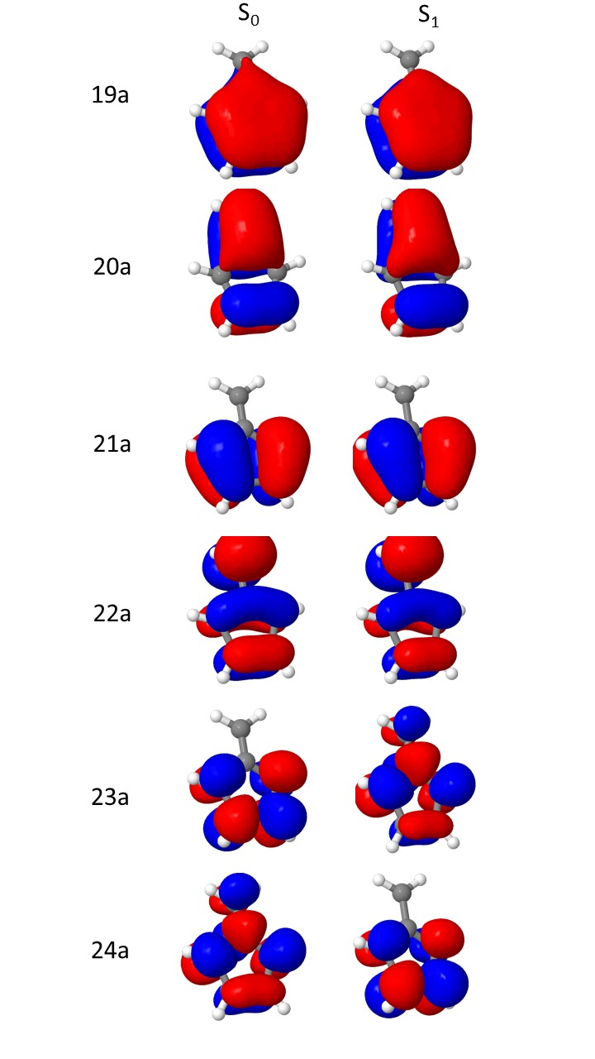

Figure 6: Optimized active orbitals for the S0 and S1 states, respectively, optimized with MRCI(CAS(6,6))/6-31G*.

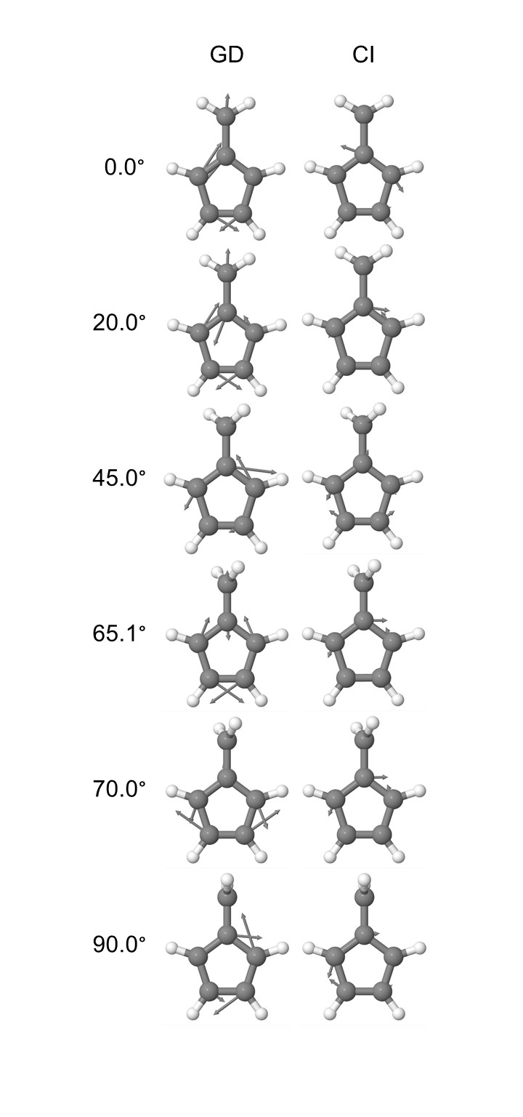

Figure 7: Plots of the GD and CI vectors of fulvene at the optimized crossing seam for several torsional angles going to the -CH2 group. The MRCI(CAS(6,6))/6-31G* was utilized. The lowest energy structure at the crossing seam corresponds to 65.1°.