Table 1: Vertical excitation energies and dominant contributions of the S0 and S1 states of fulvene optimized with SA2-CASSCF(6,6)/6-31G and MRCI(CAS(6,6))/6-31G. For MRCI, the Pople correction is also given (MRCI/+Pople).

|  |  |  |  |
| --- | --- | --- | --- |
| State | ∆E (eV) | Configuration | % |
| SA2-CASSCF(6,6) – S0 optimization | | | |
| S0 | 0.000 | (1b2)2(2b2)2(3b2)0(4b2)0  (1a2)2(2a2)0 | 75.7 |
| S1 | 4.080 | (1b2)2(2b2)2(3b2)1(4b2)0  (1a2)1(2a2)0 | 72.0 |
|  |  | (1b2)2(2b2)1(3b2)2(4b2)0  (1a2)1(2a2)0 | 14.8 |
|  | | | |
| SA2-CASSCF(6,6) – S1 optimization | | | |
| S0 | 1.403 | (1b2)2(2b2)2(3b2)0(4b2)0  (1a2)2(2a2)0 | 65.4 |
|  |  | (1b2)2(2b2)1(3b2)1(4b2)0  (1a2)2(2a2)0 | 13.8 |
| S1 | 2.630 | (1b2)2(2b2)2(3b2)1(4b2)0  (1a2)1(2a2)0 | 70.8 |
|  |  | (1b2)2(2b2)1(3b2)2(4b2)0  (1a2)1(2a2)0 | 16.1 |
|  |  |  |  |
| SA2-CASSCF(6,6) – MXS optimization | | | |
| S0 | 2.932 | (19a)2(20a)2(21a)1(22a)1(23a)0(24a)0 | 71.7 |
|  |  | (19a)2(20a)1(21a)1(22a)2(23a)0(24a)0 | 15.5 |
| S1 | 2.932 | (19a)2(20a)2(21a)2(22a)0(23a)0(24a)0 | 58.6 |
|  |  | (19a)2(20a)1(21a)2(22a)1(23a)0(24a)0 | 16.9 |
|  |  |  |  |
| MRCI – S0 optimization | | | |
| S0 | 0.000/0.000 | (1b2)2(2b2)2(3b2)0(4b2)0  (1a2)2(2a2)0 | 69.0 |
| S1 | 3.907/3.779 | (1b2)2(2b2)2(3b2)1(4b2)0  (1a2)1(2a2)0 | 70.1 |
|  |  |  |  |
| MRCI – S1 optimization | | | |
| S0 | 1.268/1.194 | (1b2)2(2b2)2(3b2)0(4b2)0  (1a2)2(2a2)0 | 61.8 |
|  |  | (1b2)2(2b2)1(3b2)1(4b2)0  (1a2)2(2a2)0 | 10.5 |
| S1 | 2.638/2.600 | (1b2)2(2b2)2(3b2)1(4b2)0  (1a2)1(2a2)0 | 67.3 |
|  |  | (1b2)2(2b2)1(3b2)2(4b2)0  (1a2)1(2a2)0 | 10.8 |
|  |  |  |  |
| MRCI – MXS optimization | | | |
| S0 |  |  |  |
| S1 |  |  |  |
|  |  |  |  |

Table 2: Total energies in Hartree of fulvene

|  |  |  |
| --- | --- | --- |
|  | S0 | S1 |
| SA2-CASSCF(6,6)-S0 opt | -230.64459 | -230.49466 |
| SA2-CASSCF(6,6)-S1 opt | -230.59303 | -230.54794 |
| SA2-CASSCF(6,6)-MXS-planar | -230.53683 | -230.53683 |
| MRCI-S0 opt | -231.07035 | -230.92677 |
| MRCI+Q-S0 opt | -231.14743 | -231.00857 |
| MRCI-S1 opt | -231.02375 | -230.97340 |
| MRCI+Q-S1 opt | -231.10356 | -231.05189 |
| MRCI-MXS-planar |  |  |

Table 3: Oscillator strength of the S0 to S1 transition of fulvene optimized with SA2-CASSCF(6,6)/6-31G* and MRCI(CAS(6,6))/6-31G.

|  |  |
| --- | --- |
| Method | *f* |
| SA2-CASSCF(6,6) – S0 optimization | 0.00 |
| SA2-CASSCF(6,6) – S1 optimization | 0.00 |
| MRCI – S0 optimization | 0.01 |
| MRCI – S1 optimization | 0.00 |

Table 4: C-C bond distances of the optimized S0, S1, and crossing seam structures using the SA2-CASSCF(6,6)/6-31G and MRCI(CAS(6,6))/6-31G methods.

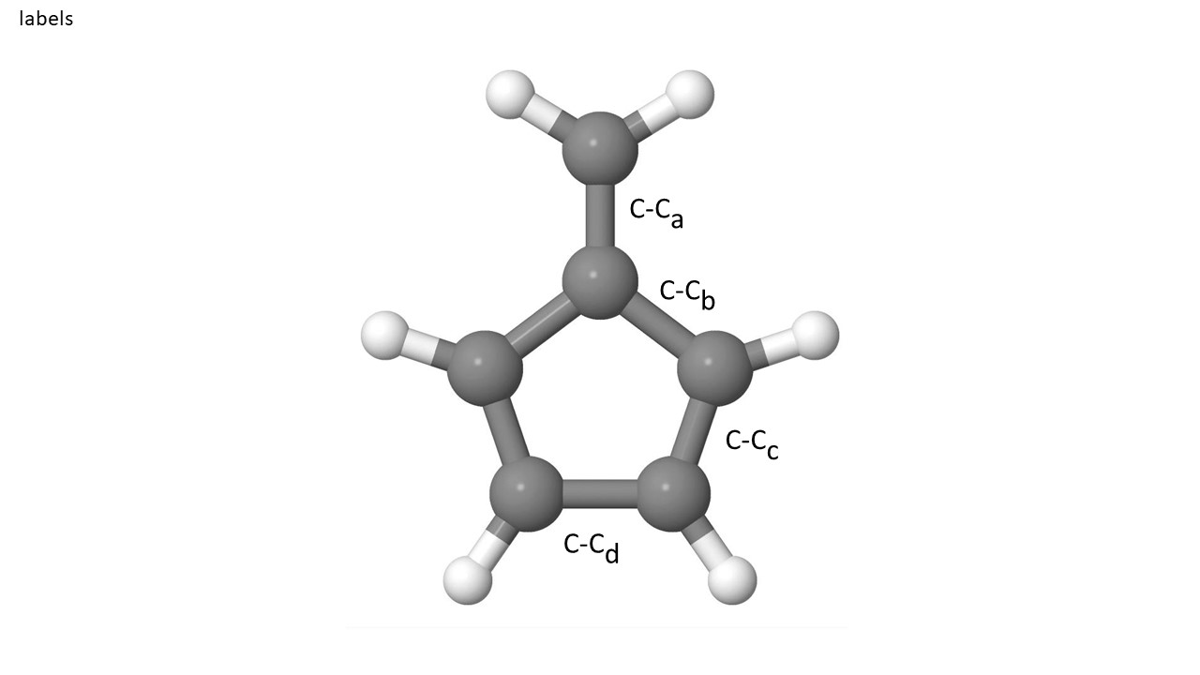

|  |  |  |  |  |
| --- | --- | --- | --- | --- |
|  | C-Ca | C-Cb | C-Cc | C-Cd |
|  | SA2-CASSCF(6,6) | | | |
| S0 | 1.352 | 1.479 | 1.360 | 1.482 |
| S1 | 1.497 | 1.402 | 1.475 | 1.363 |
| MXS | 1.583 | 1.373 | 1.538 | 1.321 |
|  | MRCI | | | |
| S0 | 1.358 | 1.489 | 1.369 | 1.493 |
| S1 | 1.495 | 1.413 | 1.482 | 1.375 |
| MXS |  |  |  |  |

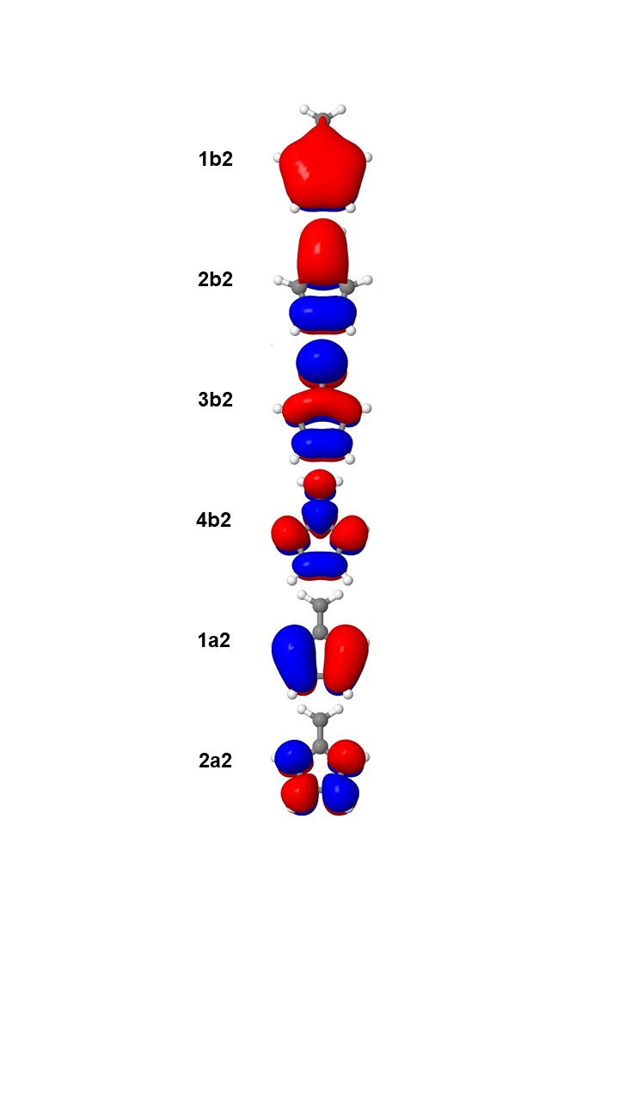

Figure 1: Optimized active orbitals for the S0 optimized with SA2-CASSCF(6,6)/6-31G.

Directories on CCR:

|  |  |
| --- | --- |
|  | SA2-CASSCF(6,6)/6-31G |
| S0 opt | /user/ub2037/fulvene/S0-CAS |
| S1 opt | /user/ub2037/fulvene/S1-CAS |
| MXS | /user/ub2037/fulvene/MXS-CAS/mxs_opt |
|  |  |
|  |  |
| S0 opt | /user/ub2037/fulvene/S0-CI |
| S1 opt | /user/ub2037/fulvene/S1-CI |
| MXS |  |