**Work plan:**

**Fulvene calculations:**

Task 1

Determine the active space: full valence CAS in the π space

Orbital occupation for scf calculation:

System: Fulvene Point Group: c2v

N. Electrons: 42 Multiplicity: 1

Level: SCF/6-31G

|  |  |  |  |  |  |  |  |  |  |
| --- | --- | --- | --- | --- | --- | --- | --- | --- | --- |
|  |  | IRREP | | | | | | | |
|  |  | a1 | b1 | b2 | a2 |  |  |  |  |
| SCF | DOCC | 11 | 7 | 2 | 1 |  |  |  |  |
|  | OPSH | 0 | 0 | 0 | 0 |  |  |  |  |

Task 2:

Perform a closed shell scf calculation (see Appendix for Cartesian geometry); analyze the π orbitals and add the lowest three virtual π orbitals to the active space. What is the resulting CAS orbital scheme?

|  |  |  |  |  |  |  |  |  |  |
| --- | --- | --- | --- | --- | --- | --- | --- | --- | --- |
| MCSCF | DOCC | **??** | **??** | **??** | **??** |  |  |  |  |
|  | RAS | 0 | 0 | 0 | 0 |  |  |  |  |
|  | CAS | **??** | **??** | **??** | **??** |  |  |  |  |
|  | AUX | 0 | 0 | 0 | 0 |  |  |  |  |

Two states should be calculated: S0 and S1. Fill out the table below

|  |  |  |  |
| --- | --- | --- | --- |
| States | Multiplicity | N. electrons | Symmetry |
| 1 | **??** | **??** | **?** |
| 2 | **??** | **??** | **?** |
| Number of distinct rows (DRTs): **??** | | |  |

Task 3:

Perform a single point state-averaged SA-CASSCF calculations with two states.

What is the excitation energy, the oscillator strength and the orbital excitation scheme of S1 in comparison to S0?

|  |  |  |  |  |
| --- | --- | --- | --- | --- |
| State | ∆E (eV) | Configuration | % | Osc. Str. |
| SA2-CASSCF(6,6) | | | |  |
| S0 |  |  |  | - |
| S1 |  |  |  |  |
|  |  |  |  |  |

Plot the six π orbitals of the active space.

Task 4

Perform a geometry optimization for the planar S1 state using the SA2-CASSCF(6,6) method.

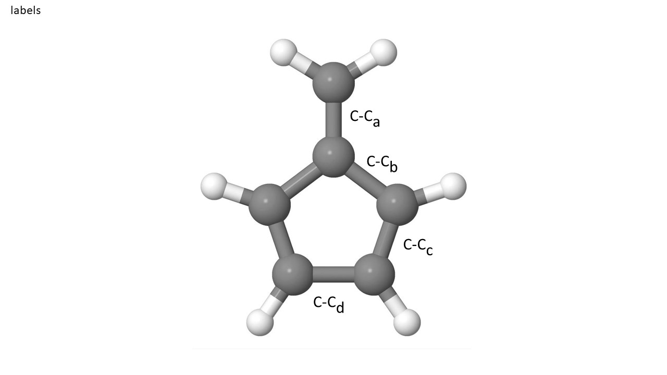

|  |  |  |  |  |
| --- | --- | --- | --- | --- |
|  | C-Ca | C-Cb | C-Cc | C-Cd |
|  | SA2-CASSCF(6,6) | | | |
| S1 |  |  |  |  |

Task 5

Compute the MXS starting from the planar S1 fulvene structure using the SA2-CASSCF(6,6) method.

|  |  |  |  |  |
| --- | --- | --- | --- | --- |
|  | C-Ca | C-Cb | C-Cc | C-Cd |
|  | SA2-CASSCF(6,6) | | | |
| MXS |  |  |  |  |

Plot or visualize the two vectors of the branching space and characterize the vibrations.

Task 6

Compute the vertical excitation energy at MRCI(CAS6,6) and MRCI(CAS6,6)+Pople correction using the S0 MRCI geometry

1. Set up the MO occupation table for MRCI

Keep the core orbitals frozen.

|  |  |  |  |  |  |  |  |  |  |
| --- | --- | --- | --- | --- | --- | --- | --- | --- | --- |
| MRCI | FC |  |  |  |  |  |  |  |  |
|  | FV |  |  |  |  |  |  |  |  |
|  | DOCC |  |  |  |  |  |  |  |  |
|  | ACT |  |  |  |  |  |  |  |  |
|  | AUX |  |  |  |  |  |  |  |  |
|  | INT |  |  |  |  |  |  |  |  |

1. Copy the SA-CASSCF input from Task 3 into a new directory and make only the MRCI input. Do it for S0 and S1 separately as they have different symmetries. Use the MRCI S0 geometry from the Appendix. Extract the vertical excitation energy and compare it with the SA2-CASSCF result.

|  |  |  |  |
| --- | --- | --- | --- |
| MRCI/MRCI+P excitation energies using the MRCI S0 optimized geometry | | | |
| State | ∆E (eV) | Configuration | % |
| S0 |  |  |  |
| S1 |  |  |  |

Task 7

Compute the vertical excitation energy at MRCI(CAS6,6) and MRCI(CAS6,6)+Pople correction using the S1 MRCI geometry

Copy the inputs from Task 6 into separate directories and use the S1 MRCI optimized geometry (file geom) given in the Appendix. Replace only the old geom file by the new one and do the calculations.

Important: compute all energies relative to the MRCI ground state energy of the S0 geometry (Task 6).

|  |  |  |  |
| --- | --- | --- | --- |
| MRCI/MRCI+P excitation energies using the MRCI S0 optimized geometry | | | |
| State | ∆E (eV) | Configuration | % |
| S0 |  |  |  |
|  |  |  |  |
| S1 |  |  |  |
|  |  |  |  |

**Solutions**

Directories on CCR:

|  |  |
| --- | --- |
|  | SA2-CASSCF(6,6)/6-31G |
| S0 opt | /user/ub2037/fulvene/S0-CAS |
| S1 opt | /user/ub2037/fulvene/S1-CAS |
| MXS | /user/ub2037/fulvene/MXS-CAS/mxs_opt |
|  |  |
|  | MRCI |
| S0 opt | /user/ub2037/fulvene/S0-CI |
| S1 opt | /user/ub2037/fulvene/S1-CI |

**Task 2:**

CAS orbital scheme

|  |  |  |  |  |  |  |  |  |  |
| --- | --- | --- | --- | --- | --- | --- | --- | --- | --- |
| MCSCF | DOCC | 11 | 7 | 0 | 0 |  |  |  |  |
|  | RAS | 0 | 0 | 0 | 0 |  |  |  |  |
|  | CAS | 0 | 0 | 4 | 2 |  |  |  |  |
|  | AUX | 0 | 0 | 0 | 0 |  |  |  |  |

|  |  |  |  |
| --- | --- | --- | --- |
| States | Multiplicity | N. electrons | Symmetry |
| 1 | 1 | 42 | A1 |
| 2 | 1 | 42 | B1 |
| Number of distinct rows (DRTs): 2 | | |  |

**Task 3:**

Vertical excitations at SA2-CASSCF calculation

|  |  |  |  |  |
| --- | --- | --- | --- | --- |
| State | ∆E (eV) | Configuration | % | Osc. Str. |
| SA2-CASSCF(6,6) – S0 optimization | | | |  |
| S0 | 0.000 | (1b2)2(2b2)2(3b2)0(4b2)0  (1a2)2(2a2)0 | 75.7 | - |
| S1 | 4.080 | (1b2)2(2b2)2(3b2)1(4b2)0  (1a2)1(2a2)0 | 72.0 | 0.0 |
|  |  | (1b2)2(2b2)1(3b2)2(4b2)0  (1a2)1(2a2)0 | 14.8 |  |

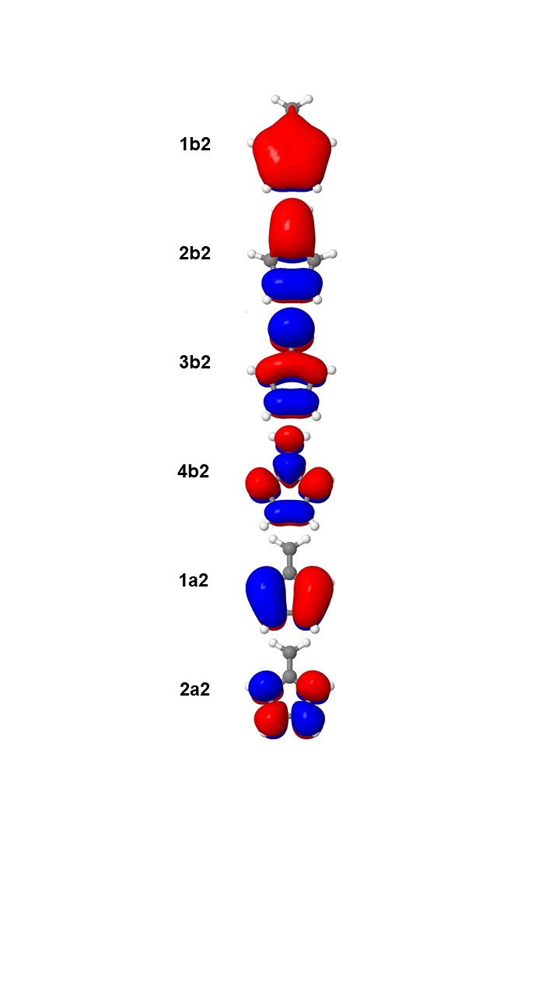

Figure 1: Optimized active orbitals for the S0 optimized with SA2-CASSCF(6,6)/6-31G.

**Task 4**

|  |  |  |  |  |
| --- | --- | --- | --- | --- |
|  | C-Ca | C-Cb | C-Cc | C-Cd |
|  | SA2-CASSCF(6,6) | | | |
| S0 | 1.352 | 1.479 | 1.360 | 1.482 |
| S1 | 1.497 | 1.402 | 1.475 | 1.363 |

**Task 5**

|  |  |  |  |  |
| --- | --- | --- | --- | --- |
|  | C-Ca | C-Cb | C-Cc | C-Cd |
|  | SA2-CASSCF(6,6) | | | |
| MXS | 1.583 | 1.373 | 1.538 | 1.321 |

**Task 6**

MRCI Occupation Table

|  |  |  |  |  |  |  |  |  |  |
| --- | --- | --- | --- | --- | --- | --- | --- | --- | --- |
| MRCI | FC | 4 | 2 | 0 | 0 |  |  |  |  |
|  | FV | 0 | 0 | 0 | 0 |  |  |  |  |
|  | DOCC | 7 | 5 | 0 | 0 |  |  |  |  |
|  | ACT | 0 | 0 | 4 | 2 |  |  |  |  |
|  | AUX | 0 | 0 | 0 | 0 |  |  |  |  |
|  | INT | 7 | 5 | 4 | 2 |  |  |  |  |

|  |  |  |  |
| --- | --- | --- | --- |
| MRCI/MRCI+P excitation energies using the MRCI S0 optimized geometry | | | |
| State | ∆E (eV) | Configuration | % |
| S0 | 0.000/0.000 | (1b2)2(2b2)2(3b2)0(4b2)0  (1a2)2(2a2)0 | 69.0 |
| S1 | 3.907/3.779 | (1b2)2(2b2)2(3b2)1(4b2)0  (1a2)1(2a2)0 | 70.1 |

Task 7

|  |  |  |  |
| --- | --- | --- | --- |
| MRCI/MRCI+P excitation energies using the MRCI S0 optimized geometry | | | |
| State | ∆E (eV) | Configuration | % |
| S0 | 1.268/1.194 | (1b2)2(2b2)2(3b2)0(4b2)0  (1a2)2(2a2)0 | 61.8 |
|  |  | (1b2)2(2b2)1(3b2)1(4b2)0  (1a2)2(2a2)0 | 10.5 |
| S1 | 2.638/2.600 | (1b2)2(2b2)2(3b2)1(4b2)0  (1a2)1(2a2)0 | 67.3 |
|  |  | (1b2)2(2b2)1(3b2)2(4b2)0  (1a2)1(2a2)0 | 10.8 |

**Appendix**

Fulvene geom_unique.xyz file containing the symmetry unique atoms using the SA-CASSCF S0 geometry

7

C 0.741279 -0.000000 -2.186935

C 1.177643 -0.000000 -0.898511

C 0.000000 0.000000 -0.004256

C -0.000000 -0.000000 1.347324

H 1.349366 -0.000000 -3.067414

H 2.192618 -0.000000 -0.559673

H 0.914227 0.000000 1.909820

Fulvene geom_unique.xyz file containing the symmetry unique atoms using the MR-CI S0 geometry

7

C 0.746320 0.000000 -2.195217

C 1.187909 0.000000 -0.899709

C 0.000000 -0.000000 -0.001599

C -0.000000 0.000000 1.356855

H 1.358935 0.000000 -3.087441

H 2.214125 0.000000 -0.555979

H 0.922835 -0.000000 1.928229

Fulvene geom file using the MR-CI S1 geometry

C 6. 1.29873323 0.00000000 -4.32672141 12.00000000

C 6. -1.29873323 -0.00000000 -4.32672141 12.00000000

C 6. 2.14563104 0.00000000 -1.65647062 12.00000000

C 6. -2.14563104 -0.00000000 -1.65647062 12.00000000

C 6. 0.00000000 0.00000000 -0.06736260 12.00000000

C 6. -0.00000000 -0.00000000 2.75695396 12.00000000

H 1. 2.53720115 0.00000000 -5.95135381 1.00782504

H 1. -2.53720115 -0.00000000 -5.95135381 1.00782504

H 1. 4.09852982 0.00000000 -1.04133635 1.00782504

H 1. -4.09852982 -0.00000000 -1.04133635 1.00782504

H 1. 1.75756975 -0.00000000 3.80378726 1.00782504

H 1. -1.75756975 0.00000000 3.80378726 1.00782504

Directories on CCR:

|  |  |
| --- | --- |
|  | SA2-CASSCF(6,6)/6-31G |
| S0 opt | /user/ub2037/fulvene/S0-CAS |
| S1 opt | /user/ub2037/fulvene/S1-CAS |
| MXS | /user/ub2037/fulvene/MXS-CAS/mxs_opt |
|  |  |
|  | MRCI |
| S0 opt | /user/ub2037/fulvene/S0-CI |
| S1 opt | /user/ub2037/fulvene/S1-CI |