**GitHub Username**: COMPENG4LF

TIPSY TALK

Description

Have you ever sent a text or made that phone call you regretted in the morning?

Sometimes after drinking people feel a bit more emotional, vulnerable, or even fearless. You may want to reach out to an ex-girlfriend/ex-boyfriend or boss, and say things that were not meant. Consider this app a guardian angel that will protect you from making the calls when under the influence.

The options to log the conversation you would have sent can be saved as well. In this way you can monitor your own behavior and look back at what you would have texted without our intervention. This will spare the embarrassment and also bring awareness to things you would write others while under the influence. This could lead to behavioral changes over time.

There is a Blood Alcohol Content Calculator to assist in an estimated BAC percentage.

There is an option to have a drink water reminder that you can set at different intervals.

There is an option as well to give you reminders at certain increments throughout the time of consuming alcohol in case of obligations. For example a reminder that you have to wake up for work tomorrow or you do not want to drink too much and need that ping to alert you that it is time to go.

Intended User

This app is intended for anyone that is of legal drinking age.

Features

List the main features of your app. For example:

* Blocks attempts to call designated contacts
* Blocks attempts to text designated contacts
* Blood Alcohol Content Calculator
* Drink water reminder (optional)
* You need to leave reminder due to work or other obligation (optional)
* Dial Emergency number
* Save text messages to file to read later

User Interface Mocks

**Screen 1**



Initial Welcome Screen for user to setup options and blocked call list.

**Screen 2**



Ongoing Home Screen when user comes in. Allows for them to set timer on how long they want to block calls/texts from their blocked list. List is saved within the app.

**Screen 3**

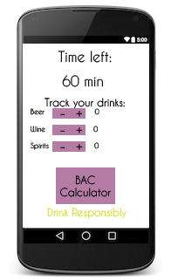

**User can track how much time is left for app to stop and they can add more time if desired. They can also track the number of drink they have had if desired. They can use the BAC calculator for themselves or others.**

**Screen 4**

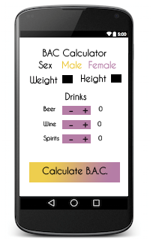

**BAC Calculator where user can insert number of drinks and what type of drink they had.**

**Screen 5**

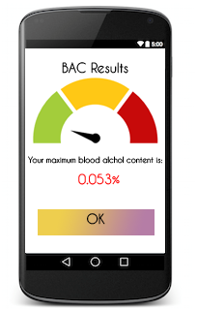

**Results Screen for BAC Results.**

**Widget**

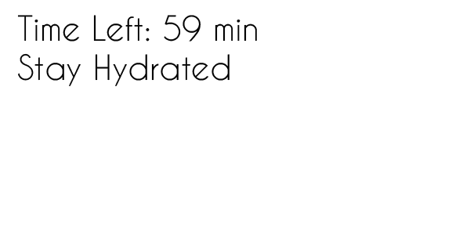

**Widget will display time left on clock and a reminder to stay hydrated. Total number of drinks if user chooses to do so.**

Key Considerations

App will be written solely in Java Programming Language

Android Studio: Version 3.3.2

Gradle: Version 3.3

Accessibility: Content descriptions

Application will need to utilize a background service in order to continue to monitor calls even when the user has closed the application.

**Resources**

Strings: strings.xml file

Colors: colors.xml file

Themes: style.xml file

**How will your app handle data persistence?**

Shared preferences - used to save all user options such as Name, Logging on/off

Internal storage- to log blocked outgoing calls and text messages that were not sent

**Describe any edge or corner cases in the UX.**

1. Timer needs to continue running even if user closes the app.
2. Calls still need to be blocked even when user closes the app.

**Describe any libraries you’ll be using and share your reasoning for including them.**

Butterknife v 2.0 will be used in the project for less boilerplate code.

**Describe how you will implement Google Play Services or other external services.**

**Maps may be used but not entirely sure yet.**

Google Location and Activity Recognition com.google.android.gms:play-services-location:17.0.0

Google Mobile Ads com.google.android.gms:play-services-ads:18.2.0

**Contacts Provider** – Will be used for users to select numbers they wish not to call when under the influence. An AsycTask will be used here to retrieve the contacts to be selected by user for saving into a list inside app.

**Call and Telecom framework** – Used to manage the calls that will be outgoing. This way we can screen them and check if there is a match from the users do not call list. If there is match then call will not be made otherwise call will be placed.

Next Steps: Required Tasks

**Task 1: Project Setup**

1. Add dependencies for call, contacts to Manifest
2. Add ButterKnife dependecies

**Task 2: Implement UI for Each Activity and Fragment**

1. Build UI for MainActivity
   1. Welcome Screen on initial open with choice to setup contacts that will not be contacted. Also, set initial options for logging and customize with name
   2. On open after contacts have been initialized then question will be asked how long to block calls/texts from contacts in list.
2. Build UI for timer countdown with options to track drinks.
3. Build UI for BAC calculator and BAC results

**Task 3: Build Settings Menu and Data Persistence**

1. Build settings menu for user with options
   1. Save text messages that were not sent.
   2. Log outgoing calls that were blocked.
   3. User reminder if they try to turn off call/text blocking
2. Data Persistence
   1. This will contain the list of contacts the user wants to block from calling
   2. Logging information will also be contained here

**Task 4: Service to keep app running in background even when closed.**

**Task 5: Build Widget**

**Task 6: Add ads to free version**

The app will have 2 versions. One paid and one free. The free version will have ads across the bottom. The paid version will have ads removed.