

# Bachelor of Computer Applications

(BCA)



Submitted By- Submitted To-

Aman Raj Dr.Kirti

1829786 (‘B’) Project Incharge

Bca department



|  |  |  |  |  |  |
| --- | --- | --- | --- | --- | --- |
| S no. |  | Content | | Page no. | Remarks |
| 1 |  | Declaration | | 3 |  |
| 2 |  | Abstract | | 4 |  |
| 3 |  | Acknowledgement | | 5 |  |
| 4 | Chapter 1 |  | 1.Introduction to Project |  |  |
| 1.1 | Introduction to JAVA | 6 |  |
| 1.2 | Introduction to Netbins | 9 |  |
| 1.3 | SQL | 10 |  |
| 1.4 | About the Project | 14 |  |
| 1.5 | Objectives | 15 |  |
| 5 | Chapter 2 | 2. Design Methodology | |  |  |
| 2.1 | DFD diagram and ER diagram | 16-20 |  |
| 6 | Chapter 3 |  | 3.Screenshots | 21 |  |
| 7 | Chapter 4 | 4. | Future Scope | 22 |  |
| 8 |  |  | Conclusion | 24 |  |

**Declaration**

The project submitted here with is a result of my own efforts in totality and in every aspects of the project works. All information that has been obtained from other sources had been fully acknowledged.

The project is submitted to the college CGC Technical campus Jhanjeri. For the partial fulfilment of the Bachelor of Computer Application.

I also declare that this project report has not been previously submitted to any other University.

Aman Raj (1829786)

# **Description**

So this project is all about how to create an ATM interface. It can display all the functionalities that an actual ATM display does. To use into the system user need to enter a unique pin. If the user will enter the correct pin then only can see all other option. After entering the correct credentials, user can see their bank details like account balance, transaction, withdraw amount, deposit amount and Quit options. It mainly consists of 4-5 classes. This project is specially suitable for the second year and third-year students.

# **Acknowledgements**

After complete my Project, I would like to take this chance to express my sincere gratitude to my project supervisor which is Ms Dr.Kirti who has guided me a lot throughout the project development. I would like to thanks Ms Dr.Kirti Ma’am for one more time because she shares her experience with us so that we can get more logic understanding on how to develop a software which suitable for the current society.

I also thank our college who have helped in successful completion of project.

Aman Raj(1829786)

**Chapter 1**

**Introduction of project**

**Introduction to JAVA**

Java is an object oriented language which gives a clear structure to programs and allows code to be reused, lowering development costs

**Java Development Kit(JDK)**

He Java Development Kit (JDK) is one of three core technology packages used in Java programming, along with the JVM (Java Virtual Machine) and the JRE (Java Runtime Environment). It's important to differentiate between these three technologies, as well as understanding how they're connected:

[The JVM](https://www.javaworld.com/article/3272244/what-is-the-jvm-introducing-the-java-virtual-machine.html?nsdr=true) is the Java platform component that executes programs.

[The JRE](https://www.javaworld.com/article/3304858/what-is-the-jre-introduction-to-the-java-runtime-environment.html) is the on-disk part of Java that creates the JVM.

The JDK allows developers to create Java programs that can be executed and run by the JVM and JRE.

**Java Runtime Environment(JRE)**

JRE is a part of JDK which means that JDK includes JRE. When you have JRE installed on your system, you can run a java program however you won’t be able to compile it. JRE includes JVM, browser plugins and applets support. When you only need to run a java program on your computer, you would only need JRE.

**The Java language was designed with the following properties:**

* Platform independent: Java programs use the Java virtual machine as abstraction and do not access the operating system directly. This makes Java programs highly portable. A Java program (which is standard-compliant and follows certain rules) can run unmodified on all supported platforms,

e.g., Windows or Linux.

* Object-orientated programming language: Except the primitive data types, all elements in Java are objects.
* Strongly-typed programming language: Java is stronglytyped, e.g., the types of the used variables must be predefined and conversion to other objects is relatively strict, e.g., must be done in most cases by the programmer.
* Interpreted and compiled language: Java source code is transferred into the bytecode format which does not depend on the target platform. These bytecode instructions will be interpreted by the Java Virtual machine (JVM). The JVM contains a so called Hotspot-Compiler which translates performance critical bytecode instructions into native code instructions.
* Automatic memory management: Java manages the memory allocation and de-allocation for creating new objects. The program does not have direct access to the memory. The socalled garbage collector automatically deletes objects to which no active pointer exists.

**1.2 What is Java Netbins?**

NetBeans IDE is a free, open source, integrated development environment (IDE) that enables you to develop desktop, mobile and web applications. The IDE supports application development in various languages, including Java, HTML5, PHP and C++. The IDE provides integrated support for the complete development cycle, from project creation through debugging, profiling and deployment. The IDE runs on Windows, Linux, Mac OS X, and other UNIX-based systems.

The IDE provides comprehensive support for JDK 7 technologies and the most recent Java enhancements. It is the first IDE that provides support for JDK 7, Java EE 7, and JavaFX 2. The IDE fully supports Java EE using the latest standards for Java, XML, Web services, and SQL and fully supports the GlassFish Server, the reference implementation of Java EE.

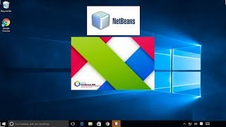

## **1.3- SQL**

SQL stands for Structured Query Language. SQL is used to communicate with a database. According to ANSI, it is the standard language for relational database management system.

SQL statements are used to perform tasks such as update data on a database, or retrieve data from a database.

Some common relational database management systems that use SQL are: Oracle, Sybase, Microsoft SQL Server, Access, Ingress, etc. Although most database systems use SQL commands such as “Select”, “Insert”, “Update”, “Delete”, “Create”, and “Drop” can be used to accomplish almost everything that one needs to do with a database.



**Key capabilities of SQL**

**High Performance-**

SQL provide high performance programming capability for highly transactional, heavy workload and high usage database system. SQL programming gives various ways to describe the data more analytically.

**High Availability-**

SQL is compatible with databases like MS Access, Microsoft SQL server, MYSQL, Oracle Database, SAP HANA, SAP Adaptive Server, etc. All of these relational data base management system supports SQL and it is easy to create and application extension for procedural programming and various other functions.

**Scalability and Flexibility-**

SQL provide Scalability and Flexibility. It is very easy to create new tables and previously created or not used tables can be dropped or deleted in a database.

**Comprehensive Application Development-**

SQL is used by many programmers to program apps to access a database. No matter what is the size of organization, SQL works for every small or large organization.

**Open Source-**

SQL is an open- source programming language for building relational database management system.

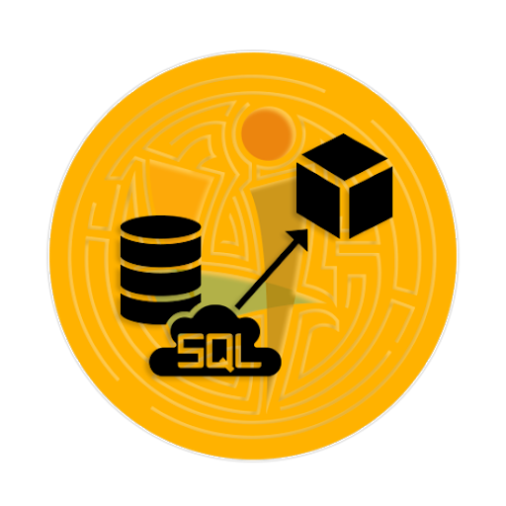

## **SQL by product**

**Functions of SQL:**

* AVG() –Returns the average value
* COUNT()–Returns the number of rows
* FIRST() - Returns the first value
* LAST() – Returns the last value
* MAX() – Returns the largest value
* MIN() – Returns the smallest value
* SUM() – Returns the sum

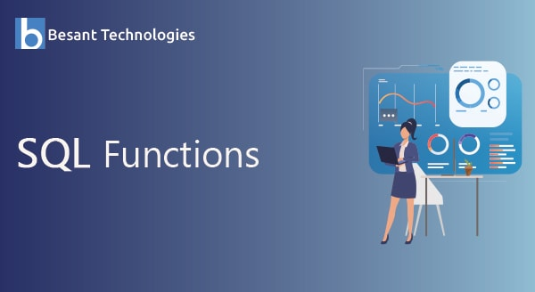

**1.4 Introduction of Project**

* The project deals with the Corporate Banking Management. This project is very helpful to both Banking Staff as well as to the public. It is having mainly Administration and Client modules.

**List of software used:**

* java JDK
* DBMS
* Java Netbins
* SQL (Backend)

 

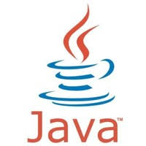

**1.5 Objectives**

* **This is beneficial for public and banking staff.**
* **We can add more features in ATM Interface like updating your passbook that kind of printing machine.**
* **You can apply for ATM card also and lining between through net banking.**

**Chapter 2 Design Methodology**

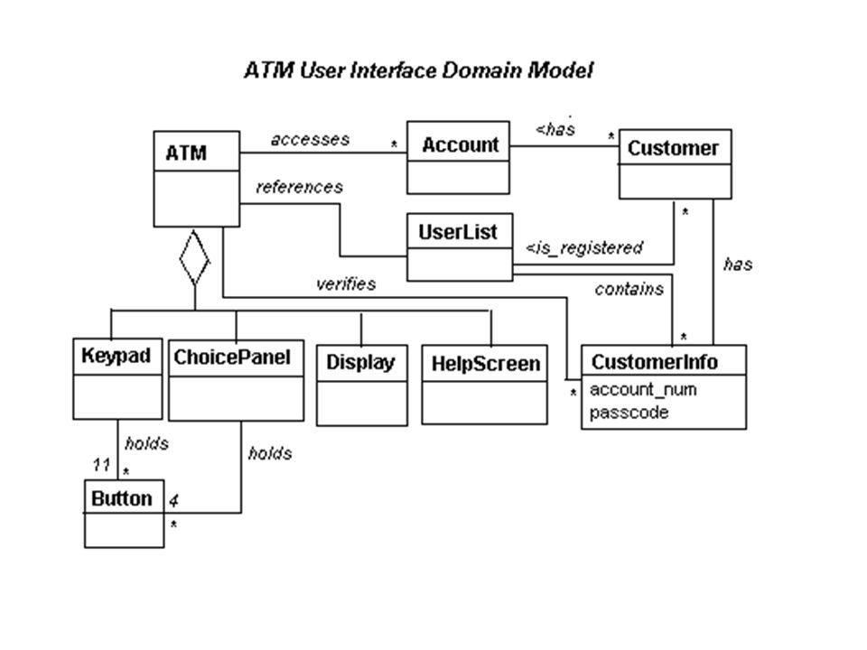

**DFD Diagram Level 0**

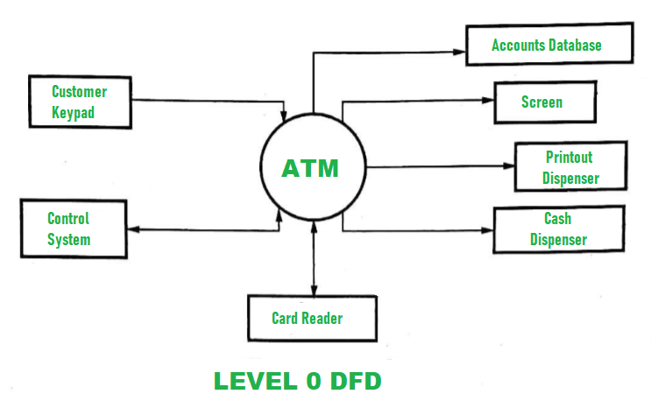

**DFD Diagram Level 1**

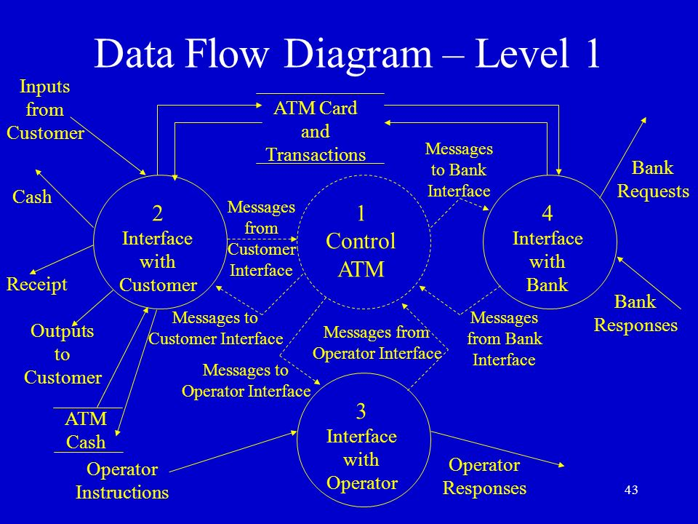

**DFD Diagram Level 2**

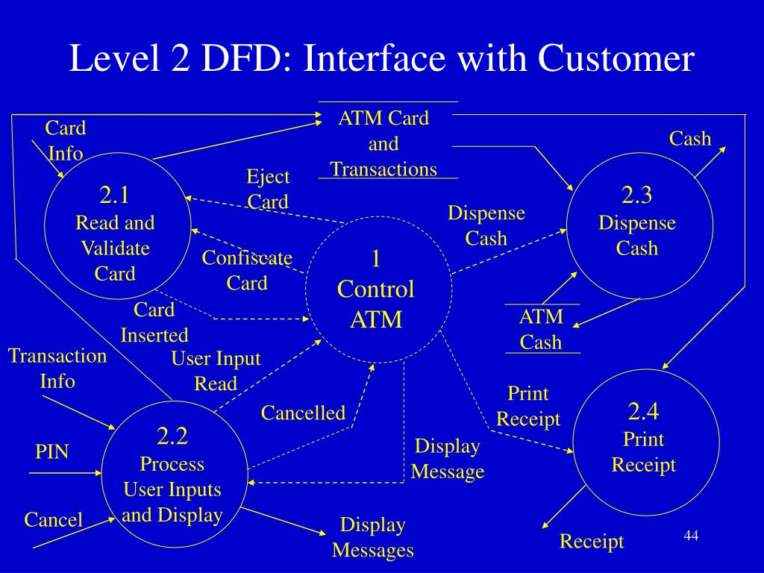

**ER Diagram**

**Chapter 3- Screenshots**

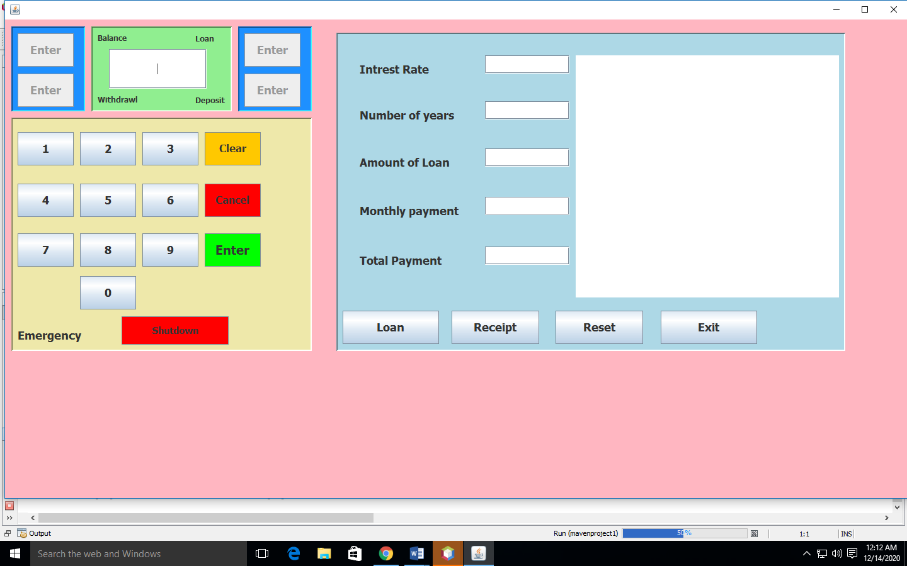

**Chapter- 4**

**Future Scope**

 The future will see multi vendor ATM popularity, which will provide personalized features and a user friendly interface. ATM will be a popular "Public Technology". Original equipment manufacturers and vendors will get ample scope for handling ATM machines. Modern ATMs are now capable of personalized branding, CRM applications, integrated fraud alert, customer notifications, and flexible services. The ATM technology has developed to such an extent that some ATMs can memorize consumer preferences as per their past transactions, behaviour, and tailor services accordingly. In many cases, ATMs have internet scope which facilitates two way communications with live agents, provide biometric options, and have the ability to demonstrate personalized advertisements. Maintenance of web enabled ATMs are easy. These ATMs can be quickly connected to central monitoring system of vendors.

ATMs will become the banks of the future as more branches close, said Bill Versen, chief product officer at Transaction Network Services, in the report. He believes ATMs will adopt biometric identifiers like fingerprint and facial recognition to enable cardless usage. They'll also include "services as diverse as applying for loans, buying lottery tickets and dispensing foreign currency,"

**Conclusion**

* The project on “ATN SYSTEM” has been developed as the best flexible and efficient project within the available resources and time.
* In future, We are planning to add new feature like finger print reader and eye detection system for authentication of user security purpose.
* Care has been taken at each step to make it more user friendly so that users can add new features where ever necessary while using this automated system. In may be enhanced for requirement of user.