ID132V: Laborationer 4A, 4B och 4C

The request was to write:

4A Text based user interface (TextUI) for the Video Rental Outlet (VRO) application.
4B Fail-safe improved code of the text based interface application written in 4A.
4C Graphical user interface (Windows Forms based GUI) for the Video Rental Outlet application.

My solution was to write identical application code both for the console (TextUI) and windows forms based (GUI) application by isolating business logic of the application from the presentation tier as much as possible. One of the major results of this approach was the TextUI library, specially written for this project, which implements basic UI components compatible with the standard .NET Windows Forms library.

The resulting code for 4A/B/C is divided into several assemblies:

Assembly | Source Folder | Description
VideoRentalOutlet-Console.exe | Application | 4A/B/C application
VideoRentalOutlet-GUI.exe | Application | 4A/B/C application
TextUserInterface.dll | Library-TextUI | 4A Text User Interface Library
VideoRentalOutlet.dll | Library-VideoRentalOutlet | Library (from Lab 2A and 3A)
VideoRentalOutlet-TestSuite.dll | Library-TestSuite | Test suite (from Lab 3A)
MbkCommons.dll | Library-MbkCommons | Common utilities

(See the “Project Dependency Graph” section for more details.)

Implementation Notes
Every source folder has as a rule its own VS C# project (a csproject file) that builds the particular assembly. However, because TextUI and GUI assemblies share the same Application source folder, that particular folder contains two csproject files: one building TextUI application and the other building GUI application. So, the source code is divided in six folders and grouped into seven VS C# projects.

Code Metrics
The summary of the code metrics for the solution is shown on the following table:

Project | Maintability  Index | Lines of Code  (effective) | Lines of Code  (with comments)
Application GUI + TUI | 71 | 4 000 | 16 564
Library TextUI | 86 | 3 900 | 15 047
Library VideoRentalOutlet | 83 | 1 067 | 5 344
Library TestSuite | 72 | 629 | 2 510
Library MbkCommons | 77 | 514 | 2 136
Total | 78 | 10 110 | 41 601

The following pages elaborate:
- source code overview (file listing) of the solution,
- project dependency graph
- essential class diagrams
- how 4A/B/C requirements are met

Solution Contents Overview
A good starting point for browsing the code are the following files:
- Application/DetailsForms/CompanyDetailsForm.cs
- Application/DetailsForms/CustomerDetailsForm.cs
- Application/ListForms/CustomerListForm.cs

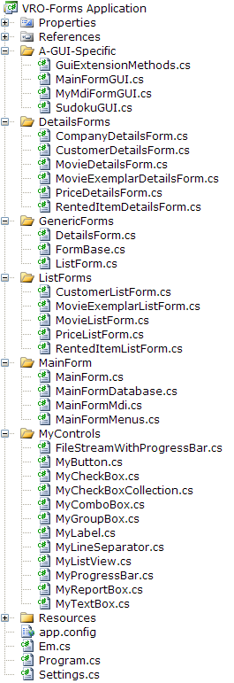
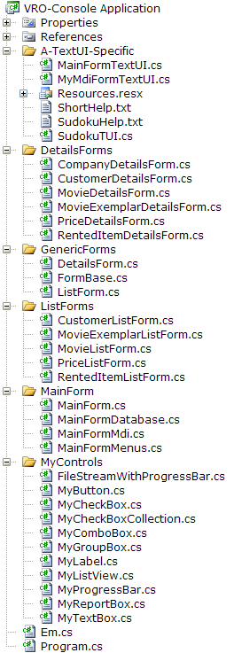

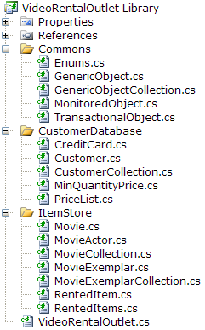
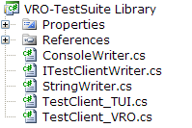
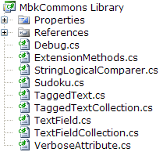
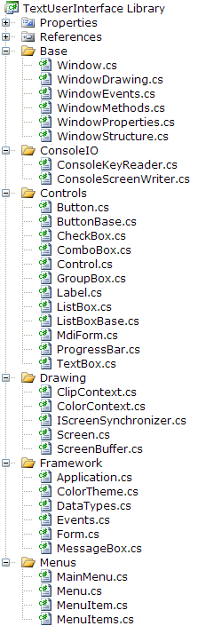

Project Dependency Graph
Video Rental Outlet TextUI Application
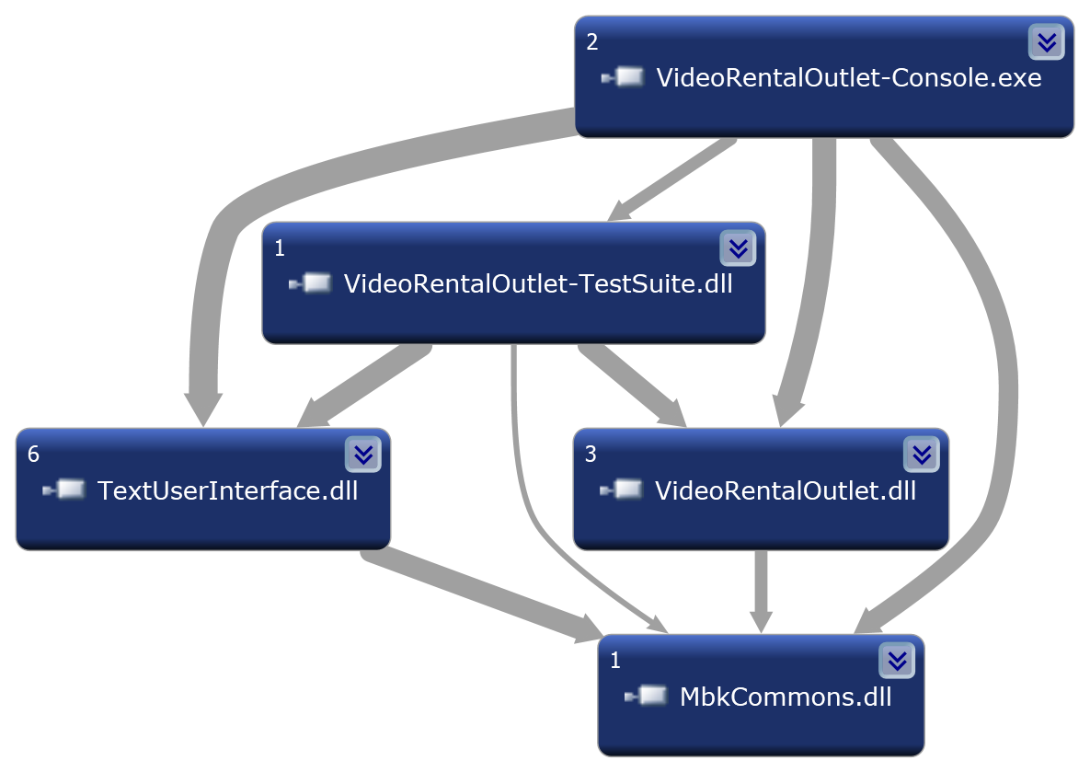

Video Rental Outlet GUI Application

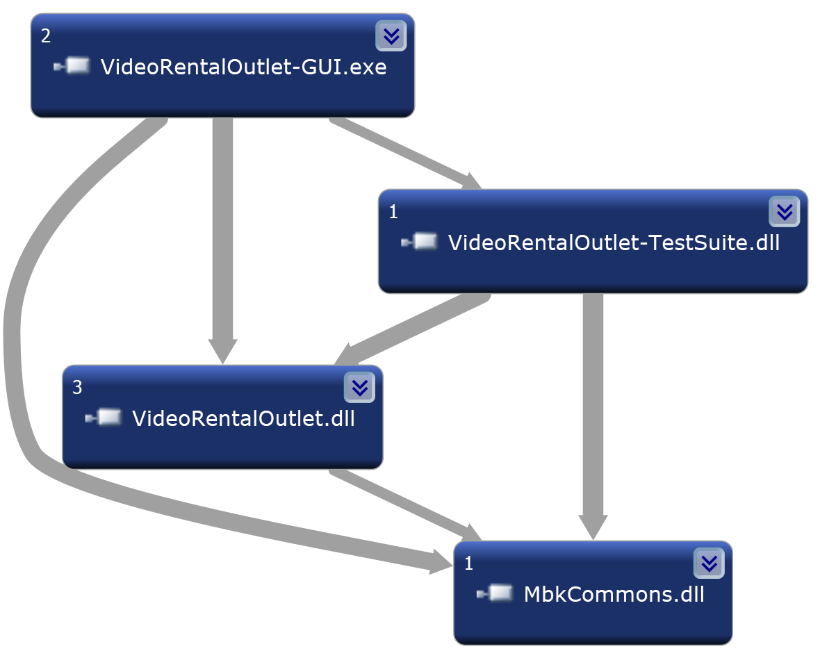
TextUI Library

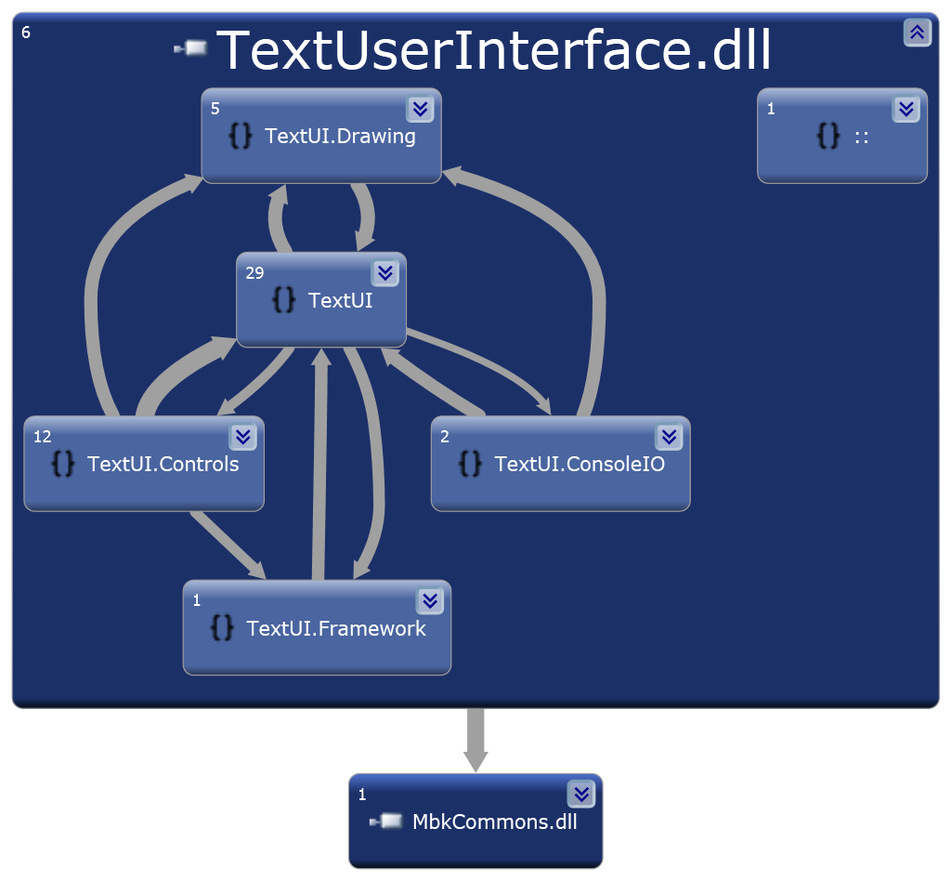

MbkCommons Library

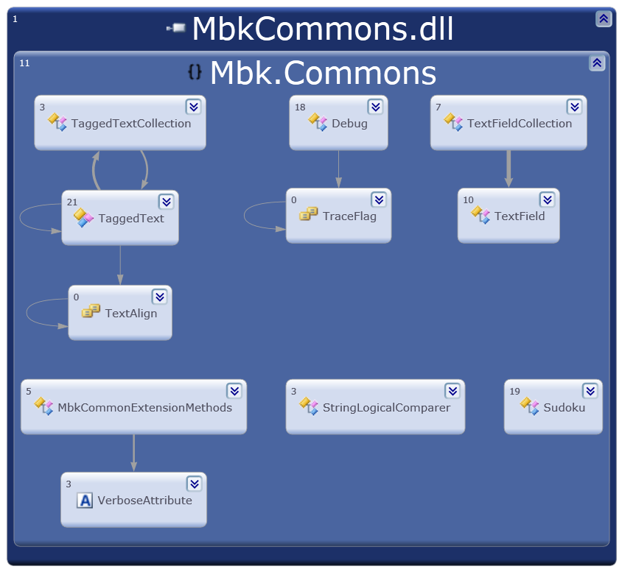

Class Diagrams

GUI/TUI Application Common Class Diagram – 1 of 2

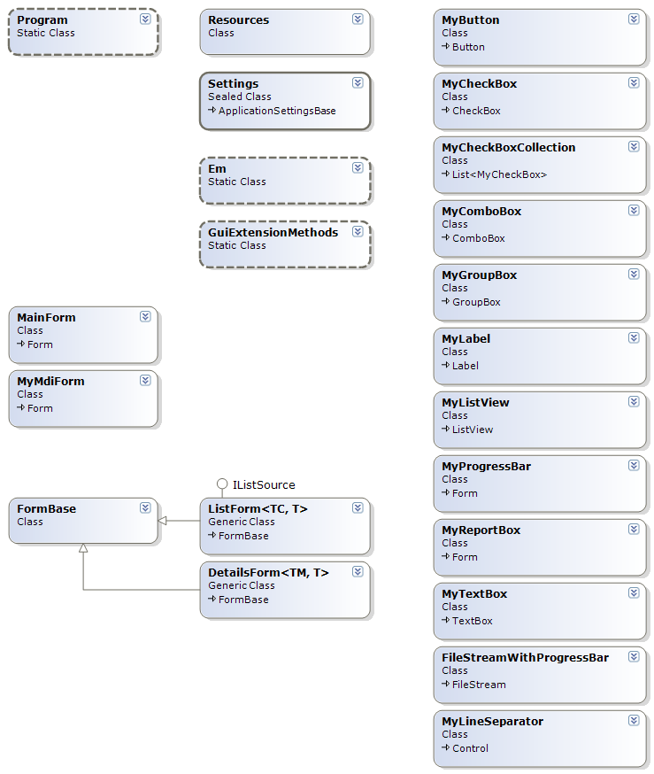

GUI/TUI Application Common Class Diagram – 2 of 2

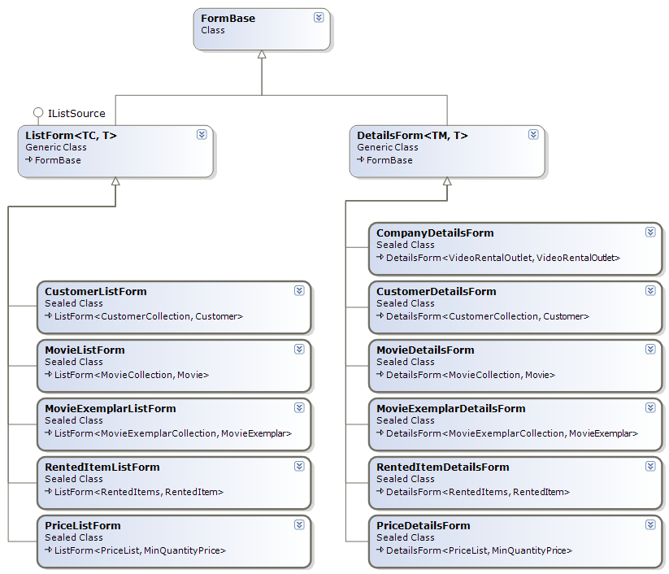

TextUI Library Class Diagram – 1 of 2

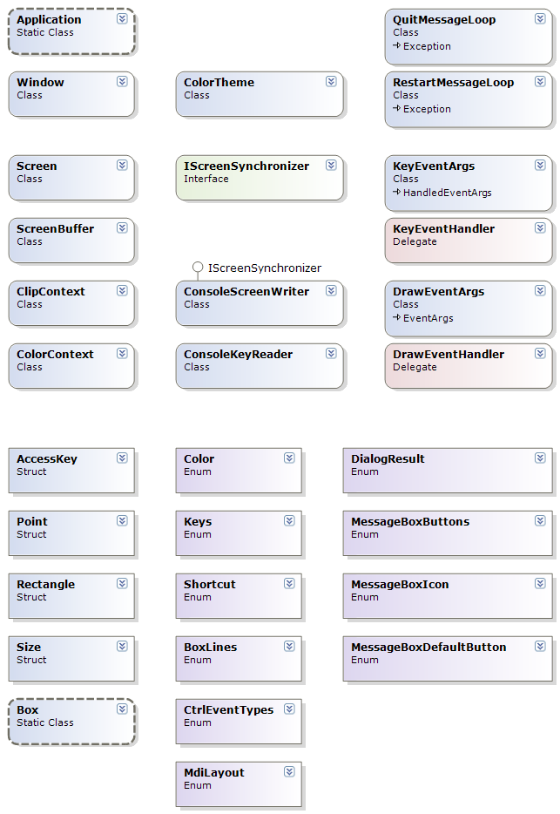

TextUI Library Class Diagram – 2 of 2

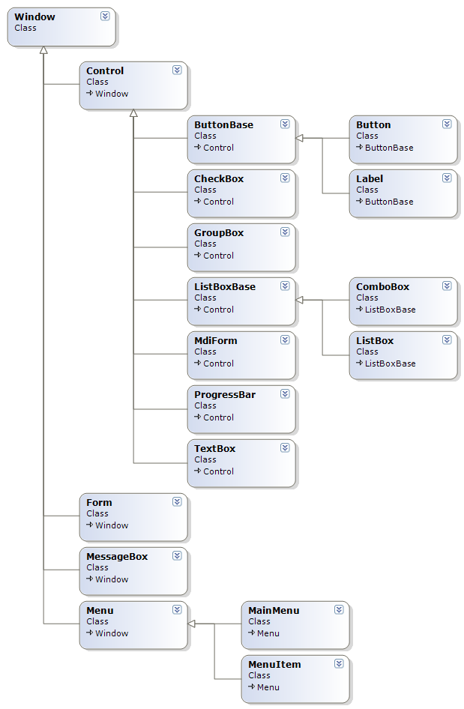

Video Rental Outlet Library Class Diagram – 1 of 2

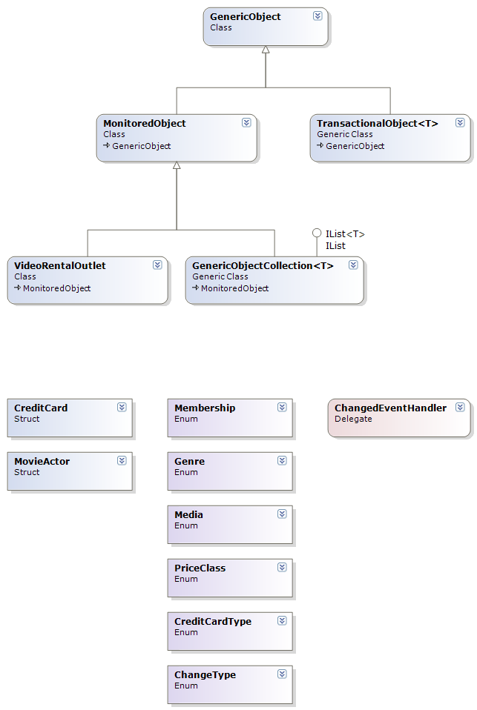

Video Rental Outlet Library Class Diagram – 2 of 2

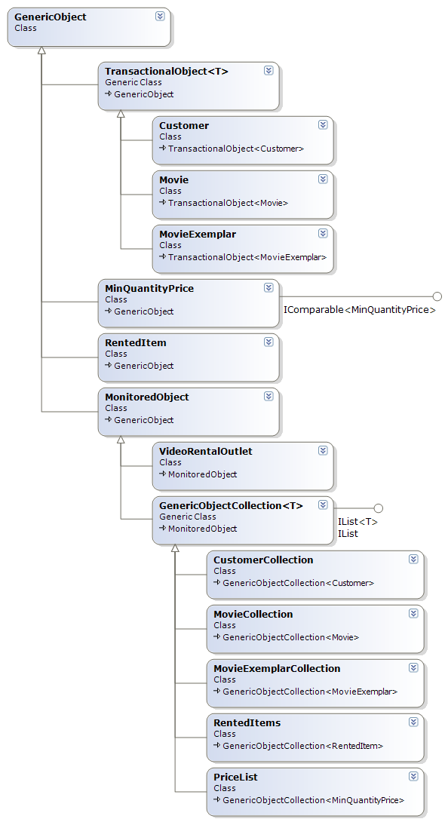

Meeting The Requirements…
4A | I denna laboration ska du skriva ett textbaserat användargränssnitt för din videobutik.

The whole new Text User Interface (TextUI alt. TUI) library was created as the result of this requirement.
The TextUI library is implemented on the top of the Console .NET class; however, the library can work on any media that provides TextUI.IScreenSynchronizer interface and the KeyDown event message pump.

In this implementation, the major message loop (a message pump reading keys from the Console and dispatching it to windows in focus) is implemented in the ConsoleKeyReader class, while the screen output is implemented in the ConsoleScreenWriter class.

The essential ConsoleKeyReader methods are :

public void Run( Screen screen );
public DialogResult DoModal( Screen screen, Window modalWindow );
private void MessagePump( Screen screen, Window modalWindow = null );
private void ReadKey_Worker ();

Writing to a screen is implemented using double-buffering scheme where all screen output is written to the off-line screen buffer (represented as matrix of screen elements consisting of a character and the character attributes i.e. its foreground/background colors), which is synchronized with the Console, when needed.

The updating process in the ConsoleScreenWriter class is implemented, as a part of IScreenSynchronizer interface, in the methods :

public void BeginUpdate ()
public void EndUpdate ()
public void Update ()

All TextUI controls are derived from the base Window class, which source code is divided into several source files :

Window.cs
WindowDrawing.cs
WindowEvents.cs
WindowMethods.cs
WindowProperties.cs
WindowStructure.cs

with the most complicated code is in the WindowStructure.cs that deals with parent/children relationship between controls and the focus navigation.

The TextUI controls used by the Video Rental Outlet console application are :

Button ButtonBase Menu
CheckBox ListBoxBase MenuItem
ComboBox MainMenu
GroupBox Form
Label MdiForm
ListBox
ProgressBar MessageBox
TextBox

The following page shows the sample screenshot of some controls listed above, as displayed in the console application. The page also shows the windows forms application for comparison.

Movie Details Form in TextUI (console) application:

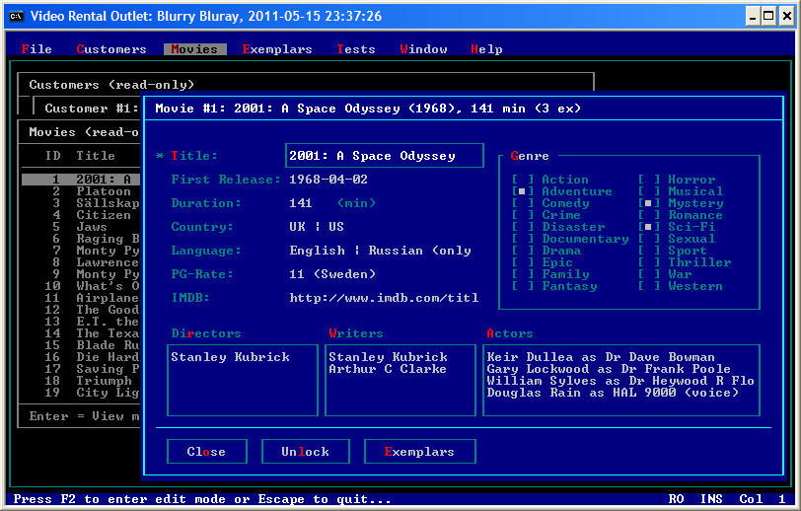

The same Movie Details Form in Windows Forms application:

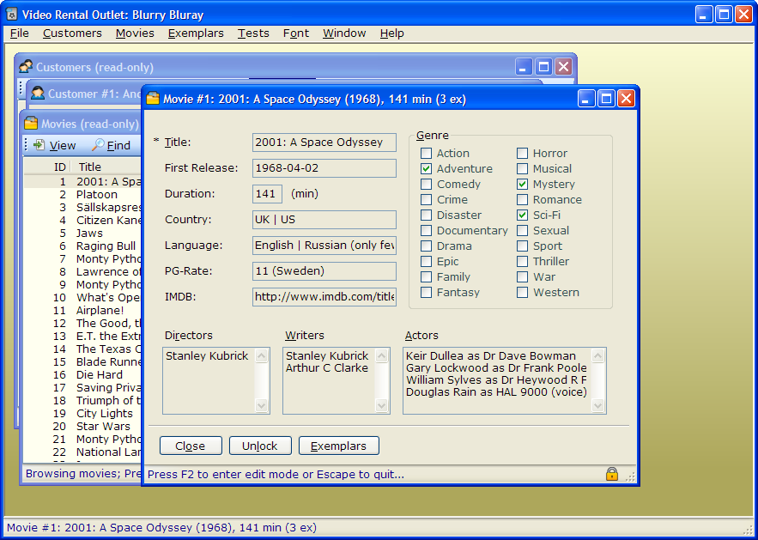

4A  k1 | All information om kunder och om filmer ska sparas ner på fil när programmet avslutas. När programmet startas ska all information läsas in igen. Du får välja om du vill lagra information på en textfil eller en binärfil (spara ett helt objekt). Du kan själv välja om du vill spara all information i samma fil eller om du vill dela upp det på fler filer (t.ex. en fil med filmer och en med kunder).

Video Rental Outlet (VRO) database is serialized to a single binary file using the BinaryFormatter class.
The Serialize and Deserialize method of the VideoRentalOutlet class are responsible for saving/loading a graph of VRO objects to/from file:

[Serializable] public class VideoRentalOutlet : MonitoredObject
{
/// <summary>
/// Saves (serializes) database in binary form to an instance of the file stream.
/// </summary>
///
public void Serialize( Stream fileStream )
{
new BinaryFormatter ().Serialize( fileStream, this );

// Note that 'dirty' flags are not serialized so we can reset flags *after* we
// have saved object to file (as it will appear 'clean' when reloaded).
// If Serialize() throws an exception, the following code won't be executed,
// so the video store would keep its dirty status unchanged.
//
IsDirty = false;
Customers.IsDirty = false;
PriceList.IsDirty = false;
Movies.IsDirty = false;
MovieExemplars.IsDirty = false;
}

/// <summary>
/// Returns a new instance of VideoRentalOutlet class deserialized (loaded)
/// from binary file stream.
/// </summary>
/// <returns>a new instance of VideoRentalOutlet database</returns>
/// <remakrs>VideoRentalOutlet factory method</remakrs>
///
public static VideoRentalOutlet Deserialize( Stream fileStream )
{
BinaryFormatter formatter = new BinaryFormatter ();

// Deserialize Video Rental Outlet database from the file and
// assign the reference to the local variable.
//
object deserializedObject = formatter.Deserialize( fileStream );
VideoRentalOutlet store = deserializedObject as VideoRentalOutlet;

if ( store != null && ! store.IsValidVersion )
{
string info = store.Version == null
? "of unkown version" : "v" + store.Version;

throw new Exception( "Incompatible VRO database version!\r\n\r\n"
+ "File format is " + info
+ ". Application can handle only files in v"
+ VROLibVersion + " format." );
}

if ( store == null )
{
throw new Exception( "Failed to deserialize VRO database." );
}

return store;
}
}
The user interface part, which automatically loads/saves database on application startup/shutdown, is implemented in the MainFormDatabase.cs file as a part of the MainForm class.

For more details see the MainForm class methods :

private void LoadDatabase( string filename, string caption, bool silent = false );
private void SaveDatabase( string filename, string caption, bool silent = false );

The code snippet showing the sample usage of the methods listed above is:

/// <summary>
/// Handles the Shown event. Loads database from file.
/// </summary>
///
private void MainForm_Shown( object sender, EventArgs e )
{
try
{
LoadDatabase( this.databaseFilename,
"Video Rental Outlet Database", /*silent*/ true );
}
catch( Exception ex )
{
// As LoadDatabase method uses external DLL, we cannot catch
// "could not load dll error" inside LoadDatabase the method, so we do it here.
// Note that the LoadDatabase method handles itself its own exceptions.
//
MessageBox.Show( ex.Message, "Error Loading DLL",
MessageBoxButtons.OK, MessageBoxIcon.Hand );
}
}

/// <summary>
/// Handles the FormClosing event. Asks user whether to save database, if database
/// is dirty.
/// </summary>
///
private void MainForm_FormClosing( object sender, FormClosingEventArgs e )
{
if ( ! this.VideoStore.IsDirty )
{
return;
}

DialogResult rc = MessageBox.Show(
"Database has been modified...\n\n"
+ "Do you want to save changes?",
"Video Rental Oultet",
MessageBoxButtons.YesNoCancel, MessageBoxIcon.Exclamation );

if ( rc == DialogResult.Yes )
{
SaveDatabase( this.databaseFilename, "Saving Database", /*silent*/true );
}
else if ( rc == DialogResult.Cancel )
{
e.Cancel = true;
}
}

4A  k2 | Nedan beskrivs vilka menyval som ska vara möjliga i ditt användargränssnitt:  Visa alla kunder, Visa alla filmer, Lägg till ny kund, Lägg till ny film, Hyr ut en film, Lämna tillbaks en film, Avsluta

The menu system of the VRO application is coded in the file MainFormMenus.cs as a part of the MainForm class implementation.

The following screenshot displays some of the menu items in the TextUI application:

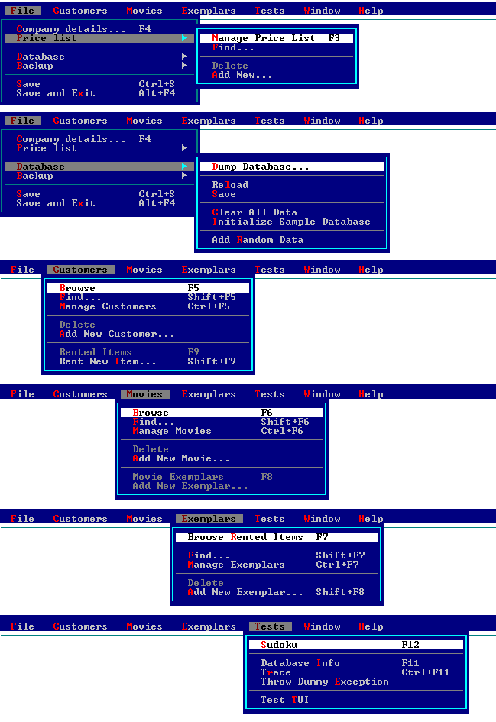

4B | Ditt program ska nu göras säkert. Om användaren skriver in något felaktigt värde, t.ex. skriver "hej" när ett menyalternativ efterfrågas, ska programmet ej krasha utan istället ge ett vettigt felmeddelande och låta användaren försöka igen. Detsamma gäller på alla ställen där användaren kan skriva in felaktiga värden.  För att uppgiften ska vara godkänd ska programmet ej krasha. Den du redovisar för kommer att försöka krasha programmet genom att skriva in konstiga saker, eller ta bort filen där data är sparat m.m.

Both GUI and TextUI applications provide exception handling and recovery by catching AppDomain exceptions. Besides that, all database violation exceptions (e.g. trying to insert Credit Card with an invalid credit number checksum) are catched by UI forms and displayed to the user.

The user interaction is based on two types of forms:

- ListForm – listing a collection of items (e.g. of Customers, Movies etc)
- DetailsForm – showing particular item in the collection (e.g. Customer, Movie ect)

(See the base class FormBase, and derived classes ListForm and DetailsForm.)

Validation of data entered by used is performed using Validating event handlers for particular fields (i.e. UI controls).

For example, in the CustomerDetailsForm class, the following code verifies that user has entered proper values as a part of the InitializeComponents method:

/////////////////////////////////////////////////////////////////////////////////
// Field validation event handlers

this.firstName.Validating += ( sender, e ) =>
{
MdiForm.ErrorMessage = null;

if ( ReadOnly || ! this.firstName.ContentsChanged )
{
return;
}

ValidateNotNull( "Customer's first name", this.firstName.Text, e );
};

this.lastName.Validating += ( sender, e ) =>
{
MdiForm.ErrorMessage = null;

if ( ReadOnly || ! this.lastName.ContentsChanged )
{
return;
}

ValidateNotNull( "Customer's last name", this.lastName.Text, e );
};

this.personID.Validating += ( sender, e ) =>
{
MdiForm.ErrorMessage = null;

if ( ReadOnly || ! this.personID.ContentsChanged )
{
return;
}

ValidateNotNull( "Customer's Person-ID", this.personID.Text, e );

if ( ! ReadOnly && ! e.Cancel )
{
string notValidInfo = Customer.ValidatePNR( this.personID.TrimmedText );

if ( notValidInfo != null )
{
MdiForm.ErrorMessage = notValidInfo;
MdiForm.Beep ();
e.Cancel = true;
}
}
};

this.email.Validating += ( sender, e ) =>
{
MdiForm.ErrorMessage = null;

if ( ReadOnly || ! this.email.ContentsChanged )
{
return;
}

ValidateEMailAddress( "E-Mail", this.email.Text, e );
};

The helper methods Validate(something) are provided in the DetailsForm class, e.g.:

/// <summary>
/// Validates text value not to be null or empty.
/// </summary>
///
public void ValidateNotNull( string fieldName, string value, CancelEventArgs e )
{
if ( e.Cancel )
{
return; // Already cancelled
}

if ( ReadOnly )
{
return; // Assume always data valid while browsing
}

value = value == null ? null : value.Trim ();

if ( string.IsNullOrEmpty( value ) )
{
MdiForm.ErrorMessage = fieldName + " must not be empty or null.";
MdiForm.Beep ();
e.Cancel = true;
}
}

/// <summary>
/// Validates text value to be a valid HTTP or HTTPS Universal Resource Identifier
/// (URI).
/// </summary>
///
public void ValidateHttpURI( string fieldName, string value, CancelEventArgs e )
{
if ( e.Cancel )
{
return; // Already cancelled
}

if ( ReadOnly )
{
return; // Assume always data valid while browsing
}

value = value == null ? null : value.Trim ();

// Accept NULL values always as valid. Not null must be validated separatelly.
//
if ( string.IsNullOrEmpty( value ) )
{
return;
}

// Parse URI and accept only URIs having scheme either http or https
//
try
{
string scheme = new Uri( value.Trim () ).Scheme.ToLower ();
if ( scheme != "http" && scheme != "https" )
{
throw new Exception( fieldName + " must be either http or https URI." );
}
}
catch( Exception ex )
{
MdiForm.ErrorMessage = ex.Message;
MdiForm.Beep ();
e.Cancel = true;
}
}

...

4C | Du ska skapa en Windowsapplikation (grafiskt gränssnitt) för din redan befintliga videobutik. Den enda klassen du bör behöva ändra på är själva startklassen som hanterar hela videobutiken. Det grafiska gränssnittet ska istället ta över dess roll.

As mentioned earlier, TextUI and GUI has the same source base and the MainForm class is common both for TextUI and GUI mode.

4C  k1 | Koden för det grafiska gränssnittet får inte vara genererad av Visual Studio .Net - du ska ha skrivit den helt själv.

The common UI is based on two types of forms:

- ListForm – listing a collection of items (e.g. of Customers, Movies etc)
- DetailsForm – showing particular item in the collection (e.g. Customer, Movie ect)

(See the base class FormBase, and derived classes ListForm and DetailsForm.)

The UI components placement is guided by units defined in the Em class, that specifies dimensions in pixels of the typical character in current font in GUI mode. In TextUI mode, the units specified in the Em class equals “one” so the forms could be layout (almost) independently from the character/graphical mode and the used font (in GUI mode).

Usage of the NewSomeControl factory methods of the DetailsForm class makes a transparent creation of the UI components both for TextUI and GUI modes. The common UI components initialization, e.g. for the CompanyDetailsForm class (derived from the DetailsForm class), looks like:

protected override void InitializeComponents ()
{
/////////////////////////////////////////////////////////////////////////////////
// Table layout grid definition, with rows and columns in Em units.

float[] col = { 4, 22 };
float[] row = { 2, 4, 6, 8, 10, 12, 14, 16, 18, 21, 23 };

// Maximum text length
float maxLen = (float)MdiForm.Width / Em.Width - col[1] - 2f;

/////////////////////////////////////////////////////////////////////////////////
// Static text

int r = 0, c = 0;

NewStaticText( col[c], row[r++], "Company Name:" );
NewStaticText( col[c], row[r++], "VAT Number:" );
NewStaticText( col[c], row[r++], "Address:" );
NewStaticText( col[c], row[r++], "Post Code:" );
NewStaticText( col[c], row[r++], "City:" );
NewStaticText( col[c], row[r++], "Country:" );
NewStaticText( col[c], row[r++], "Phone:" );
NewStaticText( col[c], row[r++], "Home Page:" );
NewStaticText( col[c], row[r++], "E-Mail Address: " );

// Mandatory fields marker:
NewStaticText( col[c]-2, row[0], "*" );
NewStaticText( col[c]-2, row[1], "*" );
NewStaticText( col[c]-2, row[2], "*" );

/////////////////////////////////////////////////////////////////////////////////
// TextBox fields

r = 0; c = 1;
this.companyName = NewTextField( col[c], row[r++], maxLen );
this.vatNo = NewTextField( col[c], row[r++], maxLen );
this.address = NewTextField( col[c], row[r++], maxLen );
this.postCode = NewTextField( col[c], row[r++], maxLen );
this.city = NewTextField( col[c], row[r++], maxLen );
this.country = NewTextField( col[c], row[r++], maxLen );
this.phone = NewTextField( col[c], row[r++], maxLen );
this.homePage = NewTextField( col[c], row[r++], maxLen );
this.email = NewTextField( col[c], row[r++], maxLen );

/////////////////////////////////////////////////////////////////////////////////
// Field validation event handlers

this.companyName.Validating += ( sender, e ) =>
{
MdiForm.ErrorMessage = null;

if ( ReadOnly || ! this.companyName.ContentsChanged )
{
return;
}

ValidateNotNull( "Company Name", this.companyName.Text, e );
};

this.vatNo.Validating += ( sender, e ) =>
{
MdiForm.ErrorMessage = null;

if ( ReadOnly || ! this.vatNo.ContentsChanged )
{
return;
}

ValidateNotNull( "Company's VAT Number", this.vatNo.Text, e );
};

this.homePage.Validating += ( sender, e ) =>
{
MdiForm.ErrorMessage = null;

if ( ReadOnly || ! this.homePage.ContentsChanged )
{
return;
}

ValidateHttpURI( "Home Page", this.homePage.Text, e );
};

this.email.Validating += ( sender, e ) =>
{
MdiForm.ErrorMessage = null;

if ( ReadOnly || ! this.email.ContentsChanged )
{
return;
}

ValidateEMailAddress( "E-Mail", this.email.Text, e );
};

/////////////////////////////////////////////////////////////////////////////////

base.InitializeComponents ();
}

4C  k2 | Textmenyn du tidigare hade gav användaren möjlighet att välja en siffra. Nu ska det istället finnas knappar eller grafiska menyer för att välja de olika valen.

The application mnu system is coded in the file MainFormMenus.cs as a part of the MainForm class implementation. The menu system is identical for TextUI and GUI.
The following screenshot displays essential GUI menus, which may be compared to the screenshot shown under the requirement 4a.k2.

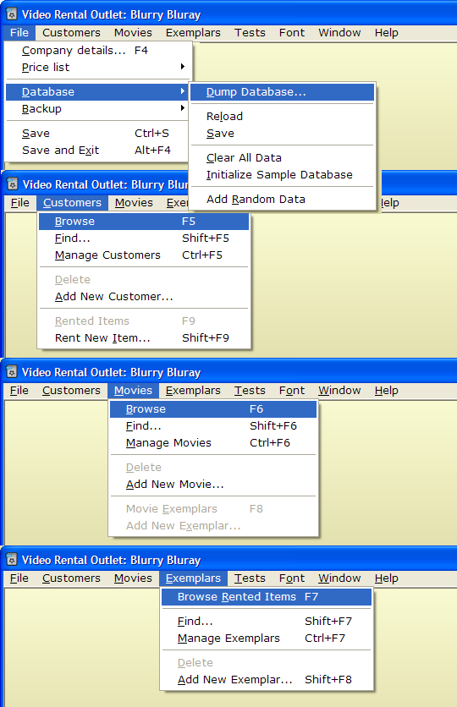

4C  k3 | Man ska i någon ruta kunna se informationen om videofilmer/kunder. Om den inte uppdateras automatiskt när något ändras bör en knapp för uppdatering finnas.

There are five classes displaying VRO collections (derived from the ListForm class) and six classes displaying item details (derived from the DetailsForm class):

List Forms:
- CustomerListForm
- MovieExemplarListForm
- MovieListForm
- PriceListForm
- RentedItemListForm

Details Forms:
- CompanyDetailsForm
- CustomerDetailsForm
- MovieDetailsForm
- MovieExemplarDetailsForm
- PriceDetailsForm
- RentedItemDetailsForm

The List Forms interface is unified having the common toolbar, context menu and the search panel. All forms are updated automatically (changes on data in one form are immediately reflected in other forms).
The following image displays the same CustomersListForm class in GUI and TextUI applications:

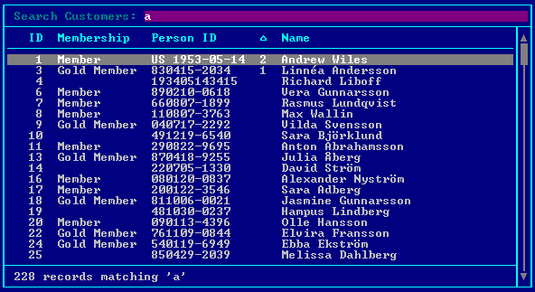
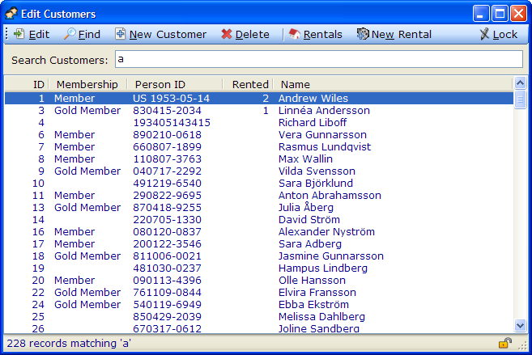

4C  k4 | Om någon information ska skrivas in (t.ex. en ny videofilm) bör detta ske i textfält. För att skicka iväg det är det lämpligt med en knapp.

The application uses the following controls (common both to TextUI and Windows Forms):
- TextBox, ComboBox and CheckBox – for user input
- Label and GroupBox – for labeling and grouping
- Button – for user actions

Customer Details Form in the windows forms VRO application:
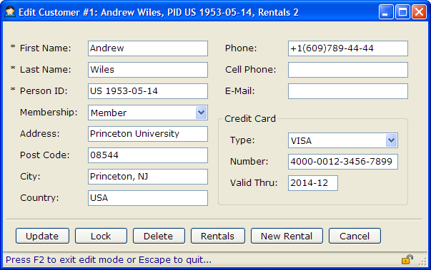

The same Customer Details Form in the console VRO application:
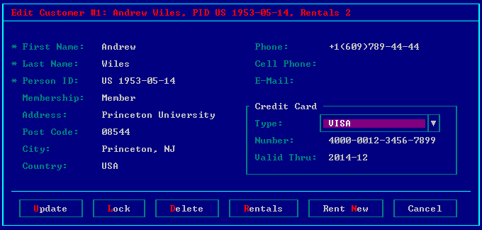
Movie Details Form in the windows forms VRO application:
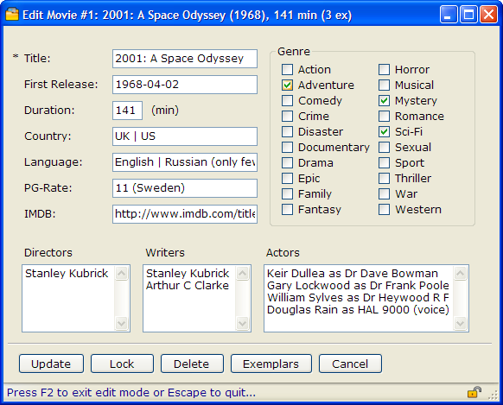

The same Movie Details Form in the console VRO application:
