Computer Lab 3
The Golf Game

Mikica Kocic
miko0008@student.umu.se

2012-04-04 (v2)

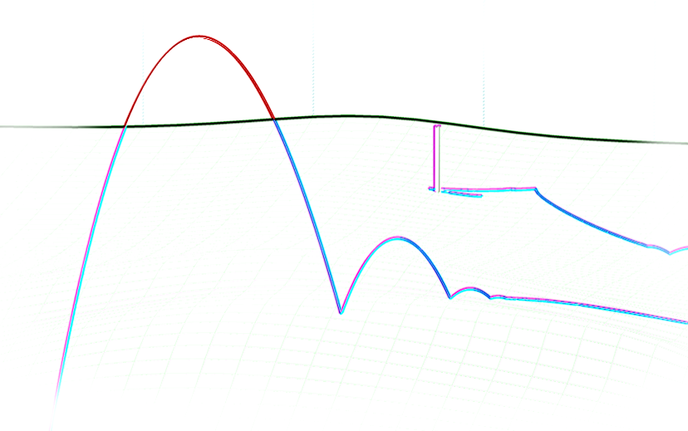

Mark what exercises you have done in this lab |  | Points  (by supervisor)
Basic level (mandatory) | ×
Extra exercise #1: collision with a non-planar terrain height field | ×
Extra exercise #2: decaying of angular velocity by dissipation from the air resistance | ×
Extra exercise #3: inclusion of a constant fluid velocity in viscous forces | ×
Extra exercise #4: GUI that allows menus/mouse interaction | ×
Extra exercise #5: friction in impulse collision model between particles, surfaces and height fld. | ×
The report is brief and to the point but still coherent and well structured.
Late report
Total points
Tutors: Martin Servin and John Nordberg

Background
The purpose of this computer lab was to implement a simple golf simulator that would include most
of the relevant physics such as viscous damping forces and Magnus force, with different contact detection models used for both collision response and simulation termination. Advanced level tasks were to include friction and effects of spin on motion, effects of a moving fluid velocity, collisions with a non-planar terrain height field and development of a model for dissipative for angular velocity decay.

Implementation and Simulation

Theory
All implemented models in this lab follow overall algorithm for a simulation of a mechanical system as presented Notes on Discrete Mechanics. There is a slight departure though, which is described in the following text.

Equation (3.11)
Descriptive subscripts in symbols for the viscous damping coefficients were changed from k_{L} and C_{L} to k_{D} and C_{D}, respectively.

Equation (3.12)
Magnus force coefficients are made physically homogenous using Π-theorem by introducing a reference angular velocity 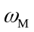 into 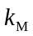 term
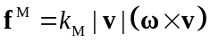
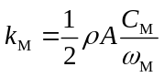
Also, using 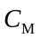 from literature gives unreasonable values for Magnus force with original set of equations, e.g. 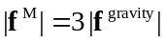 at angular velocity as low as 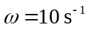. This gets even worse in real case scenarios where, for example, a typical angular velocity is around 10 800 rpm (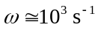) for a golf ball with initial velocity of 150 km/h when hit with a 9 iron. Introducing this way allows also experimentation with a model without touching a given referent Magnus force coefficient .

Equations (5.8) and (5.9)
As described in the earlier lab 2 report, equations are changed to
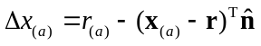
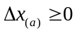
Further motivation is given in Appendix B.

Equation (5.25)
Since the expression for unit tangent vector 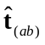 in the equation (5.25) actually defines opposite of the tangential component of the velocity v (i.e. 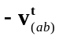), the equation was corrected into
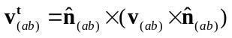
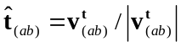
This also fixes the problem with the invalid sign before the friction coefficient in equation (5.26) and is motivated further in Appendix B.
Note that his implementation uses rather the following equivalent equation of the expression
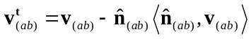

Equations (5.27) and (5.28)
As described in the earlier lab2 report, a position projections factor k_{p} is introduced into the equations. Further motivation is given in Appendix B.

Model for Decaying Angular Velocity
One of the requirements was to extend the model to include decaying angular velocity caused by a drag from the air resistance, which will be addressed here.
While rotating, there is a boundary layer near the surface of the ball where viscous forces are dominant, where the passing fluid causes a drag on the surface causing decay of the angular velocity.
Let us begin by taking a look at the velocities on the surface of the ball, assuming that the velocity v is normal to the angular velocity ω, as given on the following figure
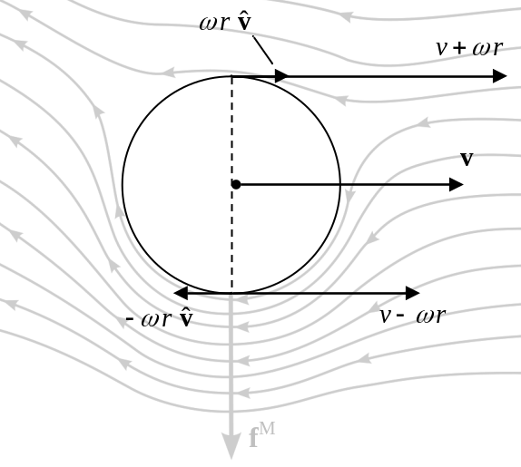
Figure 2.1–1: Velocity and angular velocity of the rotating spherical object.
Let us also assume that the drag force at surface takes a similar form like in equation (3.11) in Notes
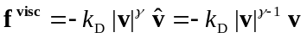 where 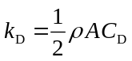 Notes, Eq. (3.11)
Then, approximating case for just two points on the opposite sides of a ball, the net torque is
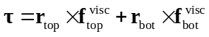
from which, assuming turbulent flow i.e. having 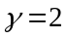, we get the net torque
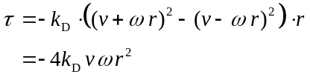
On the other side
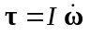
where I is the moment of inertia of an object. Since, in our case for a sphere, we have
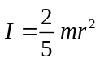
combining the last three equations gives
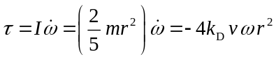
or
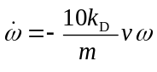
Further substituting 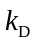 from Eq. (3.11) gives
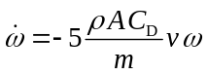
which may be finally homogenized with the notation used throughout the Notes as
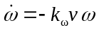
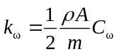
where 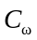 is an angular velocity damping coefficient that depends on geometrical shape (including moment of inertia!) and type of surface of an object. Variables has the following physical dimensions: 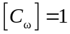, 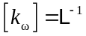 and 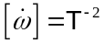.
In a similar manner, we can derive equations for 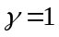 that produces but without the term 4·v. The compound equation in scalar form is then
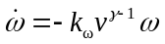
limited only to and values and with an assumption that is also dependent on .
The last equation is derived for case when v is normal to ω. In more general case, we should use a normal projection of v to ω instead of v, i.e. 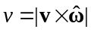, in which case the last equation becomes
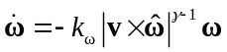.

However, more thorough analysis (presented in Appendix C) yields the following expression for angular velocity decay
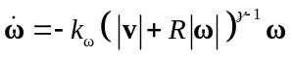.

Implementation
The implemented model is continuation of the earlier simulation framework developed for spherical particle collisions in computer lab 2. The major differences are, first, that the new implementation is object oriented with the physical model encapsulated in a ‘world of particles’ (WoP) class, and second, that the most critical part of the main loop was moved to a MEX function and implemented in C++. Individual files of the implementation are summarized in the following table with a short description, where more important files are highlighted.
File Name | Description
@WoP | Folder with the implementation of the WoP class.
@WoP/WoP.m | Declaration of the WoP class. Contains also definitions of the WoP constructor and destructor.
@WoP/Simulate.m | Implements the simulation engine that simulates and visualizes a system of colliding particles. Calls MEX function WoP_Solver for the most critical part.
@WoP/ResetSimulation.m | Resets initial time to 0 and removes final state variables.
@WoP/GetConfigIDs.m | Returns a list of recognized configuration profiles.
@WoP/loadConfiguration.m | Configures a simulation according to selected profile.
@WoP/GenerateHeightField.m | Generates a random discrete height field grid.
@WoP/Envelope.m | Finds upper and lower envelopes of a given signal.
@WoP/ExportAnnotation.m | Saves a tagged annotation from a figure to an EPS file and removes annotation from the figure.
@WoP/ExportFigure.m | Saves a figure to a file like 'print' function but fixing object’s transparencies and used PS fonts.
@WoP/diminishDimensions.m | Diminishes dimensions of a matrix of spatial vectors.
@WoP/fixPsFonts.m | Fixes matlab’s usage of ‘base 16’ PS fonts in EPS file.
@WoP/randomFaceColor.m | Generates a random particle face color and alpha.
WoP_Solver.cpp  WoP_Solver.mex* | The critical part of the @WoP/Simulate method (in the main loop) which is implemented as MEX ‘nested’ function.  Simulation algorithms are implemented here!
WoP_Matrix.h | The Matrix class used by the WoP_Solver function.
WoP_Eval.cpp  WoP_Eval.mex* | The Matrix class method evaluator to be used with a regression tester.
WoP_RegressionTests.m | Regression tests for the WoP Matrix class
make.m | Rebuilds MEX binaries
lab3.m  lab3.fig | GUI application that allows user to configure the properties of WoP objects interactively and run a series of simulations.
playGolfC.m | Command window application for the Golf Game  (basic level task).
playGolf.m  playGolf.fig | Simple GUI application for the Golf Game  (advanced level task)

The recommended simulation algorithm for using the WoP class (also implemented in lab3, playGolfC and playGolf modules) is:
(1) obj = WoP( 'profile' ); % Instantiate the WoP object
obj.N_dim = ...; obj.X_0 = ... % Setup the simulation parameters
obj.X_0 = ...; obj.V_0 = ... % Мodify some simulation parameters, optionally
(2) obj.Simulate; % Start the simulation
... = obj.X; ... = obj.V; % Use the results, optionally
obj.X = ...; obj.V = ... % Мodify some simulation parameters, optionally
(2) obj.Simulate; % Start the simulation
... = obj.X; ... = obj.V; % Use the results, optionally
% and so on...

Compiling the Code
MEX source files need to be compiled before executing simulations.
The compilation is tested with MS VS 2010 (32/64-bit), 2008 (32-bit) and VC6.0 compilers.
The default distribution contains mexw32 and mexw64 binaries compiled with MS VS 2010 compiler.
To rebuild binaries, just execute make m-file.

Running Test Simulations
1) Execute lab3 from the MATLAB command prompt. The gui should appear:
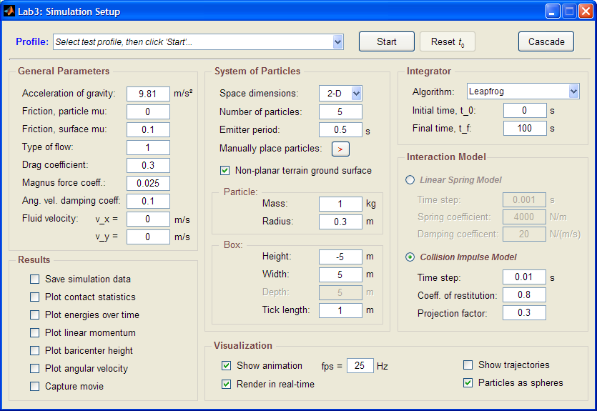
2) Select the configuration profile:
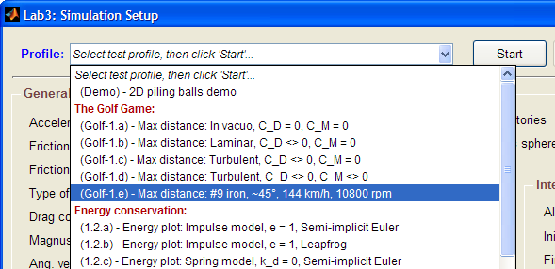
3) Change parameters (optionally). All parameters have a tool-tip with short usage info.
4) Select 'Start' button.
Note that you can always stop the current simulation and change some parameters before continuing or alternatively, restart the simulation from the initial conditions (with button Reset t₀).
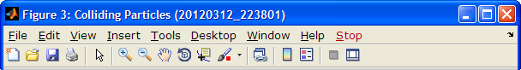

Running the Golf Game

Console Mode Application
Execute playGolfC at the MATLAB command prompt. The simulation should start and place a golf ball on a random position.
Before each shot, the user will be informed about the current wind and prompted to enter horizontal direction, initial velocity, club loft and ball spin, for example (user input is highlighted in blue):
...
----------------------------------------------------------
Wind = 5.53471 -1.36099 0
X = 50.0001 3.50375 0.413924
----------------------------------------------------------
Note: 0 degrees is along depth (Y-axis direction)
----------------------------------------------------------
Direction (degrees) ? -10
Velocity (km/h) ? 54
Loft (degrees) ? 23
Spin (rpm) ? 3600
Application will cycle until the ball is put in hole or goes out of bounds.

GUI Application
Execute playGolf at the MATLAB command prompt. The simulation should start and place a golf ball on a random position.
The player has opportunity, besides to select a club from a combo box and modify other parameters before hitting the ball, to change also the camera view of the golf field (even during simulation while the ball is flying).

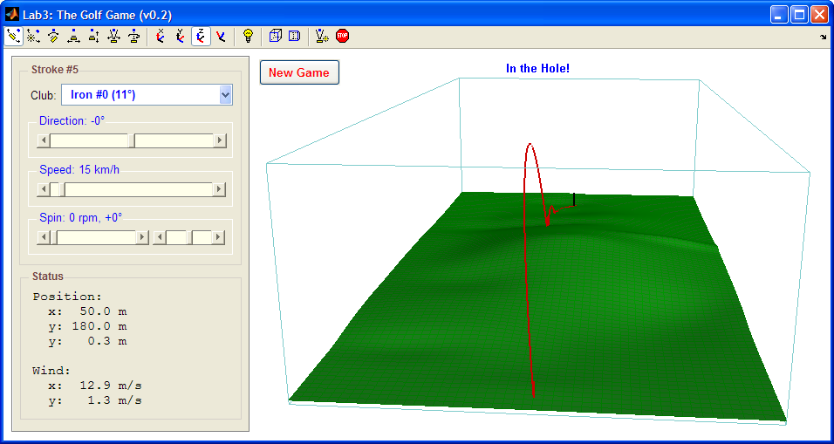
Figure 2.5–2: The snapshot of the GUI application.

Results

Basic Level Tasks

Maximum Distance
Maximum distance dependence on the initial velocity angle (club loft) under different simulation models (with or without dissipation or Magnus force) was analyzed.
The simulated trajectories (with the separation angle between different trajectories of 0.5°) under different conditions are shown on Figures 3.1-1 to 3.1-4 and the results are summarized in Table 3.1-1.
The results are also verified using Wolfram Mathematica and presented in Appendix A.
Table 3.1-1: Dependence of the maximum distance on the initial conditions.
Conditions | v₀  /(m/s) | angle  /° | ω₀  /(rad/s) | γ | C_{D} | C_{M} | distance  /m
Reference solution  (in vacuo) | 80 | 45.0 | 0 | - | 0 | 0 | 652
Laminar flow, with drag but without Magnus force | 80 | 44.5 | 0 | 1 | 0.3 | 0 | 626
Turbulent flow, with drag but without Magnus force | 80 | 36.5 | 0 | 2 | 0.3 | 0 | 212
Turbulent flow, with drag and with Magnus force | 80 | 11.5 | 10 | 2 | 0.3 | 0.025 | 244
The reference simulation shows that maximum distance is reached at 45 degrees angle, as expected.
Simulation for the laminar flow shows negligent differences in change of the angle and maximum distance when compared to the reference solution.
Simulations for turbulent flow without Magnus forces, when compared to the both laminar flow and the reference solution, shows a significant drop in maximum distance for 58 % that is reached at angle decreased for 20 %. This shows significant impact of the drag force on the maximum distance.
Simulations for turbulent flow with Magnus forces shows increase of 20 % in maximum distance at further reduced angle at 33 %. This shows how the Magnus effect extends maximum distance as increasing the lift force.
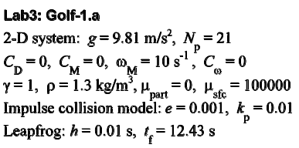
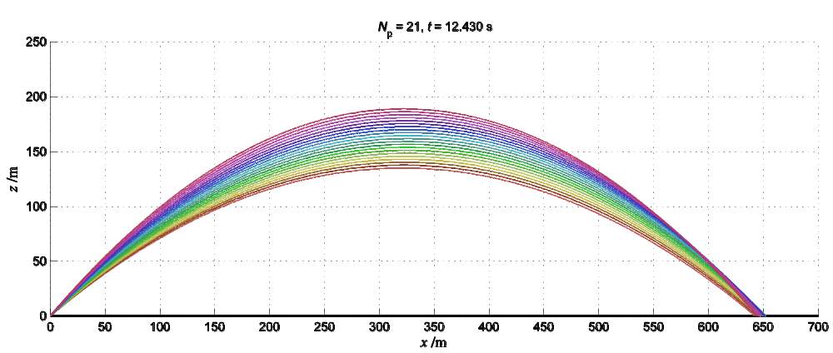
Figure 3.1–3: Reference trajectories for v₀ = 80 m/s and different initial angles 40°-50°, in vacuo
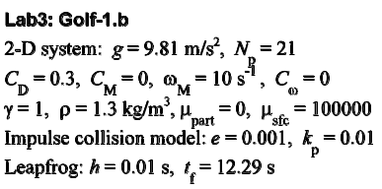
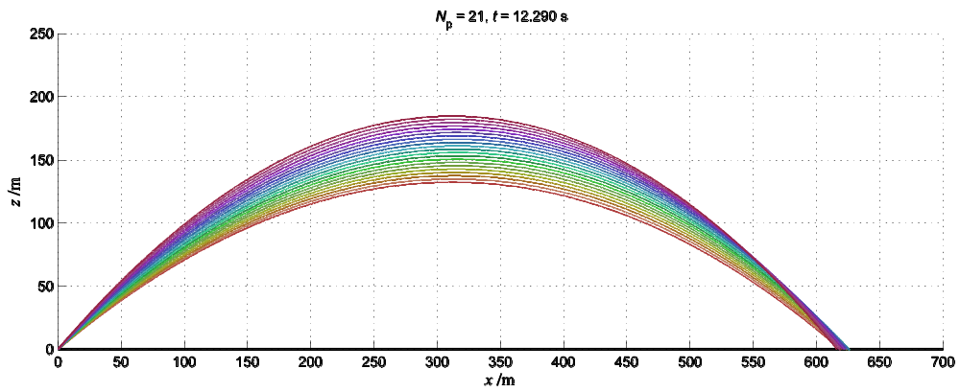
Figure 3.1–4: Trajectories for v₀ = 80 m/s and different initial angles 40°-50°, for laminar flow with air drag, without Magnus force
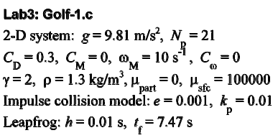
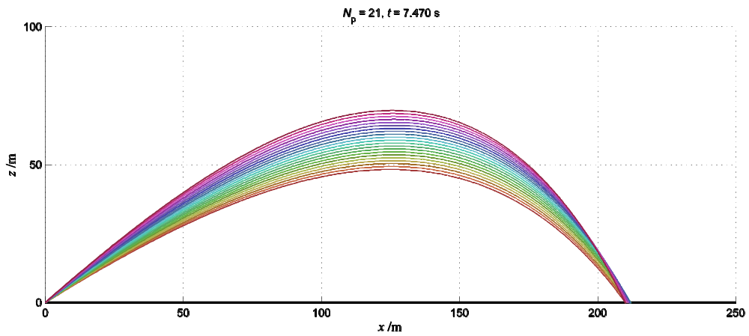
Figure 3.1–5: Trajectories for v₀ = 80 m/s and different initial angles 32°-42°, for turbulent flow with air drag, without Magnus force.
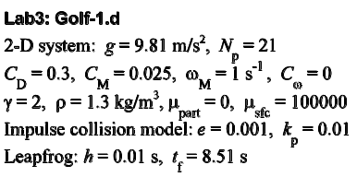
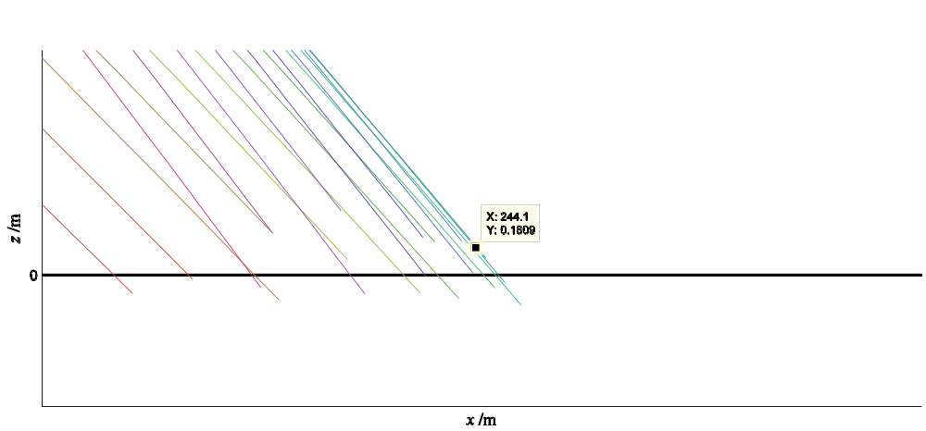
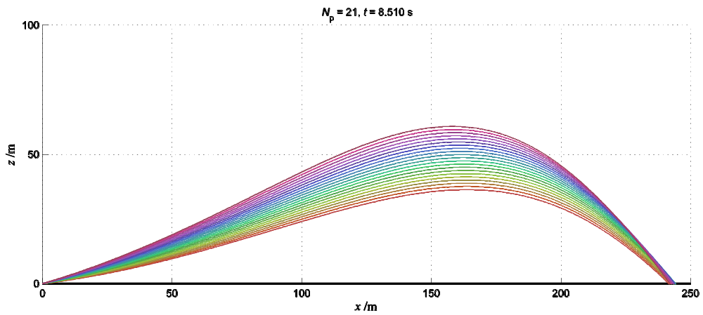
Figure 3.1–6: Trajectories for v₀ = 80 m/s and different initial angles 7°-17°, for turbulent flow with air drag, with Magnus force, initial angular velocity ω₀ = 10 rad/s and without angular velocity decay.

Example Simulation
Example simulation producing a trajectory where the ball stops in the hole is given on Figure 3.1–7.
The ball was hit 5 times with the following initial conditions:
- direction = 0°, v = 40 km/h, loft = 45°, spin = 0 rpm
- direction = 0°, v = 120 km/h, loft = 40°, spin = 600 rpm
- direction = −90°, v = 40 km/h, loft = 10°, spin = 0 rpm
- direction = −90°, v = 30 km/h, loft = 10°, spin = 0 rpm
- direction = 130°, v = 5 km/h, loft = 0°, spin = 0 rpm
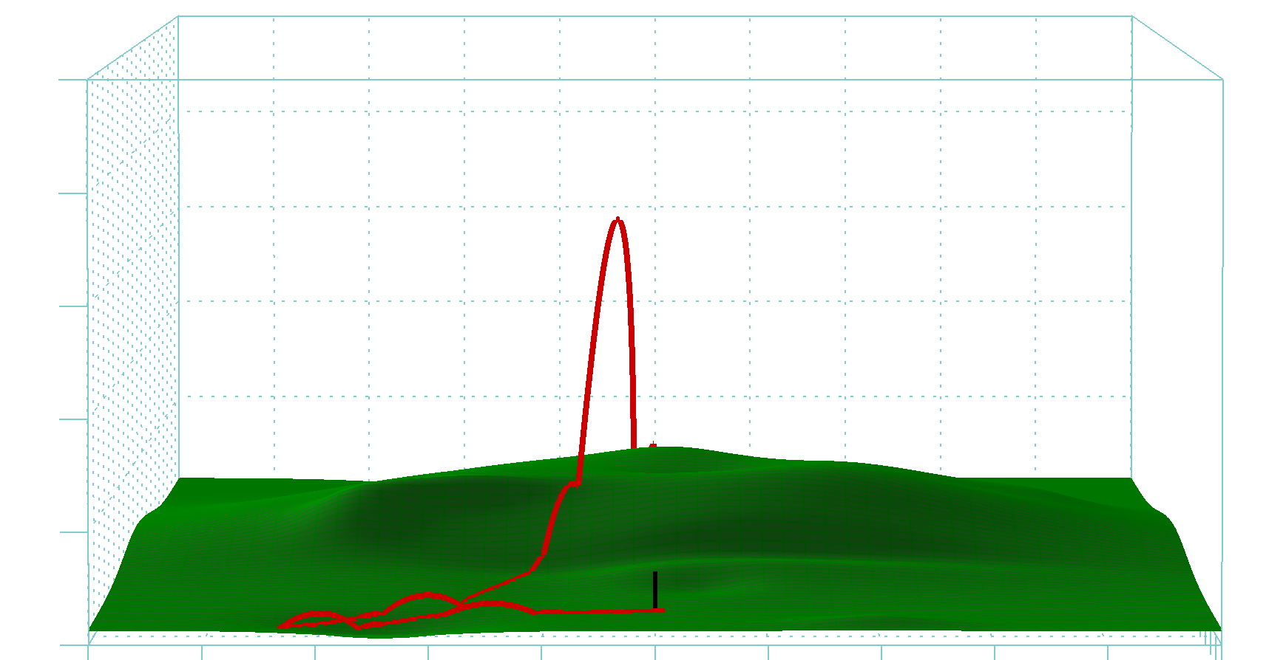
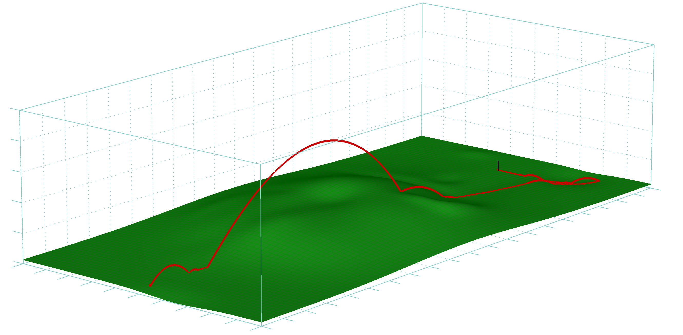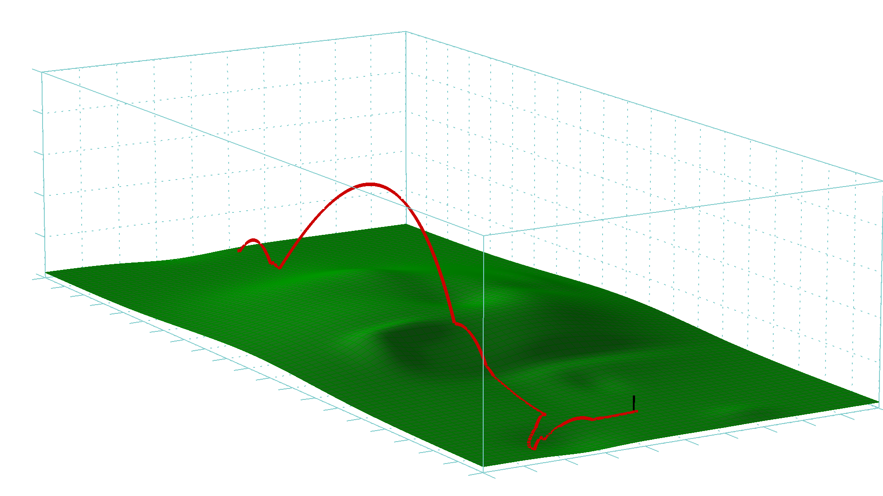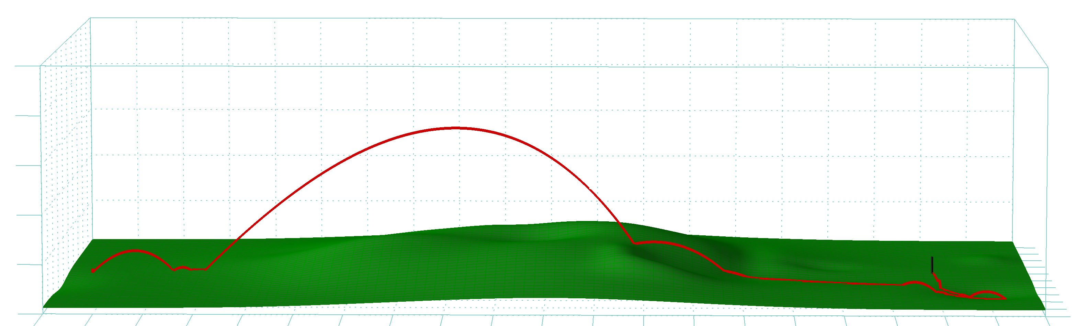
Figure 3.1–7: Snapshots of the simulation producing a trajectory where the ball stops in the hole

Advanced Level Tasks

Non-planar Terrain Height Field
Simulations demonstrating collisions with a non-planar terrain height, beside the previous simulation shown on Figure 3.1-6, are shown on the following two figures:

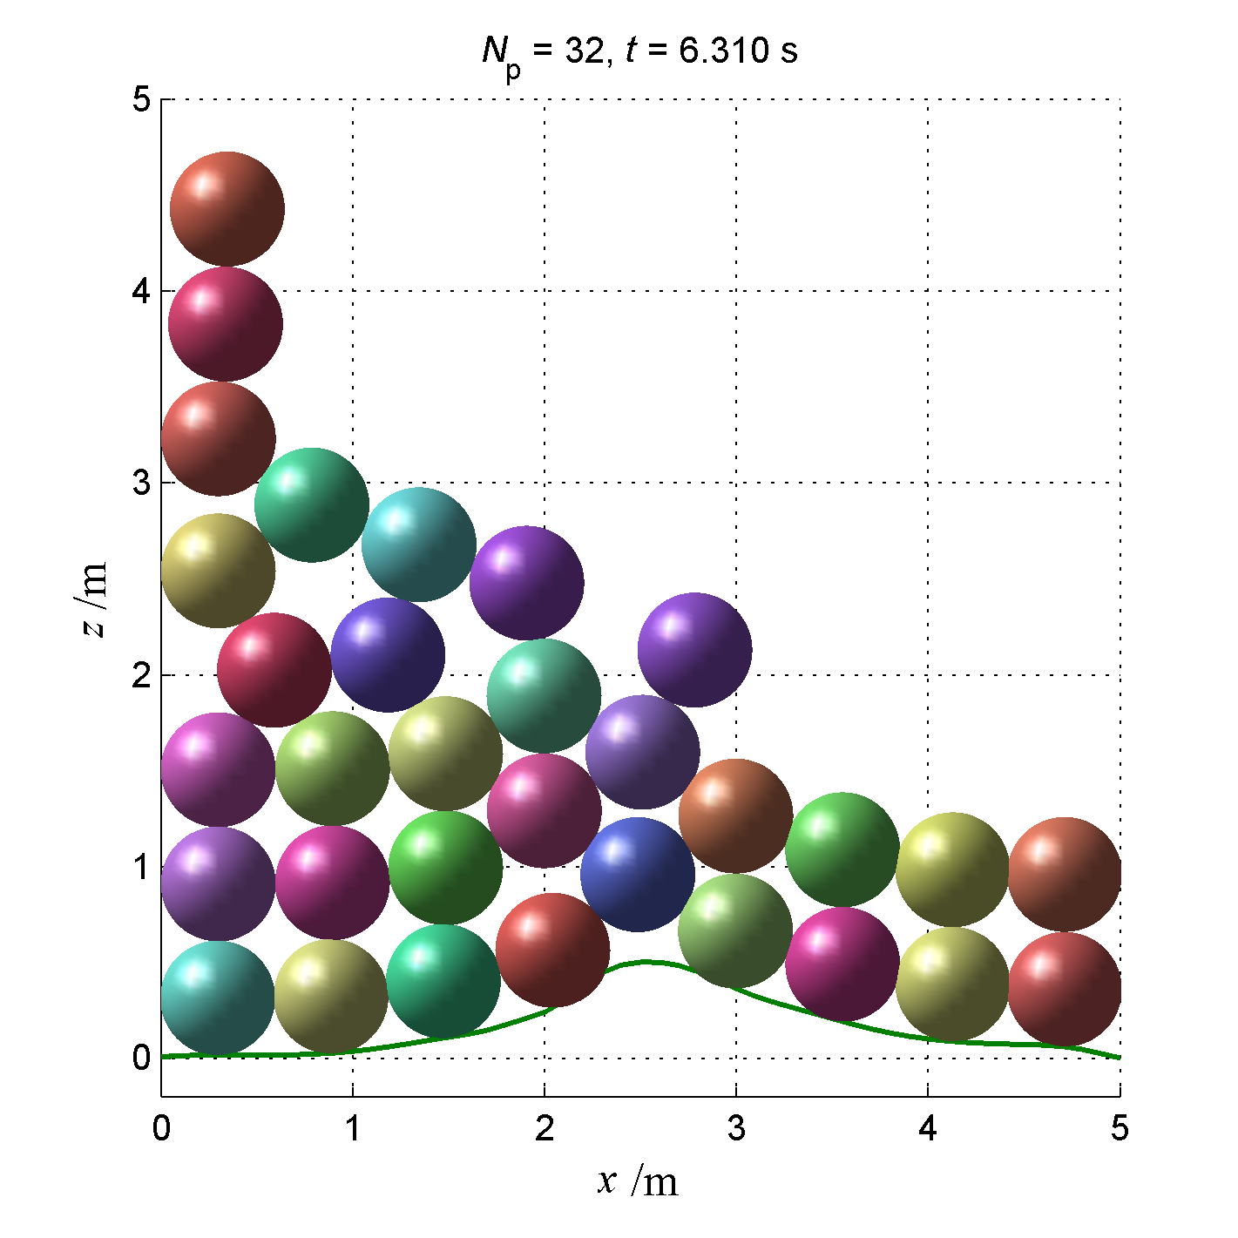
Figure 3.2–8: Simulation snapshot showing collisions with non-planar terrain height field in 2D.
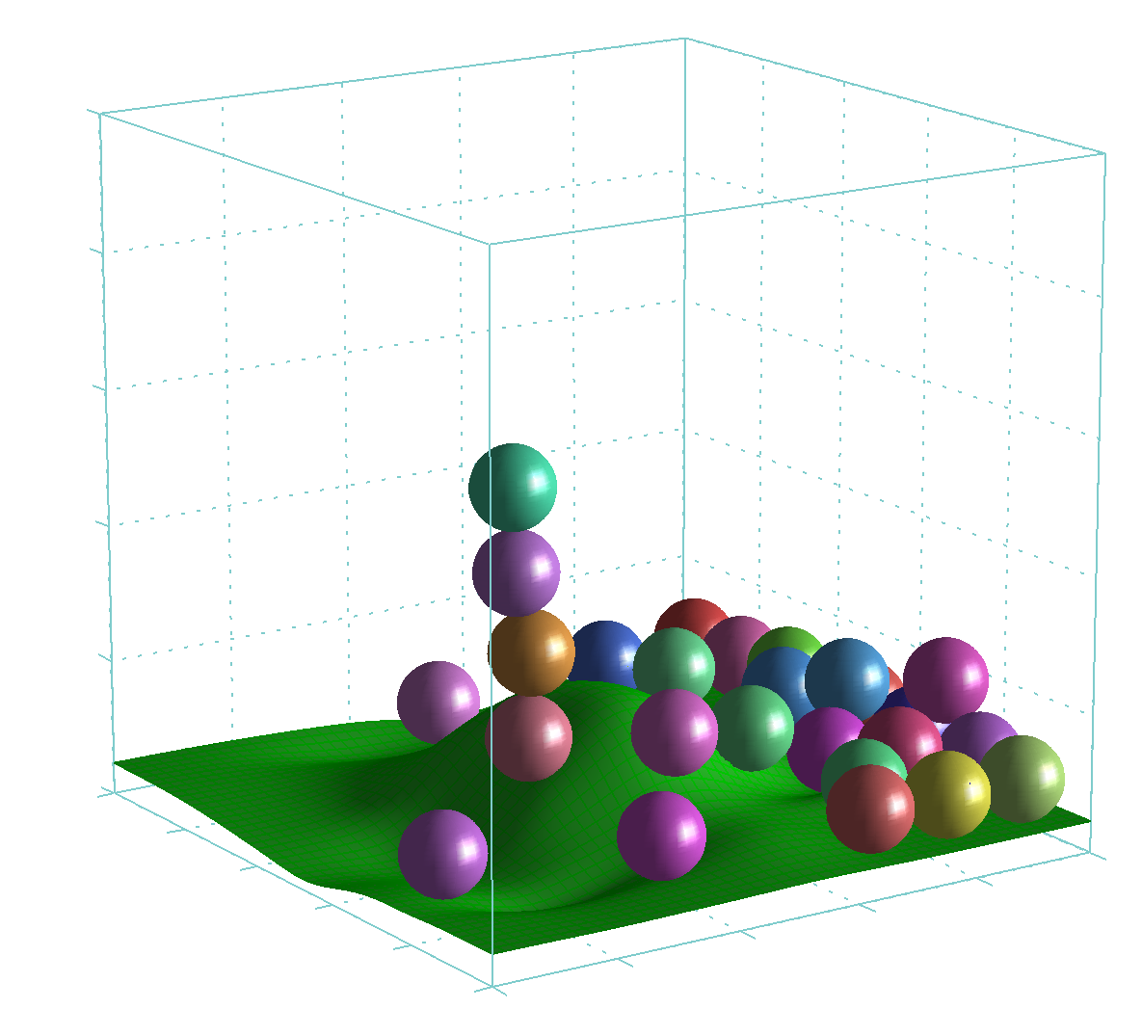

Figure 3.2–9: Simulation snapshot showing collisions with non-planar terrain height field in 3D.

Decaying Angular Velocity
The model for decaying angular velocity is presented in the Theory section. The graph displaying decaying angular velocity of the first golf ball is shown on the top of the following Figure 3.2–10. Figure which shows the snapshot of simulation where the ball was hit with iron #9 at initial velocity 144 km/h and initial spin 10800 rpm.

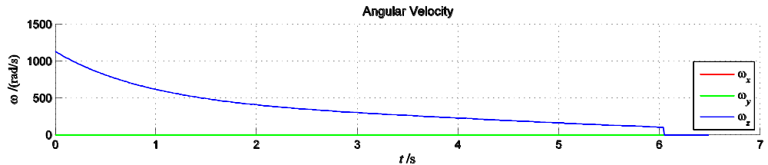
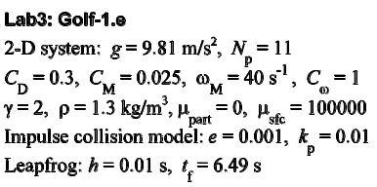
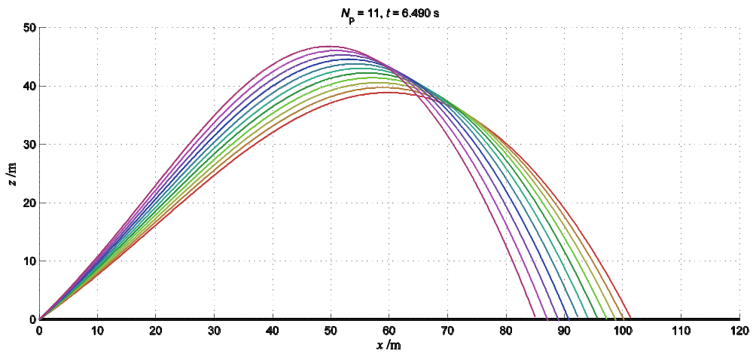
Figure 3.2–10: Decaying angular velocity of the ball example for C_{ω} = 1.
Trajectories for simulation with iron #9 hit at varied initial angles with initial ball velocity v₀ = 144 km and spin 10 800 rpm, turbulent flow with air drag, with Magnus force and with angular velocity decay included.

Impact of Fluid Velocity on Dissipative Forces
All dissipative forces in a fluid depend on the relative velocity of the object to the fluid. Equations for viscous drag force, Magnus force and angular velocity decay should be changed accordingly by replacing velocities with relative velocities to the fluid, where the relative velocity is calculated as 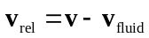. This means that the relative velocity is zero when object and fluid are traveling in the same direction at the same speed. The resulting equations are then:
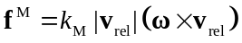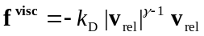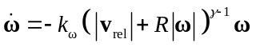
The snapshots of the simulations showing an impact of the wind speed are shown on the following two figures:
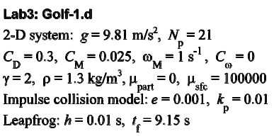
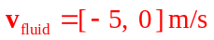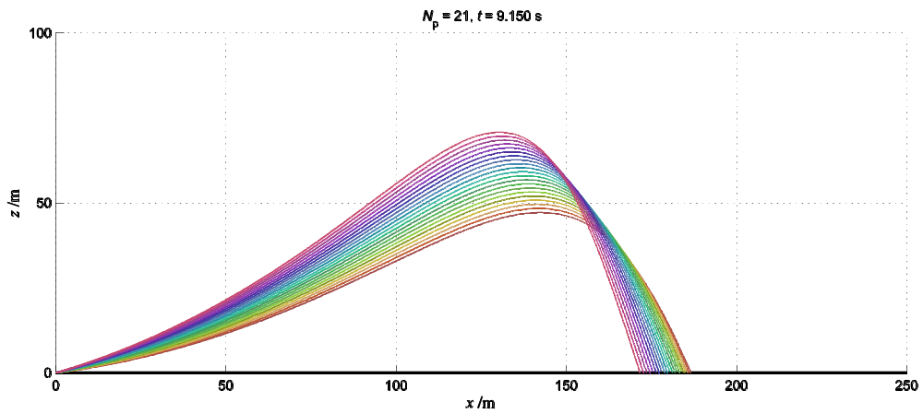
Figure 3.2–11: Trajectories for balls facing a headwind 5 m/s. Shots are with initial velocity v₀ = 80 m/s and varied different initial angles 7°-17°, for turbulent flow with air drag and Magnus force but without angular velocity decay.
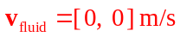
Figure 3.2–12: Trajectories for balls facing no wind. Shots are with initial velocity v₀ = 80 m/s and varied different initial angles 7°-17°, for turbulent flow with air drag and Magnus force but without angular velocity decay.

Effects of Friction on Collision
The snapshot of the simulation showing a ball on a non-planar terrain without friction is shown on Figure 3.2–13. The snapshot of the simulation with the same initial conditions but with friction between particle and the surface (for μ = 0.4) is shown on Figure 3.2–14. Note how particle stops on an inclined part of the terrain on the later figure.

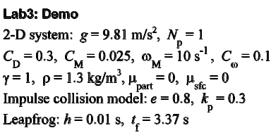
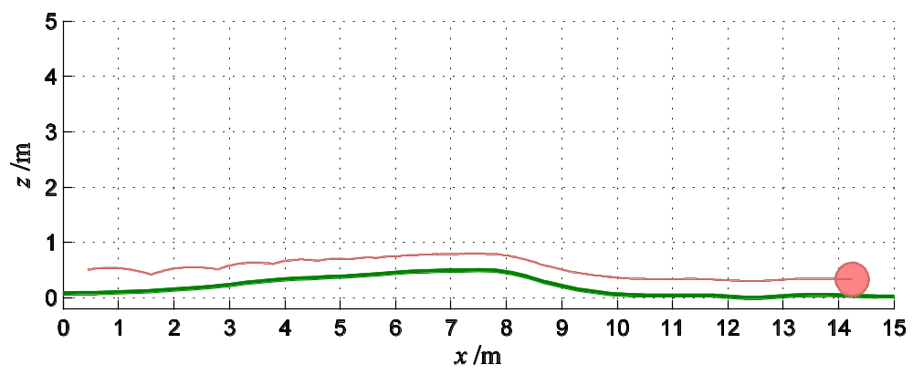
Figure 3.2–13: A ball jumping on a non-planar surface without a friction.

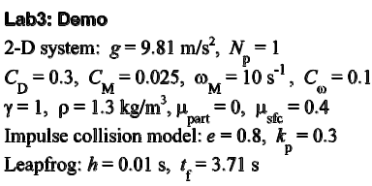
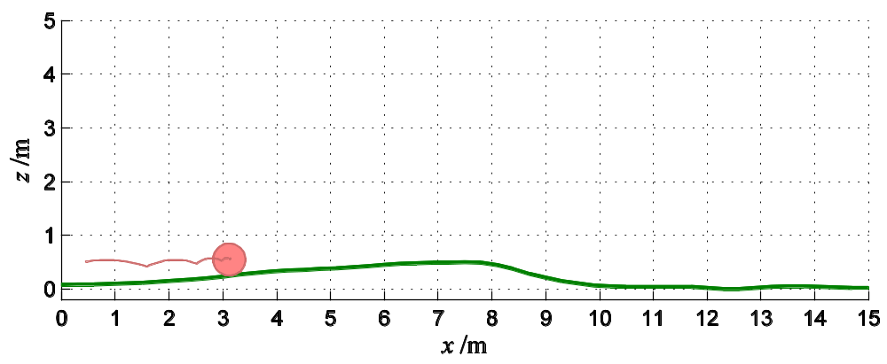
Figure 3.2–14: A boll jumping on a non-planar surface with a friction.

GUI Control Application
The snapshot of the GUI control application is shown on Figure 2.5–2 in Running the Golf Game section.

Discussion
The results emphasize an importance of verification of physical models and a high sensitivity of a physical model on values, and accepted ranges of values, of physical constants and properties emerged during a modeling of the physical system.

