Computer Lab 1
Shadowing a Particle

Mikica Kocic
2012-02-16, v2

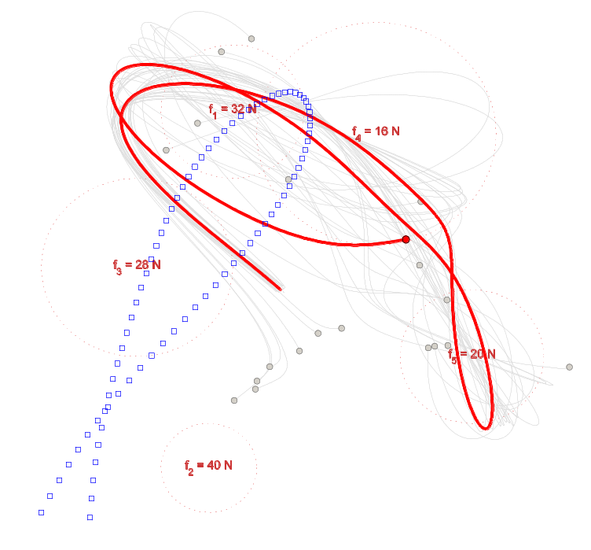

Mark what exercises you have done in this lab |  | Points  (by supervisor)
Basic level (mandatory) | ×
Extra exercise #1: min, average and max final position displacement from reference solution | ×
Extra exercise #2: abs position displacement error correlation to time-step size | ×
Extra exercise #3: abs energy error correlation to time-step size | ×
Extra exercise #4: abs displacement and energy errors correlation to numerical integrator | ×
The report is brief and to the point but still coherent and well structured.
Late report
Total points
Tutors: Martin Servin and John Nordberg

Background
The purpose of this lab was to study the numerical errors in the simulation of trajectory in a system of particles, and their relation to a) uncertainties in the initial conditions of the simulation, b) time-step size of the integration and c) choice of numerical integrator algorithm.
The simulated physical system was a 2D system of particles in the conservative force field which did not vary in time and without constraints and collisions. The model of the system was position-based governed by Newton’s equations of motion.
The tasks in brief were to: 1) simulate and visualize trajectories of the particles, 2) analyze the dependency of the trajectory on disturbances in the initial conditions, 3) analyze the dependency of 3.a) the trajectory and 3.b) the total energy on the integration time-step size, and 4) analyze the dependency of the trajectory and the total energy on different numerical integrator algorithms.

Implementation and Simulation
The system is modeled using position-based dynamics where the state of each particle is described with its mass, position and velocity, and where positions and velocities are given with initial conditions. The ODE of motion are given in explicit form of the conservative force vector field that is composed of several spherically symmetric attractive force fields and the gravity (refer to equations (1)-(4) in the Lab1 assignment document).
The model is implemented using MATLAB and the simulation is organized in the following modules:
- lab1_odeSolver.m: implements lab1_odeSolver function that simulates the trajectory of a single particle system (without visualization) and tracks the total energy of the system. Its main usage is calculation of the reference trajectory. However, it is also used for sanity-checks of simulations performed in lab1_main.
- lab1_main.m: implements lab1_main function that simulates and visualizes trajectories of a larger number of particles and calculates/tracks/plots the total energy of the whole system. It also compares simulated trajectories to the reference trajectory.
- lab1_testSuite.m: contains a script that runs a series of simulations for both basic and advanced level tasks in the assignment and produces all required results.
Since both lab1_odeSolver and lab1_main do almost the same job, the following table summarizes main differences between them:
 | lab1_odeSolver | lab1_main
Number of particles | N_{p} = 1 | N_{p} ≥ 1
Numerical integrator algorithms | Forward Euler  Semi-implicit Euler  4th-order Runge-Kutta  MATLAB ode45 | Forward Euler  Semi-implicit Euler  –  –
Uses matrices for calculations | – | Yes
Trajectory visualization | – | Yes
Total energy calculation | Yes | Yes
Energy levels visualization | – | Yes
Position displacement error statistics | – | Yes
Position displacement error calculation | Yes^{*)} | Yes
Total energy abs. error calculation | Yes^{*)} | Yes
^{*)} can be derived from returned results
In this lab in general, all implemented models follow overall algorithm for a simulation of a mechanical system as presented in course literature (Servin M., Notes on Discrete Mechanics, 2011). Further sections in this document provide particular implementation details of individual modules.
Default definitions/physical parameters used throughout all simulation modules are:
%%% Physical constants

g = [ 0, -9.81 ]; % Acceleration of Gravity, m/s^2

%%% Particle system parameters

N_p = 500; % Number of particles in the system
m = 1.0; % Particle mass, kg
L = 5.0; % Characteristic length of the system, m
x_t0 = [ -L, -L ]; % Particle initial position, m
v_t0 = [ 5, 10 ]; % Particle intital velocity, m/s

%%% Disturbances of the initial position and velocity

delX.lower = -0.02 * [L,L]; % lower bound for [x,y]
delX.upper = 0.02 * [L,L]; % upper bound for [x,y]
delV.lower = -0.02 * v_t0; % lower bound for [Vx,Vy]
delV.upper = 0.02 * v_t0; % upper bound for [Vx,Vy]

%%% Parameters of the spherically symmetric attractive force fields

fk = [ 32, 40, 28, 16, 20 ]' ; % fk(k) = strength of the force 'k'

rk = [ 0.3, 0.2, 0.4, 0.5, 0.3 ]' * L ; % rk(k) = radius of the force 'k'

pk = [ -0.2, 0.8 ; ... % pk1 % pk(k,:) = center position of the force 'k'
-0.3, -0.8 ; ... % pk2
-0.6, 0.1 ; ... % pk3
0.4, 0.7 ; ... % pk4
0.8, -0.3 ... % pk5
] * L;

%%% Integration parameters

t_0 = 0; % Initial time, s
t_f = 3; % Final (simulation) time, s

Module: lab1_odeSolver.m
Arguments:
solver one of 'ode45', 'rk4', 'forwardEuler' or 'semiEuler'; default: 'rk4'
N_pts number of points to return (i.e. rows in the result matrix); default: 80
relError relative error tolerance parameter, used by 'ode45' solver; default: 1e-7
h integration time-step parameter, used by other solvers; default: 1e-3
Returns the solution as the matrix N_pts×6 in the following format:
[ t₀ x₀ y₀ v_{x,0} v_{y,0} E_{tot,0} ;
t₁ x₁ y₁ v_{x,1} v_{y,1} E_{tot,1} ;
...
t_{f} x_{f} y_{f} v_{x,f} v_{y,f} E_{tot,f} ]
This module simulates lab1 equations of motion using time integration and tracks the total energy of the system. The functional structure of the module is:
- definitions / physical model parameters
- call selected ODEsolver (solve particle trajectory)
- calculate the total energy
where ODEsolver is either MATLAB’s ode45 function or one of the module’s nested functions: MyForwardEuler, MySemiEuler or MyRK4. The Lab1 equations of motion are implemented in nested function odeFunc and passed as a function handle to ODEsolver.
Runge-Kutta algorithm that is implemented in MyRK4 solver is described in (Mathews, 1992).
The module does not have other parameters beside the common physical model parameters.
Example usage:
>> lab1_odeSolver( 'rk4', 4, 0, 1e-2 )
ans =
0 -5.0000 -5.0000 5.0000 10.0000 13.0088
1.0000 0.1100 2.1882 3.0135 5.4953 13.0088
2.0000 -1.4480 3.2412 -4.1377 -5.2590 13.0088
3.0000 -3.9838 -5.1190 -0.8320 -11.3437 13.0088
Note: When called without arguments, lab1_odeSolver returns the reference trajectory obtained using the rk4 algorithm with time-step h = 1e-3.

Module: lab1_main.m
Arguments:
testSuiteNo ID of the test profile corresponding to specific parameter setup. If omitted, parameters are configured as required for the ‘basic level’ simulation in the assignment specification.
Returns the solution as matrix 2×6 in the following format:
[ t₀ x₀ y₀ v_{x,0} v_{y,0} E_{tot,0} ;
t_{f} x_{f} y_{f} v_{x,f} v_{y,f} E_{tot,f} ]
This module simulates and visualizes trajectories of larger number of particles and tracks and plots total energy of the whole system. Simulated trajectories of the disturbed particles are animated and compared to the reference trajectory. The first particle can be optionally marked not to be disturbed.
The simulation is force based, i.e.: first, all internal and external forces are accumulated from which accelerations are computed based on Newton’s second law of motion, and second: the positions and velocities of the particles are updated using a time integration method.
The functional structure of the module is:
- parameters, definitions and physical model constants and initialization of state variables
- simulation loop with update of state and derived variables and trajectory animation
- if N_{p} > 1, calculate displacement absolute error statistics (min, max, avg and std dev)
- display of calculated data and optionally the figure with energy level plots
Additional parameters, beside the physical model parameters, are:
%%% Simulation and visualization control flags

flags.Disturbed = true; % Disturb position and velocities
flags.UndisturbN1 = true; % Do not disturb particle #1
flags.Animate = true; % Render particles in real-time
flags.SaveFigures = false; % Save figures (plots) as EPS files
flags.PlotEnergy = true; % Plot kinetic, potential and total energy over time

%%% Integration parameters

h = 0.01; % Time-step, s
stepper = 'ForwardEuler'; % Forward Euler time-integration
%stepper = 'SemiEuler'; % Semi-implicit Euler time-integration
Note that the testSuiteNo argument ‘suits’ default parameters to a specific pre-configured parameter set. E.g. suite nr 42 performs silent simulation (without animation and plots, but with textual reports) with the parameter set: N_p = 500, h = 0.01 and stepper = 'SemiEuler'; overview of the test-suite IDs can be found in ‘Test Suite Setup’ section in lab1_main.m.
When called without arguments, lab1_main runs the basic level simulation as described in the assignment document.
Example usage:
>> lab1_main % run basic-level simulation
>> lab1_main(11) % run basic-level simulation and save figures as EPS files

Performance Considerations
The module lab1_main uses matrices for the representation of the state variables. Matrices for particle positions, velocities and forces of the system have dimension N_{p} × 2 (one row per particle). Particle masses are also represented with N_{p} × 2 dimensional matrix, so that the mass of the i-th particle is kept doubled in i-th row. This way, for example, forward Euler time-integration is implemented as:
for n = 1:NT
X = X + h * V; % solve positions
V = V + h * F_tot ./ M; % solve velocities
end
Further, matrices of the state variables can be easily ‘vectorized’ to 2N_{p}-dimensional vectors when needed, like in the following example when calculating the kinetic energy:
E_k = 0.5 * ( ( M(:) .* V(:) )' * V(:) ); % calculate kinetic energy of the system
Other optimizations include the usage of bsxfun function, like in the following example used to calculate the force of the gravity field:
F_tot = bsxfun( @times, M, g ); % calculate gravity force
or the potential energy of the gravity field:
E_p = - trace( X' * bsxfun( @times, M, g ) ); % calculate potential energy of the gravity
On the other hand, the calculation of the total force is not vectorized – it is rather done by accumulating total force in nested loops for each particle and source field. However, implemented algorithm is optimized using MATLAB profiler so that 1) the usage of the norm function is removed, and 2) the ‘for each particle’ loop is placed inside ‘for each source’ loop, as in the following code-snippet from the module:
< 0.01 316 for k = 1:NS % For each source in the force field
< 0.01 317 for i = 1:N_p % For each particle
0.58 324 X_p = X(i,:) - pk(k,:);
0.09 325 sq_X_p = X_p(1)^2 + X_p(2)^2;
0.87 327 F_tot(i,:) = F_tot(i,:) - fk... ;
0.10 332 end
< 0.01 333 end
Usage of the norm function otherwise makes implementation ~4 times slower (!) and reversing of nested loops makes implementation ~10 % slower, as shown in the following profiling report:
● Simulation with ‘for each particle’ loop inside ‘for each source’ loop and with norm function:
< 0.01 316 for k = 1:NS % For each source in the force field
< 0.01 317 for i = 1:N_p % For each particle
0.67 324 X_p = X(i,:) - pk(k,:);
3.62 325 norm_X_p = norm( X_p );
2.05 327 F_tot(i,:) = F_tot(i,:) - fk... ;
0.15 332 end
< 0.01 333 end
● Simulation with ‘for each source’ loop inside ‘for each particle’ loop and without norm function:
< 0.01 316 for i = 1:N_p % For each particle
0.05 317 for k = 1:NS % For each source in the force field
0.51 324 X_p = X(i,:) - pk(k,:);
0.02 325 sq_X_p = X_p(1)^2 + X_p(2)^2;
0.96 327 F_tot(i,:) = F_tot(i,:) - fk... ;
0.10 332 end
0.02 333 end

Module: lab1_testSuite.m
This module contains a script that runs a series of different simulations and produces all results as required by the assignment for both the basic and advanced level tasks.
The functional structure of the module is:
- perform the basic-level and the simulation for advanced-level task 1
- perform the simulations for advanced-level tasks 2-4
The only configurable parameter for this module is flags.SaveFigures boolean, which controls whether to save generated figures as EPS files or not.
Regarding the advanced tasks 2, 3 and 4, the script performs all required simulations in the single nested loop, since the simulations for tasks 2 and 3 differs from the simulations for task 4 only in a choice of numerical integrator.
Thus, the combined algorithm for the advanced tasks 2, 3 and 4 is implemented as:

algos = { 'ForwardEuler', 'SemiEuler', 'RK4' }; % Analyzed numerical integrators
H = [ 0.5, 0.1, 0.05, 0.01, 0.005, 0.001 ]; % Analyzed time-steps

for j = 1 : length(algos)
for i = 1 : length(H)

% Simulate lab1 ODE using given algorithm with given time-step

sol = lab1_odeSolver( algos{j}, 2, 0, H(i) );

X_n = sol(2,2:3); % get final X(n)
E_tot_0 = sol(1,6); % get initial E_tot(0)
E_tot_n = sol(2,6); % get final E_tot(n)

% Collect results:

store in result matrix norm( X_n - X_f ); % abs err of X
store in result matrix abs( E_tot_n - E_tot_0 ); % abs err of E_tot
end
end
After the loop, data collected in the result matrix is printed in textual form and then shown on the log/log diagrams.

Running Simulation
To run the complete set of simulations, simply execute the script from the MATLAB command prompt:
>> lab1_testSuite

Results

Basic Level Tasks
The results of the main simulation are shown on Figure 3.1–1, where the shadow trajectories of disturbed particles are shown in gray and the reference solution is shown as blue boxes. The figure shows also the trajectory of the undisturbed particle highlighted in red. The reference trajectory is simulated using 4-th order Runge-Kutta (h = 0.001 s) and the shadow trajectories and the trajectory of the undisturbed particle are simulated using forward Euler integrator (h = 0.01 s).
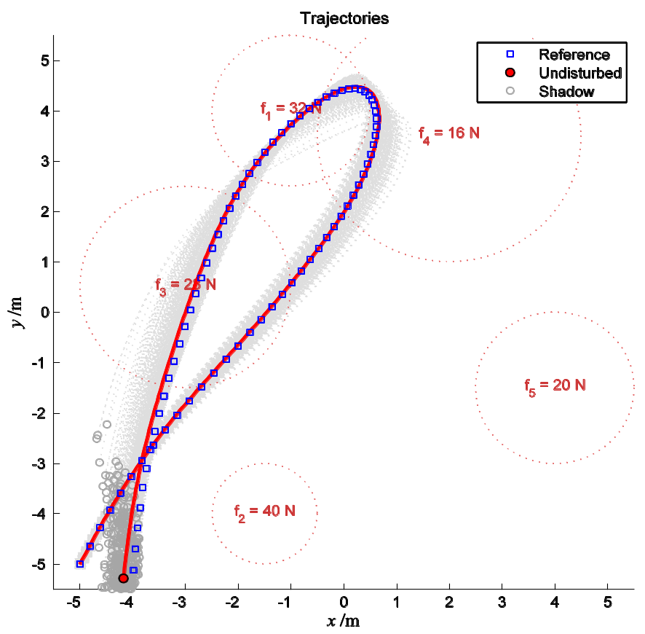
Figure 3.1–1: Shadow trajectories (N_{p} = 500) obtained using forward Euler integrator (h = 0.01 s).
For comparison, the position, velocity and the total energy of the reference particle over the time are summarized in the following table:
t /s | x /m | y /m | v_{x} /(m·s⁻¹) | v_{y} /(m·s⁻¹) | E_{tot} /J
0.000 | −5.0000 | −5.0000 | 5.0000 | 10.0000 | 13.0088
1.000 | 0.1100 | 2.1882 | 3.0135 | 5.4953 | 13.0088
2.000 | −1.4480 | 3.2412 | −4.1377 | −5.2590 | 13.0088
3.000 | −3.9838 | −5.1190 | −0.8320 | −11.3437 | 13.0088
and the same variables of the undisturbed particle are summarized in the following table:
t /s | x /m | y /m | v_{x} /(m·s⁻¹) | v_{y} /(m·s⁻¹) | E_{tot} /J
0.000 | −5.0000 | −5.0000 | 5.0000 | 10.0000 | 13.0088
1.000 | 0.1280 | 2.2020 | 3.0465 | 5.4805 | 13.1660
2.000 | −1.4094 | 3.2685 | −4.4234 | −5.4530 | 15.2254
3.000 | −4.1784 | −5.2787 | −1.2088 | −11.5980 | 15.3508

Advanced Level – Task 1
The minimum, maximum, average and standard deviation of the position displacement 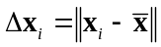 of the simulated particle positions 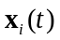 at 1) initial time t₀ and 2) final time t_{f} as compared to the reference solution 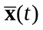 respectively, are shown in the following tables:
Table 3.2-1: Statistics for initial displacements (random disturbances, uniform distribution)
where:
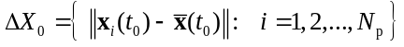
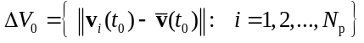
 | ∆X₀ /m | ∆V₀ /(m·s⁻¹)
Minimum | 0.005 | 0.011
Maximum | 0.139 | 0.220
Average | 0.078 | 0.115
Standard deviation | 0.028 | 0.051

Table 3.2-2: Statistics for final displacement errors
where:
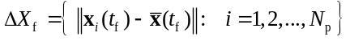
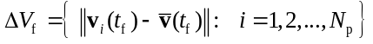
 | ∆X_{f} /m | ∆V_{f} /(m·s⁻¹)
Minimum | 0.043 | 0.026
Maximum | 3.867 | 3.844
Average | 0.687 | 0.777
Standard deviation | 0.460 | 0.444

Sample data was obtained from the simulation for N_{p} = 500 using forward Euler integrator (h = 0.01 s) and contains statistics also for the velocity displacements 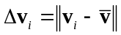 at initial and final time.

Advanced Level – Tasks 2, 3 and 4
The comparison of the trajectory displacement ||∆x|| and the total energy error |∆E_{tot}| for different numerical integrator methods and time-step sizes are shown in Table 3.3-3 and Table 3.3-4 bellow, as well on Figure 3.3–2 and Figure 3.3–3 on the next page.
Table 3.3-3: The position displacement absolute error ||∆x|| for different numerical integrator methods and time-step sizes
 | ||∆x|| /m
h /s | Forward Euler | Semi-implicit Euler | 4th-order Runge-Kutta
0.5 | 4.097 | 30.402 | 1.309 387 059 813
0.1 | 2.101 | 3.059 | 0.002 253 353 932
0.05 | 1.192 | 1.246 | 0.000 119 572 636
0.01 | 0.252 | 0.219 | 0.000 000 155 805
0.005 | 0.126 | 0.108 | 0.000 000 009 436
0.001 | 0.025 | 0.021 | 0.000 000 000 015

Table 3.3-4: The total energy absolute error |∆E_{tot}| for different numerical integrator methods
and time-step sizes
 | |∆E_{tot}| /J
h /s | Forward Euler | Semi-implicit Euler | 4th-order Runge-Kutta
0.5 | 112.667 | 61.315 | 2.555 465 352 268
0.1 | 25.370 | 5.577 | 0.011 585 215 806
0.05 | 12.249 | 4.048 | 0.000 443 531 999
0.01 | 2.342 | 0.868 | 0.000 000 318 252
0.005 | 1.169 | 0.441 | 0.000 000 016 784
0.001 | 0.234 | 0.089 | 0.000 000 000 023

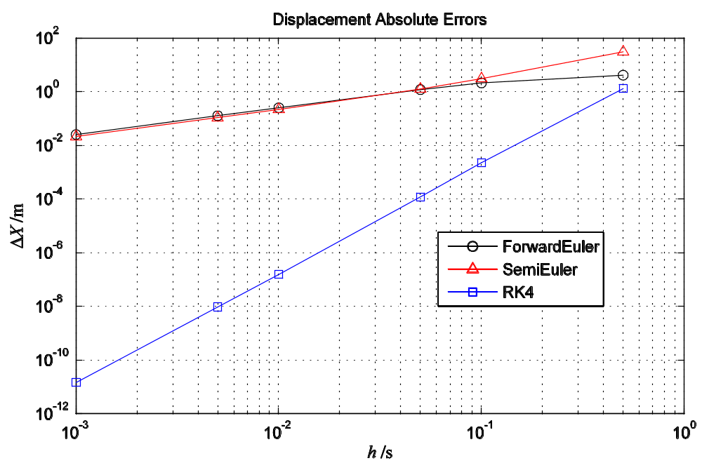
Figure 3.3–2: The position displacement absolute error ||∆x|| for different numerical integrator methods and time-step sizes

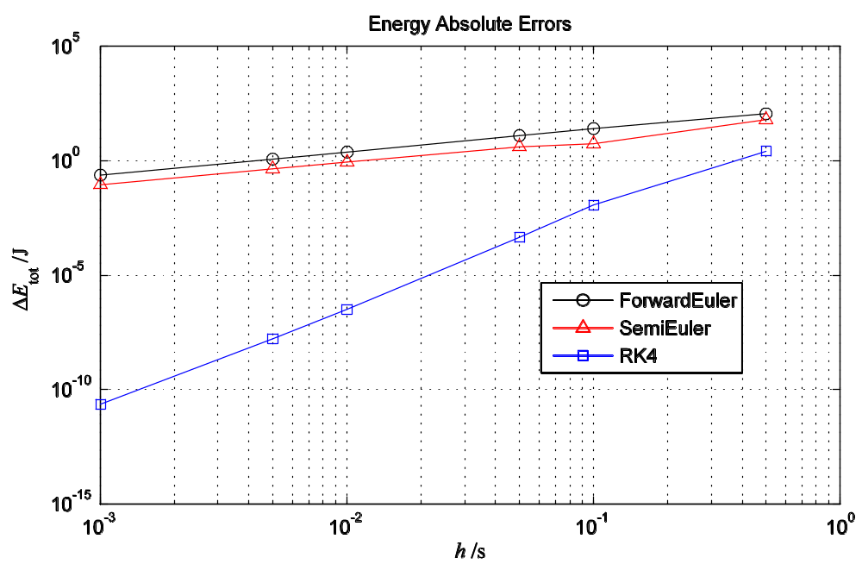
Figure 3.3–3: The total energy absolute error |∆E_{tot}| for different numerical integrator methods
and time-step sizes

Discussion
The results show the dependence of the numerical errors from the uncertainties in the initial conditions, selected time-step size of the integration and the choice of numerical integrator algorithm.

Influence of the Initial Conditions
From the statistical results in Table 3.3-3 and Table 3.3-4, it can be seen that, for the modeled physical system during the period of time 3 s, the forward Euler integrator (h = 0.01 s) magnifies 1) the initial position disturbances from δx₀ = 0.078(29) m to final δx_{f} = 0.687(460) m, and 2) the initial velocity disturbances from δv₀ = 0.115(50) m/s to final δv_{f} = 0.777(443) m/s, where the number in parentheses is the numerical value of the standard deviation referred to the corresponding last digits of the quoted result; this gives approximately δx_{f} /δx₀ ~ 9 and δv_{f} /δv₀ ~ 7.
Note that during the simulation, the random initial conditions were distributed uniformly in the rectangular box in the phase space. It would be more appropriate, however, to use normally distributed spatially spherical disturbances, so the position and velocity displacement errors (calculated as norms) would be more meaningful.

Influence of the Time-Step Size
Data on figures Figure 3.3–2 and Figure 3.3–3 (and corresponding tables Table 3.3-3 and Table 3.3-4) shows that, for the analyzed numerical integrator algorithms, the numerical errors follow the power-law of the integration time-step size since the graphs on the referred figures are plotted in log/log scale and they resemble linear functions with the different slope for different numerical integrator.
Thus, it could be conjectured that log(δ) = c + k log(h) or that δ ∝ h^{k}, where k is the constant dependent of the numerical integrator and δ is the numerical error (either the position displacement absolute error ||∆x|| and total energy absolute error |∆E_{tot}|).
The respective values of k calculated from Table 3.3-3, i.e. from δ =||∆x|| as a function of h, are:
 | Forward Euler | Semi-implicit Euler | 4th-order Runge-Kutta
k | 0.960 | 1.078 | 4.088
and the respective values of k calculated from Table 3.3-4, i.e. from δ =|∆E_{tot}| as a function of h, are:
 | Forward Euler | Semi-implicit Euler | 4th-order Runge-Kutta
k | 1.018 | 0.898 | 4.351

Influence of the Numerical Integrator Algorithm
Similarly, data on figures Figure 3.3–2 and Figure 3.3–3 (and corresponding tables) show the significant difference between the numerical errors obtained using different numerical integrator algorithms for the same time-step size.
Starting from the previous conclusion that the numerical error δ is proportional to h^{k}, it can be seen that the slope k is nearly the same for the forward Euler and the semi-implicit Euler integrators, while the slope k for the 4th-order Runge-Kutta integrator is roughly 4 times steeper than for the Euler integrators. This agrees with the theory, as k correlates to the order of the used numerical integrator methods.

Energy Conservation
Since the system is modeled without dissipative forces, it is expected that the total energy of the system is conserved; but—as previously concluded—there is the power-law dependency of the total energy absolute error of the time-step, meaning that the total energy eventually drifts away with time. On the other hand, how fast the total energy drifts away differs between numerical integrators.
The most interesting difference is notably between the forward Euler and semi-implicit Euler integrators, since both are first-order integrators and also have the same algorithmic complexity. Namely, simulated data shows that the semi-implicit Euler method almost conserves the energy, while the energy increases steadily using the standard Euler method.
This can be observed on Figure 3.3–3 where the semi-implicit Euler curve is slightly bellow the forward Euler curve, and also on the following figures showing how the energies of the undisturbed particle changes over time, for both integrators respectively:
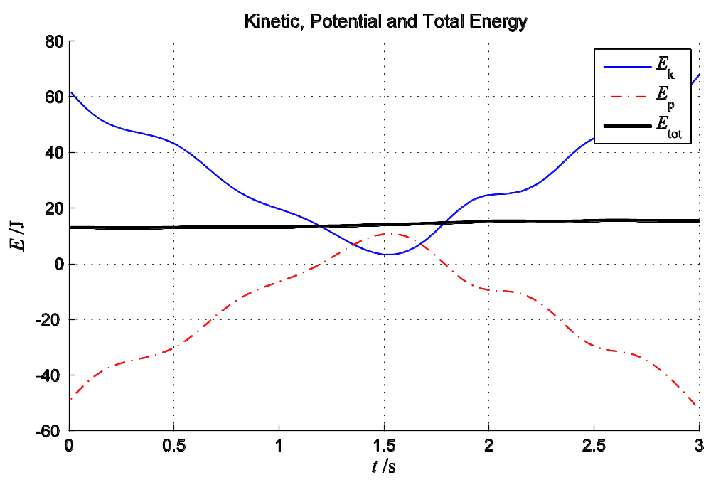
Integrator: Forward Euler, h = 0.01 s
Figure 4–4: The energies of the undisturbed particle (N_{p} = 1) over the time, obtained using the forward Euler integrator (h = 0.01 s)

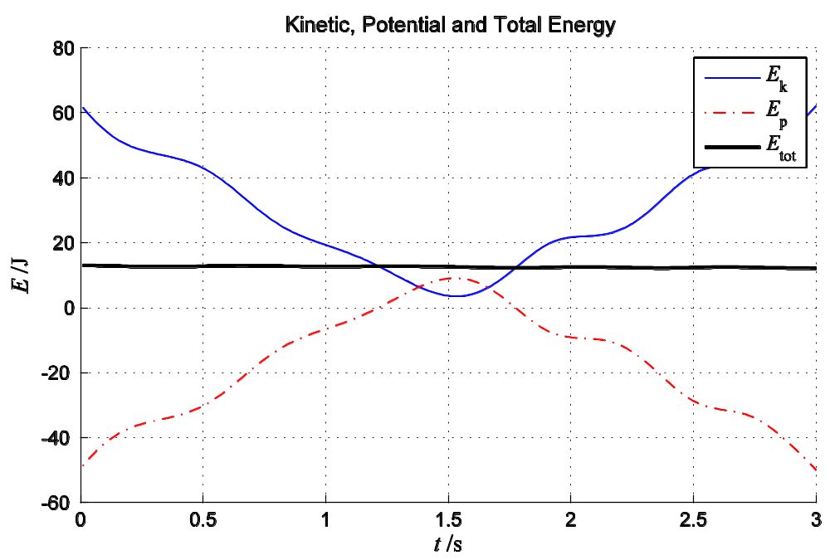
Integrator: Semi-implicit Euler, h = 0.01 s
Figure 4–5: The energies of the undisturbed particle (N_{p} = 1) over the time, obtained using semi-implicit Euler integrator (h = 0.01 s)
At the same time, regarding the position displacement absolute errors, the semi-implicit Euler performs also slightly better than forward Euler for time-step sizes h ≤ 0.01 s. This can be also observed on the following comparative figure showing trajectory simulations for the undisturbed particle for forward Euler (to the left) and semi-implicit Euler integrator (to the right):
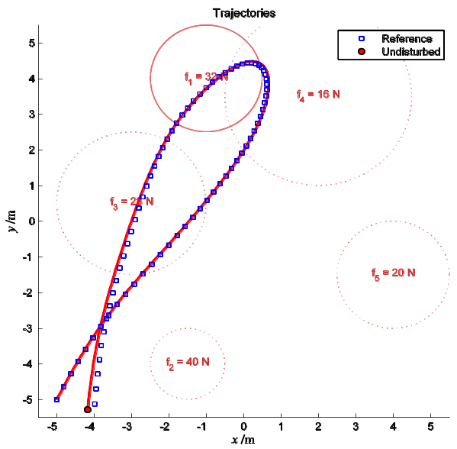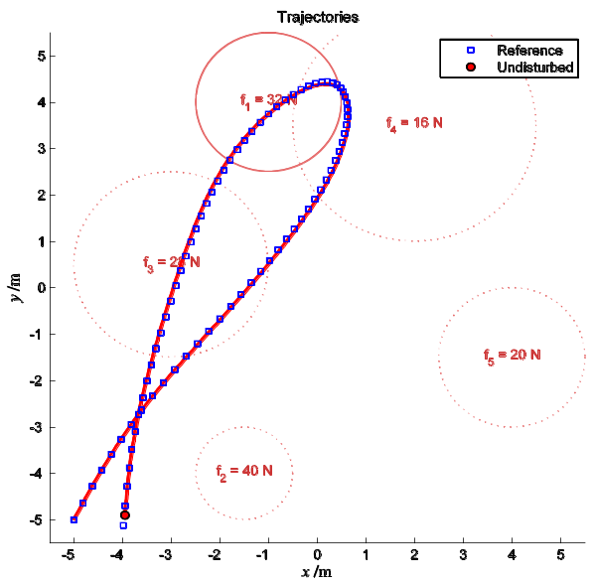
Forward Euler
h = 0.01 s
Semi-implicit Euler
h = 0.01 s

Figure 4–6: Trajectories of the undisturbed particle obtained using the forward Euler (left) and the semi-implicit Euler integrator (right) with h = 0.01 s

References
- Mathews, John H., Numerical Methods for Mathematics, Science and Engineering, 2nd Ed, Prentice Hall, 1992, Section 9.5: Runge-Kutta Methods (p. 460)

