New Tickets Only From Know Emails

Absctract
An OTRS Package that block the creation of new tickets from e-mails which are not registered on the system as customers.

Configuration
Install the Package throught the Package Manager
At this time, your system will start to send all unwanted e-mails as tickets under the Junk queue

Access SysConfig → Ticket → Core::Postmaster
Scroll the screen to find the parameters bellow:
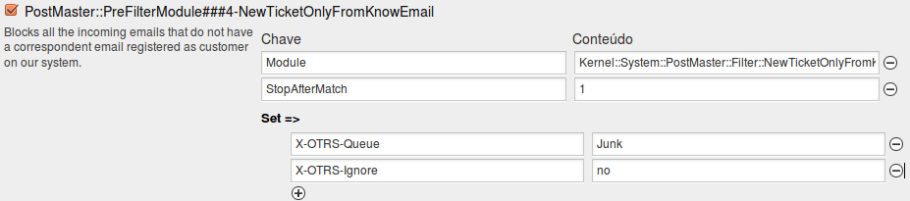
If want to move the unwanted tickets to other queue, change X-OTRS-Queue parameter.
If you just want to discar the tickets from unkown customers, change the parameter X-OTRS-Ignore, from “no” to “yes”.
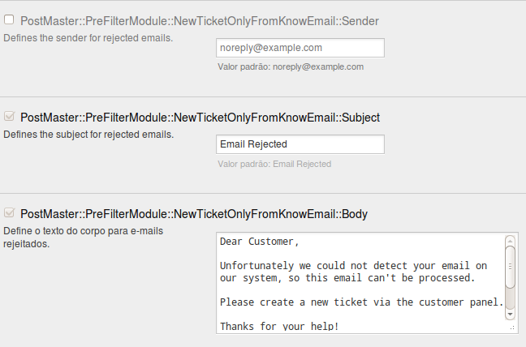
Those parameters above allows you to customize the message that will be sent to the unknow sender.

