**PicNiC: Pediatric Nutrition Checker**

**Project Documentation**

In partial fulfillment of the requirements for Blue Hacks 2017

The Global Goals: For Sustainable Development

Submitted by:

Team RARR

Members:

Cabrera, Reuben Joseph B.

Lopez, Abegail Lyn C.

Quito, Rai Earl Don S.J.

Valdez, Romeo Jr. C.

February 19, 2017

**Table of Contents**

1. Project Overview
2. Software Requirements Specification
3. User’s Manual
4. Technical Manual
5. System Quality Assurance
6. **Project Overview**
   1. **Project Description**

This project aims to inform families/communities of the nutritional state of their members, and what steps they should take to get back on the road to wellness.

1. **Software Requirements**
   1. **System Functionalities**

The app possesses several functionalities that help serve this purpose:

1. Family Account Registration through Google
2. BMI Calculator
3. Basic Health Information from BMI Result
4. Direct SMS between Families and Doctors
   1. **Users and User Roles**
      1. Family/Community
         1. One account for all members.
         2. Per new user, will add another member to the account.
      2. Nutritionist
         1. Provide necessary information to the family and community members.
   2. **Limitations of the System**
5. The app is not usable when there is no internet connection.
6. Not all families have a smart phone.
7. **User’s Manual**
   1. **User Login**

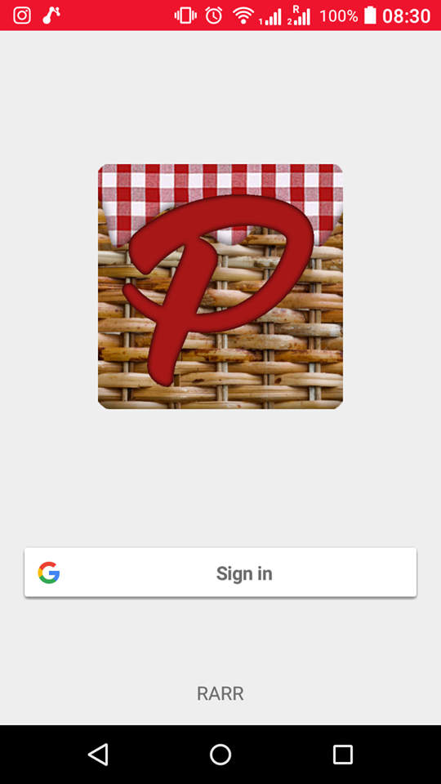

* 1. **Verification**

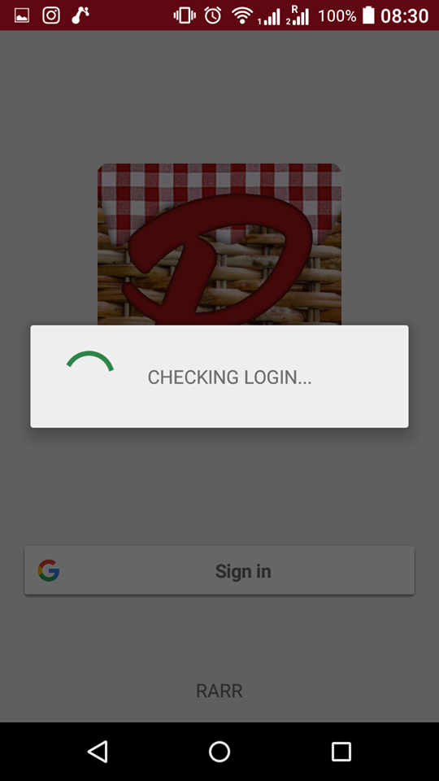

* 1. **Successful Login User Interface**

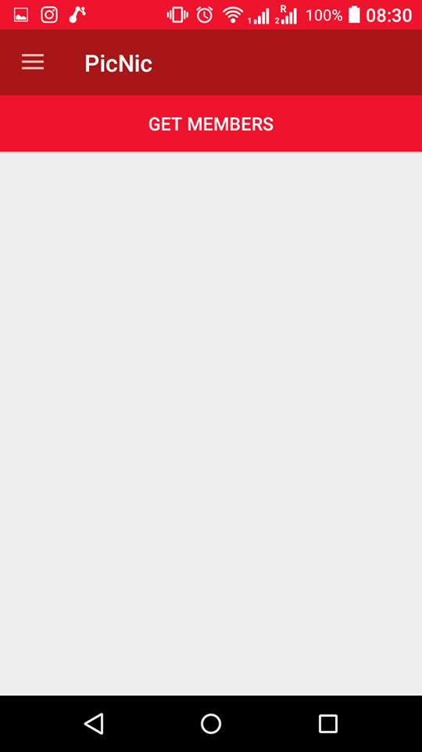

* 1. **Navigation Bar Components**

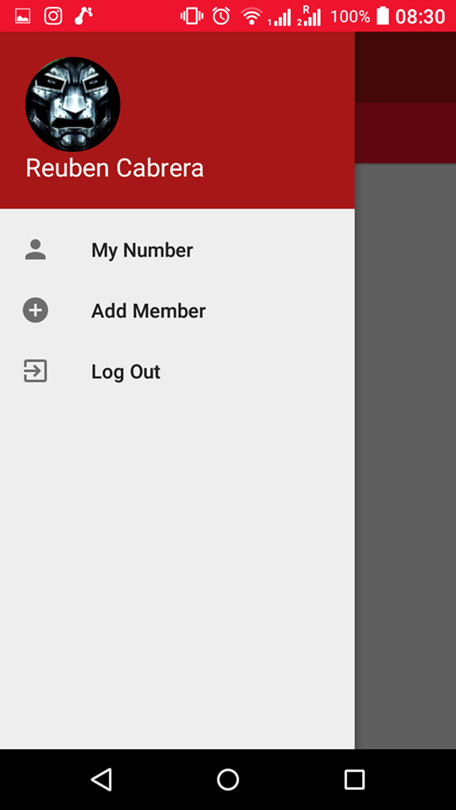

* 1. **Add Account Number**

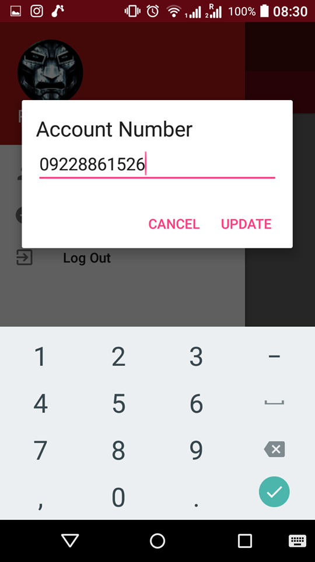

* 1. **Successful import to Firebase**

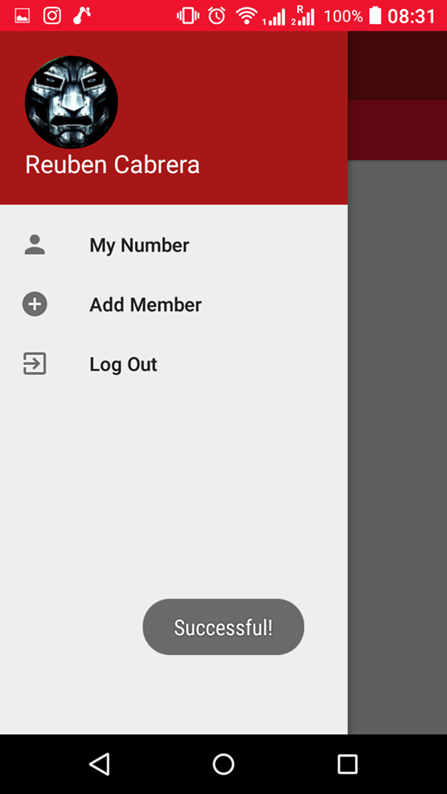

* 1. **View List of Members**

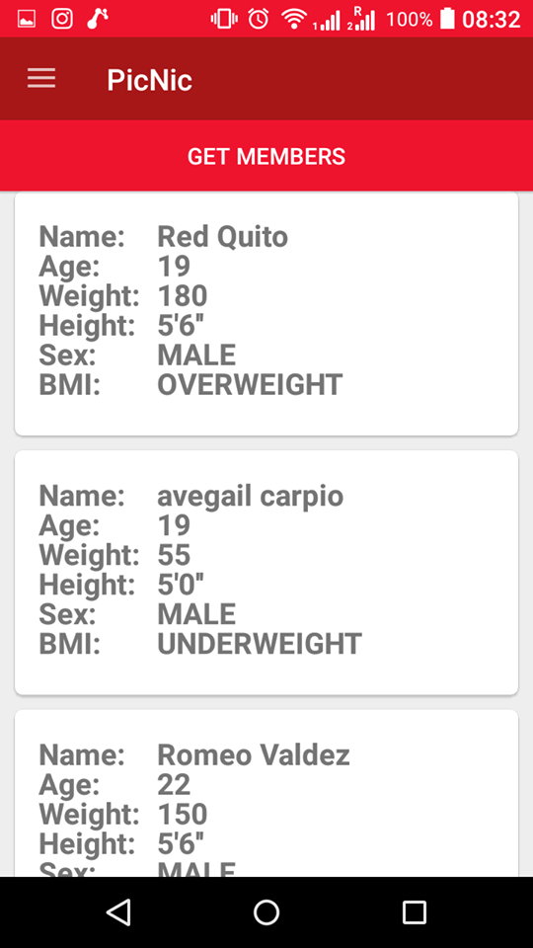

* 1. **View Current Status Recommendation for a Member**

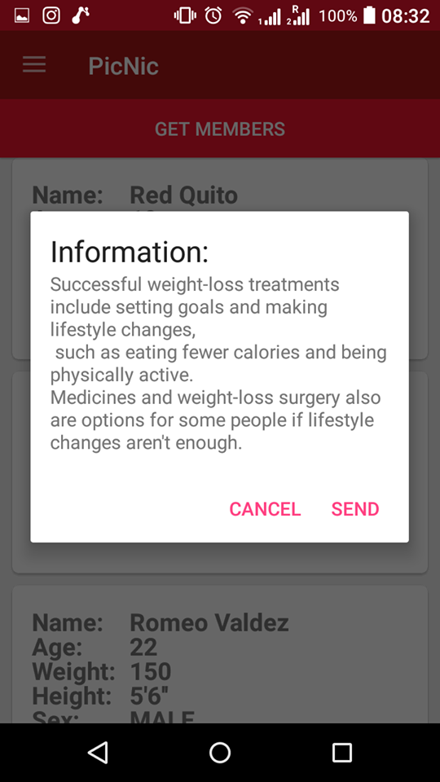

* 1. **Ask for a Nutritionist’s Additional Recommendation**

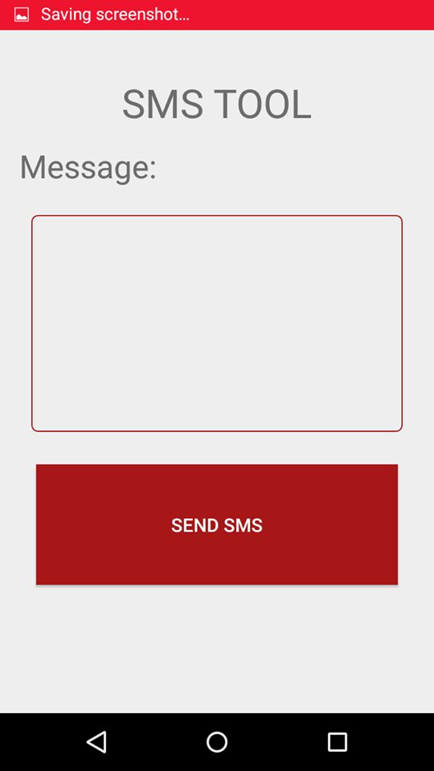

1. **Technical Manual**
   1. **Formula to calculate BMI with pounds and inches**

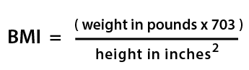

* 1. **BMI Graphs for Boys and Girls aged 2-20**

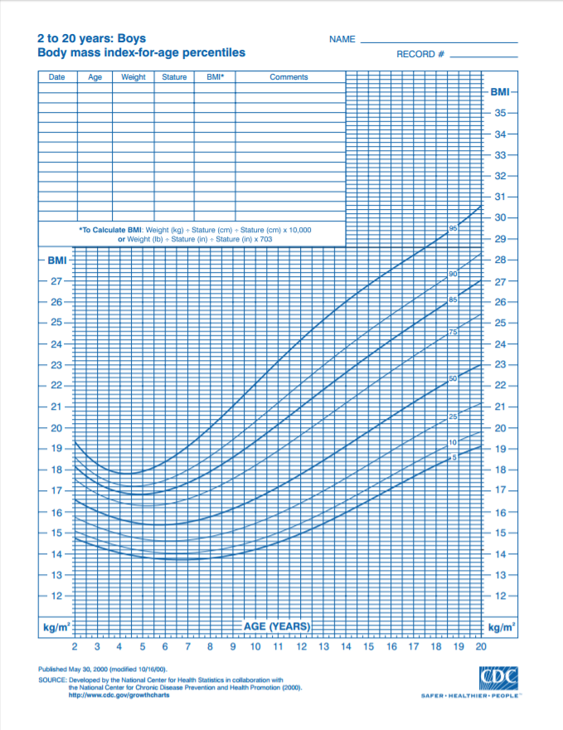

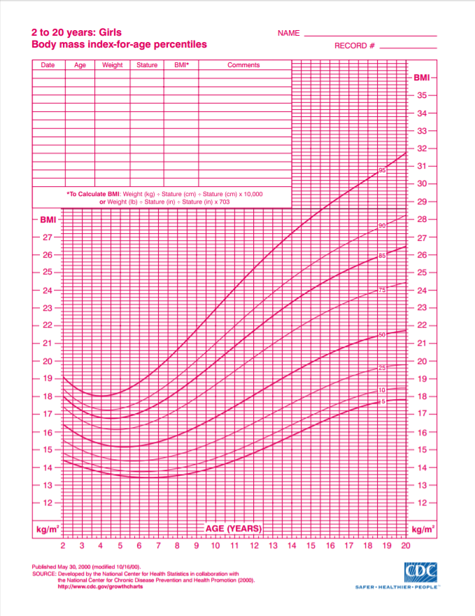

* 1. **BMI Percentile Table for Boys and Girls aged 2-20**

**GIRLS**

**5TH PERCENTILE**

|  |  |
| --- | --- |
| 2 | 14.6 |
| 3 | 14.2 |
| 4 | 13.7 |
| 5 | 13.5 |
| 6 | 13.4 |
| 7 | 13.4 |
| 8 | 13.6 |
| 9 | 13.8 |
| 10 | 14 |
| 11 | 14.4 |
| 12 | 14.8 |
| 13 | 15.2 |
| 14 | 15.8 |
| 15 | 16.3 |
| 16 | 16.8 |
| 17 | 17.2 |
| 18 | 17.6 |
| 19 | 17.7 |
| 20 | 17.8 |

.

**85TH**

|  |  |
| --- | --- |
| 2 | 18 |
| 3 | 17.2 |
| 4 | 16.8 |
| 5 | 16.8 |
| 6 | 17.1 |
| 7 | 17.6 |
| 8 | 18.1 |
| 9 | 19.1 |
| 10 | 19.9 |
| 11 | 20.8 |
| 12 | 21.7 |
| 13 | 22.6 |
| 14 | 23.2 |
| 15 | 24 |
| 16 | 24.6 |
| 17 | 25.2 |
| 18 | 25.7 |
| 19 | 26.1 |
| 20 | 26.7 |

**95TH**

|  |  |
| --- | --- |
| 2 | 19.1 |
| 3 | 18.3 |
| 4 | 18 |
| 5 | 18.2 |
| 6 | 18.8 |
| 7 | 19.8 |
| 8 | 20.6 |
| 9 | 21.7 |
| 10 | 22.9 |
| 11 | 24.1 |
| 12 | 25.2 |
| 13 | 26.8 |
| 14 | 27.2 |
| 15 | 28.1 |
| 16 | 28.9 |
| 17 | 29.6 |
| 18 | 30.3 |
| 19 | 31 |
| 20 | 31.8 |

**BOYS**

**5TH PERCENTILE**

|  |  |
| --- | --- |
| 2 | 14.8 |
| 3 | 14 |
| 4 | 14.1 |
| 5 | 9 |
| 6 | 17.9 |
| 7 | 13.7 |
| 8 | 13.8 |
| 9 | 14 |
| 10 | 14.2 |
| 11 | 14.6 |
| 12 | 15 |
| 13 | 15.45 |
| 14 | 16 |
| 15 | 16.5 |
| 16 | 17.1 |
| 17 | 17.7 |
| 18 | 18.2 |
| 19 | 18.7 |
| 20 | 19.1 |

**85TH**

|  |  |
| --- | --- |
| 2 | 18.2 |
| 3 | 17.4 |
| 4 | 16.9 |
| 5 | 8 |
| 6 | 17 |
| 7 | 17.4 |
| 8 | 18 |
| 9 | 18.6 |
| 10 | 19.3 |
| 11 | 20.2 |
| 12 | 21 |
| 13 | 21.8 |
| 14 | 22.6 |
| 15 | 23.4 |
| 16 | 24.2 |
| 17 | 24.2 |
| 18 | 25.6 |
| 19 | 26.3 |
| 20 | 27.1 |

**95TH**

|  |  |
| --- | --- |
| 2 | 19.4 |
| 3 | 18.3 |
| 4 | 17.8 |
| 5 | 9 |
| 6 | 18.4 |
| 7 | 19.1 |
| 8 | 20 |
| 9 | 21 |
| 10 | 22.1 |
| 11 | 23.2 |
| 12 | 24.2 |
| 13 | 25.1 |
| 14 | 26 |
| 15 | 26.8 |
| 16 | 27.5 |
| 17 | 28.2 |
| 18 | 29.9 |
| 19 | 29.7 |
| 20 | 30.6 |

1. **Third Party Libraries:**
   1. **Picasso**

Source: <http://square.github.io/picasso/>

* 1. **Firebase**

Source: <https://firebase.google.com/>

1. **Source Code**

**>> account_number.xml**

<?xml version="1.0" encoding="utf-8"?>

<LinearLayout xmlns:android="http://schemas.android.com/apk/res/android"

android:id="@+id/custom_dialog_layout_design_user_input"

android:layout_width="match_parent"

android:layout_height="match_parent"

android:orientation="vertical"

android:padding="16dp">

<TextView

android:id="@+id/dialogTitle"

android:layout_width="wrap_content"

android:layout_height="wrap_content"

android:text="Account Number"

android:textAppearance="?android:attr/textAppearanceLarge" />

<EditText

android:id="@+id/acc_number"

android:layout_width="match_parent"

android:layout_height="wrap_content"

android:hint="Number"

android:inputType="number" />

</LinearLayout>

**>> activity_contract_doctor.xml**

<?xml version="1.0" encoding="utf-8"?>

<RelativeLayout xmlns:android="http://schemas.android.com/apk/res/android"

xmlns:tools="http://schemas.android.com/tools"

android:id="@+id/activity_contact_doctor"

android:layout_width="match_parent"

android:layout_height="match_parent"

android:paddingBottom="@dimen/activity_vertical_margin"

android:paddingLeft="@dimen/activity_horizontal_margin"

android:paddingRight="@dimen/activity_horizontal_margin"

android:paddingTop="@dimen/activity_vertical_margin"

tools:context="rarr.picnic.contact_doctor">

<TextView

android:text="SMS TOOL"

android:layout_width="wrap_content"

android:layout_height="wrap_content"

android:layout_marginTop="22dp"

android:id="@+id/textView6"

android:textSize="30sp"

android:layout_alignParentTop="true"

android:layout_centerHorizontal="true" />

<TextView

android:text="Message:"

android:layout_width="match_parent"

android:layout_height="wrap_content"

android:layout_marginTop="13dp"

android:id="@+id/textView7"

android:layout_below="@+id/textView6"

android:layout_alignParentStart="true"

android:textSize="24sp" />

<EditText

android:layout_width="match_parent"

android:inputType="textMultiLine"

android:ems="10"

android:background="@drawable/input_outline"

android:id="@+id/message"

android:padding="10dp"

android:layout_marginLeft="10dp"

android:layout_marginRight="10dp"

android:layout_height="180dp"

android:gravity="top"

android:singleLine="true"

android:layout_marginTop="23dp"

android:layout_below="@+id/textView7"

android:layout_centerHorizontal="true" />

<Button

android:text="Send SMS"

android:layout_marginTop="27dp"

android:id="@+id/send_message"

style="@style/Widget.AppCompat.Button.Colored"

android:background="@color/colorPrimary"

android:layout_width="300dp"

android:layout_below="@+id/message"

android:layout_centerHorizontal="true"

android:layout_height="100dp" />

</RelativeLayout>

**>> activity_main.xml**

<?xml version="1.0" encoding="utf-8"?>

<RelativeLayout xmlns:android="http://schemas.android.com/apk/res/android"

xmlns:app="http://schemas.android.com/apk/res-auto"

xmlns:tools="http://schemas.android.com/tools"

android:id="@+id/activity_main"

android:layout_width="match_parent"

android:layout_height="match_parent"

android:paddingBottom="@dimen/activity_vertical_margin"

android:paddingLeft="@dimen/activity_horizontal_margin"

android:paddingRight="@dimen/activity_horizontal_margin"

android:paddingTop="@dimen/activity_vertical_margin"

tools:context="rarr.picnic.MainActivity">

<TextView

android:text="RARR"

android:layout_width="wrap_content"

android:layout_height="wrap_content"

android:layout_alignParentBottom="true"

android:layout_centerHorizontal="true"

android:id="@+id/textView" />

<ImageView

app:srcCompat="@drawable/picniclogo"

android:id="@+id/imageView2"

android:layout_height="200dp"

android:layout_width="200dp"

android:layout_alignParentTop="true"

android:layout_centerHorizontal="true"

android:layout_marginTop="93dp" />

<com.google.android.gms.common.SignInButton

android:layout_width="match_parent"

android:layout_height="wrap_content"

android:id="@+id/googleBtn"

android:layout_marginBottom="64dp"

android:layout_above="@+id/textView"

android:layout_alignParentStart="true"></com.google.android.gms.common.SignInButton>

</RelativeLayout>

**>> activity_menu.xml**

<?xml version="1.0" encoding="utf-8"?>

<android.support.v4.widget.DrawerLayout xmlns:android="http://schemas.android.com/apk/res/android"

xmlns:tools="http://schemas.android.com/tools"

xmlns:app="http://schemas.android.com/apk/res-auto"

android:id="@+id/drawerLayout"

android:layout_width="match_parent"

android:layout_height="match_parent"

tools:context="rarr.picnic.Menu">

<LinearLayout

android:layout_width="match_parent"

android:layout_height="match_parent"

android:orientation="vertical">

<include layout="@layout/navigation_action"

android:layout_width="match_parent"

android:layout_height="wrap_content" />

<Button

android:text="GET MEMBERS"

android:layout_width="match_parent"

android:layout_height="wrap_content"

android:id="@+id/getdata"

style="@style/Widget.AppCompat.Button.Colored"

android:background="@color/colorPrimaryDark" />

<android.support.v7.widget.RecyclerView

android:id="@+id/card_recycler_view"

android:scrollbars="vertical"

android:layout_width="match_parent"

android:layout_height="match_parent"/>

</LinearLayout>

<android.support.design.widget.NavigationView

android:id="@+id/nav_view"

android:layout_width="wrap_content"

android:layout_height="match_parent"

app:menu="@menu/navigation_menu"

android:layout_gravity="start"

app:headerLayout="@layout/navigation_header">

</android.support.design.widget.NavigationView>

</android.support.v4.widget.DrawerLayout>

**>> add_member.xml**

<?xml version="1.0" encoding="utf-8"?>

<RelativeLayout xmlns:android="http://schemas.android.com/apk/res/android"

xmlns:tools="http://schemas.android.com/tools"

android:id="@+id/add_pet_dialog"

android:layout_width="match_parent"

android:layout_height="match_parent"

android:orientation="vertical"

android:padding="16dp">

<ScrollView

android:layout_width="match_parent"

android:layout_height="match_parent"

android:layout_alignParentTop="true"

android:layout_alignParentStart="true">

<LinearLayout

android:layout_width="match_parent"

android:layout_height="match_parent"

android:orientation="vertical"

android:weightSum="1">

<TextView

android:id="@+id/dialogTitle"

android:layout_width="wrap_content"

android:layout_height="wrap_content"

android:text="Member Information"

android:textAppearance="?android:attr/textAppearanceLarge" />

<TextView

android:text="Name:"

android:layout_width="wrap_content"

android:layout_height="wrap_content"

android:layout_below="@+id/dialogTitle"

android:layout_alignParentStart="true"

android:layout_marginTop="15dp"

android:id="@+id/textView3" />

<EditText

android:id="@+id/family_name"

android:layout_width="match_parent"

android:layout_height="wrap_content"

android:inputType="text"

android:layout_below="@+id/textView3"

android:layout_alignParentStart="true" />

<TextView

android:text="Birthdate:"

android:layout_width="wrap_content"

android:layout_height="wrap_content"

android:layout_below="@+id/family_name"

android:layout_alignParentStart="true"

android:layout_marginTop="7dp"

android:id="@+id/pet_bday" />

<EditText

android:layout_width="match_parent"

android:layout_height="wrap_content"

android:inputType="date"

android:ems="10"

android:id="@+id/family_bday"

android:hint="mm/dd/yyyy" />

<TextView

android:text="Height:"

android:layout_width="match_parent"

android:layout_height="wrap_content"

android:id="@+id/textView11" />

<RelativeLayout

android:layout_width="match_parent"

android:layout_height="match_parent">

<EditText

android:layout_width="102dp"

android:layout_height="wrap_content"

android:inputType="number"

android:ems="10"

android:id="@+id/family_height_feet"

android:hint="feet"

android:layout_alignParentTop="true"

android:layout_alignParentStart="true" />

<EditText

android:layout_width="102dp"

android:layout_height="wrap_content"

android:inputType="number"

android:ems="10"

android:id="@+id/family_height_inches"

android:hint="inches"

android:layout_marginStart="46dp"

android:layout_alignParentTop="true"

android:layout_toEndOf="@+id/family_height_feet" />

</RelativeLayout>

<TextView

android:text="Weight:"

android:layout_width="match_parent"

android:layout_height="wrap_content"

android:id="@+id/textView12" />

<EditText

android:layout_width="match_parent"

android:layout_height="wrap_content"

android:inputType="number"

android:ems="10"

android:id="@+id/family_weight"

android:hint="lbs" />

<TextView

android:text="Sex:"

android:layout_width="match_parent"

android:layout_height="wrap_content"

android:id="@+id/textView2" />

<Spinner

android:layout_width="match_parent"

android:layout_height="wrap_content"

android:id="@+id/spinner" />

<TextView

android:text="Age"

android:layout_width="match_parent"

android:layout_height="wrap_content"

android:id="@+id/textView4" />

<EditText

android:layout_width="match_parent"

android:layout_height="wrap_content"

android:inputType="number"

android:ems="10"

android:id="@+id/family_age" />

</LinearLayout>

</ScrollView>

</RelativeLayout>

**>> bmi_tips.xml**

<?xml version="1.0" encoding="utf-8"?>

<LinearLayout xmlns:android="http://schemas.android.com/apk/res/android"

android:orientation="vertical" android:layout_width="match_parent"

android:layout_height="match_parent">

</LinearLayout>

**>> card_row.xml**

<?xml version="1.0" encoding="utf-8"?>

<android.support.v7.widget.CardView

xmlns:card_view="http://schemas.android.com/apk/res-auto"

xmlns:android="http://schemas.android.com/apk/res/android"

android:layout_width="match_parent"

android:id="@+id/card"

android:layout_marginLeft="10dp"

android:layout_marginRight="10dp"

android:layout_marginBottom="10dp"

card_view:cardCornerRadius="5dp"

android:layout_height="165dp">

<RelativeLayout xmlns:android="http://schemas.android.com/apk/res/android"

xmlns:tools="http://schemas.android.com/tools"

android:id="@+id/card_row"

android:layout_width="match_parent"

android:layout_height="match_parent"

android:paddingBottom="@dimen/activity_vertical_margin"

android:paddingLeft="@dimen/activity_horizontal_margin"

android:paddingRight="@dimen/activity_horizontal_margin"

android:paddingTop="@dimen/activity_vertical_margin"

tools:context="com.example.romeo.apps.MyActivity">

<TextView

android:id="@+id/tag_name"

android:layout_marginBottom="10dp"

android:layout_gravity="center"

android:textSize="18sp"

android:layout_width="wrap_content"

android:layout_height="wrap_content"

android:textStyle="bold" />

<TextView

android:id="@+id/name1"

android:layout_marginBottom="10dp"

android:layout_marginLeft="80dp"

android:layout_gravity="center"

android:textSize="18sp"

android:layout_width="wrap_content"

android:layout_height="wrap_content"

android:textStyle="bold" />

<TextView

android:id="@+id/tag_age"

android:layout_marginTop="20dp"

android:layout_gravity="center"

android:textSize="18sp"

android:layout_width="wrap_content"

android:layout_height="wrap_content"

android:textStyle="bold" />

<TextView

android:id="@+id/age1"

android:layout_marginTop="20dp"

android:layout_marginLeft="80dp"

android:layout_gravity="center"

android:textSize="18sp"

android:layout_width="360dp"

android:layout_height="100dp"

android:textStyle="bold" />

<TextView

android:id="@+id/tag_weight"

android:layout_marginTop="40dp"

android:layout_gravity="center"

android:textSize="18sp"

android:layout_width="wrap_content"

android:layout_height="wrap_content"

android:textStyle="bold" />

<TextView

android:id="@+id/weight1"

android:layout_marginTop="40dp"

android:layout_marginLeft="80dp"

android:layout_gravity="center"

android:textSize="18sp"

android:layout_width="360dp"

android:layout_height="100dp"

android:textStyle="bold" />

<TextView

android:id="@+id/tag_height"

android:layout_marginTop="60dp"

android:layout_gravity="center"

android:textSize="18sp"

android:layout_width="wrap_content"

android:layout_height="wrap_content"

android:textStyle="bold" />

<TextView

android:id="@+id/height1"

android:layout_marginTop="60dp"

android:layout_marginLeft="80dp"

android:layout_gravity="center"

android:textSize="18sp"

android:layout_width="360dp"

android:layout_height="100dp"

android:textStyle="bold" />

<TextView

android:id="@+id/tag_sex"

android:layout_marginTop="80dp"

android:layout_gravity="center"

android:textSize="18sp"

android:layout_width="360dp"

android:layout_height="100dp"

android:textStyle="bold" />

<TextView

android:id="@+id/sex1"

android:layout_marginTop="80dp"

android:layout_marginLeft="80dp"

android:layout_gravity="center"

android:textSize="18sp"

android:layout_width="360dp"

android:layout_height="100dp"

android:textStyle="bold" />

<TextView

android:id="@+id/tag_bmi"

android:layout_marginTop="100dp"

android:layout_gravity="center"

android:textSize="18sp"

android:layout_width="360dp"

android:layout_height="100dp"

android:textStyle="bold" />

<TextView

android:id="@+id/bmi1"

android:layout_marginTop="100dp"

android:layout_marginLeft="80dp"

android:layout_gravity="center"

android:textSize="18sp"

android:layout_width="360dp"

android:layout_height="100dp"

android:textStyle="bold" />

</RelativeLayout>

</android.support.v7.widget.CardView>

**>> navigation_action.xml**

<?xml version="1.0" encoding="utf-8"?>

<android.support.v7.widget.Toolbar xmlns:android="http://schemas.android.com/apk/res/android"

android:orientation="vertical" android:layout_width="match_parent"

android:layout_height="wrap_content"

android:id="@+id/nav_action"

android:background="@color/colorPrimary"

android:theme="@style/Base.ThemeOverlay.AppCompat.Dark">

</android.support.v7.widget.Toolbar>

**>> navigation_header.xml**

<?xml version="1.0" encoding="utf-8"?>

<RelativeLayout xmlns:android="http://schemas.android.com/apk/res/android"

xmlns:app="http://schemas.android.com/apk/res-auto"

android:orientation="vertical"

android:layout_width="match_parent"

android:layout_height="140dp"

android:background="@color/colorPrimary"

android:padding="20dp">

<TextView

android:text="TextView"

android:layout_width="wrap_content"

android:layout_height="wrap_content"

android:id="@+id/textView"

android:textColor="@color/common_google_signin_btn_text_dark_default"

android:layout_alignParentBottom="true"

android:layout_alignParentStart="true"

android:textSize="18sp" />

<ImageView

android:layout_width="wrap_content"

android:layout_height="wrap_content"

app:srcCompat="@mipmap/ic_person_black_24dp"

android:id="@+id/pPic"

android:layout_alignParentTop="true"

android:layout_alignParentStart="true" />

</RelativeLayout>

**>> tips.xml**

<?xml version="1.0" encoding="utf-8"?>

<LinearLayout xmlns:android="http://schemas.android.com/apk/res/android"

xmlns:tools="http://schemas.android.com/tools"

android:id="@+id/custom_dialog_layout_design_user_input"

android:layout_width="match_parent"

android:layout_height="match_parent"

android:orientation="vertical"

android:padding="16dp">

<TextView

android:id="@+id/dialogTitle"

android:layout_width="wrap_content"

android:layout_height="wrap_content"

android:text="Information:"

android:textAppearance="?android:attr/textAppearanceLarge" />

<ScrollView

android:layout_width="match_parent"

android:layout_height="match_parent">

<TextView

android:text="TextView"

android:layout_width="match_parent"

android:layout_height="wrap_content"

android:id="@+id/info_bmi" />

</ScrollView>

</LinearLayout>

**>> JAVA FILES <<**

**>> CircleTransform.java**

package rarr.picnic;

import android.graphics.Bitmap;

import android.graphics.BitmapShader;

import android.graphics.Canvas;

import android.graphics.Paint;

import com.squareup.picasso.Transformation;

**/\***

**\* Copyright 2014 Julian Shen**

**\***

**\* Licensed under the Apache License, Version 2.0 (the "License");**

**\* you may not use this file except in compliance with the License.**

**\* You may obtain a copy of the License at**

**\***

**\* http://www.apache.org/licenses/LICENSE-2.0**

**\***

**\* Unless required by applicable law or agreed to in writing, software**

**\* distributed under the License is distributed on an "AS IS" BASIS,**

**\* WITHOUT WARRANTIES OR CONDITIONS OF ANY KIND, either express or implied.**

**\* See the License for the specific language governing permissions and**

**\* limitations under the License.**

**\*/**

import android.graphics.Bitmap;

import android.graphics.BitmapShader;

import android.graphics.Canvas;

import android.graphics.Paint;

import com.squareup.picasso.Transformation;

/**

* Created by julian on 13/6/21.

*/

public class CircleTransform implements Transformation {

@Override

public Bitmap transform(Bitmap source) {

int size = Math.min(source.getWidth(), source.getHeight());

int x = (source.getWidth() - size) / 2;

int y = (source.getHeight() - size) / 2;

Bitmap squaredBitmap = Bitmap.createBitmap(source, x, y, size, size);

if (squaredBitmap != source) {

source.recycle();

}

Bitmap bitmap = Bitmap.createBitmap(size, size, source.getConfig());

Canvas canvas = new Canvas(bitmap);

Paint paint = new Paint();

BitmapShader shader = new BitmapShader(squaredBitmap, BitmapShader.TileMode.CLAMP, BitmapShader.TileMode.CLAMP);

paint.setShader(shader);

paint.setAntiAlias(true);

float r = size/2f;

canvas.drawCircle(r, r, r, paint);

squaredBitmap.recycle();

return bitmap;

}

@Override

public String key() {

return "circle";

}

}

contract_doctor.java

package rarr.picnic;

import android.app.ProgressDialog;

import android.content.Intent;

import android.support.v7.app.AppCompatActivity;

import android.os.Bundle;

import android.telephony.SmsManager;

import android.view.View;

import android.widget.Button;

import android.widget.EditText;

import android.widget.Toast;

import com.google.firebase.auth.FirebaseAuth;

import com.google.firebase.auth.FirebaseUser;

import com.google.firebase.database.DataSnapshot;

import com.google.firebase.database.DatabaseError;

import com.google.firebase.database.DatabaseReference;

import com.google.firebase.database.FirebaseDatabase;

import com.google.firebase.database.ValueEventListener;

import java.util.ArrayList;

public class contact_doctor extends AppCompatActivity {

private Button send;

private EditText message;

private DatabaseReference mDatabase;

private DatabaseReference mDatabase_doctor;

private FirebaseUser user;

private ProgressDialog Progress;

private ArrayList Numbers;

@Override

protected void onCreate(Bundle savedInstanceState) {

super.onCreate(savedInstanceState);

setContentView(R.layout.activity_contact_doctor);

send = (Button) findViewById(R.id.send_message);

message = (EditText) findViewById(R.id.message);

Numbers = new ArrayList<>();

init();

send.setOnClickListener(new View.OnClickListener() {

@Override

public void onClick(View view) {

SendMessage();

}

});

}

private void SendMessage() {

String message1 = message.getText().toString() + " \n SENT VIA Pic-Ni-C";

for(int i = 0; i < Numbers.size();i++){

String mobile1 = Numbers.get(i).toString();

try {

SmsManager smsManager = SmsManager.getDefault();

smsManager.sendTextMessage("+639"+mobile1.substring(2), null,message1, null, null);

Toast.makeText(getApplicationContext(), "SMS sent to +639"+mobile1.substring(2), Toast.LENGTH_LONG).show();

}

catch (Exception e) {

Toast.makeText(getApplicationContext(), "SMS faild, please try again.", Toast.LENGTH_LONG).show();

e.printStackTrace();

}

Intent intent = new Intent(contact_doctor.this,Menu.class);

startActivity(intent);

finish();

}

}

private void init(){

Progress = new ProgressDialog(this);

Progress.setMessage("LOADING DATA");

Progress.show();

mDatabase = FirebaseDatabase.getInstance().getReference();

mDatabase.child("Nutrionist").addValueEventListener(new ValueEventListener() {

@Override

public void onDataChange(DataSnapshot dataSnapshot) {

for( DataSnapshot child : dataSnapshot.getChildren()){

String number = child.child("Number").getValue().toString();

Numbers.add(number);

}

Progress.dismiss();

}

@Override

public void onCancelled(DatabaseError databaseError) {

}

});

}

@Override

public void onBackPressed() {

Intent intent = new Intent(contact_doctor.this,Menu.class);

startActivity(intent);

finish();

}

}

**>> DataAdapter.java**

package rarr.picnic;

/**

* Created by REUBEN on 19/02/2017.

*/

import android.support.v7.widget.RecyclerView;

import android.view.LayoutInflater;

import android.view.View;

import android.view.ViewGroup;

import android.widget.TextView;

import android.widget.Toast;

import java.util.ArrayList;

public class DataAdapter extends RecyclerView.Adapter<DataAdapter.ViewHolder> {

private ArrayList<String> name1;

private ArrayList<String> age1;

private ArrayList<String> weight1;

private ArrayList<String> height1;

private ArrayList<String> sex1;

private ArrayList<String> bmi1;

private String tag_name;

private String tag_age;

private String tag_weight;

private String tag_height;

private String tag_sex;

private String tag_bmi;

public DataAdapter(ArrayList<String> name, ArrayList<String> age, ArrayList<String> weight, ArrayList<String> height, ArrayList<String> sex, ArrayList<String> bmi, String tag_name, String tag_age, String tag_weight, String tag_height, String tag_sex, String tag_bmi) {

this.name1 = name;

this.age1 = age;

this.weight1 = weight;

this.height1 = height;

this.sex1 = sex;

this.bmi1 = bmi;

this.tag_name = tag_name;

this.tag_age = tag_age;

this.tag_weight = tag_weight;

this.tag_height = tag_height;

this.tag_sex = tag_sex;

this.tag_bmi = tag_bmi;

}

@Override

public DataAdapter.ViewHolder onCreateViewHolder(ViewGroup viewGroup, int i) {

View view = LayoutInflater.from(viewGroup.getContext()).inflate(R.layout.card_row, viewGroup, false);

return new ViewHolder(view);

}

@Override

public void onBindViewHolder(DataAdapter.ViewHolder viewHolder, int i) {

viewHolder.name1.setText(name1.get(i));

viewHolder.age1.setText(age1.get(i));

viewHolder.weight1.setText(weight1.get(i));

viewHolder.height1.setText(height1.get(i));

viewHolder.sex1.setText(sex1.get(i));

viewHolder.bmi1.setText(bmi1.get(i));

viewHolder.tag_name.setText(tag_name);

viewHolder.tag_age.setText(tag_age);

viewHolder.tag_weight.setText(tag_weight);

viewHolder.tag_height.setText(tag_height);

viewHolder.tag_sex.setText(tag_sex);

viewHolder.tag_bmi.setText(tag_bmi);

}

@Override

public int getItemCount() {

return name1.size();

}

public class ViewHolder extends RecyclerView.ViewHolder{

private TextView name1;

private TextView age1;

private TextView weight1;

private TextView height1;

private TextView sex1;

private TextView bmi1;

private TextView tag_name;

private TextView tag_age;

private TextView tag_weight;

private TextView tag_height;

private TextView tag_sex;

private TextView tag_bmi;

public ViewHolder(View view) {

super(view);

view.setOnClickListener(new View.OnClickListener(){

@Override

public void onClick(View v){

}

});

name1 = (TextView)view.findViewById(R.id.name1);

age1 = (TextView)view.findViewById(R.id.age1);

weight1 = (TextView)view.findViewById(R.id.weight1);

height1 = (TextView)view.findViewById(R.id.height1);

sex1 = (TextView)view.findViewById(R.id.sex1);

bmi1 = (TextView)view.findViewById(R.id.bmi1);

tag_name = (TextView)view.findViewById(R.id.tag_name);

tag_age = (TextView)view.findViewById(R.id.tag_age);

tag_weight = (TextView)view.findViewById(R.id.tag_weight);

tag_height = (TextView)view.findViewById(R.id.tag_height);

tag_sex = (TextView)view.findViewById(R.id.tag_sex);

tag_bmi = (TextView)view.findViewById(R.id.tag_bmi);

}

}

}

**>> MainActivity.java**

package rarr.picnic;

import android.app.ProgressDialog;

import android.content.Intent;

import android.os.Bundle;

import android.support.annotation.NonNull;

import android.support.v4.widget.DrawerLayout;

import android.support.v7.app.ActionBarDrawerToggle;

import android.support.v7.app.AppCompatActivity;

import android.support.v7.widget.LinearLayoutManager;

import android.support.v7.widget.RecyclerView;

import android.util.Log;

import android.view.GestureDetector;

import android.view.MotionEvent;

import android.view.View;

import android.widget.Toast;

import com.google.android.gms.auth.api.Auth;

import com.google.android.gms.auth.api.signin.GoogleSignInAccount;

import com.google.android.gms.auth.api.signin.GoogleSignInOptions;

import com.google.android.gms.auth.api.signin.GoogleSignInResult;

import com.google.android.gms.common.ConnectionResult;

import com.google.android.gms.common.SignInButton;

import com.google.android.gms.common.api.GoogleApiClient;

import com.google.android.gms.tasks.OnCompleteListener;

import com.google.android.gms.tasks.Task;

import com.google.firebase.auth.AuthCredential;

import com.google.firebase.auth.AuthResult;

import com.google.firebase.auth.FirebaseAuth;

import com.google.firebase.auth.GoogleAuthProvider;

import java.util.ArrayList;

public class MainActivity extends AppCompatActivity {

private SignInButton mGoogleBtn;

private static final int RC_SIGN_IN = 1;

private GoogleApiClient mGoogleApiClient;

private FirebaseAuth mAuth;

private FirebaseAuth.AuthStateListener mAuthListener;

private ProgressDialog mProgress;

private static final String TAG = "main_activity";

@Override

protected void onCreate(Bundle savedInstanceState) {

super.onCreate(savedInstanceState);

setContentView(R.layout.activity_main);

mAuth = FirebaseAuth.getInstance();

mAuthListener = new FirebaseAuth.AuthStateListener() {

@Override

public void onAuthStateChanged(@NonNull FirebaseAuth firebaseAuth) {

if(firebaseAuth.getCurrentUser() != null){

mProgress.dismiss();

startActivity(new Intent(MainActivity.this,Menu.class));

finish();

}

}

};

mGoogleBtn = (SignInButton) findViewById(R.id.googleBtn);

mProgress = new ProgressDialog(this);

// Configure Google Sign In

GoogleSignInOptions gso = new GoogleSignInOptions.Builder(GoogleSignInOptions.DEFAULT_SIGN_IN)

.requestIdToken(getString(R.string.default_web_client_id))

.requestEmail()

.build();

mGoogleApiClient = new GoogleApiClient.Builder(getApplicationContext())

.enableAutoManage(this, new GoogleApiClient.OnConnectionFailedListener() {

@Override

public void onConnectionFailed(@NonNull ConnectionResult connectionResult) {

Toast.makeText(MainActivity.this,"ERROR",Toast.LENGTH_SHORT).show();

}

})

.addApi(Auth.GOOGLE_SIGN_IN_API,gso)

.build();

mGoogleBtn.setOnClickListener(new View.OnClickListener() {

@Override

public void onClick(View view) {

signIn();

}

});

}

@Override

protected void onStart() {

super.onStart();

mAuth.addAuthStateListener(mAuthListener);

}

private void signIn() {

Intent signInIntent = Auth.GoogleSignInApi.getSignInIntent(mGoogleApiClient);

startActivityForResult(signInIntent, RC_SIGN_IN);

}

@Override

public void onActivityResult(int requestCode, int resultCode, Intent data) {

super.onActivityResult(requestCode, resultCode, data);

// Result returned from launching the Intent from GoogleSignInApi.getSignInIntent(...);

if (requestCode == RC_SIGN_IN) {

GoogleSignInResult result = Auth.GoogleSignInApi.getSignInResultFromIntent(data);

if (result.isSuccess()) {

// Google Sign In was successful, authenticate with Firebase

mProgress.setMessage("CHECKING LOGIN...");

mProgress.show();

GoogleSignInAccount account = result.getSignInAccount();

firebaseAuthWithGoogle(account);

/*Toast.makeText(MainActivity.this, "Authentication successful.",

Toast.LENGTH_SHORT).show();*/

} else {

// Google Sign In failed, update UI appropriately

// ...

}

}

}

private void firebaseAuthWithGoogle(GoogleSignInAccount account) {

Log.d(TAG, "firebaseAuthWithGoogle:" + account.getId());

AuthCredential credential = GoogleAuthProvider.getCredential(account.getIdToken(), null);

mAuth.signInWithCredential(credential)

.addOnCompleteListener(this, new OnCompleteListener<AuthResult>() {

@Override

public void onComplete(@NonNull Task<AuthResult> task) {

Log.d(TAG, "signInWithCredential:onComplete:" + task.isSuccessful());

// If sign in fails, display a message to the user. If sign in succeeds

// the auth state listener will be notified and logic to handle the

// signed in user can be handled in the listener.

if (!task.isSuccessful()) {

Log.w(TAG, "signInWithCredential", task.getException());

Toast.makeText(MainActivity.this, "Authentication failed.",

Toast.LENGTH_SHORT).show();

}

else{

// Toast.makeText(MainActivity.this, "Authentication successful.",

// Toast.LENGTH_SHORT).show();

}

// ...

}

});

}

@Override

public void onBackPressed() {

finish();

}

}

**>> Menu.java**

package rarr.picnic;

import android.app.ProgressDialog;

import android.content.Context;

import android.content.DialogInterface;

import android.content.Intent;

import android.graphics.Color;

import android.net.Uri;

import android.os.Handler;

import android.support.annotation.NonNull;

import android.support.design.widget.NavigationView;

import android.support.v4.widget.DrawerLayout;

import android.support.v7.app.ActionBarDrawerToggle;

import android.support.v7.app.AlertDialog;

import android.support.v7.app.AppCompatActivity;

import android.os.Bundle;

import android.support.v7.widget.LinearLayoutManager;

import android.support.v7.widget.RecyclerView;

import android.support.v7.widget.Toolbar;

import android.text.TextUtils;

import android.view.GestureDetector;

import android.view.LayoutInflater;

import android.view.MenuItem;

import android.view.MotionEvent;

import android.view.View;

import android.view.animation.Animation;

import android.view.animation.AnimationUtils;

import android.webkit.WebView;

import android.widget.AdapterView;

import android.widget.ArrayAdapter;

import android.widget.Button;

import android.widget.EditText;

import android.widget.ImageView;

import android.widget.Spinner;

import android.widget.TextView;

import android.widget.Toast;

import com.google.android.gms.tasks.OnCompleteListener;

import com.google.android.gms.tasks.Task;

import com.google.firebase.auth.FirebaseAuth;

import com.google.firebase.auth.FirebaseUser;

import com.google.firebase.auth.UserInfo;

import com.google.firebase.database.DataSnapshot;

import com.google.firebase.database.DatabaseError;

import com.google.firebase.database.DatabaseReference;

import com.google.firebase.database.FirebaseDatabase;

import com.google.firebase.database.ValueEventListener;

import com.squareup.picasso.Picasso;

import org.w3c.dom.Text;

import java.util.ArrayList;

import java.util.HashMap;

public class Menu extends AppCompatActivity {

private DrawerLayout nDrawerLayout;

private ActionBarDrawerToggle nToggle;

private Toolbar nToolbar;

private FirebaseAuth mAuth;

private FirebaseAuth.AuthStateListener mAuthListener;

private DatabaseReference mDatabase;

private FirebaseUser user;

private TextView mName;

private Uri photoUrl;

private ImageView mPic;

private WebView browser;

private final Context c = this;

private ProgressDialog Progress ;

private NavigationView mNavigationView;

private String fsex;

private EditText fname;

private EditText birthdate;

private EditText height;

private EditText weight;

private Spinner sex;

private EditText age;

private String name;

String Sname;

String Sweight;

String Sage;

String Sheight_inches;

String Sheight_feet;

String sBirthdate;

private ArrayList name1;

private ArrayList age1;

private ArrayList weight1;

private ArrayList height1;

private ArrayList sex1;

private ArrayList bmi1;

private String tag_name;

private String tag_age;

private String tag_weight;

private String tag_height;

private String tag_sex;

private String tag_bmi;

private Button get;

@Override

protected void onCreate(Bundle savedInstanceState) {

super.onCreate(savedInstanceState);

setContentView(R.layout.activity_menu);

nToolbar = (Toolbar) findViewById(R.id.nav_action);

setSupportActionBar(nToolbar);

nDrawerLayout = (DrawerLayout)findViewById(R.id.drawerLayout);

nToggle = new ActionBarDrawerToggle(this, nDrawerLayout, R.string.open, R.string.close);

nDrawerLayout.addDrawerListener(nToggle);

nToggle.syncState();

getSupportActionBar().setDisplayHomeAsUpEnabled(true);

mAuth = FirebaseAuth.getInstance();

mAuthListener = new FirebaseAuth.AuthStateListener() {

@Override

public void onAuthStateChanged(@NonNull FirebaseAuth firebaseAuth) {

if(firebaseAuth.getCurrentUser() == null){

startActivity(new Intent(Menu.this,MainActivity.class));

}

}

};

mNavigationView = (NavigationView) findViewById(R.id.nav_view);

mName = (TextView) mNavigationView.getHeaderView(0).findViewById(R.id.textView);

mPic = (ImageView) mNavigationView.getHeaderView(0).findViewById(R.id.pPic);

getCurrentinfo();

mNavigationView.setNavigationItemSelectedListener(new NavigationView.OnNavigationItemSelectedListener() {

@Override

public boolean onNavigationItemSelected(final MenuItem menuItem) {

int id = menuItem.getItemId();

switch (id) {

case R.id.nav_account: {

//Toast.makeText(Menu.this, "Account Selected", Toast.LENGTH_SHORT).show();

UpdateNumber();

return true;

}

case R.id.nav_pets: {

//addPet();

addMember();

return true;

}

case R.id.nav_logout: {

mAuth.signOut();

// Google sign out

}

default:

return true;

}

}

});

name1 = new ArrayList<>();

age1 = new ArrayList<>();

weight1 = new ArrayList<>();

height1 = new ArrayList<>();

sex1 = new ArrayList<>();

bmi1 = new ArrayList<>();

Progress = new ProgressDialog(this);

Progress.setMessage("LOADING DATA");

Progress.show();

mDatabase = FirebaseDatabase.getInstance().getReference();

user = FirebaseAuth.getInstance().getCurrentUser();

mDatabase.child("Family").child(user.getUid().toString()).child("Family_members").addValueEventListener(new ValueEventListener() {

@Override

public void onDataChange(DataSnapshot dataSnapshot) {

for( DataSnapshot child : dataSnapshot.getChildren()){

String name = new String(child.child("Member_Name").getValue().toString());

String age = new String(child.child("Age").getValue().toString());

String BMI_result = child.child("BMI_Result").getValue().toString();

String Height_ft = child.child("Height_ft").getValue().toString();

String Height_inches = child.child("Height_inches").getValue().toString();

String Height = Height_ft +"'" + Height_inches +"''";

String Sex = child.child("Sex").getValue().toString() ;

String Weight = child.child("Weight").getValue().toString();

name1.add(name);

age1.add(age);

weight1.add(Weight);

height1.add(Height);

sex1.add(Sex);

bmi1.add(BMI_result);

}

Progress.dismiss();

}

@Override

public void onCancelled(DatabaseError databaseError) {

}

});

get = (Button)findViewById(R.id.getdata);

get.setOnClickListener(new View.OnClickListener() {

@Override

public void onClick(View view) {

initViews();

}

});

}

private void initViews(){

RecyclerView recyclerView = (RecyclerView)findViewById(R.id.card_recycler_view);

recyclerView.setHasFixedSize(true);

RecyclerView.LayoutManager layoutManager = new LinearLayoutManager(getApplicationContext());

recyclerView.setLayoutManager(layoutManager);

tag_name = new String("Name:");

tag_age = new String("Age:");

tag_weight = new String("Weight:");

tag_height = new String("Height:");

tag_sex = new String("Sex:");

tag_bmi = new String("BMI:");

RecyclerView.Adapter adapter = new DataAdapter(name1, age1, weight1, height1, sex1, bmi1, tag_name, tag_age, tag_weight, tag_height, tag_sex, tag_bmi);

recyclerView.setAdapter(adapter);

recyclerView.addOnItemTouchListener(new RecyclerView.OnItemTouchListener() {

GestureDetector gestureDetector = new GestureDetector(getApplicationContext(), new GestureDetector.SimpleOnGestureListener() {

@Override public boolean onSingleTapUp(MotionEvent e) {

return true;

}

});

@Override

public boolean onInterceptTouchEvent(RecyclerView rv, MotionEvent e) {

View child = rv.findChildViewUnder(e.getX(), e.getY());

if(child != null && gestureDetector.onTouchEvent(e)) {

int position = rv.getChildAdapterPosition(child);

String bmi_get = bmi1.get(position).toString();

provideTips(bmi_get);

}

return false;

}

@Override

public void onTouchEvent(RecyclerView rv, MotionEvent e) {

}

@Override

public void onRequestDisallowInterceptTouchEvent(boolean disallowIntercept) {

}

});

}

private void provideTips(String bmi_get) {

LayoutInflater layoutInflaterAndroid = LayoutInflater.from(c);

View mView = layoutInflaterAndroid.inflate(R.layout.tips, null);

AlertDialog.Builder alertDialogBuilderUserInput = new AlertDialog.Builder(c);

alertDialogBuilderUserInput.setView(mView);

final Animation animationFadeIn = AnimationUtils.loadAnimation(this, R.anim.fadein);

final TextView info = (TextView) mView.findViewById(R.id.info_bmi);

info.startAnimation(animationFadeIn);

if(bmi_get.equals("OVERWEIGHT")){

info.setText(

"Successful weight-loss treatments include setting goals and making lifestyle changes," +

"\n such as eating fewer calories and being physically active." +

"\nMedicines and weight-loss surgery also are options for some people if lifestyle changes aren't enough.");

}

else if(bmi_get.equals("UNDERWEIGHT")){

info.setText(

"A healthy balanced diet is recommended for prevention of malnutrition. There are four major food groups that include:" +

"\n 1.\tBread, rice, potatoes, and other starchy foods. This forms the largest portion of the diet and provides calories for energy and carbohydrates that are converted to sugars which provide energy." +

"\n 2.\tMilk and dairy foods – Vital sources of fats and simple sugars like lactose as well as minerals like Calcium." +

"\n 3.\tFruit and vegetables – Vital sources of vitamins and minerals as well as fiber and roughage for better digestive health." +

"\n4.\tMeat, poultry, fish, eggs, beans and other non-dairy sources of protein – These form the building blocks of the body and help in numerous body and enzyme functions.\n" +

"\nSource: http://www.news-medical.net/health/Treatment-of-malnutrition.aspx");

}

else if(bmi_get.equals("OBESE")){

info.setText(

"Successful weight-loss treatments include setting goals and making lifestyle changes," +

"\n such as eating fewer calories and being physically active." +

"\nMedicines and weight-loss surgery also are options for some people if lifestyle changes aren't enough.");

}

else{

info.setText(

"Congratulations. Your family member is healthy.");

}

alertDialogBuilderUserInput

.setCancelable(false)

.setPositiveButton("Send", new DialogInterface.OnClickListener() {

public void onClick(DialogInterface dialogBox, int id) {

Intent intent = new Intent(Menu.this,contact_doctor.class);

startActivity(intent);

finish();

}

})

.setNegativeButton("Cancel",

new DialogInterface.OnClickListener() {

public void onClick(DialogInterface dialogBox, int id) {

dialogBox.cancel();

}

});

AlertDialog alertDialogAndroid = alertDialogBuilderUserInput.create();

alertDialogAndroid.show();

}

private void addMember() {

LayoutInflater layoutInflaterAndroid = LayoutInflater.from(c);

View mView = layoutInflaterAndroid.inflate(R.layout.add_member, null);

AlertDialog.Builder alertDialogBuilderUserInput = new AlertDialog.Builder(c);

Progress = new ProgressDialog(this);

mDatabase = FirebaseDatabase.getInstance().getReference();

alertDialogBuilderUserInput.setView(mView);

final EditText pName = (EditText) mView.findViewById(R.id.family_name);

final EditText pBdate = (EditText) mView.findViewById(R.id.family_bday);

final EditText pHeight_inches = (EditText) mView.findViewById(R.id.family_height_inches);

final EditText pHeight_feet = (EditText) mView.findViewById(R.id.family_height_feet);

final EditText pWeight= (EditText) mView.findViewById(R.id.family_weight);

final EditText pAge = (EditText) mView.findViewById(R.id.family_age);

final Spinner spinner = (Spinner) mView.findViewById(R.id.spinner);

String [] sex ={

"MALE","FEMALE"

};

ArrayAdapter adapter = new ArrayAdapter(this,android.R.layout.simple_spinner_dropdown_item,sex);

spinner.setAdapter(adapter);

spinner.setOnItemSelectedListener(new AdapterView.OnItemSelectedListener() {

public void onItemSelected(AdapterView<?> parent, View view, int pos, long id) {

fsex = parent.getItemAtPosition(pos).toString().trim();

}

public void onNothingSelected(AdapterView<?> parent) {

}

});

alertDialogBuilderUserInput

.setCancelable(false)

.setPositiveButton("Send", new DialogInterface.OnClickListener() {

public void onClick(DialogInterface dialogBox, int id) {

Sname = pName.getText().toString().trim();

Sweight = pWeight.getText().toString().trim();

Sage = pAge.getText().toString().trim();

Sheight_inches = pHeight_inches.getText().toString().trim();

Sheight_feet = pHeight_feet.getText().toString().trim();

sBirthdate = pBdate.getText().toString().trim();

/*Calculate BMI*/

int totalInches = (Integer.parseInt(Sheight_feet) * 12) + Integer.parseInt(Sheight_inches);

double uWeight = 0.0, oWeight = 0.0, obese = 0.0;

double dWeight = Double.parseDouble(Sweight);

double dHeight = (double) totalInches;

double Sbmi = (dWeight/(dHeight*dHeight)) * 703;

String bmiRes;

int age = Integer.parseInt(Sage);

if(age <= 20) {

if (fsex.equals("MALE")) {

switch(age) {

case 2: uWeight = 14.8;

oWeight = 18.2;

obese = 19.4;

break;

case 3: uWeight = 14.0;

oWeight = 17.4;

obese = 18.3;

break;

case 4: uWeight = 14.1;

oWeight = 16.9;

obese = 17.8;

break;

case 5: uWeight = 13.9;

oWeight = 16.8;

obese = 17.9;

break;

case 6: uWeight = 13.7;

oWeight = 17.0;

obese = 18.4;

break;

case 7: uWeight = 13.7;

oWeight = 17.4;

obese = 19.1;

break;

case 8: uWeight = 13.8;

oWeight = 18.0;

obese = 20.0;

break;

case 9: uWeight = 14.0;

oWeight = 18.6;

obese = 21.0;

break;

case 10: uWeight = 14.2;

oWeight = 19.3;

obese = 22.1;

break;

case 11: uWeight = 14.6;

oWeight = 20.2;

obese = 23.2;

break;

case 12: uWeight = 15.0;

oWeight = 21.0;

obese = 24.2;

break;

case 13: uWeight = 15.45;

oWeight = 21.8;

obese = 25.1;

break;

case 14: uWeight = 16.0;

oWeight = 22.6;

obese = 26.0;

break;

case 15: uWeight = 16.5;

oWeight = 23.4;

obese = 26.8;

break;

case 16: uWeight = 17.1;

oWeight = 24.2;

obese = 27.5;

break;

case 17: uWeight = 17.7;

oWeight = 24.9;

obese = 28.2;

break;

case 18: uWeight = 18.2;

oWeight = 25.6;

obese = 29.9;

break;

case 19: uWeight = 18.7;

oWeight = 26.3;

obese = 29.7;

break;

case 20: uWeight = 19.1;

oWeight = 27.1;

obese = 30.6;

break;

default: break;

}

} else { //FEMALE

switch(age) {

case 2: uWeight = 14.6;

oWeight = 18.0;

obese = 19.1;

break;

case 3: uWeight = 14.2;

oWeight = 17.2;

obese = 18.3;

break;

case 4: uWeight = 13.7;

oWeight = 16.8;

obese = 18.0;

break;

case 5: uWeight = 13.5;

oWeight = 16.8;

obese = 18.2;

break;

case 6: uWeight = 13.4;

oWeight = 17.1;

obese = 18.8;

break;

case 7: uWeight = 13.4;

oWeight = 17.6;

obese = 19.8;

break;

case 8: uWeight = 13.6;

oWeight = 18.1;

obese = 20.6;

break;

case 9: uWeight = 13.8;

oWeight = 19.1;

obese = 21.7;

break;

case 10: uWeight = 14.0;

oWeight = 19.9;

obese = 22.9;

break;

case 11: uWeight = 14.4;

oWeight = 20.8;

obese = 24.1;

break;

case 12: uWeight = 14.8;

oWeight = 21.7;

obese = 25.2;

break;

case 13: uWeight = 15.2;

oWeight = 22.6;

obese = 26.8;

break;

case 14: uWeight = 15.8;

oWeight = 23.2;

obese = 27.2;

break;

case 15: uWeight = 16.3;

oWeight = 24.0;

obese = 28.1;

break;

case 16: uWeight = 16.8;

oWeight = 24.6;

obese = 28.9;

break;

case 17: uWeight = 17.2;

oWeight = 25.2;

obese = 29.6;

break;

case 18: uWeight = 17.6;

oWeight = 25.7;

obese = 30.3;

break;

case 19: uWeight = 17.7;

oWeight = 26.1;

obese = 31.0;

break;

case 20: uWeight = 17.8;

oWeight = 26.7;

obese = 31.8;

break;

default: break;

}

}

} else {

uWeight = 18.5;

oWeight = 25.0;

obese = 30.0;

}

if(Sbmi < uWeight) {

bmiRes = "UNDERWEIGHT";

} else if (Sbmi < oWeight) {

bmiRes = "HEALTHY";

} else if (Sbmi < obese) {

bmiRes = "OVERWEIGHT";

} else

bmiRes = "OBESE";

Progress.setMessage("Adding Family Member. Please Wait.");

Progress.show();

Sname = pName.getText().toString().trim();

Sweight = pWeight.getText().toString().trim();

Sage = pAge.getText().toString().trim();

Sheight_inches = pHeight_inches.getText().toString().trim();

Sheight_feet = pHeight_feet.getText().toString().trim();

sBirthdate = pBdate.getText().toString().trim();

HashMap<String,String> dataMap = new HashMap<String, String>();

dataMap.put("Member_Name",Sname);

dataMap.put("Birthdate",sBirthdate);

dataMap.put("Height_ft",Sheight_feet);

dataMap.put("Height_inches",Sheight_inches);

dataMap.put("Weight",Sweight);

dataMap.put("Sex",fsex);

dataMap.put("Age",Sage);

dataMap.put("BMI_Result",bmiRes);

user = FirebaseAuth.getInstance().getCurrentUser();

mDatabase.child("Family").child(user.getUid()).child("Family_members").push().setValue(dataMap).addOnCompleteListener(new OnCompleteListener<Void>() {

@Override

public void onComplete(@NonNull Task<Void> task) {

if(task.isSuccessful()){

//Toast.makeText(Menu.this,"Successful.",Toast.LENGTH_SHORT).show();

}

else{

Toast.makeText(Menu.this,"Failed.",Toast.LENGTH_SHORT).show();

}

Progress.dismiss();

}

});

}

})

.setNegativeButton("Cancel",

new DialogInterface.OnClickListener() {

public void onClick(DialogInterface dialogBox, int id) {

dialogBox.cancel();

}

});

AlertDialog alertDialogAndroid = alertDialogBuilderUserInput.create();

alertDialogAndroid.show();

}

private void UpdateNumber() {

LayoutInflater layoutInflaterAndroid = LayoutInflater.from(c);

View rView = layoutInflaterAndroid.inflate(R.layout.account_number, null);

AlertDialog.Builder alertDialogBuilderUserInput = new AlertDialog.Builder(c);

alertDialogBuilderUserInput.setView(rView);

mDatabase = FirebaseDatabase.getInstance().getReference();

user = FirebaseAuth.getInstance().getCurrentUser();

final EditText number = (EditText) rView.findViewById(R.id.acc_number);

alertDialogBuilderUserInput

.setCancelable(false)

.setPositiveButton("Update", new DialogInterface.OnClickListener() {

public void onClick(DialogInterface dialogBox, int id) {

String num = number.getText().toString().trim();

mDatabase.child("Accounts").child(user.getUid().toString()).child("Number").setValue(num).addOnCompleteListener(new OnCompleteListener<Void>() {

@Override

public void onComplete(@NonNull Task<Void> task) {

if(task.isSuccessful()){

Toast.makeText(Menu.this,"Successful!",Toast.LENGTH_SHORT).show();

}

}

});

}

})

.setNegativeButton("Cancel",

new DialogInterface.OnClickListener() {

public void onClick(DialogInterface dialogBox, int id) {

dialogBox.cancel();

}

});

AlertDialog alertDialogAndroid = alertDialogBuilderUserInput.create();

alertDialogAndroid.show();

}

@Override

public boolean onOptionsItemSelected(MenuItem item) {

if(nToggle.onOptionsItemSelected(item)){

return true;

}

return super.onOptionsItemSelected(item);

}

@Override

public void onBackPressed() {

new AlertDialog.Builder(this)

.setTitle("Really Exit?")

.setMessage("Are you sure you want to exit?")

.setNegativeButton(android.R.string.no, null)

.setPositiveButton(android.R.string.yes, new DialogInterface.OnClickListener() {

public void onClick(DialogInterface arg0, int arg1) {

finish();

}

}).create().show();

}

@Override

protected void onStart() {

super.onStart();

mAuth.addAuthStateListener(mAuthListener);

}

private void getCurrentinfo(){

FirebaseUser user = FirebaseAuth.getInstance().getCurrentUser();

if (user != null) {

for (UserInfo profile : user.getProviderData()) {

// Id of the provider (ex: google.com)

String providerId = profile.getProviderId();

// UID specific to the provider

String uid = profile.getUid();

// Name, email address, and profile photo Url

name = profile.getDisplayName();

photoUrl = profile.getPhotoUrl();

mName.setText(name);

Picasso.with(getApplicationContext())

.load(photoUrl.toString())

.placeholder(R.drawable.logo)

.resize(150, 150)

.transform(new CircleTransform())

.centerCrop()

.into(mPic);

};

}

}

}

**>> build.gradle**

apply plugin: 'com.android.application'

android {

compileSdkVersion 24

buildToolsVersion "24.0.2"

defaultConfig {

applicationId "rarr.picnic"

minSdkVersion 19

targetSdkVersion 24

versionCode 1

versionName "1.0"

testInstrumentationRunner "android.support.test.runner.AndroidJUnitRunner"

}

buildTypes {

release {

minifyEnabled false

proguardFiles getDefaultProguardFile('proguard-android.txt'), 'proguard-rules.pro'

}

}

}

dependencies {

compile fileTree(dir: 'libs', include: ['*.jar'])

androidTestCompile('com.android.support.test.espresso:espresso-core:2.2.2', {

exclude group: 'com.android.support', module: 'support-annotations'

})

compile 'com.android.support:appcompat-v7:24.2.1'

compile 'com.android.support:appcompat-v7:24.2.1'

compile 'com.android.support:recyclerview-v7:24.2.1'

compile 'com.android.support:cardview-v7:24.2.1'

compile 'com.android.support:design:24.2.1'

compile 'com.google.firebase:firebase-database:10.0.1'

compile 'com.firebaseui:firebase-ui-database:1.1.1'

compile 'com.google.android.gms:play-services-auth:10.0.1'

compile 'com.google.firebase:firebase-storage:10.0.1'

compile 'com.google.firebase:firebase-auth:10.0.1'

compile 'com.squareup.picasso:picasso:2.5.2'

compile 'com.android.support:design:24.2.1'

compile 'com.squareup.picasso:picasso:2.5.2'

compile 'de.hdodenhof:circleimageview:2.1.0'

testCompile 'junit:junit:4.12'

}

apply plugin: 'com.google.gms.google-services'

1. **Sources**
2. <http://www.whathealth.com/bmi/formula.html>
3. <http://www.rappler.com/move-ph/issues/hunger/130046-philippines-chronic-malnutrition>
4. http://www.rappler.com/move-ph/issues/hunger/144630-philippines-economic-loss-childhood-stunting
5. <https://www.cdc.gov/growthcharts/data/set1clinical/cj41c023.pdf>
6. https://www.cdc.gov/growthcharts/data/set1clinical/cj41c024.pdf