**Goal Project 1 Solution & Explanation**

All html website code must be contained within html tags, thus, to start writing your website, write these tags:

<html>

CODE GOES HERE

</html>

Now, you need to write the code for the body of the website. This code goes between body tags:

<html>

<body>

CODE GOES HERE

</body>

</html>

Now you need to write the code to make the website look like this:

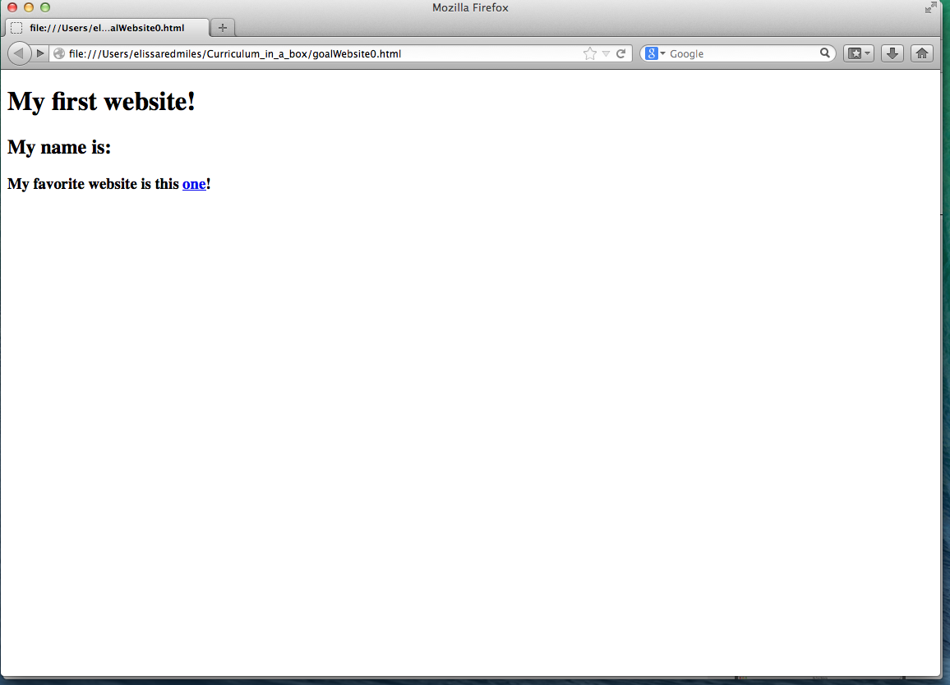

Notice that the word “one” in the third line is blue and underlined. This typically indicates that it is a hyperlink (when you click on the word you will be redirected to another website). The code you need to create hyperlinks is <a href=[website address]> [word to link on] </a>. In this case, lets imagine my favorite website is [www.neopets.com](http://www.neopets.com), I would do: <a href=”www.neopets.com”> one </a> to create the hyperlink on the word *one*.

Also notice that the first line: *My first website!* is bigger than the second line *My name is:*, which is bigger than the third line *My favorite website is this one!*. This means that we are probably using headings. Remember, there are six headings: h1, h2, h3, h4, h5, h6. h1 is the biggest and h6 is the smallest. Thus, to create the look we see above, *My first website!* is probably contained in <h1> </h1> tags, *My name is:*  is probably contained in <h2> </h2> tags and *My favorite website is this one!*  is probably contained in <h3></h3> tags.

The final code should look like this:

<html>

<body>

<h1> My first website! </h1>

<h2> My name is: </h2>

<h3> My favorite website is this <a href=”www.neopets.com”> one </a>!</h3>

</body>

</html>