**Goal Project 2 Solution & Explanation**

All html website code must be contained within html tags, thus, to start writing your website, write these tags:

<html>

CODE GOES HERE

</html>

Now, you need to write the code for the body of the website. This code goes between body tags:

<html>

<body>

CODE GOES HERE

</body>

</html>

Now you need to write the code to make the website look like this:

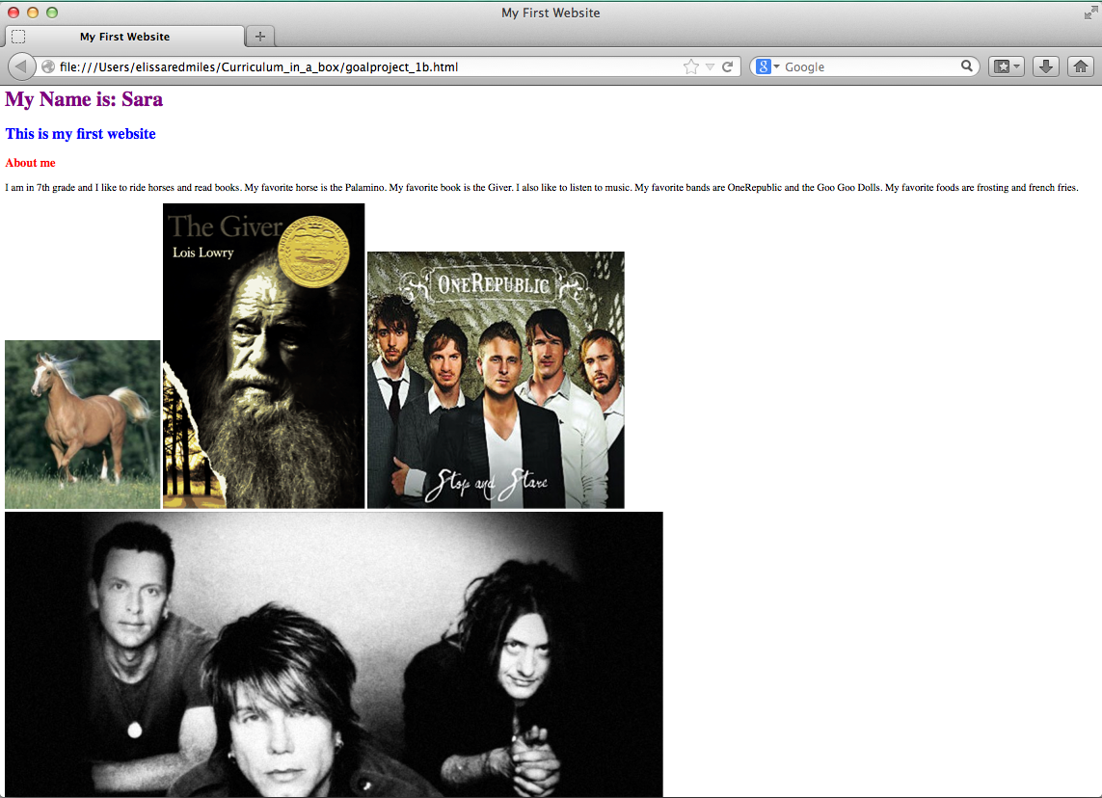

HTML Information (same as in Goal Project 2):

Notice that the first line: *My Name is: Sara* is bigger than the second line & bold (just like in goal project 2). As in Goal Project 2, the second line, is bigger than the third line, although both the second and third lines are bold. This means that again we are probably using headings. Remember, there are six headings: h1, h2, h3, h4, h5, h6. h1 is the biggest and h6 is the smallest. Thus, to create the look we see above, *My Name is: Sara* is probably contained in <h1> </h1> tags, *This is my first website*  is probably contained in <h2> </h2> tags and *About me* is probably contained in <h3></h3> tags.

NEW CSS Information for Colors

Notice that the font of the first line is purple, the font of the second line is blue, and the font of the third line is red. In order to change the colors we need to use CSS. Remember, CSS goes in the head between style tags:

<html>

<head>  
 <style> CSS GOES HERE </style>

</head>

<html>

In order to make the font in h1 (remember, the first line is contained within heading 1 tags) purple, we need to change the color using color: purple. So the code would look like this:

<html>

<head>  
 <style>

h1{

color: purple;

}

</style>

</head>

<html>

Similarly, to make the second line of text, which is contained within h2 tags, blue we would write:

h2{

color: blue;

}

And for the third line of text, which is contained within h3 tags, red, we would write:

h3{

color: red;

}

Thus, the full CSS code for the three lines would be:

<html>

<head>  
 <style>

h1{

color: purple;

}

h2{

color: blue;

}

h3{

color: red;

}

</style>

</head>

<html>

The long line is “normal text” so it is probably contained within a paragraph (<p>) tag.

Finally, the four images are each different sizes, so we can assume they weren’t resized. Students can use Google images to search for their four images (http://www.google.com/imghp). Once they find an image they like they should click on the image and then click “view image”.

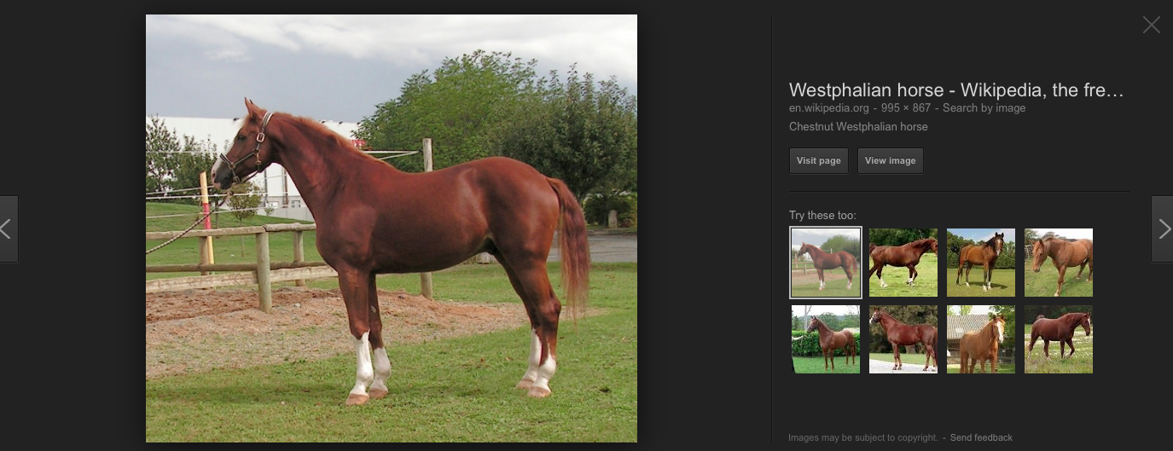

Click

“view image”

Next, the student should copy the URL of the image and use the URL as the image source in their line of code to insert the image:

<img src=”[URL GOES HERE]”>

<img src=”http://upload.wikimedia.org/wikipedia/commons/9/9a/Avenger_-_Westphalian_horse.jpg”>

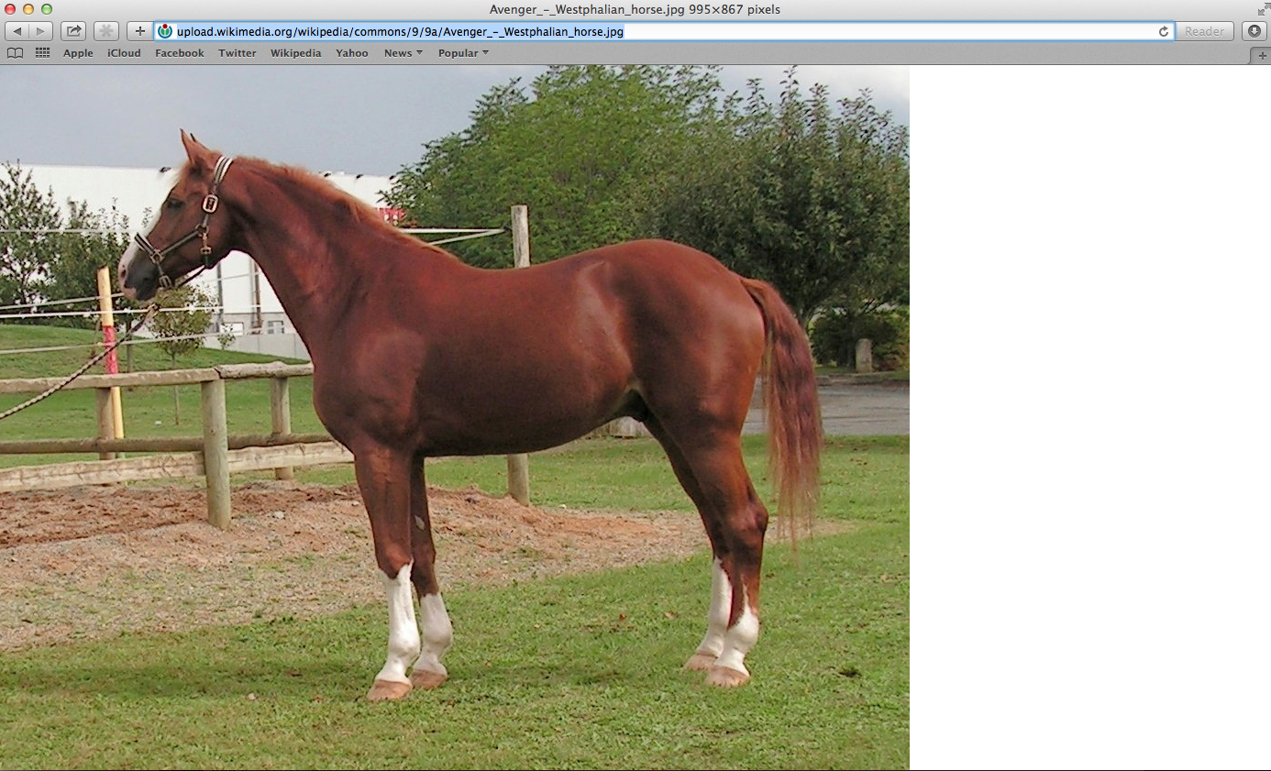

Copy this URL

The student should do this for each of the four images.

The final code should look like this:

<html>

<head>

<title>My First Website</title>

</head>

<body>

<h1>

My Name is: Sara

</h1>

<h2>

This is my first website

</h2>

<h3>

About me

</h3>

<p>

I am in 7th grade and I like to ride horses and read books. My favorite horse is the

Palamino.

My favorite book is the Giver. I also like to listen to music.

My favorite bands are OneRepublic and the Goo Goo Dolls. My favorite foods are frosting

and french fries.

</p>

<img src="http://upload.wikimedia.org/wikipedia/commons/2/21/Palomino_Horse.jpg"/>

<img src="http://upload.wikimedia.org/wikipedia/en/c/c4/The_Giver_Cover.gif"/>

<img src="http://imgsrv.mix93.com/image/kmxv3/UserFiles/Image/one-republic.jpg"/>

<img src="http://www.choosingpeaceblog.com/wp-content/uploads/2013/06/goo-goo-dolls.jpg"/>

</body>

</html>