**Goal Project 2b Solution & Explanation**

Assuming your students are building from their Project 2, the only new code they will need to add is CSS Code. (See Project 2 solution for information on the HTML code)

You need to write the code to make the website look like this:

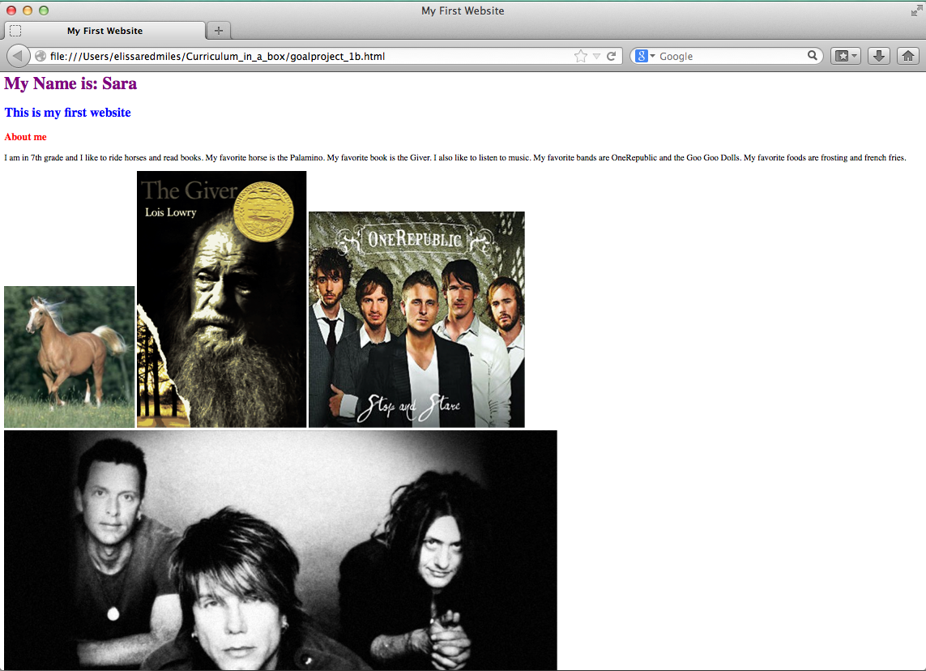

Notice that the font of the first line is purple, the font of the second line is blue, and the font of the third line is red. In order to change the colors we need to use CSS. Remember, CSS goes in the head between style tags:

<html>

<head>  
 <style> CSS GOES HERE </style>

</head>

<html>

In order to make the font in h1 (remember, the first line is contained within heading 1 tags) purple, we need to change the color using color: purple. So the code would look like this:

<html>

<head>  
 <style>

h1{

color: purple;

}

</style>

</head>

<html>

Similarly, to make the second line of text, which is contained within h2 tags, blue we would write:

h2{

color: blue;

}

And for the third line of text, which is contained within h3 tags, red, we would write:

h3{

color: red;

}

Thus, the full CSS code for the three lines would be:

<html>

<head>  
 <style>

h1{

color: purple;

}

h2{

color: blue;

}

h3{

color: red;

}

</style>

</head>

<body>

<html>

Nothing else changes from Project 2.

The full code for this page is:

<html>

<head>

<title>My First Website</title>

<style>

h1{

color: purple;

}

h2{

color: blue;

}

h3{

color: red;

}

</style>

</head>

<body>

<h1>

My Name is: Sara

</h1>

<h2>

This is my first website

</h2>

<h3>

About me

</h3>

<p>

I am in 7th grade and I like to ride horses and read books. My favorite

horse is the Palamino.

My favorite book is the Giver. I also like to listen to music.

My favorite bands are OneRepublic and the Goo Goo Dolls. My favorite

foods are frosting and french fries.

</p>

<img src="http://upload.wikimedia.org/wikipedia/commons/2/21/Palomino_Horse.jpg"/>

<img src="http://upload.wikimedia.org/wikipedia/en/c/c4/The_Giver_Cover.gif"/>

<img src="http://imgsrv.mix93.com/image/kmxv3/UserFiles/Image/one-republic.jpg"/>

<img src="http://www.choosingpeaceblog.com/wp-content/uploads/2013/06/goo-goo-dolls.jpg"/>

</body>

</html>