**Goal Project 2c Solution & Explanation**

Assuming your students are building from their Project 2b, the only new code they will need to add is CSS Code. (See Project 2b solution for information on the HTML code)

You need to write the code to make the website look like this:

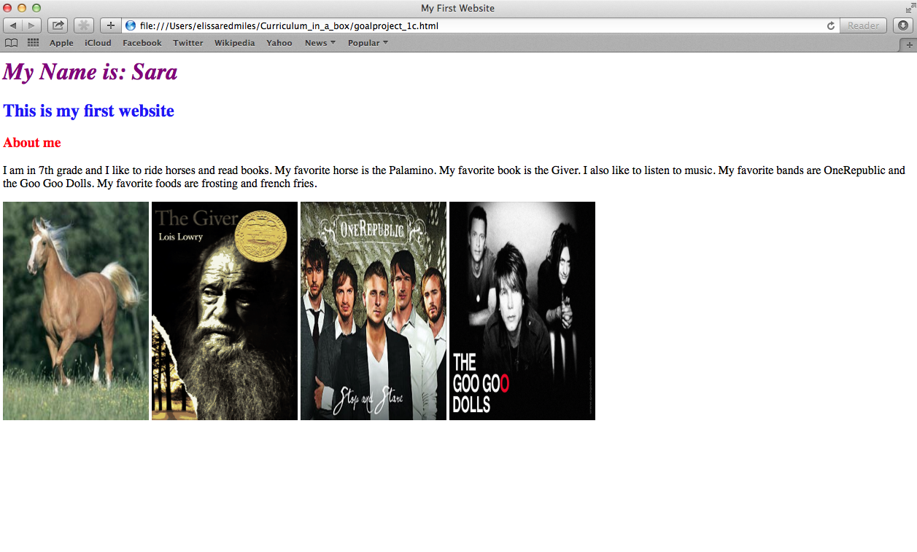

Remember that CSS code goes between the style tags in the head section of your website:

<html>

<head>  
 <style> CSS GOES HERE </style>

</head>

<html>

Notice that the first line is italicized, and none of the other lines have changed.

In order to italicized text, we use the font-style property:

<html>

<head>  
 <style>

h1{

**font-style: italic;**

color: purple;

}

</style>

</head>

<html>

Also notice that all the images are now the same size. This is an HTML based modification rather than a CSS modification. To change the image size, we need to use the height and width properties within the image tag:

<img src=”[URL HERE]” height=”[size here]” width=”[size here]”>

<img src=”http://picture.jpg” height=”400” width=”200”>

(The units of 400 and 200 are pixels (px), more about pixels here: <http://www.howitworksdaily.com/technology/question-of-the-day-what-are-pixels/>)

src, height and width can be ordered in any order after img, e.g.:

<img height=”[size here]” width=”[size here]” src=”[URL here]”>

Nothing else changes from Project 2.

The full code for this page is:

<html>

<head>

<title>My First Website</title>

<style>

h1{

color: purple;

font-style: italic;

}

h2{

color: blue;

}

h3{

color: red;

}

</style>

</head>

<body>

<h1>

My Name is: Sara

</h1>

<h2>

This is my first website

</h2>

<h3>

About me

</h3>

<p>

I am in 7th grade and I like to ride horses and read books. My favorite horse is the Palamino.

My favorite book is the Giver. I also like to listen to music.

My favorite bands are OneRepublic and the Goo Goo Dolls. My favorite foods are frosting and french fries.

</p>

<img width="200" height="300" src="http://upload.wikimedia.org/wikipedia/commons/2/21/Palomino_Horse.jpg"/>

<img width="200" height="300" src="http://upload.wikimedia.org/wikipedia/en/c/c4/The_Giver_Cover.gif"/>

<img width="200" height="300" src="http://imgsrv.mix93.com/image/kmxv3/UserFiles/Image/one-republic.jpg"/>

<img width="200" height="300" src="http://www.choosingpeaceblog.com/wp-content/uploads/2013/06/goo-goo-dolls.jpg"/>

</body>

</html>