Mini Project 3 Report

Members: D.J. Bucciero, Annie Tao

Class: Advanced Computer Systems

# Table of Contents

Table of Contents 1

1. Introduction 2

2. Intel Memory Latency Checker Results and Analysis 3

2.1 Peak Injection Bandwidth 3

2.2 Maximum Memory Bandwidth 5

2.3 Loaded Latencies 6

2.4 Additional Intel MLC Data 7

3. Flexible I/O Tester (FIO) Tests and Analysis 8

3.1 Reads vs Writes test 8

3.2 Latency Tests 9

3.3 Comparison to the Intel Data Center NVMe SSD D7-P5600 (1.6TB) 11

3.4 Throughput vs Latency In FIO 12

4. Conclusion 13

Appendix A: Intel Memory Latency Checker 14

Appendix B: Flexible I/O Tester (FIO) 19

References 30

# 

# 

# 1. Introduction

The purpose of this mini-project is to develop first-hands knowledge and deeper understanding of modern memory and storage devices. In order to achieve this the software Intel Memory Latency Checker, as well as Flexible IO tester will be used. Tests will be run in order to analyze and compare both lab partners' hardware performance, and storage/memory tests will also be cross checked with the Intel Data Center NVMe SSD D7-P5600. The first computer which will be referred to as "Device 1" has an intel i7-8700k processor overclocked at 4.45 GHz. It has 32 GB of DDR4 ram installed with a 3600 MHz clock rate. The SSD installed is the Samsung SSD 960 Evo, with 500GB of storage. The second computer which will be referred to as "Device 2" has an Intel Core i7 8705G with a clock rate of 3.1 GHz. It has 8 GB of DDR4 ram installed with a 2400 MHz clock rate. The SSD installed is the Samsung PM981 M.2 SSD, with 256GB of storage.

The Intel Memory Latency Checker runs a variety of tests in order to measure the memory latency of your Intel processor. It measures idle memory latencies, peak injection memory bandwidth, memory bandwidth, latency at different bandwidths, as well as latency between caches in the processor. All of these tests vary some sort of input, such as socket origination/destination, read/write size, bandwidth, etc. The output of each of these tests is a matrix which can be used to compare different processors’ performance.

Flexible IO tester was originally created in order to simulate an I/O workload with many varying parameters such as number of processes or threads. Given that a fake workload can be created by giving FIO a “job,” test cases can be run in order to understand how your device’s storage devices function, and how effective they are in various situations.

This report will cover the results of all of our experiments and analysis with both Intel MLC, as well as FIO. All command lines and shell output will be presented in the appendices at the end of the document, and all data will be cleanly presented in graphs, when necessary, in the results section.

# 2. Intel Memory Latency Checker Results and Analysis

## 2.1 Peak Injection Bandwidth

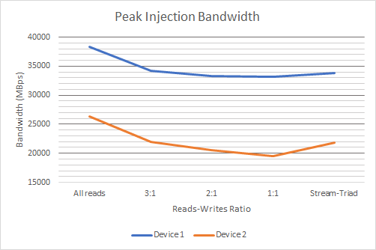

*Figure 1: Peak injection bandwidth of Device 1 and 2 at different read-write ratios*

According to the Intel MLC readme, peak injection bandwidth is when each core is generating requests as fast as it can, therefore maxing out your cache and memory in order to achieve as many reads and writes as possible. Above is a graph of the peak injection bandwidth in MBps of both Device 1 and Device 2. This shows how bandwidth is affected by altering the read-write ratio, with STREAM-triad also included for additional context. Typically cache and memory have a higher peak injection associated with more reads than writes. Our test results are consistent with our expectations, given that 1:1, our highest quantity of writes, showed the lowest bandwidth.

STREAM triad is included by the memory latency checker in order to show how the device operates when performing a more complex operation, see the explanation from the Intel website below.

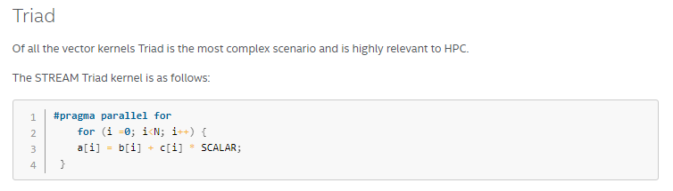

*Figure 2: STREAM Triad kernel explanation*

Given the information we learned when researching STREAM triad, we expected it to be less efficient than 1:1 read-write, but the actual result was consistently between 3:1 and 2:1, therefore making it exceed our expectations for both devices. It is also worth noting that there are other STREAM operations that MLC does not test, such as copy, scale, and sum.

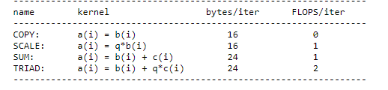

*Figure 3: Stream Operations*

## 2.2 Maximum Memory Bandwidth

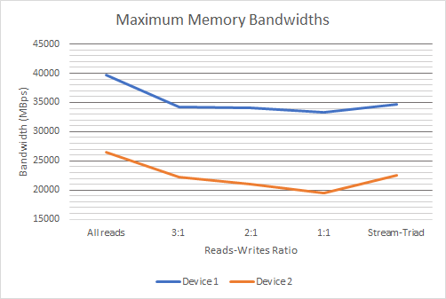

*Figure 4: Maximum memory bandwidths of Device 1 and 2 at different read-write ratios*

Maximum memory bandwidth, as defined by Intel, is the “maximum rate at which data can be read from or stored into a semiconductor memory by the processor.” This tells us that our results should theoretically be in line and fully consistent with our peak injection bandwidth. Given our test results seen for both Device 1 and Device 2 in the graph above, this is true with the only exception being that STREAM-triad saw slightly better results. The graph as a whole is also more “smooth” from 3:1 to 1:1 read-writes. There is a clear linear relationship with decreasing efficiency as more writes are attempted. As a whole, across all cache and memory tests, our results showed greater efficiency and less of a load on each device when performing read operations even at maximum capacity. This was as expected as there is an extra workload associated with writing operations in cache and memory.

## 2.3 Loaded Latencies

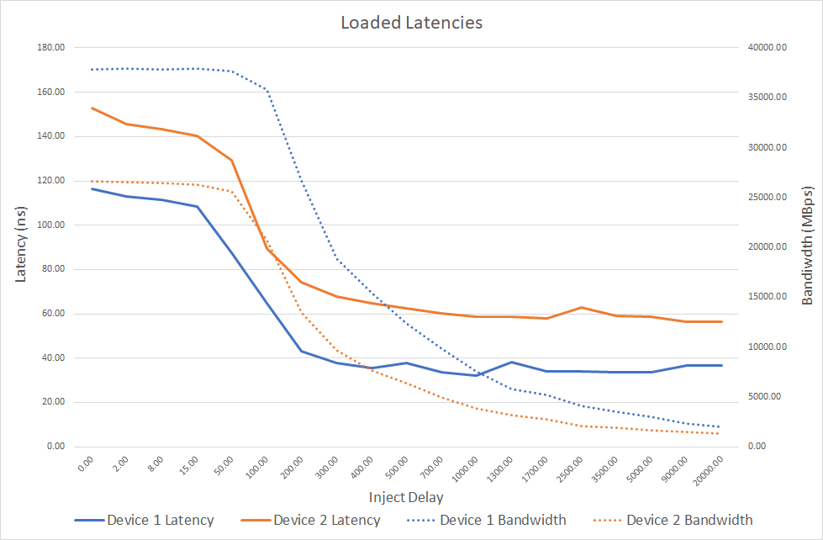

*Figure 5: Loaded latencies of Device 1 and 2 at different inject delays*

The loaded latency command is for truly seeing how bandwidth can come to influence latency. As shown by the graph above, latency increases with overall bandwidth, and decreases with a decreasing bandwidth. As injection delay is varied, bandwidth and latency both change and follow roughly the same correlation. If you focus on the lower end of the graph (0 to 15000 MBps bandwidth) the latency is almost negligible, however, as bandwidth increases the latency becomes more and more of an issue, especially with device 2. Although the axes aren’t equivalent (the latency is not scaled to bandwidth) the latency disproportionately increased with increasing bandwidth greatly affecting performance. With lower end hardware, the ratio of latency to bandwidth is relatively similar, but assuming you have a minimum performance standard, in a limited hardware environment the latency can really cause issues for the system.

This idea of latency increasing with bandwidth was one of the goals set out by the research project to identify. As a result, our data is in line with our expectations and it was interesting to see how the devices compared to each other and to see if they followed the same trends. Understanding performance even in lesser quality hardware environments is important not only for maximizing high quality enterprise grade hardware, but also for getting the most out of consumer grade hardware.

## 2.4 Additional Intel MLC Data

MLC can also be used to collect more data which was not fully explored and elaborated on in this section. Idle latencies as well as cache-to-cache transfer latency was also measured. The results were in line with our expectations and there was not much to elaborate on other than just providing the terminal output. See appendix A for more information as well as command line input and output.

# 3. Flexible I/O Tester (FIO) Tests and Analysis

## 3.1 Reads vs Writes test

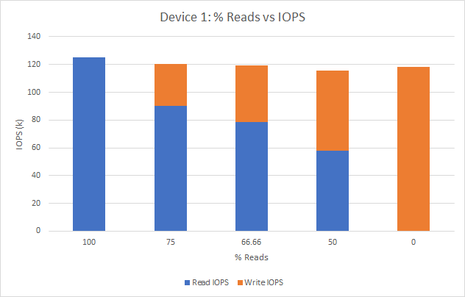

*Figure 6: IOPS of Device 1 at varying reads/writes*

The Flexible I/O tester (FIO) was used to run a test work load on storage devices to test for the IOPS for different ratios of read/write. The IOPS measured for Device 1, ranged from 30.4k IOPS to 125k IOPS varying with the ratio of read operations to write operations. The total IOPS throughout the different read/write tests are relatively consistent, ranging from around 118k IOPS to 125k IOPS. In the Figure X below, the results from running FIO on Device 2 are shown. The IOPS ranged from 3k IOPS to 41.5k IOPS. The IOPS for this device is significantly lower than the expected IOPS of the SSD installed, determined by the spec sheet on the manufacturer’s website, had far less throughput when compared with Device 1. This was expected given the limited hardware environment of device 2.

The total efficiency peaked when Device 1 was doing purely reads, which was expected, and efficiency decreased, minimizing at 1:1 reads to writes. The efficiency slightly increased when switching back to only write statements. This is as expected as writing has a higher overhead than read and given the lack of a two way channel, reading and writing at the same time are the worst efficiency possible. All results for Device 1 were as expected, Device 2 however was somewhat of an anomaly. This could be a result of the age and past use of Device 2, but it overall gained efficiency the more write statements that were made, and reading had an overall far worse efficiency. The throughput and latency greatly increased especially when reading.

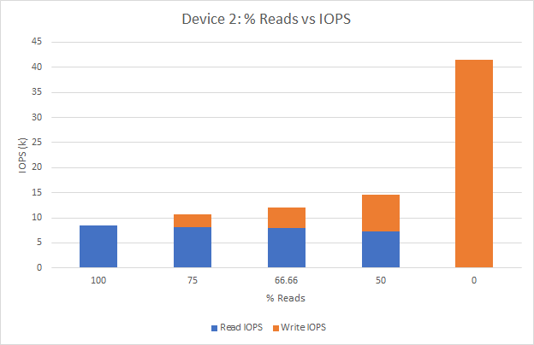

*Figure 7: IOPS of Device 2 at varying reads/writes*

## 3.2 Latency Tests

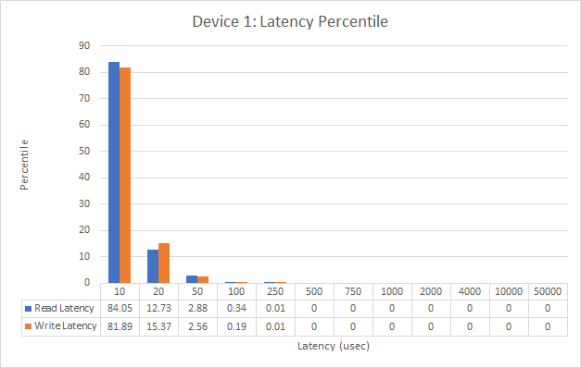

*Figure 8: Latency Percentile of Device 1*

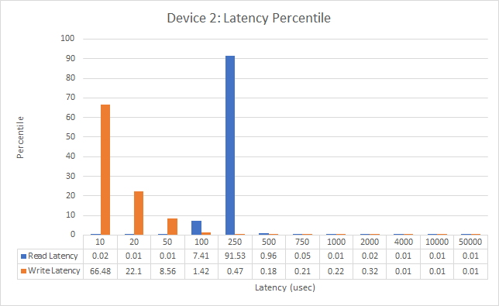

*Figure 9: Latency Percentile of Device 2*

Above are two charts showing the latency of Device 1 and 2 when performing all reads, or all writes. As a whole, Device 1 functioned exactly as expected, minor latency across the board, with a few outliers of 50+ microseconds. In addition, the latency increased with throughput when we ran additional tests. Device 2 continued to function irregularly, but aligned with our expectations set forth by the previous tests. The latency of read was far higher for Device 2 which explains why the read IOPS was significantly decreased for Device 2 in the previous tests. Device 1 and 2 despite having different baselines of both latency, IOPS, etc. followed the same increase in latency as throughput was increased.

## 3.3 Comparison to the Intel Data Center NVMe SSD D7-P5600 (1.6TB)

The Intel Data Center has an advertised read-only 4KB IOPS of 400k and write-only 4KB IOPS of 118k. Our devices both functioned with far less efficiency for reading, but device 1 had a write IOPS that was actually slightly superior. Both of our devices were significantly used and aged, and not optimized at all for the operations we’re doing, they also both have file systems installed. This was unexpected partially because the expectation was that Device 1, a workstation grade SSD, would be far inferior to the enterprise grade Intel Data center. Device 2, a consumer grade SSD, functioned mostly as expected for an SSD of its age and quality. The Samsung SSD contained in Device 1 is expected to function over 300k IOPS read and write, but these tests are done in a controlled environment on a fresh SSD that is optimized for stress tests of this caliber, complete with a 2 way file system to simultaneously read and write. The Intel Data Center NVMe SSD functions far superior to device 2, but device 1 in its prime could technically compete which is quite impressive for a workstation grade SSD.

## 3.4 Throughput vs Latency In FIO

## 

*Figure 10: I/O Depth vs Latency*

In order to test how latency and IOPS are affected by throughput, Device 1 was used for consistency. A multitude of 4kb reads were done in the tests above, increasing queue depth and monitoring IOPS and latency. The purpose of this experiment was to determine at what point did pushing throughput (IO depth or queue depth) start to negatively affect performance rather than helping it. Initially, varying queue depths between 1 and 200 greatly increased performance despite the steady and increasing latency of read accesses. As latency proceeded to increase exponentially, it started to outweigh the performance increase, decreasing IOPS. This is consistent with our expectations and with our previous results involving cache and memory with Intel MLC.

This is a problem that is very thematic through all of computer programming as well as hardware design. There is a point where pushing throughput, size, efficiency, etc. become increasingly futile. In a way, it is a reminder of Moore’s law and how development of both software and hardware is ultimately a battle we’re always fighting and slowly losing. Increasing throughput and putting more and more into your accesses does not guarantee success, therefore instead of just multiplying throughput we need a new solution so that latency can become less of an issue.

# 4. Conclusion

As a whole the results of our tests were mostly in line with our expectations. All of the Intel MLC results were as expected regarding the cache and memory. Reading appeared to function more efficiently than writing, and a combination of operations, complex or simple, reduced overall efficiency. In our cache and memory tests it is also worth noting there was an increase in latency as throughput increased limiting performance of both devices.

Most of the variance in expectations or results occurred in the FIO storage and memory category of testing. Device 1 functioned as expected, but not necessarily as efficiently as expected in the context of FIO, storage, and memory. That can be attributed to both its age as well as the filesystem installed. Device 2 functioned irregularly in the context of storage and memory especially, given that it found incredible difficulty in achieving high throughput when reading, the latency was growing increasingly and it is indicative that there are significant issues with the functionality with Device 2’s SSD.

Regarding storage, Device 2 was the only device that functioned with reading at a decreased IOPS/throughput. Device 1 proved to be far superior while also being consistent and in line with expectations set out by both the information available prior to testing and the manufacturer’s spec sheet. Consistently across the board there was an increase in latency with higher throughput that would eventually overtake the operational benefit of pushing a higher throughput. In addition, device 1 functioned much more efficienciently overall when performing only reads or only writes. Device 2 was somewhat of an anomaly as it purely increased in efficiency the more writing was happening (as opposed to reading).

Overall there was a lot to be observed in all 3 devices examined. Device 1 proved to be relatively effective and quite impressive for a workstation build when compared to an enterprise grade data center. Device 2 was also interesting to observe, as there was an opportunity to acknowledge irregular trends and the type of inhibited performance that can occur with an inconsistent and aged device. It may have not provided the most clean data but it was thought provoking nonetheless.

# 

# 

# Appendix A: Intel Memory Latency Checker

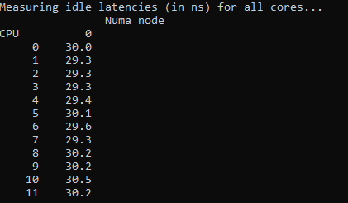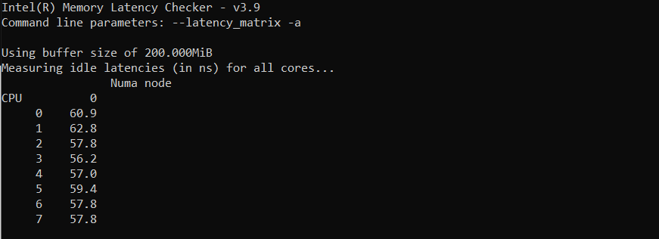

*Figure 11: Latency matrix on all CPUs (Device 1: left, Device 2: right)*

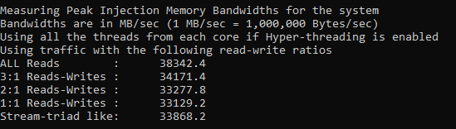

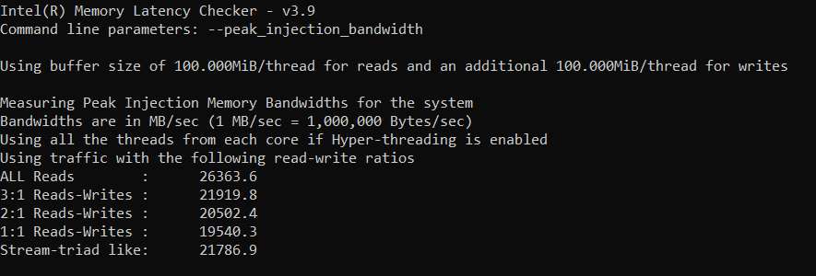

*Figure 12: Peak injection memory bandwidths (Device 1: top, Device 2: bottom)*

(a) 100% Read, 0% Write

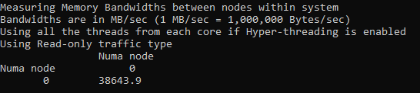

(b) 75% Read, 25% Write

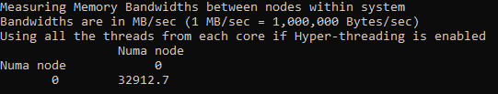

(c) 66.66% Read, 33.37% Write

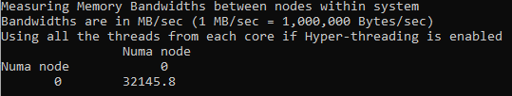

(d) 50% Read, 50% Write

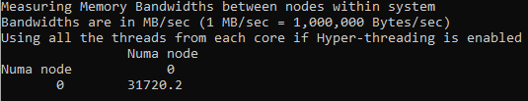

(e) 0% Read, 100% Write

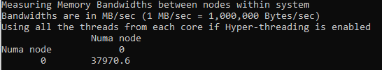

*Figure 13: Memory Bandwidth Matrices of Device 1*

(a) 100% Read, 0% Write

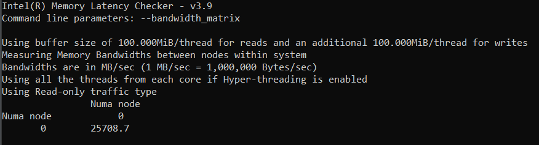

(b) 75% Read, 25% Write

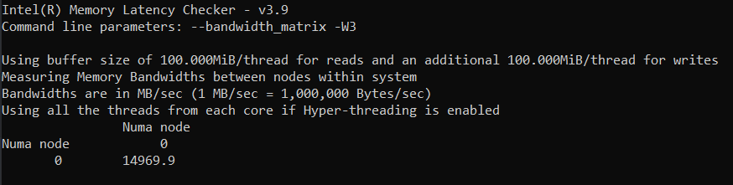

(c) 66.66% Read, 33.37% Write

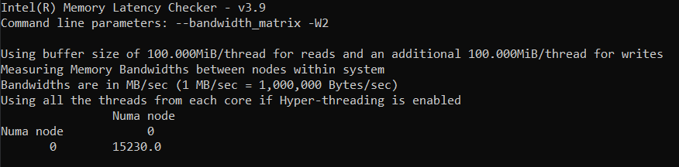

(d) 50% Read, 50% Write

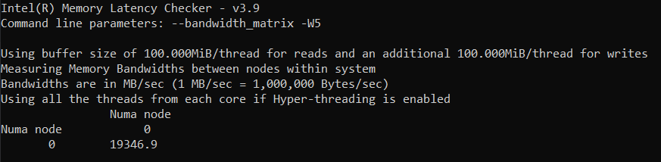

(e) 0% Read, 100% Write

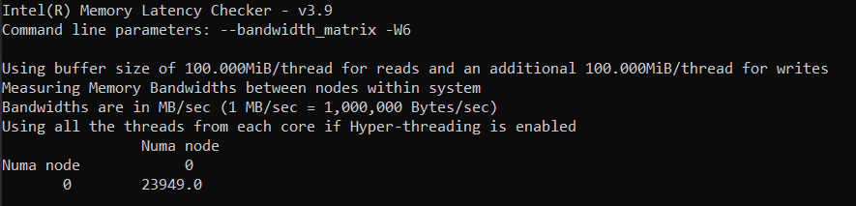

*Figure 14: Memory bandwidth matrices of Device 2*

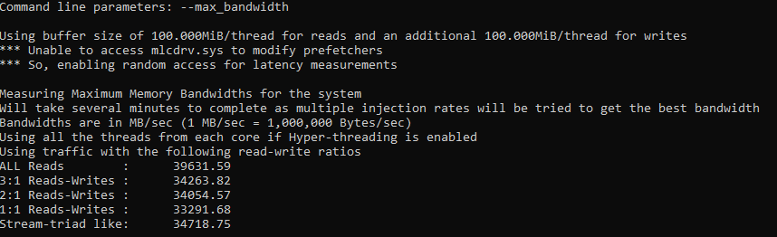

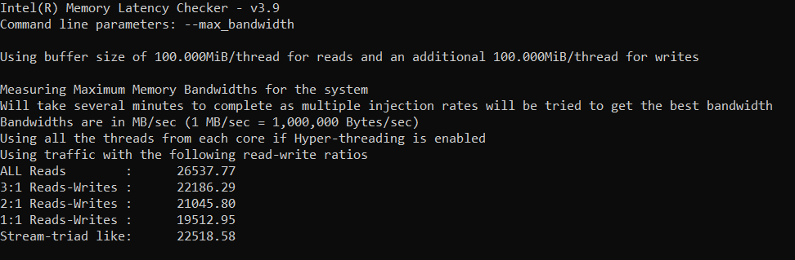

*Figure 15: Maximum Memory Bandwidths (Device 1: Top, Device 2: Bottom)*

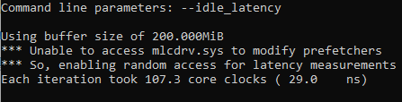

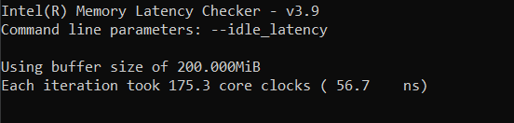

*Figure 16: Idle Latency (Device 1: Top, Device 2: Bottom)*

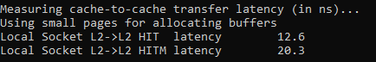

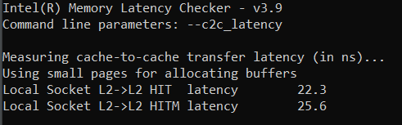

*Figure 17: Cache to Cache Transfer Latency (Device 1: Top, Device 2: Bottom)*

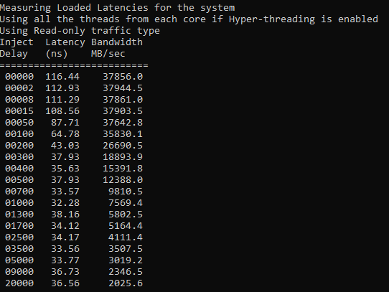

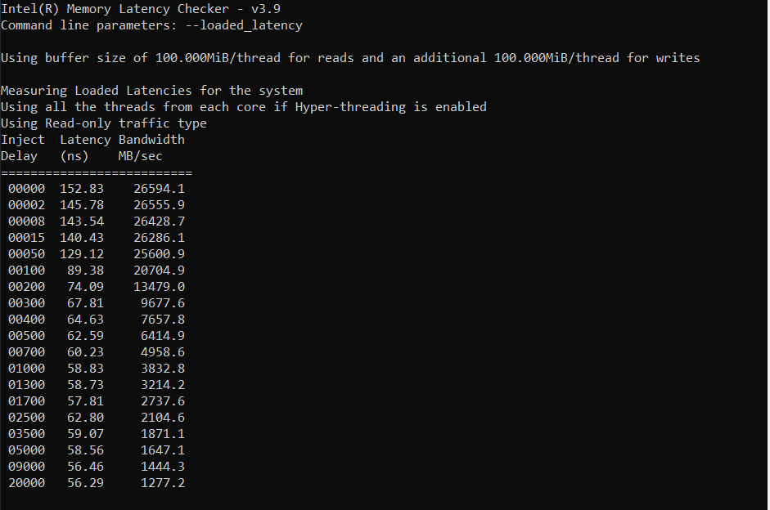

*Figure 18: Loaded Latency (Device 1: Top, Device 2: Bottom)*

# Appendix B: Flexible I/O Tester (FIO)

(a) 100% Read, 0% Write

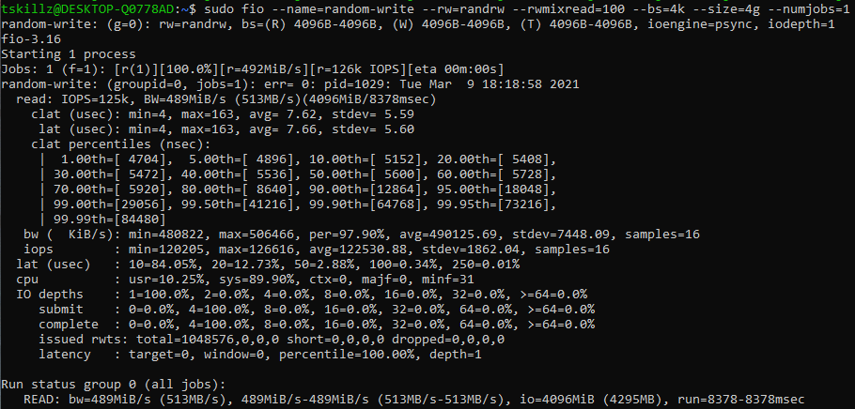

(b) 75% Read, 25% Write

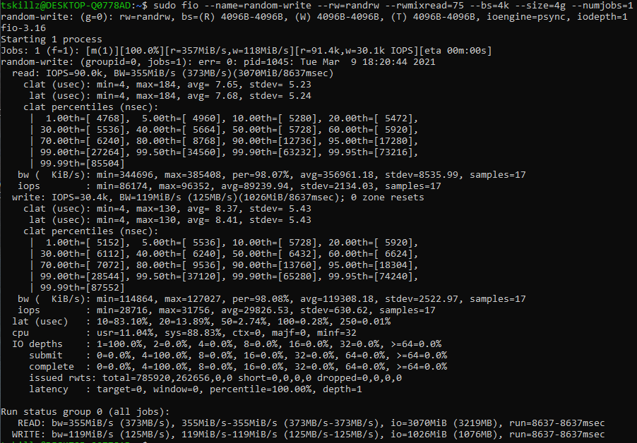

(c) 66.66% Read, 33.37% Write

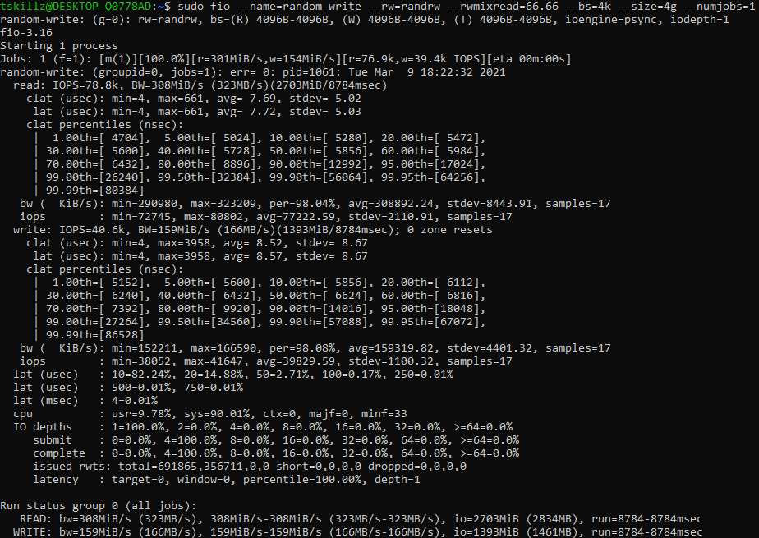

(d) 50% Read, 50% Write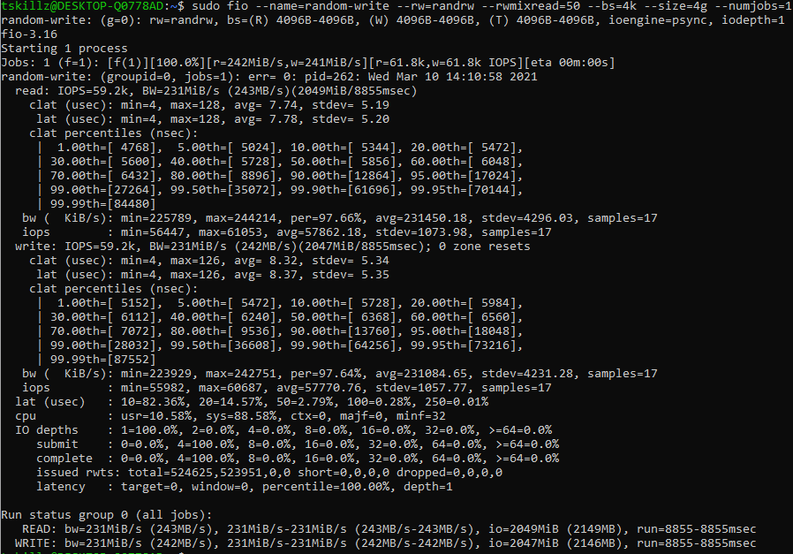

(e) 0% Read, 100% Write

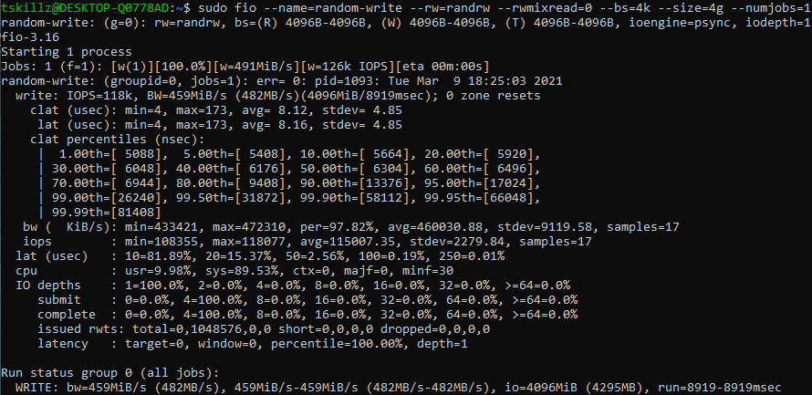

*Figure 18: Results from running fio with file size of 4GB and block size of 4KB for Device 1*

(a) 100% Read, 0% Write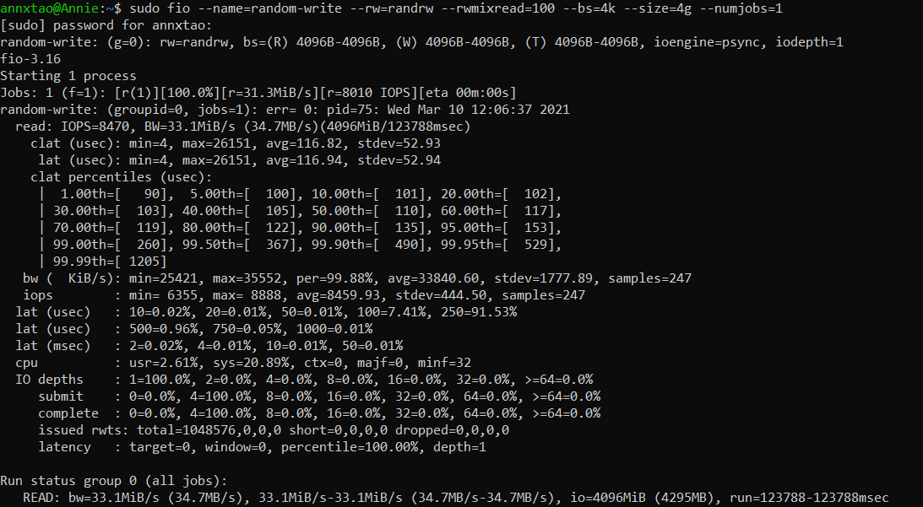

(b) 75% Read, 25% Write

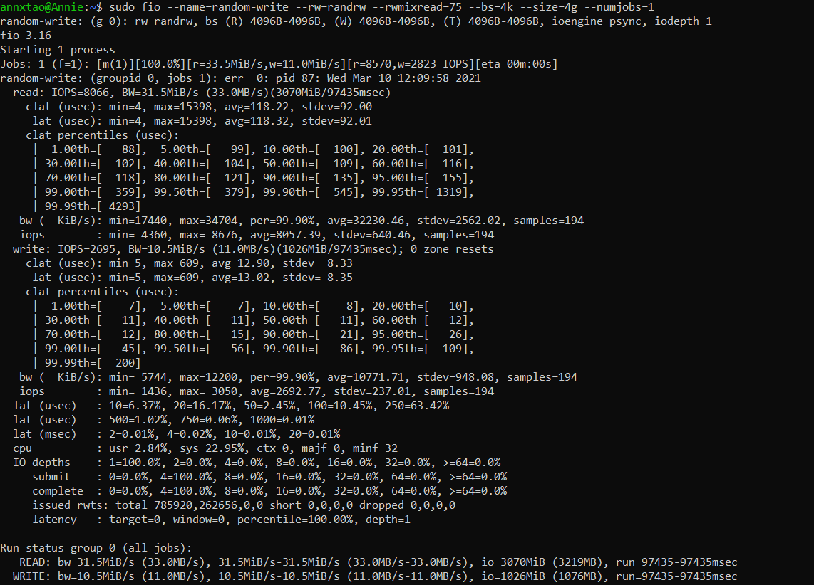

(c) 66.66% Read, 33.37% Write

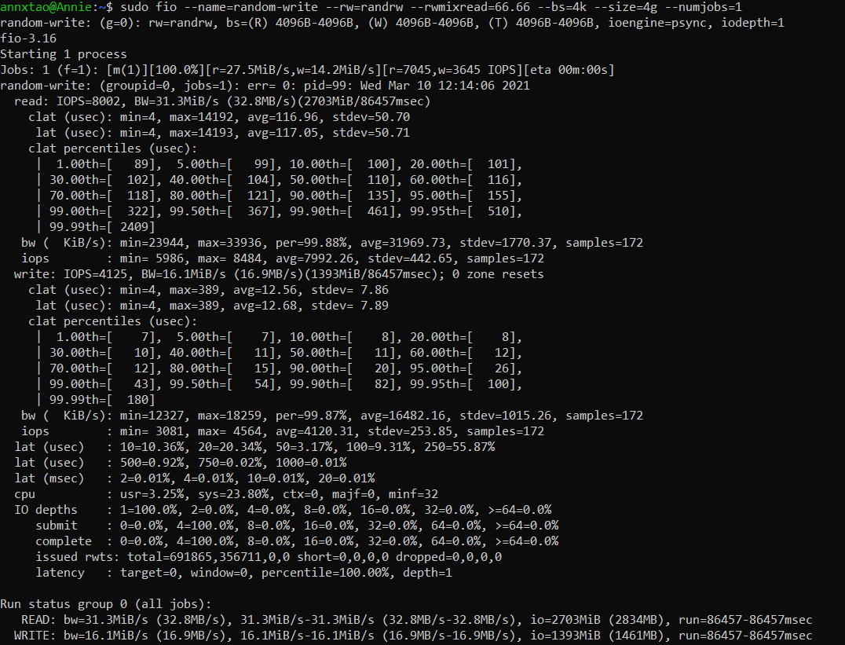

(d) 50% Read, 50% Write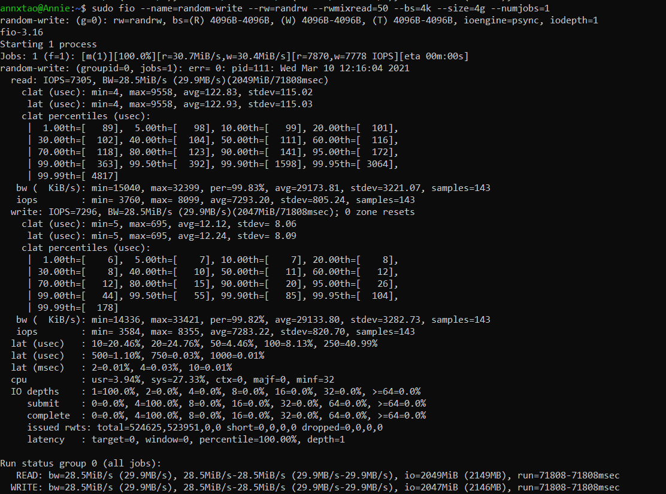

(e) 0% Read, 100% Write

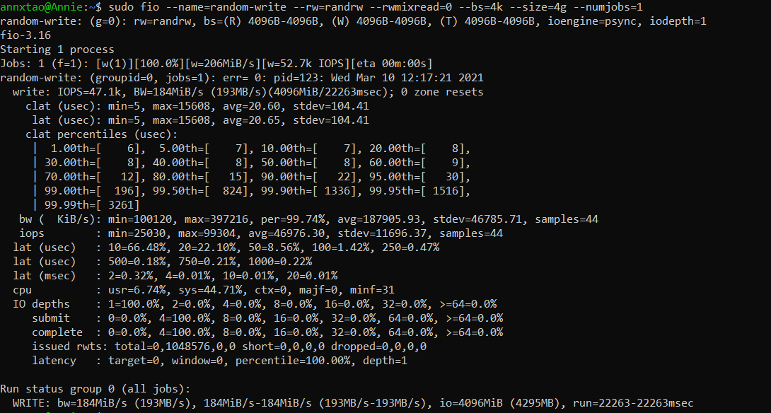

*Figure 19: Results from running fio with file size of 4GB and block size of 4KB for Device 2*

(a) IO Depth = 0

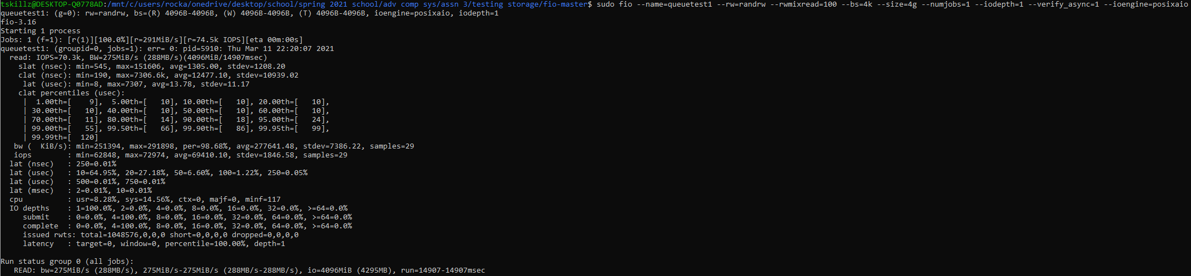

(b) IO Depth = 10

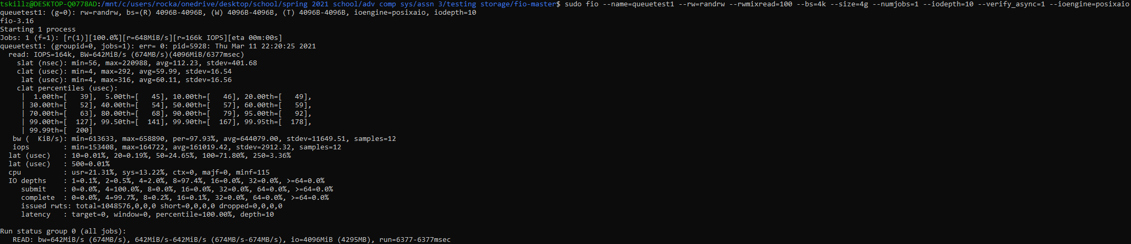

(c) IO Depth = 100

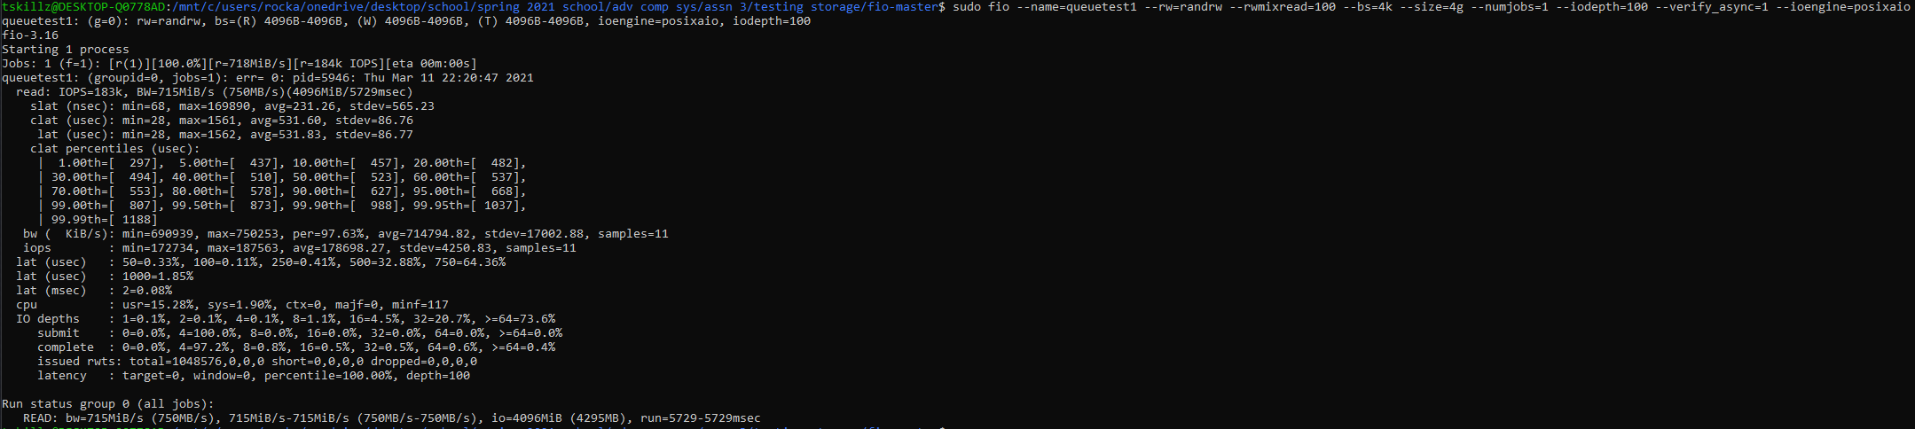

(d) IO Depth = 200

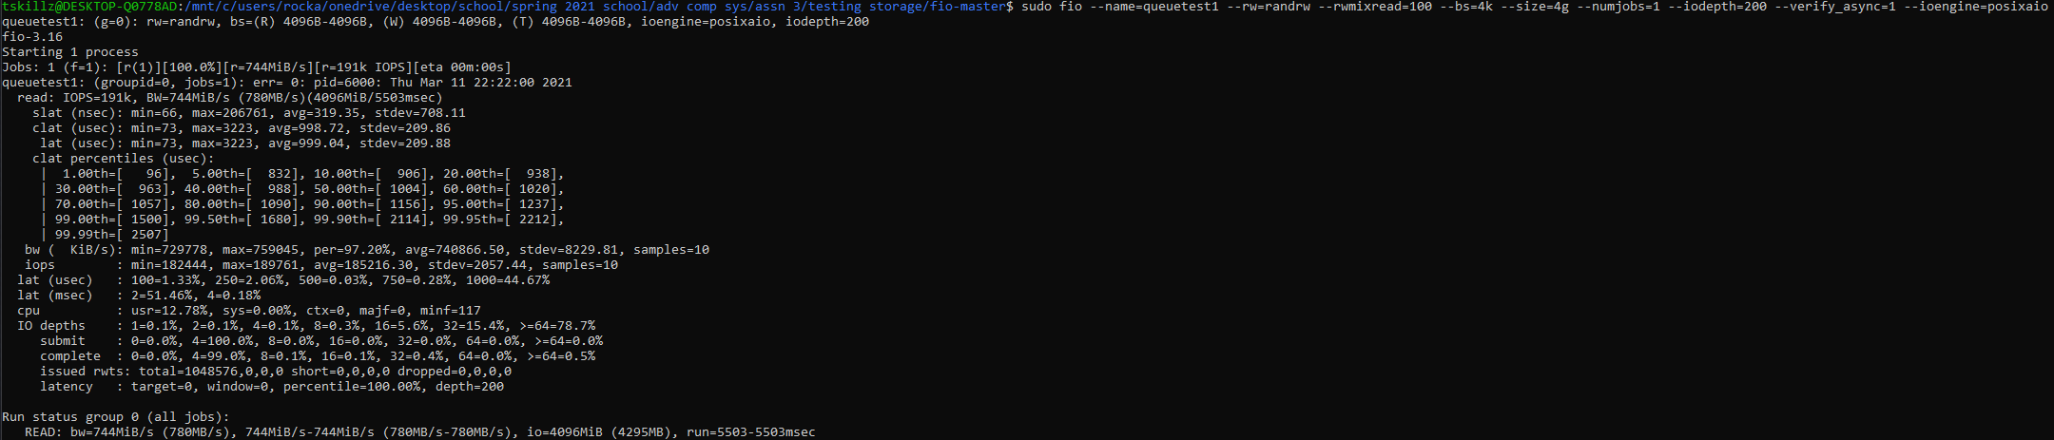

(e) IO Depth = 300

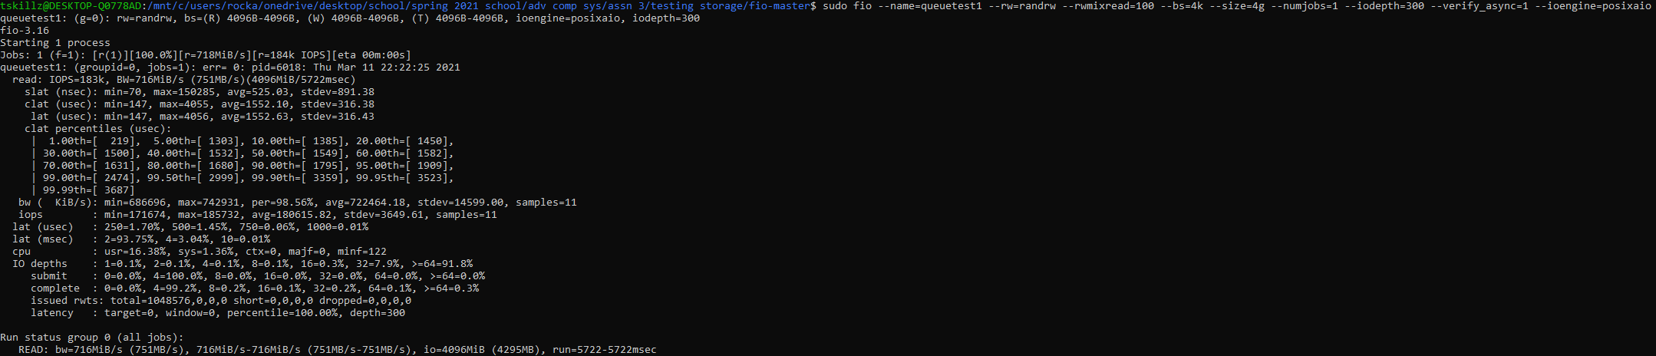

(f) IO Depth = 400

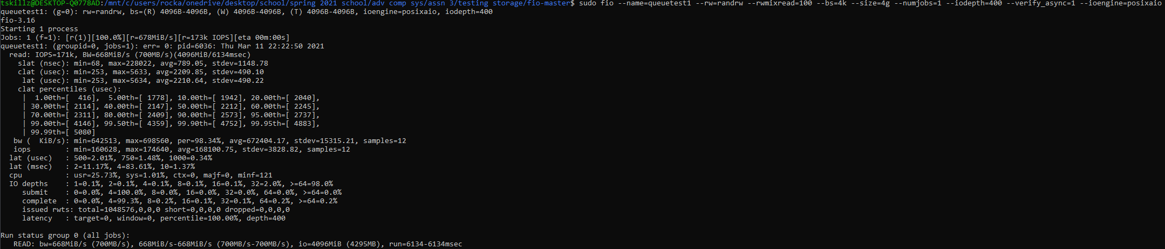

(f) IO Depth = 500

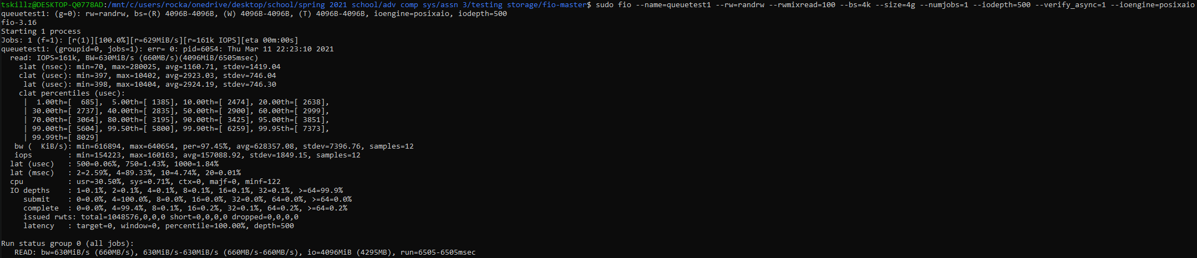

(g) IO Depth = 750

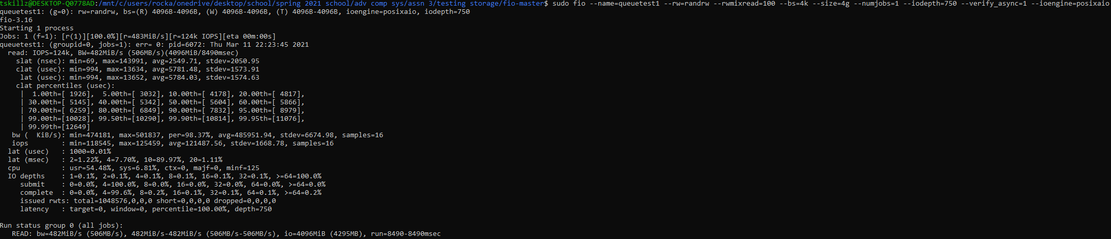

(f) IO Depth = 1000

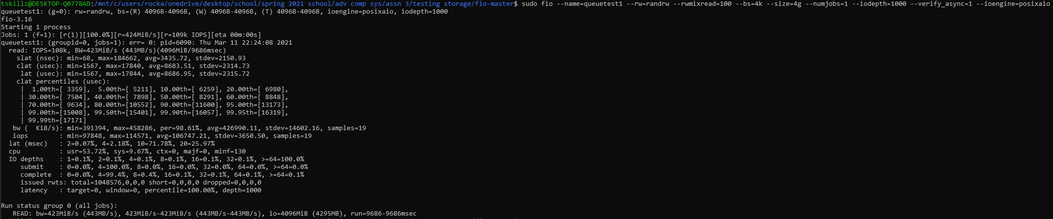

*Figure 20: Results from running fio with file size of 4GB and block size of 4KB for at varying I/O depth*

# 

# References

1. fio - Flexible I/O tester rev. 3.25. (n.d.). Retrieved March 11, 2021, from <https://fio.readthedocs.io/en/latest/fio_doc.html>

Axboe. (n.d.). Axboe/fio. Retrieved March 11, 2021, from <https://github.com/axboe/fioPdenchfi>. (n.d.).

Fio(1) - Linux man page. (n.d.). Retrieved March 11, 2021, from <https://linux.die.net/man/1/fio>

Monroe, K. (2017, August 05). How to use Fio (FLEXIBLE i/o Tester) to measure disk performance in Linux. Retrieved March 11, 2021, from <https://dotlayer.com/how-to-use-fio-to-measure-disk-performance-in-linux/>

Optimizing memory bandwidth on stream triad. (n.d.). Retrieved March 11, 2021, from <https://software.intel.com/content/www/us/en/develop/articles/optimizing-memory-bandwidth-on-stream-triad.html#:~:text=Introduction,Scale%2C%20Add%20and%20Triad>).&amp;text=STREAM%20is%20also%20a%20part%20of%20the%20HPCC%20Benchmark%20suite.

Sample fio commands for block volume performance tests on Linux-based instances. Retrieved March 11, 2021, from <https://docs.oracle.com/en-us/iaas/Content/Block/References/samplefiocommandslinux.htm>

Stream benchmark reference information. (n.d.). Retrieved March 11, 2021, from <http://www.cs.virginia.edu/stream/ref.html>

Theoretical maximum memory bandwidth FOR Intel® Core™ X-Series... (n.d.). Retrieved March 11, 2021, from <https://www.intel.com/content/www/us/en/support/articles/000056722/processors/intel-core-processors.html>