CALL ALL
  MAP | 10
Ferndown Avenue Papatoetoe | Printed 1/1//2014
Do not calls Misty 8
Carringbah 28 Chantelle 26
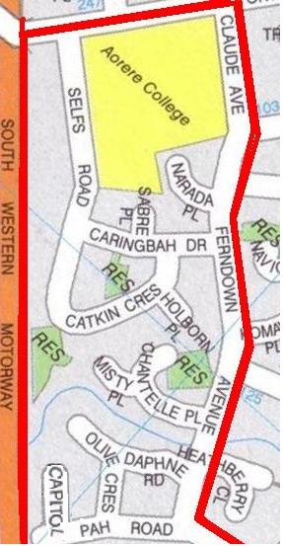

CALL ALL
  MAP | 10
Ferndown Avenue Papatoetoe | Printed 1/1//2014
Do not calls Misty 8
Carringbah 28 Chantelle 26

CALL ALL
  MAP | 10
Ferndown Avenue Papatoetoe | Printed 1/1//2014
Do not calls Misty 8
Carringbah 28 Chantelle 26

CALL ALL
  MAP | 10
Ferndown Avenue Papatoetoe | Printed 1/1//2014
Do not calls Misty 8
Carringbah 28 Chantelle 26

