CALL ALL
  MAP | 11
Grange Road Papatoetoe | Printed 1/1/2014
Do not call
Grange 11 and 19
Great South Road 65a and 769 and 775
Lansdown 5 (halfway house)
McCullough 2 and 25 and 27
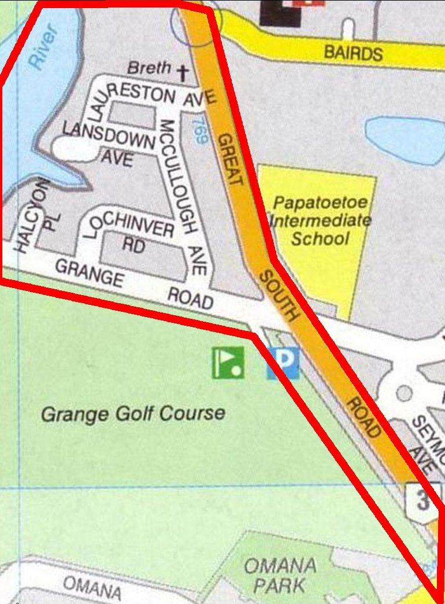
CALL ALL
  MAP | 11
Grange Road Papatoetoe | Printed 1/1/2014
Do not call
Grange 11 and 19
Great South Road 65a and 769 and 775
Lansdown 5 (halfway house)
McCullough 2 and 25 and 27
CALL ALL
  MAP | 11
Grange Road Papatoetoe | Printed 1/1/2014
Do not call
Grange 11 and 19
Great South Road 65a and 769 and 775
Lansdown 5 (halfway house)
McCullough 2 and 25 and 27
CALL ALL
  MAP | 11
Grange Road Papatoetoe | Printed 1/1/2014
Do not call
Grange 11 and 19
Great South Road 65a and 769 and 775
Lansdown 5 (halfway house)
McCullough 2 and 25 and 27

