CALL ALL
  MAP | 12
Motatau Road Papatoetoe | Printed 1/1/2014
Do not Calls
Motatau Road 30 and 35 and 106 and 127
Pukeko 8a and 8b Kautami 66
Seymour Ave 24 Kakapo 29a
Sunnyside 14 and 17 and 27 and 36

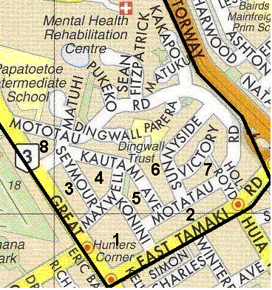

CALL ALL
  MAP | 12
Motatau Road Papatoetoe | Printed 1/1/2014
Do not Calls
Motatau Road 30 and 35 and 106 and 127
Pukeko 8a and 8b Kautami 66
Seymour Ave 24 Kakapo 29a
Sunnyside 14 and 17 and 27 and 36

CALL ALL
  MAP | 12
Motatau Road Papatoetoe | Printed 1/1/2014
Do not Calls
Motatau Road 30 and 35 and 106 and 127
Pukeko 8a and 8b Kautami 66
Seymour Ave 24 Kakapo 29a
Sunnyside 14 and 17 and 27 and 36

CALL ALL
  MAP | 12
Motatau Road Papatoetoe | Printed 1/1/2014
Do not Calls
Motatau Road 30 and 35 and 106 and 127
Pukeko 8a and 8b Kautami 66
Seymour Ave 24 Kakapo 29a
Sunnyside 14 and 17 and 27 and 36

