CALL ALL
  MAP | 14
Favona Road Mangere | Printed 1/1/2014
Do not Call Favona 85
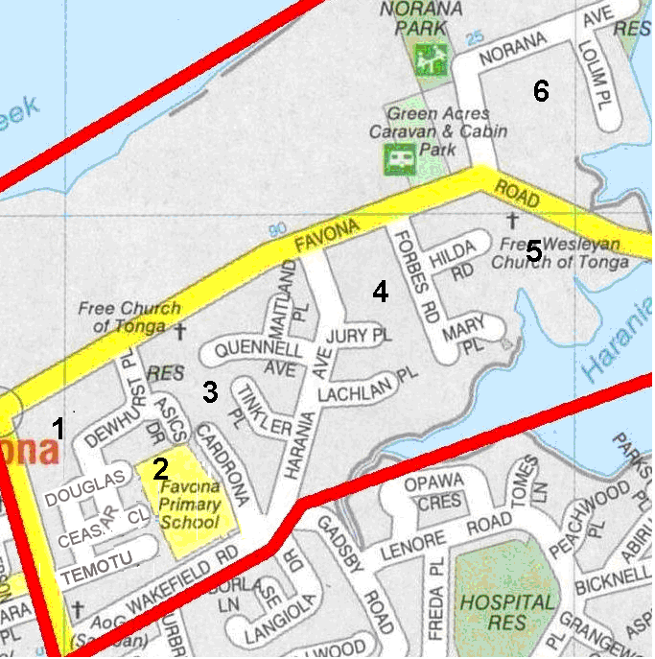

CALL ALL
  MAP | 14
Favona Road Mangere | Printed 1/1/2014
Do not Call Favona 85

CALL ALL
  MAP | 14
Favona Road Mangere | Printed 1/1/2014
Do not Call Favona 85

CALL ALL
  MAP | 14
Favona Road Mangere | Printed 1/1/2014
Do not Call Favona 85

