CALL ALL
  MAP | 15
Gadsby Road Mangere | Printed 1/1/2014

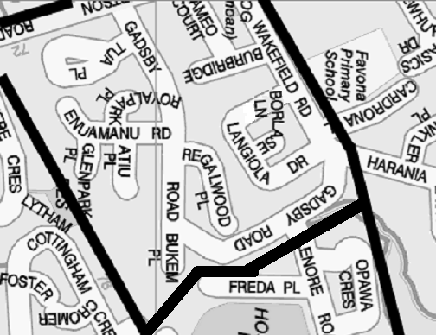

CALL ALL
  MAP | 15
Gadsby Road Mangere | Printed 1/1/2014

CALL ALL
  MAP | 15
Gadsby Road Mangere | Printed 1/1/2014

CALL ALL
  MAP | 15
Gadsby Road Mangere | Printed 1/1/2014

