CALL ALL
  MAP | 16
McKinstry Avenue Mangere | Printed 1/1/2014

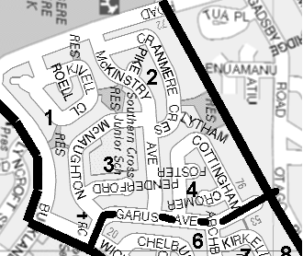

CALL ALL
  MAP | 16
McKinstry Avenue Mangere | Printed 1/1/2014

CALL ALL
  MAP | 16
McKinstry Avenue Mangere | Printed 1/1/2014

CALL ALL
  MAP | 16
McKinstry Avenue Mangere | Printed 1/1/2014

