CALL ALL
  MAP | 17
Yates Road Mangere | Printed 1/1/2013

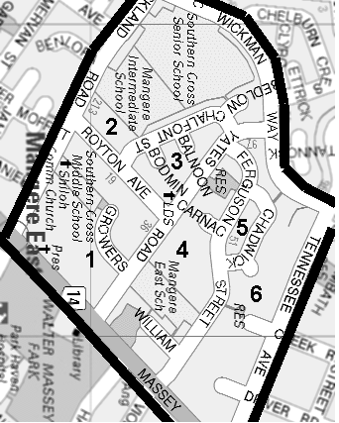

CALL ALL
  MAP | 17
Yates Road Mangere | Printed 1/1/2013

CALL ALL
  MAP | 17
Yates Road Mangere | Printed 1/1/2013

CALL ALL
  MAP | 17
Yates Road Mangere | Printed 1/1/2013

