CALL ALL
  MAP | 18
Ashley Avenue Mangere | Printed 1/1/2014

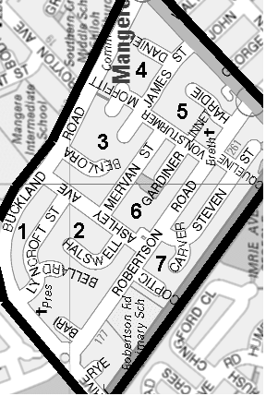
CALL ALL
  MAP | 18
Ashley Avenue Mangere | Printed 1/1/2014

CALL ALL
  MAP | 18
Ashley Avenue Mangere | Printed 1/1/2014

CALL ALL
  MAP | 18
Ashley Avenue Mangere | Printed 1/1/2014

