CALL ALL
  MAP | 19
Mahunga Drive Mangere | Printed 1/1/2014

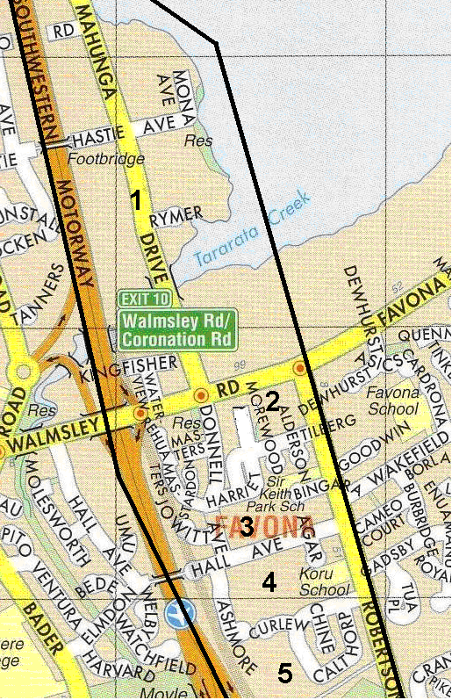

CALL ALL
  MAP | 19
Mahunga Drive Mangere | Printed 1/1/2014

CALL ALL
  MAP | 19
Mahunga Drive Mangere | Printed 1/1/2014

CALL ALL
  MAP | 19
Mahunga Drive Mangere | Printed 1/1/2014

