CALL ALL
  MAP | 1
Hillside Road Otahuhu | Printed 1/1/2014
Do not call. Camp Rd 30

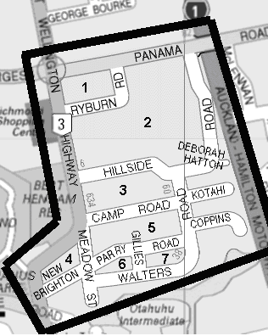

CALL ALL
  MAP | 1
Hillside Road Otahuhu | Printed 1/1/2014
Do not call. Camp Rd 30

CALL ALL
  MAP | 1
Hillside Road Otahuhu | Printed 1/1/2014
Do not call. Camp Rd 30

CALL ALL
  MAP | 1
Hillside Road Otahuhu | Printed 1/1/2014
Do not call. Camp Rd 30

