CALL ALL
  MAP | 20
Omana Road Papatoetoe | Printed 1/1/2014
Do not Call
Cambourne 11
Trimmer 22
Omana 22/1
Shirley Rd 182/1
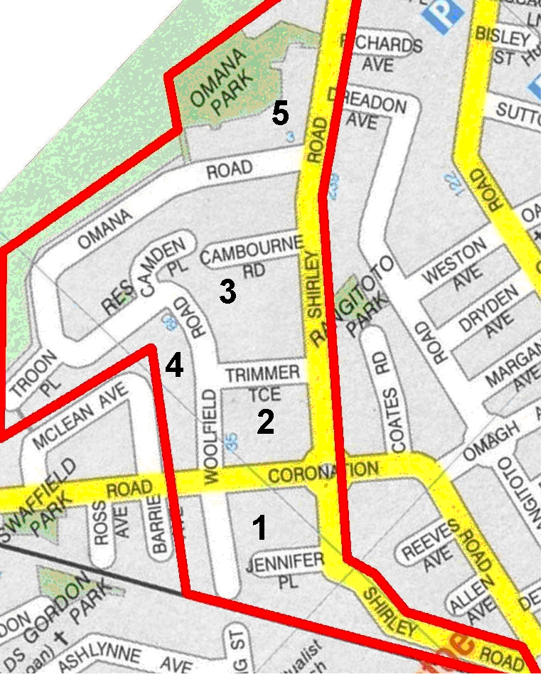

CALL ALL
  MAP | 20
Omana Road Papatoetoe | Printed 1/1/2014
Do not Call
Cambourne 11
Trimmer 22
Omana 22/1
Shirley Rd 182/1

CALL ALL
  MAP | 20
Omana Road Papatoetoe | Printed 1/1/2014
Do not Call
Cambourne 11
Trimmer 22
Omana 22/1
Shirley Rd 182/1

CALL ALL
  MAP | 20
Omana Road Papatoetoe | Printed 1/1/2014
Do not Call
Cambourne 11
Trimmer 22
Omana 22/1
Shirley Rd 182/1

