CALL ALL
  MAP | 21
Swaffield Road Papatoetoe | Printed 1/1/2014
Do Not Call
Barrie 16
McLean 28 and 35 and 42 and 54
Middlemore crescent 7c and 42 and 73
Swaffield Crescent 44/2
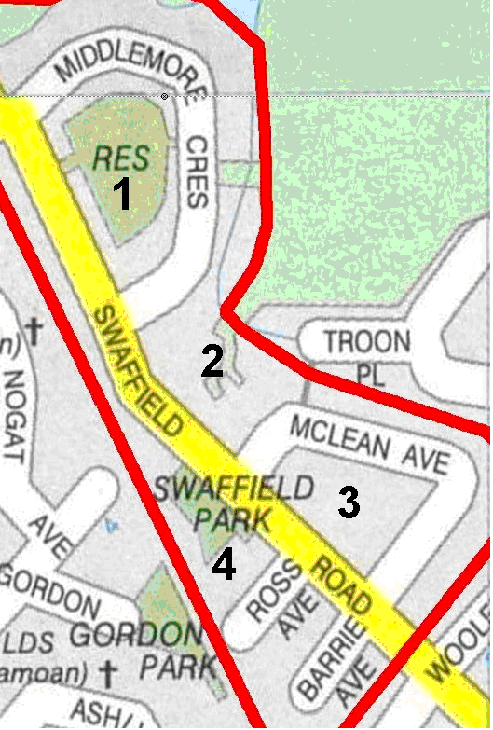
CALL ALL
  MAP | 21
Swaffield Road Papatoetoe | Printed 1/1/2014
Do Not Call
Barrie 16
McLean 28 and 35 and 42 and 54
Middlemore crescent 7c and 42 and 73
Swaffield Crescent 44/2
CALL ALL
  MAP | 21
Swaffield Road Papatoetoe | Printed 1/1/2014
Do Not Call
Barrie 16
McLean 28 and 35 and 42 and 54
Middlemore crescent 7c and 42 and 73
Swaffield Crescent 44/2
CALL ALL
  MAP | 21
Swaffield Road Papatoetoe | Printed 1/1/2014
Do Not Call
Barrie 16
McLean 28 and 35 and 42 and 54
Middlemore crescent 7c and 42 and 73
Swaffield Crescent 44/2

