CALL ALL
  MAP | 22
Coronation Road Papatoetoe | Printed 1/1/2014
Do not call
Allen 50 Coronation Road 75/1 and 79
Reeves 11/1 Shirley Road 209/1 and 283
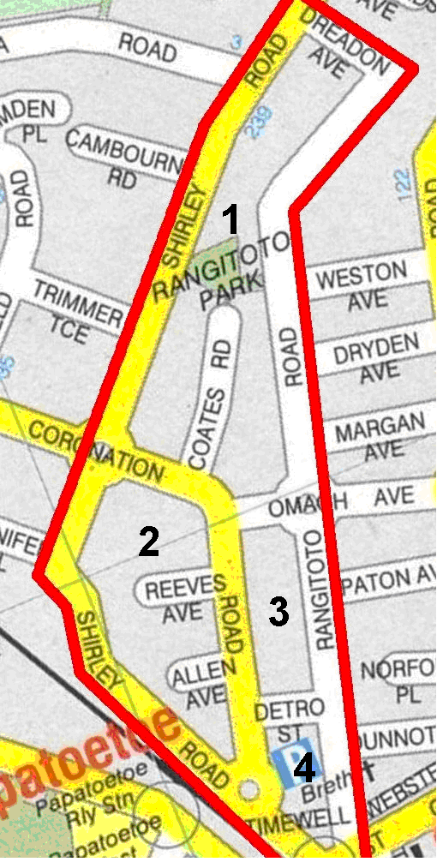
CALL ALL
  MAP | 22
Coronation Road Papatoetoe | Printed 1/1/2014
Do not call
Allen 50 Coronation Road 75/1 and 79
Reeves 11/1 Shirley Road 209/1 and 283
CALL ALL
  MAP | 22
Coronation Road Papatoetoe | Printed 1/1/2014
Do not call
Allen 50 Coronation Road 75/1 and 79
Reeves 11/1 Shirley Road 209/1 and 283
CALL ALL
  MAP | 22
Coronation Road Papatoetoe | Printed 1/1/2014
Do not call
Allen 50 Coronation Road 75/1 and 79
Reeves 11/1 Shirley Road 209/1 and 283

