CALL ALL
  MAP | 23
Kolmar Road Papatoetoe | Printed 1/1/2014
Do not Call
Weston 13 Omagh 31/3
Rangitoto 58 & 101 Dryden 22
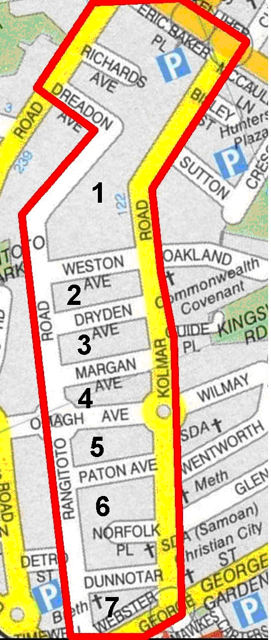
CALL ALL
  MAP | 23
Kolmar Road Papatoetoe | Printed 1/1/2014
Do not Call
Weston 13 Omagh 31/3
Rangitoto 58 & 101 Dryden 22
CALL ALL
  MAP | 23
Kolmar Road Papatoetoe | Printed 1/1/2014
Do not Call
Weston 13 Omagh 31/3
Rangitoto 58 & 101 Dryden 22
CALL ALL
  MAP | 23
Kolmar Road Papatoetoe | Printed 1/1/2014
Do not Call
Weston 13 Omagh 31/3
Rangitoto 58 & 101 Dryden 22

