CALL ALL
  MAP | 24
Rosella Road Papatoetoe | Printed 1/1/2014
Do not call Miami 17
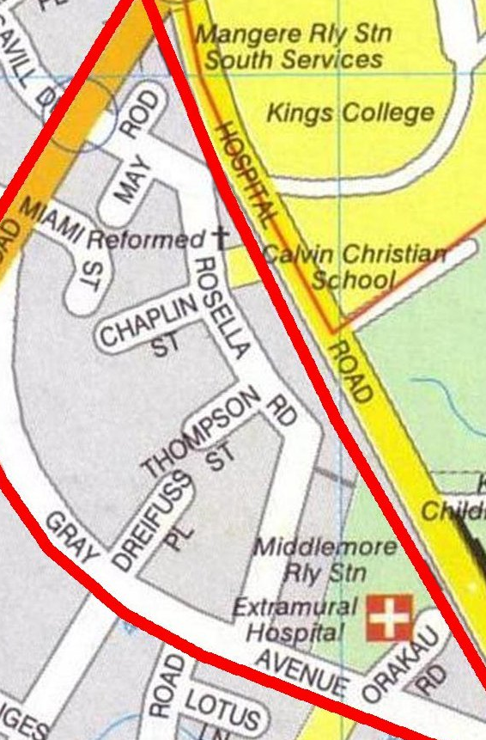

CALL ALL
  MAP | 24
Rosella Road Papatoetoe | Printed 1/1/2014
Do not call Miami 17

CALL ALL
  MAP | 24
Rosella Road Papatoetoe | Printed 1/1/2014
Do not call Miami 17

CALL ALL
  MAP | 24
Rosella Road Papatoetoe | Printed 1/1/2014
Do not call Miami 17

