CALL ALL
  MAP | 25
Hain Avenue Papatoetoe | Printed 1/1/2014
Do not Call
Buckland 47 and 81 Gray Avenue 19a
Hallberry 64 Malcolm 4

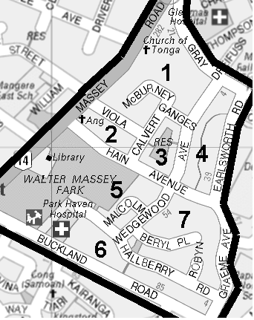

CALL ALL
  MAP | 25
Hain Avenue Papatoetoe | Printed 1/1/2014
Do not Call
Buckland 47 and 81 Gray Avenue 19a
Hallberry 64 Malcolm 4

CALL ALL
  MAP | 25
Hain Avenue Papatoetoe | Printed 1/1/2014
Do not Call
Buckland 47 and 81 Gray Avenue 19a
Hallberry 64 Malcolm 4

CALL ALL
  MAP | 25
Hain Avenue Papatoetoe | Printed 1/1/2014
Do not Call
Buckland 47 and 81 Gray Avenue 19a
Hallberry 64 Malcolm 4

