CALL ALL
  MAP | 26
Station Road Papatoetoe | Printed 1/1/2014
Do not Call
Ashlynne 24 and 24a Gordon 9
Peverill 18 Station Rd 70
Portage Extension 34/3
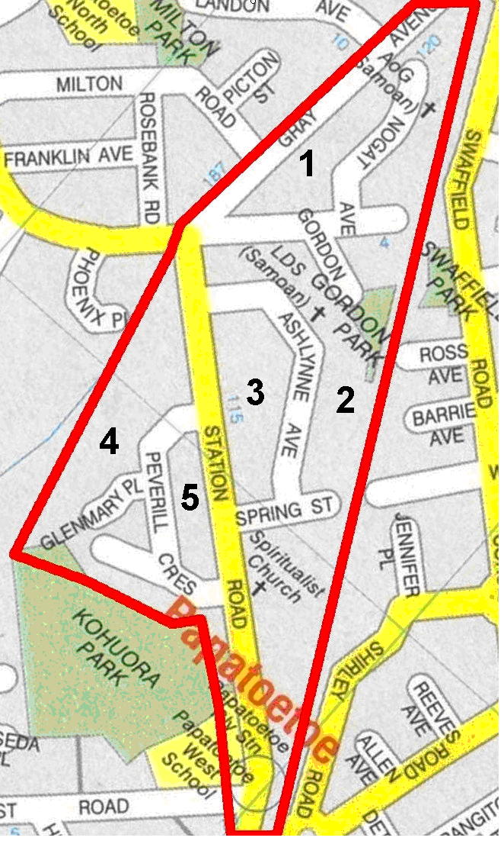

CALL ALL
  MAP | 26
Station Road Papatoetoe | Printed 1/1/2014
Do not Call
Ashlynne 24 and 24a Gordon 9
Peverill 18 Station Rd 70
Portage Extension 34/3

CALL ALL
  MAP | 26
Station Road Papatoetoe | Printed 1/1/2014
Do not Call
Ashlynne 24 and 24a Gordon 9
Peverill 18 Station Rd 70
Portage Extension 34/3

CALL ALL
  MAP | 26
Station Road Papatoetoe | Printed 1/1/2014
Do not Call
Ashlynne 24 and 24a Gordon 9
Peverill 18 Station Rd 70
Portage Extension 34/3

