CALL ALL
  MAP | 27
Alabaster Drive Papatoetoe | Printed 1/1/2014
Do not call
Komako 6 and 8 Lendenfeld 5
Malte Brun 6 McDonald 24/5
Phoenix 10/3 Portage 150 and 170a and 210
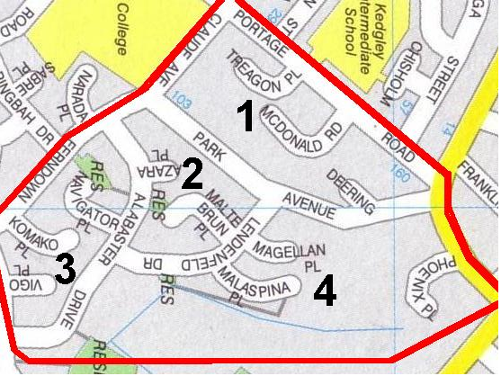

CALL ALL
  MAP | 27
Alabaster Drive Papatoetoe | Printed 1/1/2014
Do not call
Komako 6 and 8 Lendenfeld 5
Malte Brun 6 McDonald 24/5
Phoenix 10/3 Portage 150 and 170a and 210

CALL ALL
  MAP | 27
Alabaster Drive Papatoetoe | Printed 1/1/2014
Do not call
Komako 6 and 8 Lendenfeld 5
Malte Brun 6 McDonald 24/5
Phoenix 10/3 Portage 150 and 170a and 210

CALL ALL
  MAP | 27
Alabaster Drive Papatoetoe | Printed 1/1/2014
Do not call
Komako 6 and 8 Lendenfeld 5
Malte Brun 6 McDonald 24/5
Phoenix 10/3 Portage 150 and 170a and 210

