CALL ALL
  MAP | 28
Landon Avenue Papatoetoe | Printed 1/1/2014
Do not call
Buckland 44 Gray Ave 103/1 and 155b
Eden 20 Landon 10 and 13 and 50/1
Milton 44 Picton 18
Rosebank 25 Staines 3

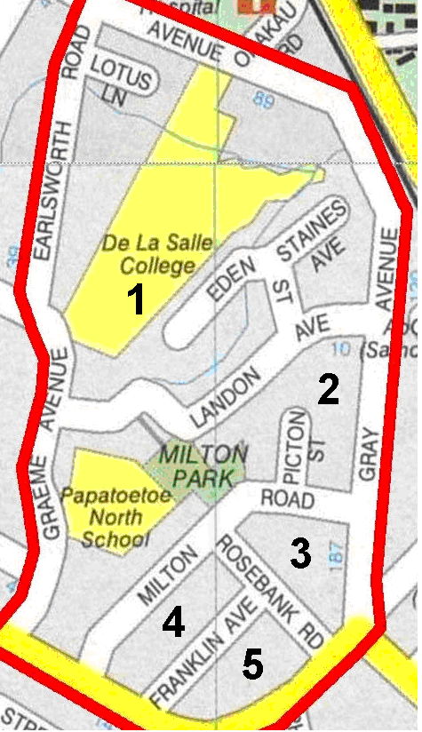
CALL ALL
  MAP | 28
Landon Avenue Papatoetoe | Printed 1/1/2014
Do not call
Buckland 44 Gray Ave 103/1 and 155b
Eden 20 Landon 10 and 13 and 50/1
Milton 44 Picton 18
Rosebank 25 Staines 3

CALL ALL
  MAP | 28
Landon Avenue Papatoetoe | Printed 1/1/2014
Do not call
Buckland 44 Gray Ave 103/1 and 155b
Eden 20 Landon 10 and 13 and 50/1
Milton 44 Picton 18
Rosebank 25 Staines 3

CALL ALL
  MAP | 28
Landon Avenue Papatoetoe | Printed 1/1/2014
Do not call
Buckland 44 Gray Ave 103/1 and 155b
Eden 20 Landon 10 and 13 and 50/1
Milton 44 Picton 18
Rosebank 25 Staines 3

