CALL ALL
  MAP | 29
Hokianga Papatoetoe | Printed 1/1/2014
Do not Call
Celia 2 Kairanga 13
Haddon 3a Tiari 9

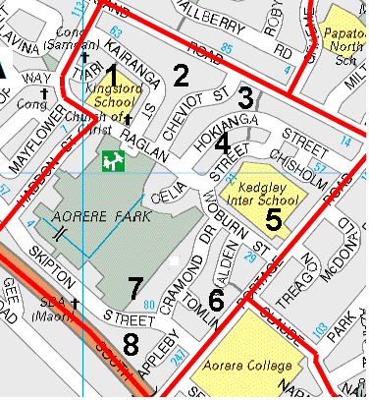

CALL ALL
  MAP | 29
Hokianga Papatoetoe | Printed 1/1/2014
Do not Call
Celia 2 Kairanga 13
Haddon 3a Tiari 9

CALL ALL
  MAP | 29
Hokianga Papatoetoe | Printed 1/1/2014
Do not Call
Celia 2 Kairanga 13
Haddon 3a Tiari 9

CALL ALL
  MAP | 29
Hokianga Papatoetoe | Printed 1/1/2014
Do not Call
Celia 2 Kairanga 13
Haddon 3a Tiari 9

