CALL ALL
  MAP | 2
Luke St Otahuhu | Printed 1/1/2014

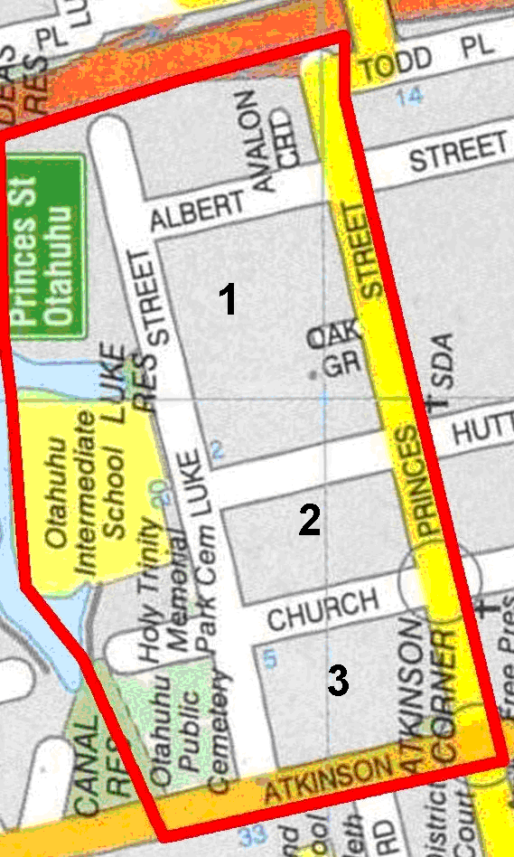

CALL ALL
  MAP | 2
Luke St Otahuhu | Printed 1/1/2014

CALL ALL
  MAP | 2
Luke St Otahuhu | Printed 1/1/2014

CALL ALL
  MAP | 2
Luke St Otahuhu | Printed 1/1/2014

